Integrating with the G6 Pay Per Install iOS SDK

SDK Setup

Download
To install the G6Pay SDK, first download the latest G6SDK package. After unzipping the download archive, you will see the following directories:

G6SDK/G6 Demo.xcodeproj/
G6SDK/G6Pay/
G6SDK/doc/

The G6Pay folder contains all the source files that will be needed to integrate into your Xcode project.
The G6 Demo.xcodeproj can be opened in Xcode. This is a sample project that demonstrates how to utilize the G6 SDK.
The doc directory contains additional documentation.

Application Setup
The G6SDK/G6Pay directory contains the source files that need to be copied into your application. You should copy this folder into your Xcode project. Simple drag the G6Pay folder into your Xcode project.

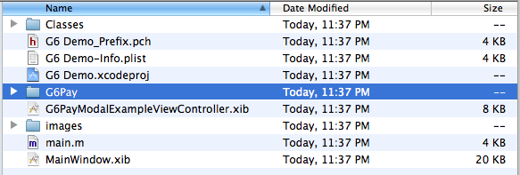
When prompted, selected “create group...” and select “Finish”.
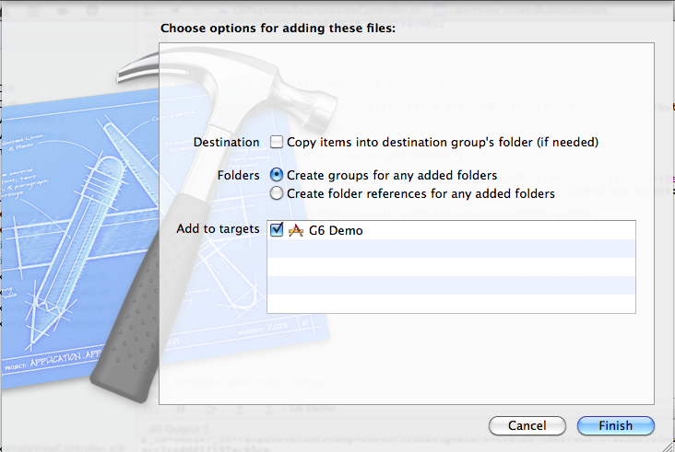

After you have copied the source files to your project, you can set up the SDK to utilize your G6 APP ID and Secret key.
Your APP ID and Secret key can be obtained from the G6 dashboard. You will need these values to configure the SDK.
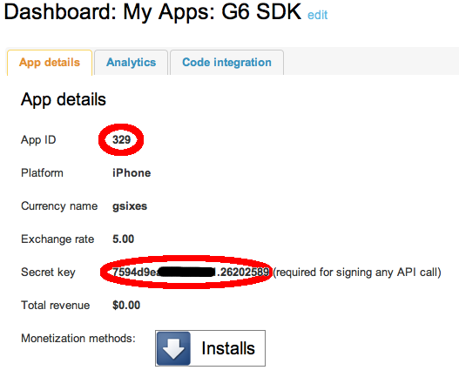

SDK Usage

Install Confirmation

Confirming install involves the following code. This code should be added to your application delegate.

Once you've done that, configuration is simple:
#import "G6Pay.h"

- (BOOL)application:(UIApplication *)application didFinishLaunchingWithOptions:(NSDictionary *)launchOptions {
… snip ...
[G6Pay initSDKWithAppId:@"YourAppId" andSecretKey:@"yourAppSecret"];

[[G6Pay getG6Instance] installConfirm];
… snip …
}

