Coding in R Midterm - Bay Area Bike Rental Operation Research

Ahmed Mokhtar

**Introduction and Exploratory Data Analysis**

This report is prepared as part of the Bay Area Bike Rental Operation Research at SF Bay Area Bike Operations HQ. The datasets used in the making of this report spans from January 1, 2014, to December 31, 2014. This encompasses data on the flow of bikes, including when and where they were picked up an returned, station information, and weather information for the specified time period. The three datasets are called “trips”, “station” and “weather” respectively.

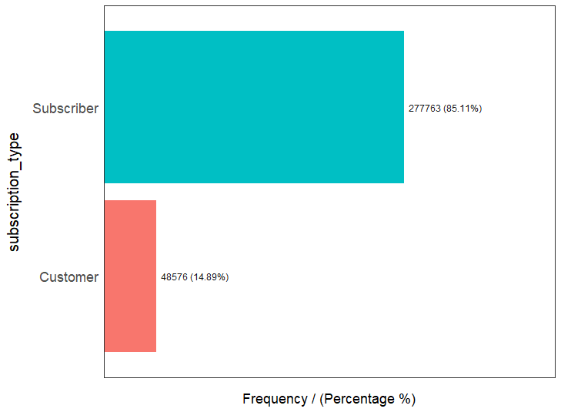

**Figure 1:** Distribution of Bike User Status

To start, we will begin with previewing the trips dataset. Figure 1 provides a breakdown of the status of users. 85% of the trips recorded in 2014 were by subscribers, whereas 15% were by customers. Subscribers are defined as individuals with annual or 30-day memberships, whereas customers are individuals with 24-hour or 3-day memberships. (Parry, 2016) The high proportion of subscribers compared to customers illustrates that bike rentals are a commodity that is essential to the lives of hundreds of thousands of people in Bay Area. Additionally, it also reveals that the majority of the customer base are returning, which will be essential to interpreting data such as the utilization ratio and the station frequency analyses.

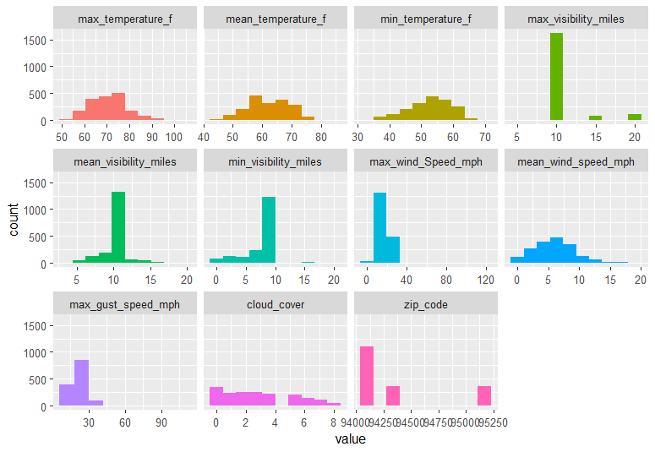

**Figure 2:** Further EDA for the “weather” Dataset

A detailed EDA was performed on all three datasets. These EDAs were used by the team of data analysts to guide the process of data cleaning. Generally speaking, all three datasets were fairly clean. Figure 2 illustrates relevant data distributions for weather factors in the “weather” dataset. It can be observed that most of the categories exhibit a distribution that is quiet expected. For example, the mean temperature histogram shows a fairly normal distribution, which is to be expected given the fluctuation of temperatures throughout the year.

**Data Cleaning**

Although the data was fairly well structured and organized, there was some cleaning that was performed. The first item of cleaning that was performed was removing trip data for trips that were less than 3 minutes, and were both started and returned at the same station. These trips are void since they were cancelled. As such, I opted to remove these rides from the data to avoid skewing the duration times. The trip ids for all cancelled trips can be found the file “cancelled_trips_ids.csv” in the R_Midterm_Project repo. Next, in order to perform effective analyses on the duration times, which a key indicator that will be used later in the correlation tests, I opted to remove outliers from the duration column. I classified outliers as any data point that falls outside a range that encompasses 98% of the dataset. This ensures that extremely long or extremely short rides that are not actually representative of most rides are removed from the dataset. The trip ids for the excluded outliers can be found in the “outlier_ids.csv” file in the R_Midterm_Project repo. Lastly, the last major item of cleaning that I performed was replacing “T” denoting trace amounts from the precipitation column with 0.005. The dataset collected precipitation levels in inches. However, on days with levels of precipitation that were less than 0.01, and were considered trace, I marked them with a value of 0.005. (Parry, 2016) The assumption I am making is that 0.005 represents the mean of all trace amounts of precipitation that are below 0.01, and were not recorded.

**Rush Hour Analysis**

The next step in our analysis was to establish a breakdown of the number of trips per hour on weekdays. The idea behind this is that this would provide insight into when bikes are highest in demand, and allow us to potentially understand the population demographic that uses the bike rental services most frequently.

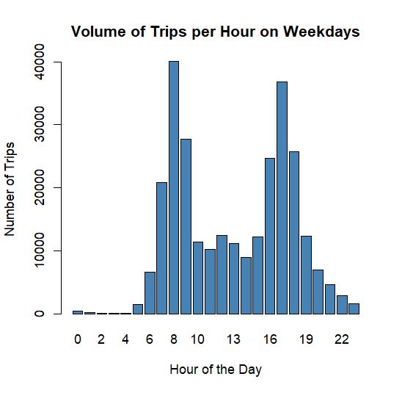

**Figure 3**: Breakdown of the total number of trips by hour on weekdays.

Figure 3 clearly shows some of the trends that might be expected. Bike rentals at midnight and into sunrise hours are very close to 0. This can be attributed that most people are asleep at this time. In contrast, it can be observed that bike rentals peak twice a day. The first peak phase is between the hours of 7-9 am. This can be attributed to the fact that a large segment of the population is commuting to their day jobs. A similar trend can be observed in the hours of 4-6 pm, which is the time when most people finish their workday. These findings are consistent with the fact that the majority of bike users in the Bay Area are subscribers, who rely on the use of bikes to commute to and from work on a daily basis. Another very interesting finding is that at 12pm, there is a small increase in bike rentals. This can be attributed to noon being the traditional lunch time that most people have.

**Station Frequencies**

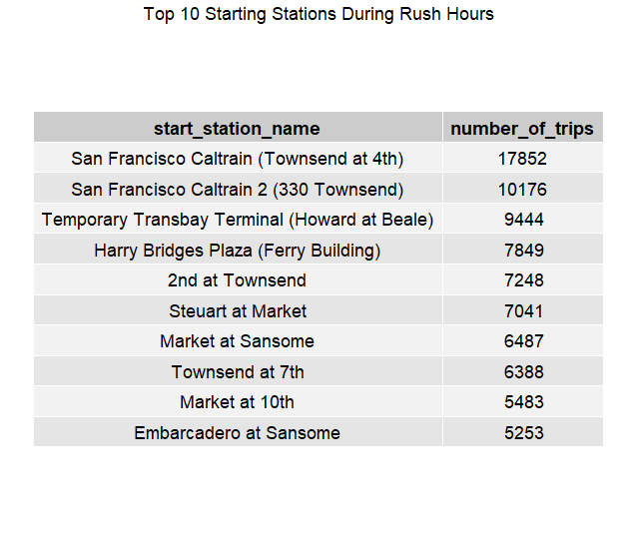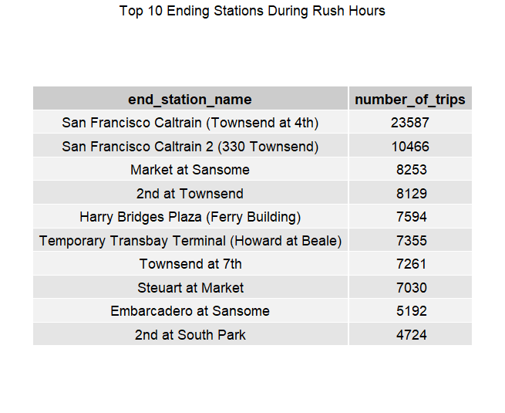

**Figure 4**: Illustration of the most common starting and ending stations during rush hours.

Now that we have an understanding of the two rush hour peaks and some of the potential causalities behind why they occur, we can start analyzing the traffic per station. Interestingly, the two top stations in terms of starting and ending during the rush hours are the same in both cases. However, in order to develop a better understanding of the meaning behind this, I decided to examine this data based on the rush hour that they occur. I collected the top ten starting and ending stations during morning and evening rush hours separately, and the results were interesting.

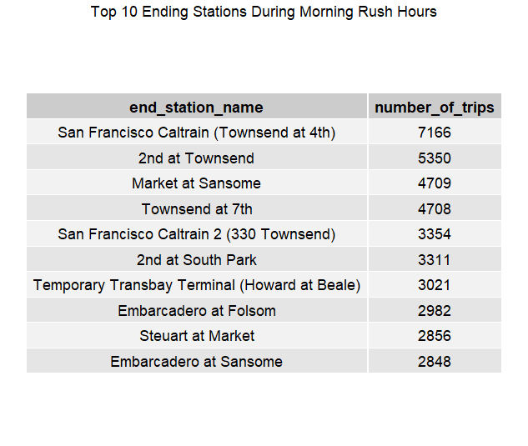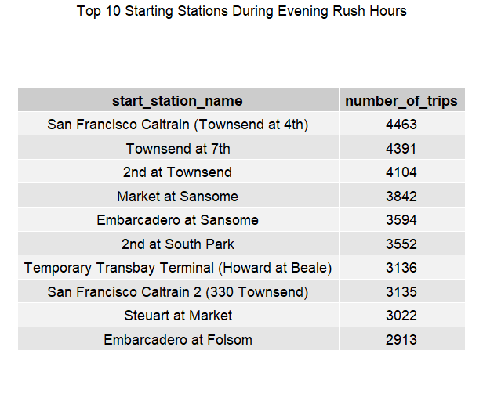

**Figure 5:** Illustration of the most common ending stations during morning rush hours, and most common starting stations during evening rush hours.

Following the theory that workers commute to work in the morning rush, and commute back home in the evening hours, it can be assumed that the morning end station and the evening start stations are the same, since they arrive and depart from the same place. Figure 5 shows data that tests that hypothesis. It is indeed observed that all 10 morning ending stations are the same as the 10 most commonly used evening starting stations. It can be further observed that most of these stations maintain about the same level of traffic during those times.

Now that we have an understanding behind the traffic during weekdays, and have broken it down by rush period, it is also necessary to understand the station frequencies during weekends.

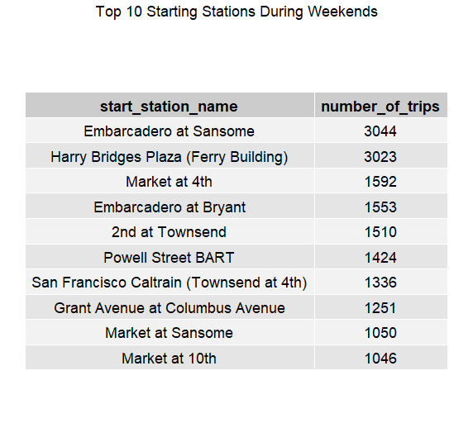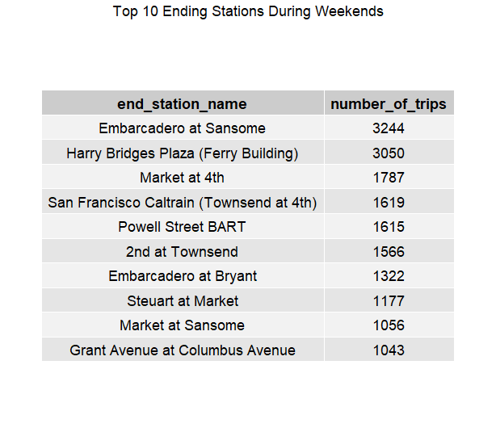

**Figure 6**: Illustration of the most commonly used starting and ending stations on weekends.

Traffic flow on weekends can be more ambiguous than weekdays. However, given that most people have their typical workdays on weekdays, weekends are usually spent relaxing. This can be observed by the significant reduction in the number of rides during weekends compared to just rush hours on weekdays. However, one interesting observation from Figure 6 is that the top stations on weekends are completely different than those on weekdays, and are also the same for starting and ending. This can be potentially attributed to the fact that these stations are closer to more recreational destinations in the Bay Area. As such, workers and children who are free on weekends exhibit vastly different traffic behaviours. The second most common station for both starting and ending trips on weekends is Harry Bridges Plaza, which is a common tourist and recreational attraction.

**References**

Parry (2016). Codebook from Data Source. *Kaggle*.

<https://www.kaggle.com/datasets/benhamner/sf-bay-area-bike-share/discussion/23165>