OpenVR-Input-Emulator
YawVR edition

PURPOSE

OpenVR-Input-Emulator-YawVR is based on the original open-source OpenVR-Input-Emulator OpenVR tool created by matzman666. Originally this tool helps you to configure OpenVR devices and implements motion compensation based on a controller attached to the any dynamic seat.
Additionally OpenVR-Input-Emulator-YawVR add support for YawVR motion simulator dynamic seat and implements motion compensation based on YawVR seat orientation instead of using a controller.

MOTION COMPENSATION EXPLAINED

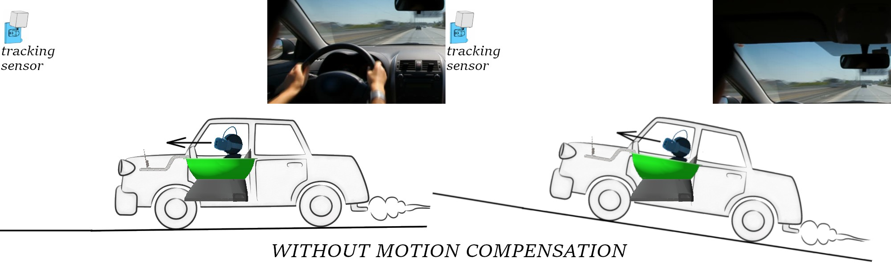

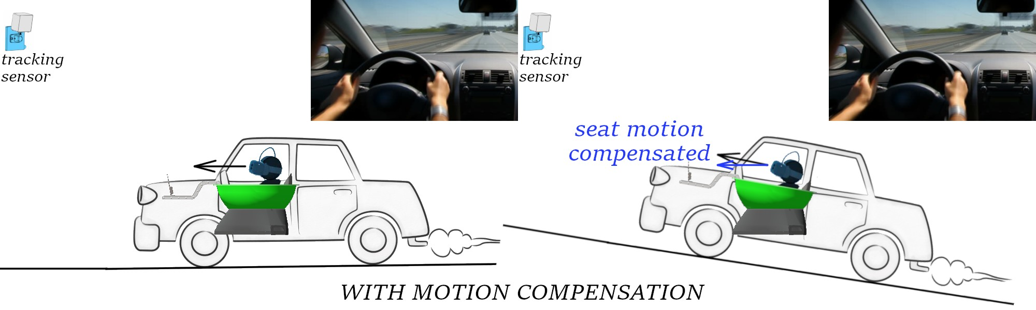

SETUP GUIDE

Downloaded archive contains this manual and the setup file OpenVR-InputEmulator-YawVR.exe.

First, stop SteamVR if running.

Run the setup OpenVR-InputEmulator-YawVR.exe.

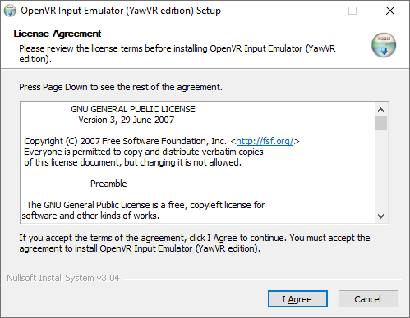
If necessary, install the VC++ dependencies (Microsoft Visual C++ 2015-2019 redistributable)
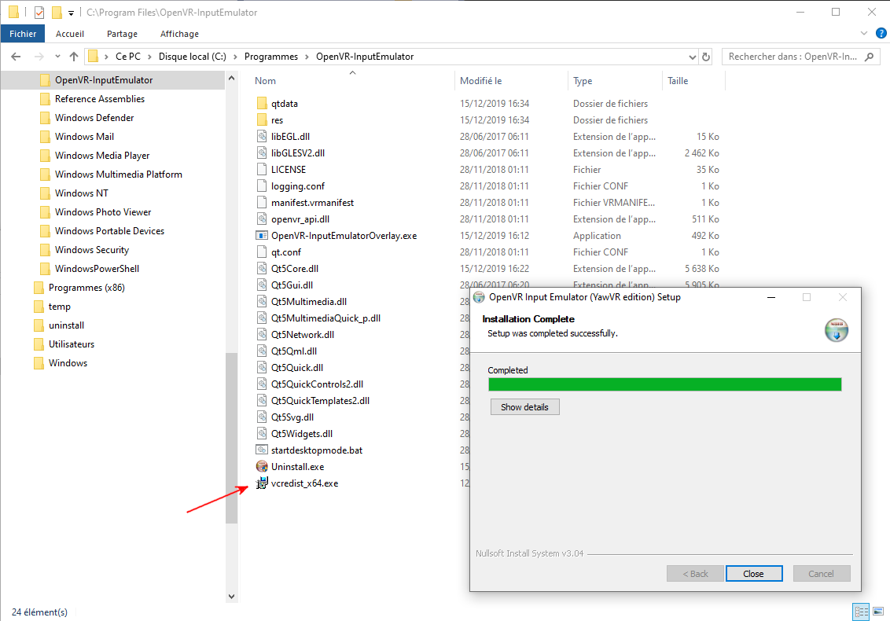
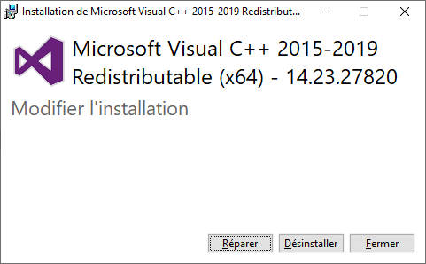
Run SteamVR

Go to SteamVR parameters by pressing Menu button of any controller
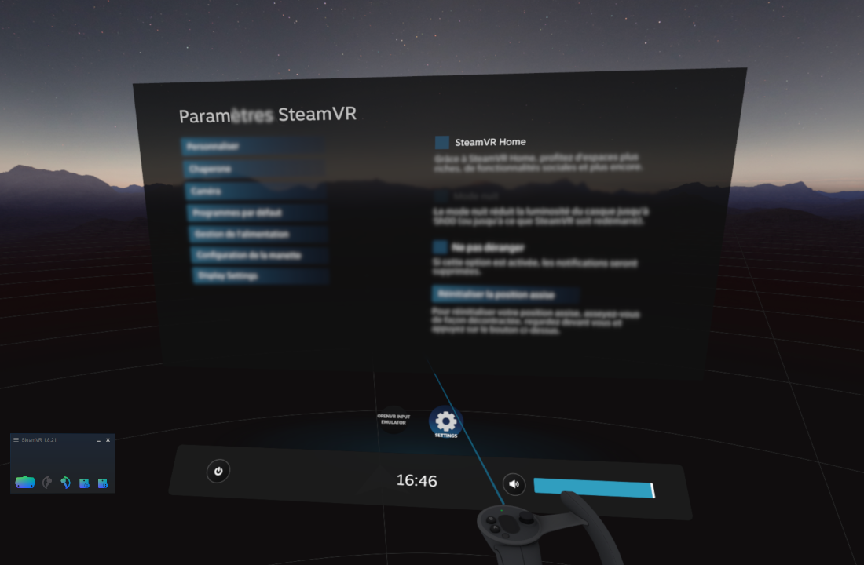
Select OPENVR INPUT EMULATOR settings
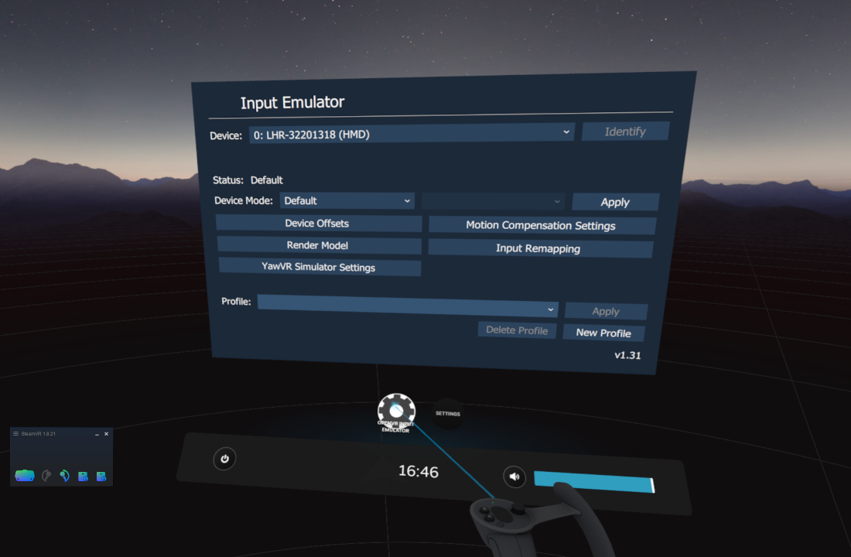
Go to YawVR Simulator Settings page
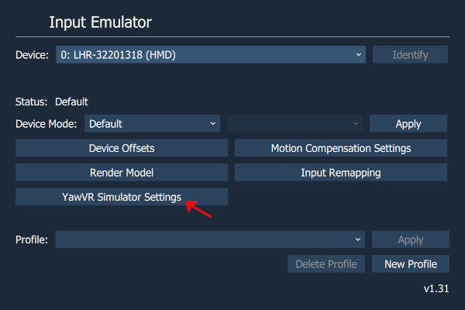
Setup your YawVR IP address (refer to the YawVR application)
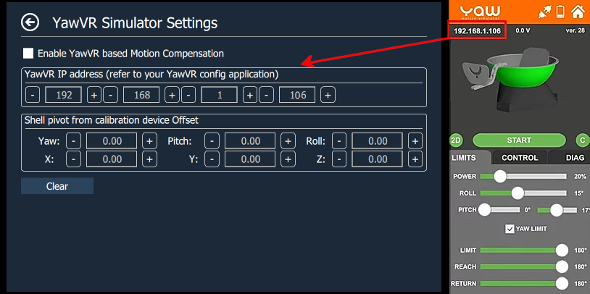
Enable YawVR based Motion Compensation, tool will connect to your YawVR simulator and YawVR application upper banner should toggle from orange to blue indicating connection succeeded.
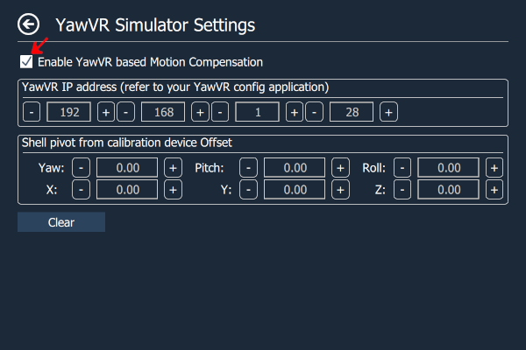
Finally you have to calibrate your YawVR shell pose (position and orientation) by placing a controller near the shell pivot.
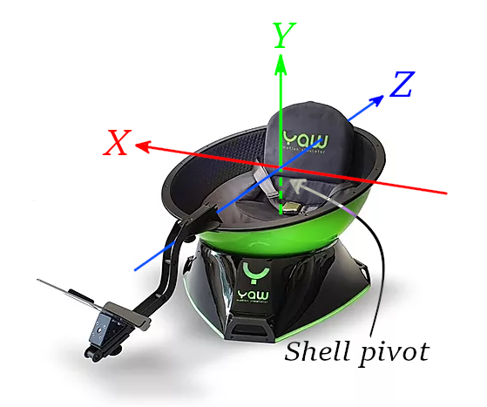
Choose the controller, bind it the Motion Compensation mode
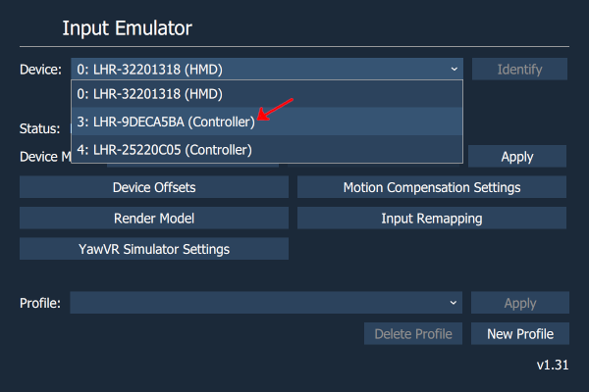
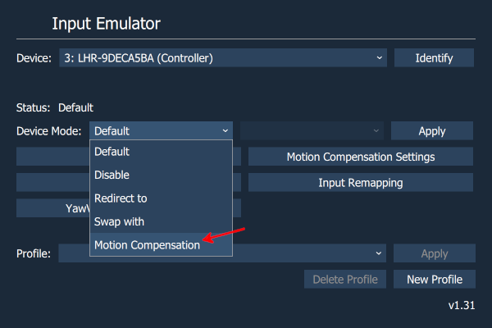
Place the controller near the shell pivot and Apply
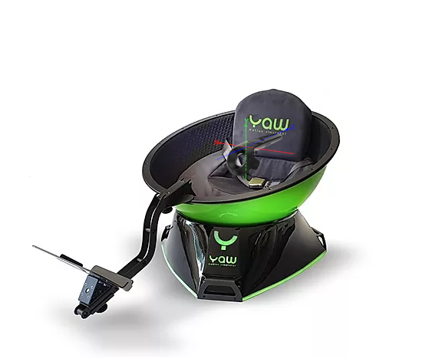
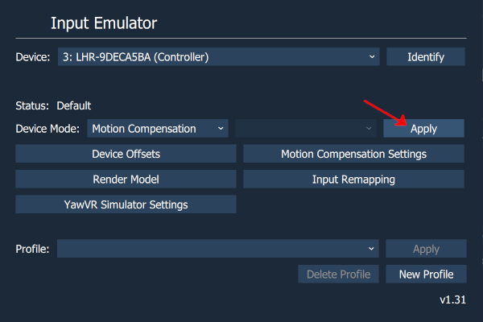

Check your calibration by putting a controller in the seat, get out of the seat, disconnect YawVR motors, put your headset and rotate manually the shell, the controller should rotate on itself and VR world should rotate around.

Now you do not need controller anymore, YawVR shell orientation is used to perform motion compensation.

REMARKS

Note 1 You can use shell pivot from calibration device offset to configure an offset between a more practical pose relative to the YawVR shell and its pivot.

Note 2 Be aware, compensation is dependent to YawVR internal orientation computation and if it drifts you will see this drift through your compensated orientation, typically yaw drift.

Note 2 You can still use original controller based motion compensation by disabling YawVR based Motion Compensation checkbox into YawVR Simulator Settings page.

