Codes:-

I)FALLING BALLS:-

<style>

  .balls{

    border-radius: 50%;

    background: linear-gradient(

      35deg,

      #ccffff,

      #ffcccc

    );

    position: fixed;

    width: 50px;

    height: 50px;

    margin-top: 50px;

    animation-name: bounce;

    animation-duration: 2s;

    animation-iteration-count: infinite;

  }

  #ball1 {

    left: 27%;

    animation-timing-function: linear;

  }

  #ball2 {

    left: 56%;

    animation-timing-function: ease-out;

  }

  @keyframes bounce {

    0% {

      top: 0px;

    }

    100% {

      top: 249px;

    }

  }

</style>

<div class="balls" id="ball1"></div>

<div class="balls" id="ball2"></div>

II)FALLING BALLS with cubic- bezier(x1,x2,y1,y2):-

<style>

  .balls{

    border-radius: 50%;

    position: fixed;

    width: 50px;

    height: 50px;

    margin-top: 50px;

    animation-name: bounce;

    animation-duration: 2s;

    animation-iteration-count: infinite;

  }

  #red {

    background: red;

    left: 27%;

    animation-timing-function:  cubic-bezier(0, 0, 0.58, 1);

  }

  #blue {

    background: blue;

    left: 56%;

    animation-timing-function: ease-out;

  }

  @keyframes bounce {

    0% {

      top: 0px;

    }

    100% {

      top: 249px;

    }

  }

</style>

<div class="balls" id= "red"></div>

<div class="balls" id= "blue"></div>

III) THREE FALLING BALLS

<style>

  .balls {

    border-radius: 50%;

    position: fixed;

    width:50px;

    height:50px;

    top: 60%;

    animation-name: jump;

    animation-duration: 2s;

    animation-iteration-count: infinite;

  }

  #red {

    background: red;

    left: 25%;

    animation-timing-function: linear;

  }

  #blue {

    background: blue;

    left: 50%;

    animation-timing-function: ease-out;

  }

  #green {

    background: green;

    left: 75%;

    animation-timing-function: cubic-bezier( 0.311, 0.441, 0.444, 1.649);

  }

  @keyframes jump {

    50% {

      top: 300px;

<!--> Since there is a keyframe rule set in the middle of the animation duration (at 50%), it results in two identical animation progressions at the upward and downward movement of the ball.</--->

    }

  }

</style>

<div class="balls" id="red"></div>

<div class="balls" id="blue"></div>

<div class="balls" id="green"></div>

***IV***) ***Audio Installation:-***

<body>

  <header>

    <h1>Real Coding Ninjas</h1>

  </header>

  <main>

    <p>

      <audio id="" controls>

        <source src="https://s3.amazonaws.com/freecodecamp/screen-reader.mp3" type="audio/mpeg"/>

      </audio>

      A sound clip of Zersiax's screen reader in action.</p>

  </main>

</body>

***V***)***Box in the radio button:-***

<body>

  <header>

    <h1>Deep Thoughts with Master Camper Cat</h1>

  </header>

  <section>

    <form>

      <p>Sign up to receive Camper Cat's blog posts by email here!</p>

      <label for="email">Email:</label>

      <input type="text" id="email" name="email">

       <fieldset>

        <legend>What level ninja are you?</legend>

        <input id="newbie" type="radio" name="levels" value="newbie">

        <label for="newbie">Newbie Kitten</label><br>

        <input id="intermediate" type="radio" name="levels" value="intermediate">

        <label for="intermediate">Developing Student</label><br>

        <input id="master" type="radio" name="levels" value="master">

        <label for="master">Master</label>

      </fieldset>

            <input type="submit" name="submit" value="Submit">

    </form>

***VI***)***Date Selector:-***

<label for="pickdate">Preferred Date:</label>

        <!-- Only change code below this line -->

<input type="date" id="pickdate" name="date">

        <!-- Only change code above this line -->

***VI***)***Table:-***

***Class code:-***

.sr-only {

position: absolute;

left: -10000px;

width: 1px;

height: 1px;

top: auto;

overflow: hidden;

}

*Code for Table:-*

<table class="sr-only">

      <caption>Hours of Weekly Training in Stealth, Combat, and Weapons</caption>

      <thead>

        <tr>

          <th></th>

          <th scope="col">Stealth &amp; Agility</th>

          <th scope="col">Combat</th>

          <th scope="col">Weapons</th>

          <th scope="col">Total</th>

        </tr>

      </thead>

      <tbody>

        <tr>

          <th scope="row">Week One</th>

          <td>3</td>

          <td>5</td>

          <td>2</td>

          <td>10</td>

        </tr>

        <tr>

          <th scope="row">Week Two</th>

          <td>4</td>

          <td>5</td>

          <td>3</td>

          <td>12</td>

        </tr>

        <tr>

          <th scope="row">Week Three</th>

          <td>4</td>

          <td>6</td>

          <td>3</td>

          <td>13</td>

        </tr>

      </tbody>

    </table>

*Table:-*

| **Stealth & Agility** | **Combat** | **Weapons** | **Total** |
| --- | --- | --- | --- |
| **Week One** | 3 | 5 | 2 | 10 |
| **Week Two** | 4 | 5 | 3 | 12 |
| **Week Three** | 4 | 6 | 3 | 13 |

***VII***)***Form:-***

<label for="username">Username:</label>

      <input type="text" id="username" name="username"><br>

      <fieldset>

        <legend>What level ninja are you?</legend>

        <input id="newbie" type="radio" name="levels" value="newbie">

        <label for="newbie">Newbie Kitten</label><br>

        <input id="intermediate" type="radio" name="levels" value="intermediate">

        <label for="intermediate">Developing Student</label><br>

        <input id="master" type="radio" name="levels" value="master">

        <label for="master">9th Life Master</label>

      </fieldset>

      <br>

      <fieldset>

      <legend>Select your favorite weapons:</legend>

      <input id="stars" type="checkbox" name="weapons" value="stars">

      <label for="stars">Throwing Stars</label><br>

      <input id="nunchucks" type="checkbox" name="weapons" value="nunchucks">

      <label for="nunchucks">Nunchucks</label><br>

      <input id="sai" type="checkbox" name="weapons" value="sai">

      <label for="sai">Sai Set</label><br>

      <input id="sword" type="checkbox" name="weapons" value="sword">

      <label for="sword">Sword</label>

      </fieldset>

      <br>

      <input type="submit" name="submit" value="Submit">

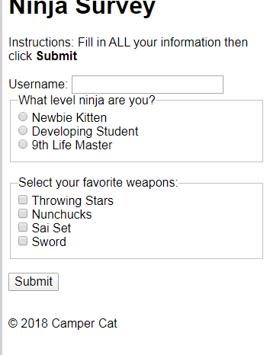

***VIII***)***Grid:-***

<style>

  .d1{background:LightSkyBlue;}

  .d2{background:LightSalmon;}

  .d3{background:PaleTurquoise;}

  .d4{background:LightPink;}

  .d5{background:PaleGreen;}

  .container {

    font-size: 40px;

    width: 100%;

    background: LightGray;

    /* Only change code below this line */

    display:grid;

    /* Only change code above this line */

  }

</style>

<div class="container">

  <div class="d1">1</div>

  <div class="d2">2</div>

  <div class="d3">3</div>

  <div class="d4">4</div>

  <div class="d5">5</div>

</div>

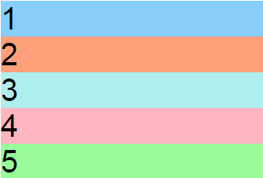

***IX***)***Grid with col.&Row:-***

<style>

  .item1{background:LightSkyBlue;}

  .item2{background:LightSalmon;}

  .item3{background:PaleTurquoise;}

  .item4{background:LightPink;}

  .item5{background:PaleGreen;}

  .container {

    font-size: 40px;

    min-height: 300px;

    width: 100%;

    background: LightGray;

    display: grid;

    grid-template-columns: 1fr 1fr 1fr;

    grid-template-rows: 1fr 1fr 1fr;

    grid-gap: 10px;

    /* Only change code below this line */

    /* Only change code above this line */

  }

</style>

<div class="container">

  <div class="item1">1</div>

  <div class="item2">2</div>

  <div class="item3">3</div>

  <div class="item4">4</div>

  <div class="item5">5</div>

</div>

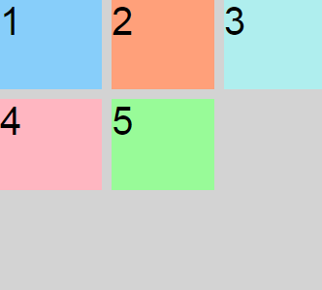

***IX***)***Grid with Content:-***

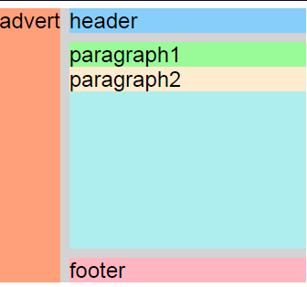

<style>

  .container {

    font-size: 1.5em;

    min-height: 300px;

    width: 100%;

    background: LightGray;

    display: grid;

    grid-template-columns: auto 1fr;

    grid-template-rows: auto 1fr auto;

    grid-gap: 10px;

    grid-template-areas:

      "advert header"

      "advert content"

      "advert footer";

  }

  .item1 {

    background: LightSkyBlue;

    grid-area: header;

  }

  .item2 {

    background: LightSalmon;

    grid-area: advert;

  }

  .item3 {

    background: PaleTurquoise;

    grid-area: content;

    /* Only change code below this line */

    /* Only change code above this line */

  }

  .item4 {

    background: lightpink;

    grid-area: footer;

  }

  .itemOne {

    background: PaleGreen;

  }

  .itemTwo {

    background: BlanchedAlmond;

  }

</style>

<div class="container">

  <div class="item1">header</div>

  <div class="item2">advert</div>

  <div class="item3">

    <div class="itemOne">paragraph1</div>

    <div class="itemTwo">paragraph2</div>

  </div>

  <div class="item4">footer</div>

</div>

**WWWC HTML References:** <https://www.w3.org/TR/html52/>

**WWWC CSS References:**<https://www.w3.org/css/>

**CSS Units:**<https://www.w3schools.com/cssref/css_units.asp>

**Specifying Colours with CSS:**<https://www.w3schools.com/css/css_colors.asp>

**The 10 Most Important HTML Tags You Need to Know for Search Engine Optimisation:**<https://www.greengeeks.com/blog/2019/01/03/html-tags-for-seo/>

**Using the Viewport <meta> Tag to Control Layout on Mobile Browsers:** <https://developer.mozilla.org/en-US/docs/Mozilla/Mobile/Viewport_meta_tag>

**A Beginner’s Introduction to GitHub:**<https://kinsta.com/knowledgebase/what-is-github/>