Blog-Junction-Prototyping

* By: Gaurav Todwal

My website “Blog-Junction” will give a good user interface to the people who like reading blogs. It would be a single platform which will contain the best blogs from classes and genre like:- Education , Technical , Trending topics (Corona Virus , SEO/SEM , etc) , Political and many more. User will get well defined and user-friendly experience of reading***.***

Expected List of features:

* Reading Mode : Same as all the smartphones , my website will have a reading mode option which will give a eye-friendly color background to my website.
* Blog-Shortcut : ***This option will provide s***hortcut to all the tending blogs and discussion. You will be 1 click away to aceess your favourite hot-topic
* Discussion-forum : Discussion forum will provide a proper place to discuss about the current blog they are reading but not like typical “comment section”.
* Publishing : This feature will provide you opportunity to post your own blogs and get it posted in front of world audience.

***Please scroll down***

Expected Prototype :-

*HOME-PAGE:- It will be the the single colour page containing just the brief introduction about the web-site , provide the instruction about how the website works and will contain Button which will help the user to read the blog or directly go and write their own blog****.***

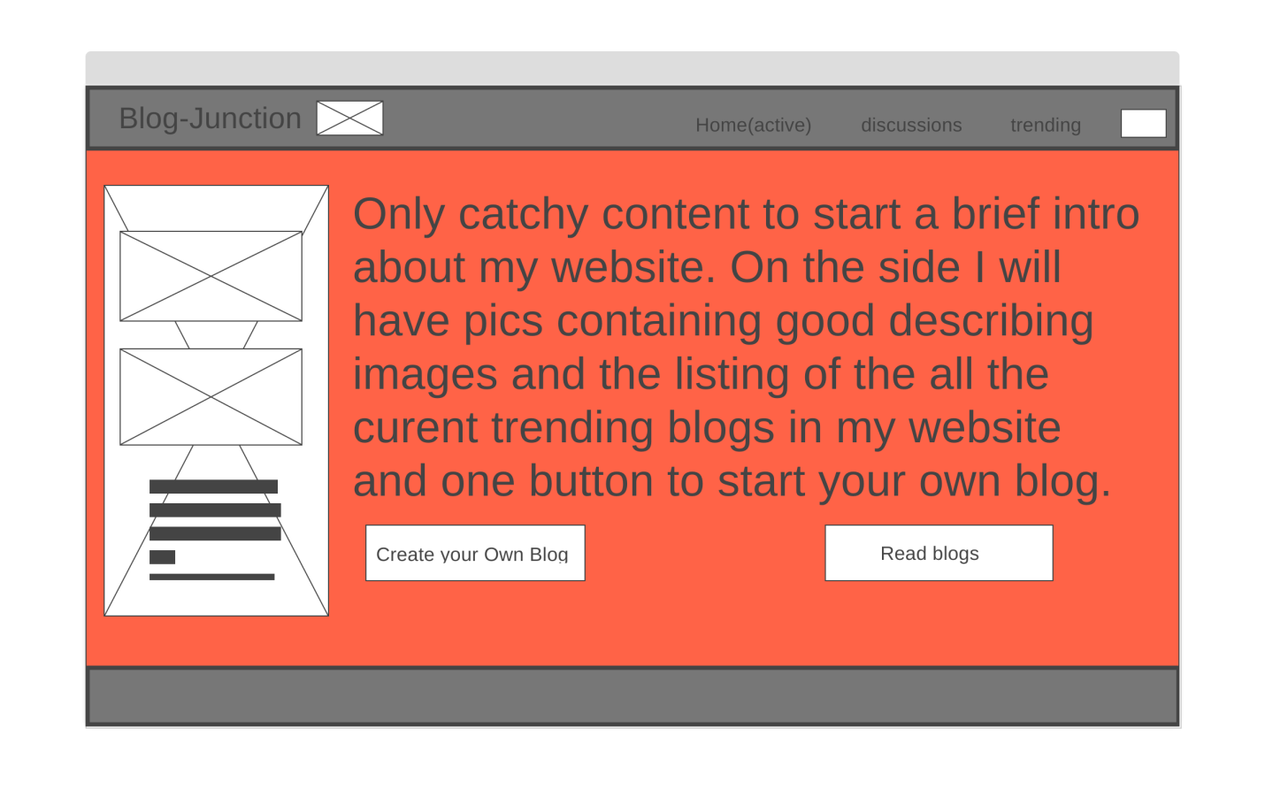

NAVIGATION OF HOME-PAGE:

Navigtion of the home-page will be the same as shown in figure. Simple navigations having links and button to all the important features of my page.

***Please scroll down***

TRENDING AND BLOG-PAGE:- This page will contain the links of the blog and some description of there content. User will click on the content and they will go to there selected blog. It will also contain search option to search the topic or genre of the blog they want to read.

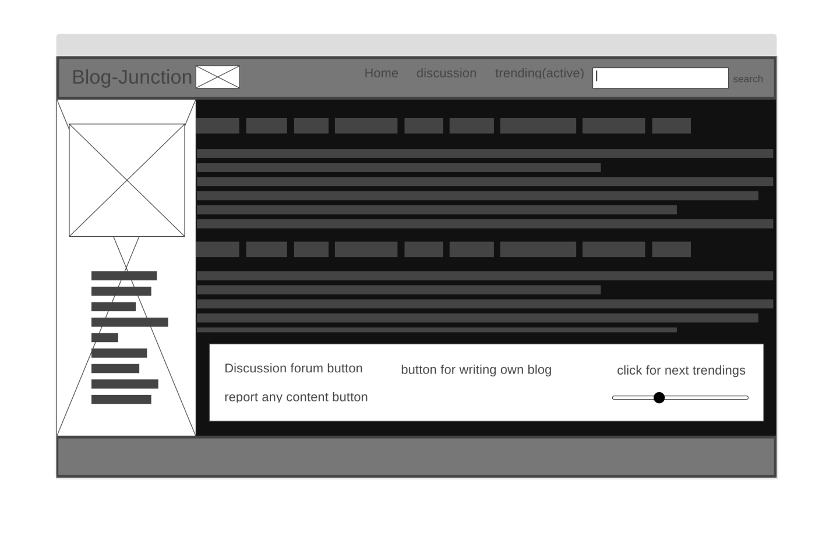

***Please scroll down***

OWN BLOG-PAGE:- Here you can write your own blog with all the nessecary options which you like to include in your blog like images,refrences etc. The blog will be published in the website under your name.

