LAB 4 — IP, ICMP, AND TCP PROTOCOL ANALYSIS
Course: DA5241
Student: Gagan Adhikari
Task 0 — Background Questions
Question 1: In IP header, what is the “Protocol (Type)” field used for?
- The Protocol field in the IPv4 header identifies which upper-layer protocol the IP packet’s payload should be delivered to. Examples:
- 1 → ICMP
- 6 → TCP
- 17 → UDP
It acts as a demultiplexer, so the receiving host knows how to interpret the payload.
Question 2: How is an ICMP message transported (encapsulation)?
- ICMP is encapsulated inside an IPv4 packet, directly following the IP header. Structure: Ethernet → IP header → ICMP header → ICMP data
ICMP does not use TCP or UDP.
Question 3: Show the TCP 3-way handshake and explain what information is exchanged.
Explanation:
- SYN (Client → Server):
  - Client sends initial sequence number (ISN).
- SYN-ACK (Server → Client):
  - Server acknowledges client’s ISN.
  - Server sends its own ISN.
- ACK (Client → Server):
  - Client acknowledges server’s ISN.
  - Connection established.
Information exchanged:
- Initial sequence numbers
- Window sizes
- TCP options (MSS, SACK permitted, etc.)
Task 1 — IP Fragmentation
Question 4: What is the value in the Identification field? On the line "IP Fragments (3008 bytes):", why is the payload data in this IP packet 3008 bytes? Also check the ICMP response message. How many data bytes were sent in the ICMP response? Do they have the same lengths? From the document:
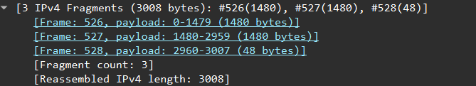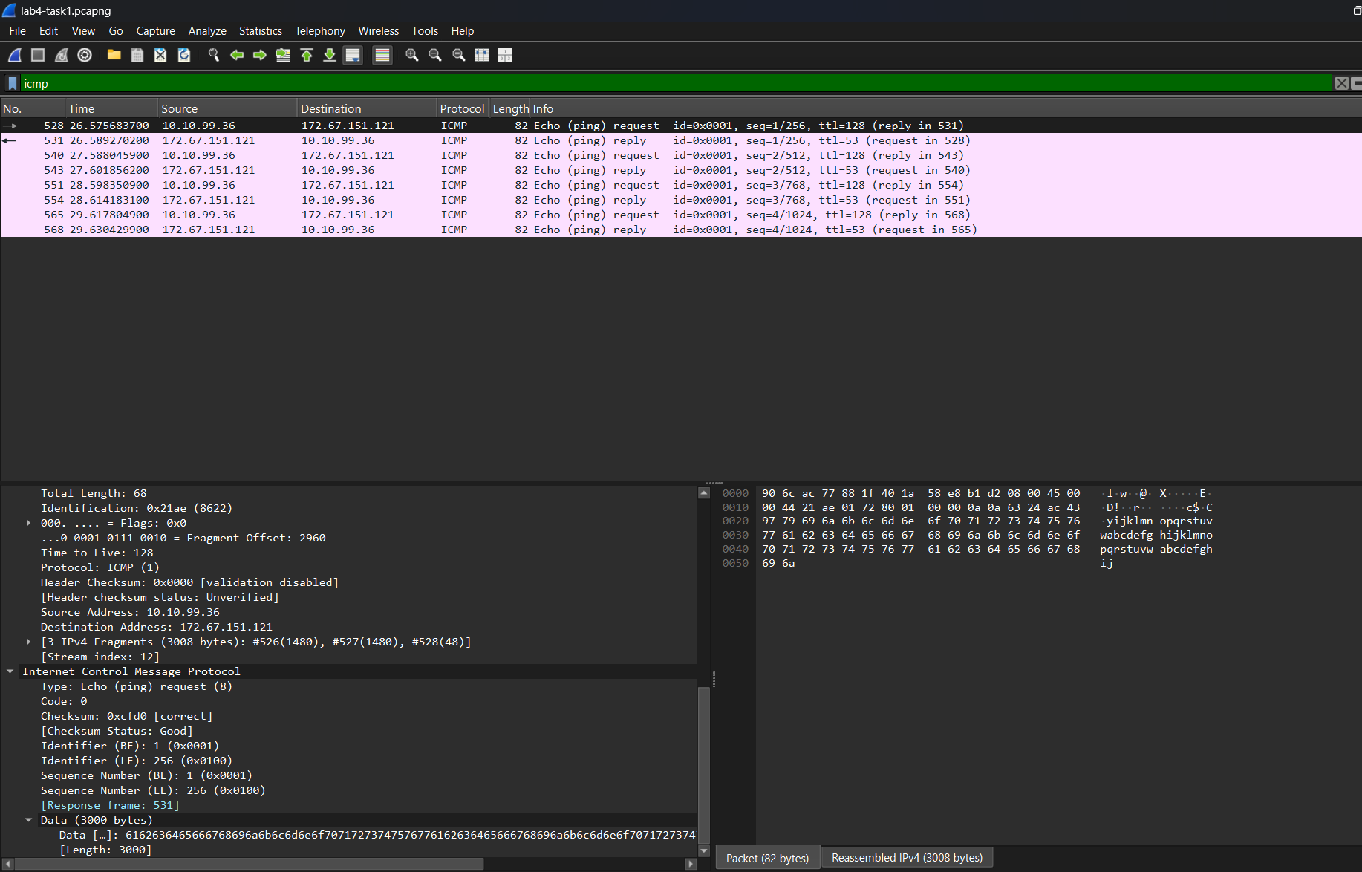
Identification: - Frame: 526 (1480 bytes), Frame: 527 (1480 bytes), Frame: 528 (48 bytes).
Why 3008 bytes? The ICMP Echo Request contained 3000 bytes of data, plus:
- 8 bytes ICMP header Total = 3008 bytes of payload before fragmentation.
ICMP response size: The reply contains the same amount of data (3000 bytes) unless the server modifies it. Yes, request and reply have equal lengths.
Question 5: Fragment table
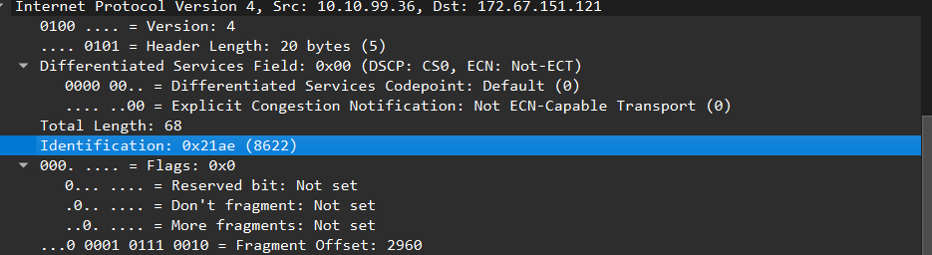
Frame | IP ID | MF bit | Offset (bytes) | Offset (8-byte units) | Header Len | Total Len
526 | 8620 | 1 | 0 | 0 | 20 | 1500
535 | 8620 | 1 | 1480 | 185 | 20 | 1500
536 | 8620 | 0 | 2960 | 370 | 20 | 68
Question 6: How to identify first and last fragments?
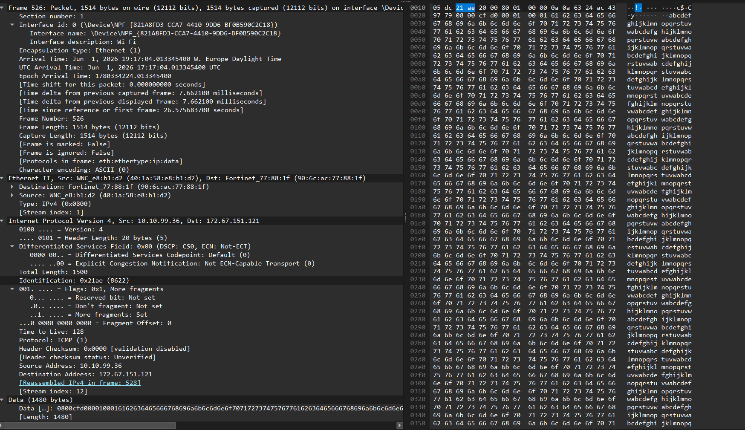
First fragment: 526
- Fragment offset = 0
- MF (More Fragments) bit = 1
Last fragment:528
- MF bit = 0
- Offset > 0

Task 2 — TCP Operations
Question 7 — IP Addresses and Port Numbers
- Handshake packet numbers: 114, 117, 118
- Payload: None of these packets carry application-layer data.
- TCP options exchanged during handshake:
  - MSS (Maximum Segment Size)
  - Window Size (Win)
  - Window Scale (WS)
- Purpose of the 3-way handshake:
  - Establish a reliable TCP connection
  - Confirm both hosts are ready
  - Exchange initial sequence numbers and options
Question 9 — Sequence Numbers, ACK Numbers, Window Sizes
- Initial sequence numbers (relative):
  - Client: 0
  - Server: 0
- Advertised window sizes:
  - Client: 64240 bytes
  - Server: 65535 bytes
- Meaning of window size:
  - Indicates how much buffer space is available for receiving data
Question 10 — Sequence Numbers for First HTTP GET
- Client GET request sequence number: 1
- Server response:
  - Sequence number: 1
  - ACK number: 432
- Meaning of ACK = 432:
  - Server has received all bytes up to 431
  - Next expected byte is 432
- Why relative numbering is used:
  - Makes analysis simpler and easier to read
Question 11 — TCP Segments for alice.htm
- Client → Server (GET request): 1 TCP segment
- Server → Client (alice.htm file): 1 TCP segment
- Reason: The GET request and the file both fit within a single segment each
Question 12 — TCP Segments for alice_ch1.txt
- Server → Client: 4 TCP segments
- Reason: The file is larger and requires multiple segments
Question 13 — HTTP Response Size for alice.htm
- HTTP response size: 521 bytes
- How determined:
  - The entire HTTP response fits inside one TCP segment
  - Therefore, HTTP message size = TCP payload size = 521 bytes
Question 14 – TCP Connections Count
- The number of TCP connections created between my browser and the server is 4.
This is determined by counting the number of SYN packets initiated by the client.
Question 15 – Number of GET Requests
- A total of 3 GET requests were sent to download the home page and its embedded objects.
Question 16: how many TCP connections were used to download this home page and embedded objects? Which of them were downloaded in serial and which of them were downloaded in parallel (need to provide the fact)?

Question 17: how many TCP segments were used to transport the image sunrise.gif? How is it possible to assemble these data in right order to form file sunrise.gif?

Question 18: If one of these segments (of sending sunrise.gif) were lost during the transportation, what would happen? Will all the segments be discarded? Why or why not?
- No, all segments are not discarded. TCP retransmits only the lost segment using sequence numbers and acknowledgments, ensuring reliable and efficient data transfer.

