UDC 004.8 (artificial intelligence); 004 (computer science)
A Layered Self-Validating Knowledge Base with Hybrid Retrieval for Grounding LLM Agents: Architecture, Method and Empirical Evaluation on a Real Corpus
Davletbaev Aleksandr Sergeevich
Lead Software Engineer, LLC «KB Production» (ООО «КБ Продакшн»)
System development and numerical experiments were carried out with the aid of AI tools (LLM assistants). Framework DavASko LLM Wiki, v3.x — fully offline, reproducible.
Abstract
It is verified empirically whether a curated hybrid (symbolic and semantic) retrieval layer over a knowledge base outperforms a trivial lexical file search when grounding LLM agents. The system architecture is described in detail: a downward-dependent layer model that separates immutable source snapshots from derived curated pages with content-hash provenance; a hybrid retriever with a per-query adaptive threshold; and a deduplicated, machine-shared embedding model resolved through a system marker. On a deployed 162-document base with 15 labeled queries, recall@5, MRR and nDCG@5 are computed for the proposed engine and baselines. Semantic retrieval yields recall@5 0.633 and MRR 0.718 against 0.333 and 0.435 for the lexical baseline; structure-aware chunking exceeds the fixed-window one by 7.8% MRR; GPU embedding gives an eight-fold speed-up. The retrieval layer is justified by measurement.
Keywords: information retrieval; knowledge base; retrieval-augmented generation; vector embeddings; layered architecture; ranking quality evaluation; LLM agents
Аннотация
Эмпирически проверяется, превосходит ли курируемый гибридный (символьный и семантический) слой поиска по базе знаний тривиальный лексический поиск по файлам при заземлении LLM-агентов. Подробно описана архитектура системы: слоевая модель со строго нисходящими зависимостями, отделяющая иммутабельные снимки источников от производных курируемых страниц с провенансом по контент-хешам; гибридный ретривер с адаптивным порогом на запрос; и дедуплицированная, общая для машины модель эмбеддингов, разрешаемая через системную метку. На развёрнутой базе из 162 документов с 15 размеченными запросами вычислены recall@5, MRR и nDCG@5 для предложенного движка и базлайнов. Семантический поиск даёт recall@5 0.633 и MRR 0.718 против 0.333 и 0.435 у лексического базлайна; структурный чанкинг превосходит оконный на 7.8% MRR; эмбеддинг на GPU даёт восьмикратное ускорение. Слой поиска оправдан измерением.
Ключевые слова: информационный поиск; база знаний; дополненная поиском генерация; векторные эмбеддинги; слоевая архитектура; оценка качества ранжирования; LLM-агенты
1. Introduction
Relevance. LLM agents in software development increasingly operate over large and evolving project knowledge. A common grounding approach is retrieval-augmented generation (RAG) [5], in which relevant context is retrieved and supplied to the model. Yet the underlying assumption that a dedicated retrieval layer is effective is usually asserted rather than tested: it remains open whether a curated indexed knowledge layer beats the trivial alternative — direct full-text search by the agent over the files. A retrieval layer that does not beat that baseline is negative-value complexity, as it adds maintenance burden and a second, drifting copy of the truth.
Aim and objectives. The aim is to establish quantitatively whether the proposed hybrid retrieval engine earns its use, and to describe the architecture that makes it maintainable. The objectives are: (1) to formalize the layered architecture and retrieval method; (2) to build an evaluation harness with information-retrieval metrics and baselines; (3) to evaluate on a real corpus; (4) to refine the method based on observed data.
Contributions. (i) A layered, self-validating knowledge-base architecture with explicit source-vs-derived separation and content-hash provenance (§2.2, §2.5); (ii) a hybrid retriever with a per-query adaptive threshold (2) proposed as a replacement for a constant cosine cutoff (§2.4); (iii) a machine-shared embedding model resolved through a marker, removing per-base model duplication (§2.6); (iv) an evaluation harness sharing the engine's own core, and a measurement-driven refinement loop (§3–§4).
Related work. Dense retrieval maps a query and text fragments into a shared vector space and ranks by cosine similarity [4]; RAG couples such retrieval with a generator [5, 2]. The embedding model is the multilingual Jina v3 with task-specific LoRA adapters and asymmetric query:/passage: prefixes [8], run locally via ONNX Runtime in Transformers.js [10]. Inverted-file (IVF) indexes partition vectors into clusters and probe the nearest at query time, trading recall for speed [3]. Structure-aware splitters cut a document along its structure and improve fragment coherence [1]. Combining lexical and dense retrieval is established practice [2].
2. Materials and Methods
2.1 System overview
The system has two pipelines over a shared store: an offline indexing pipeline that turns knowledge into vectors, and an online query pipeline that retrieves grounded context for an agent. The store is organized into independent layers (§2.2); each layer separates immutable source snapshots (raw/) from derived curated pages (wiki/), and both are indexed. The end-to-end pipelines are shown in Figure 1.
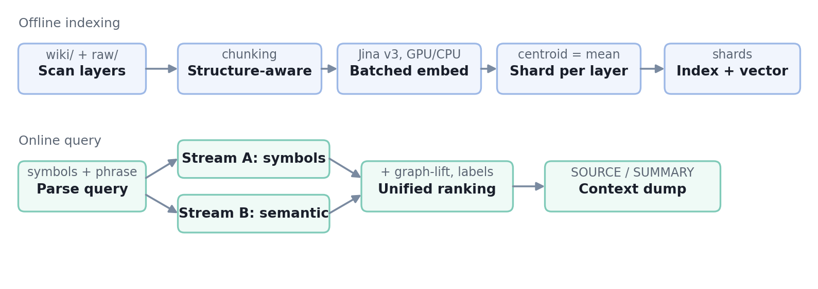
Figure 1 — Indexing (top) and query (bottom) pipelines
2.2 Layered knowledge model
Knowledge is partitioned into independent layers forming a strictly downward dependency graph (a directed acyclic graph): a more specific layer may depend on and link to more general ones, never the reverse. This isolates universal agent rules from engine constraints, framework conventions and project specifics, and lets several project layers reuse a common base in parallel. Each layer declares its dependencies in a wiki.json manifest. When the same topic exists in two layers, the more specific layer wins by default and the agent must flag the duplicate. The dependency model and the internal split of a single layer are shown in Figure 2.
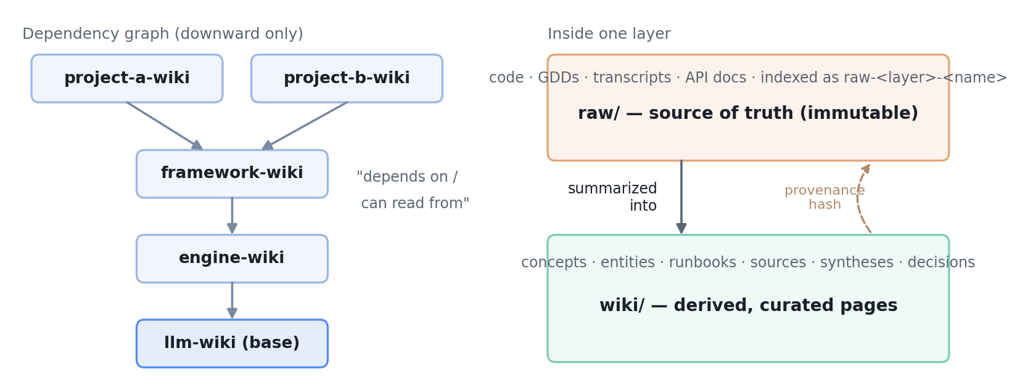
Figure 2 — Layered dependency graph (left) and the source-vs-derived split inside one layer (right)
2.3 Hybrid retrieval
The symbolic stream (A) matches strict code identifiers (PascalCase of at least two parts, I* interfaces, m_* fields) against document fields; matches are weighted by field type and down-weighted by an inverse document frequency in the spirit of IDF [6]. The semantic stream (B) embeds the query with the query: prefix and ranks fragments by cosine similarity (1) [6]:
sim(q, d) = (q · d) / (‖q‖ · ‖d‖) (1)
The streams are merged by a single effective score rather than by a hard precedence of one over the other (justification in §4.1). Exact symbolic hits (score ≈ 1.0) and dense cosine scores (0–1) thus compete on one scale, so a strong semantic match can outrank a tangential identifier match.
2.4 Routing and adaptive threshold
Vectors are stored one shard per layer; a shard centroid is the mean of its member vectors. At query time, shards are ranked by centroid proximity and the nprobe nearest are scanned (IVF-style multi-probe [3]); when nprobe is not smaller than the number of shards, the search is exhaustive and loses no recall. Instead of a fixed cosine threshold, sensitive to a shift of the similarity distribution, a per-query adaptive threshold (2) is used:
τ_q = max( φ, α · max_d sim(q, d) ) (2)
where α is a fraction of the maximum similarity (default 0.85) and φ is a lower noise floor (default 0.35). Construction (2) is proposed in this work as a replacement for a constant threshold: it adapts to each query's own best score and is therefore robust to distribution shifts induced by language (RU/EN) and document length. Finally, graph-lift expands the top results by one hop along extends parents and [[wiki-links]], pulling in directly related pages.
2.5 Structure-aware chunking and provenance
The indexer tokenizes Markdown into headings, paragraphs and atomic code blocks, packs them to a target size within the [min, max] word range, hard-splits only oversized blocks, merges undersized fragments and prepends the heading path; the approach follows the idea of structure-aware splitting [1]. Code is treated as the source of truth and wiki/ pages as derived; on close scores the source is ranked higher and results are labeled primary (SOURCE) or derived (SUMMARY). Each derived page stores content hashes of its cited sources; a staleness check recomputes them, so a divergence between a changed source and its summary becomes detectable rather than silent.
2.6 Shared embedding model and deployment
The embedding model is large (~1.1 GB). Storing a copy inside every deployed base would multiply disk use and management. Instead the model is installed once per machine into a system location and its path is published through a small marker file (a JSON config); every base resolves the model through that marker. Resolution order is: an explicit environment variable, then the marker, then a repository-local fallback, and otherwise the deployer asks where to install the shared model. The mechanism is shown in Figure 3.
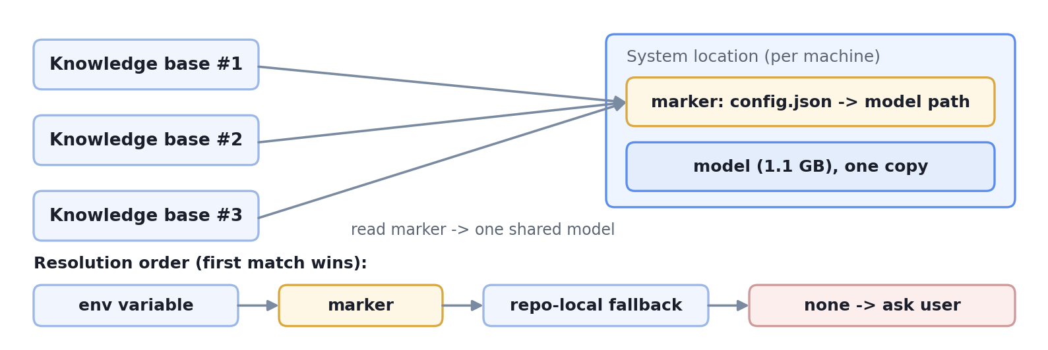
Figure 3 — One machine-shared model resolved by every base through a marker; resolution order below
Deployment of a complete base is one command (or the equivalent agent skill) performing five steps: scaffold the layers and base pages, install the shared model and write the marker, install the agent rules, install the operating skills, and run a baseline validation (unit tests, linter, index build). The write path is closed end-to-end: ingesting a source places it under raw/, auto-creates a derived summary stub, lints, and finishes with vectorization, so new knowledge is immediately searchable.
2.7 Evaluation metrics
For a set of relevant documents R and a ranked result list, standard metrics are used [6, 7]. Recall in the first k (3) is the fraction of relevant documents in the top-k [6]:
recall@k = |R ∩ top-k| / |R| (3)
Mean reciprocal rank (4) averages the reciprocal rank of the first relevant document over queries Q [6]:
MRR = (1/|Q|) · Σ 1 / rank_i (4)
Normalized discounted cumulative gain (5)–(6) accounts for the position of a relevant result [7]:
DCG@k = Σ rel_i / log₂(i+1); nDCG@k = DCG@k / IDCG@k (5)–(6)
2.8 Experimental setup
The evaluation corpus is the deployed KBPro base; its composition is given in Table 1. The query set comprises 15 labeled questions with required-source annotations. The model is jinaai/jina-embeddings-v3 (fp16, 1024 dimensions). The parameter top-k = 5; the threshold is adaptive (α = 0.85, φ = 0.35). The retrievers compared are semantic (dense multi-probe only), hybrid (symbols and semantics with unified ranking), flat (exhaustive flat cosine), and lexical (term overlap over the files — the agent-reads-the-files model). The harness reuses the engine's own core functions and therefore evaluates the real engine, not a re-implementation. Embedding runs on a GPU via the DirectML provider with fallback to the CPU [9].
Table 1 — Evaluation corpus composition
Scope | layers | documents | fragments | shards
evaluation subset (kbpro-wiki, llm-wiki) | 2 | 162 | 433 | 2
full deployment | 6 | 343 | — | 6
With 2 shards, multi-probe equals exhaustive search; clustering matters only across many layers.

3. Results
The main results are given in Table 2 and Figure 4. On the real corpus the retrieval layer roughly doubles recall (0.633 against 0.333) and improves first-relevant ranking by 65% in MRR (0.718 against 0.435) relative to the lexical baseline.
Table 2 — Main retrieval results (162 documents, 15 queries, top-k = 5)
Retriever | recall@5 | MRR | nDCG@5
semantic (proposed engine) | 0.633 | 0.718 | 0.626
hybrid (symbols + semantic) | 0.633 | 0.718 | 0.626
flat (exhaustive cosine) | 0.633 | 0.718 | 0.626
lexical (lexical baseline) | 0.333 | 0.435 | 0.303
The equality semantic = hybrid = flat is due to having only two shards, in which case multi-probe equals exhaustive search.

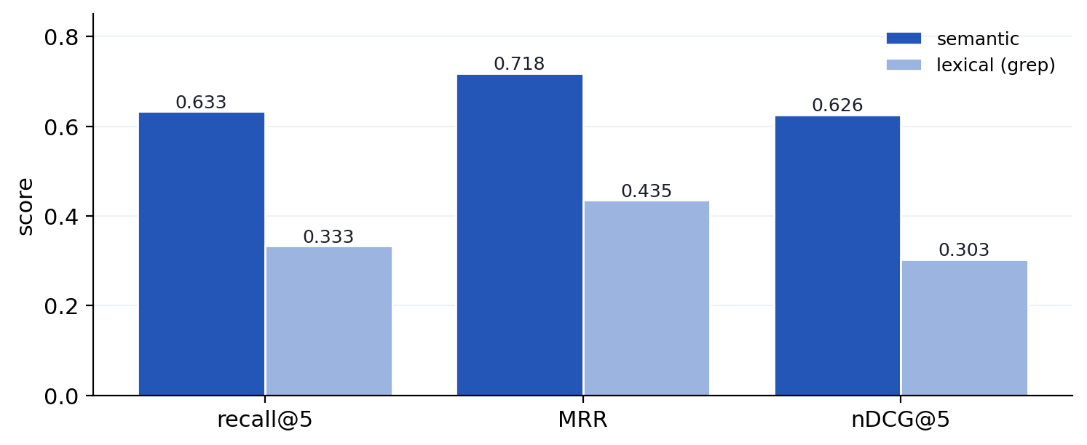
Figure 4 — Dense retrieval versus the lexical baseline across three metrics
4. Result Discussion and Method Refinement
4.1 Hybrid ranking
The first run revealed a defect: under the original merge all symbolic matches were placed above semantic ones, whereby tangential exact matches displaced the best semantic results and the hybrid ranked worse than pure semantics (MRR 0.641 against 0.718). Two refinements, measured on the same index, removed the gap (Table 3, Figure 5): a switch to unified score-based ranking and a tightening of symbol extraction that excludes generic acronyms. The diagnosis was localized to a single query in which the acronym JSON was treated as a code identifier.
Table 3 — Ranking refinement (hybrid-retriever metrics)
Configuration | MRR | nDCG@5
original (hard symbol precedence) | 0.641 | 0.577
+ unified score-based ranking | 0.685 | 0.610
+ strict symbol extraction | 0.718 | 0.626
Total gain — 12% MRR with no change in recall.

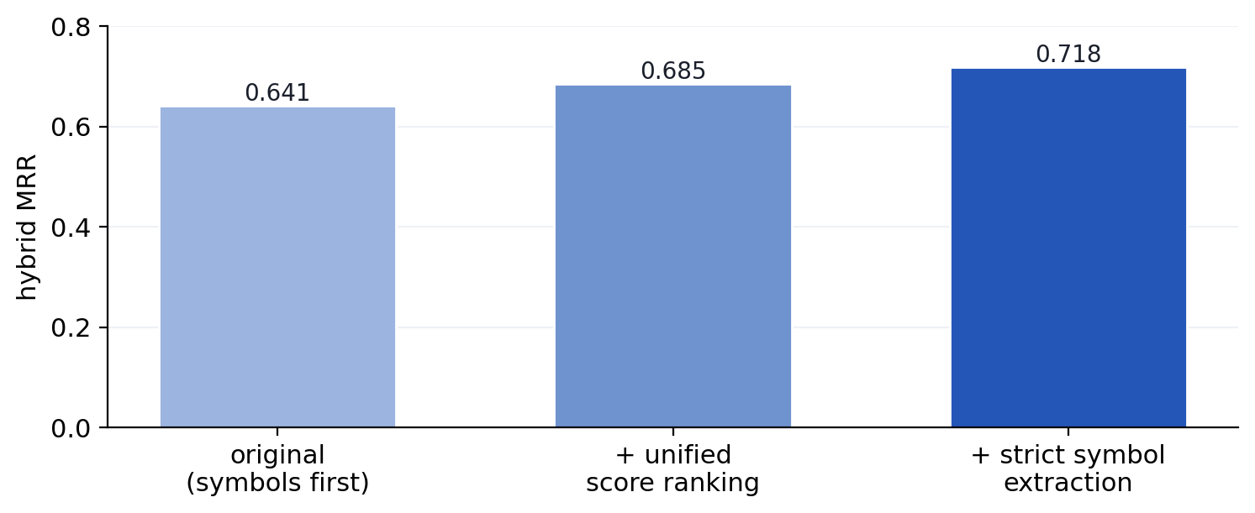
Figure 5 — Measurement-driven progression of hybrid MRR (0.641 → 0.685 → 0.718)
4.2 Comparison of chunking strategies
With all else equal, the index was rebuilt under each strategy. Structure-aware chunking surpassed the fixed-window one in ranking at equal recall (Table 4, Figure 6), which confirms on this corpus the common qualitative observation on the benefit of structural splitting [1].
Table 4 — Structure-aware chunking versus fixed window
Chunking | recall@5 | MRR | nDCG@5 | fragments
structure-aware | 0.633 | 0.718 | 0.626 | 433
fixed window | 0.633 | 0.666 | 0.585 | 418
Gain of structure-aware chunking — 7.8% MRR and 7% nDCG.

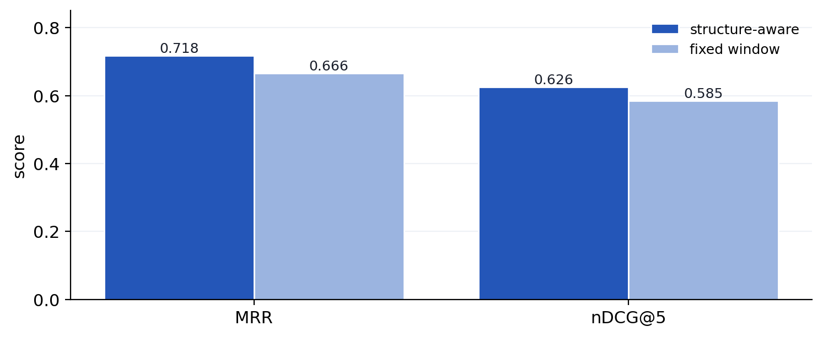
Figure 6 — Structure-aware versus fixed-window chunking at equal recall
4.3 Indexing speed
The correctness of each speed-up was verified before time was measured. Batched embedding is provably equivalent to single-item embedding (minimum cosine 0.99999997), but on the CPU it gives only about 11% gain, since a forward pass of the model saturates the computation. Moving computation to a GPU via DirectML [9] gives an eight-fold speed-up while preserving numerical equivalence (Table 5, Figure 7), reducing full-index time from about half an hour to a few minutes.
Table 5 — Embedding speed and result equivalence
Configuration | time (12 emb.) | speed-up | cosine to CPU
central processor (baseline) | 9657 ms | 1.0× | —
+ batching (on 45 fragments) | ≈ 11% faster | ≈ 1.1× | ≥ 0.99999997
graphics processor (DirectML) | 1205 ms | 8.0× | 0.999984
The dominant speed lever is the GPU; batching is a small free gain.

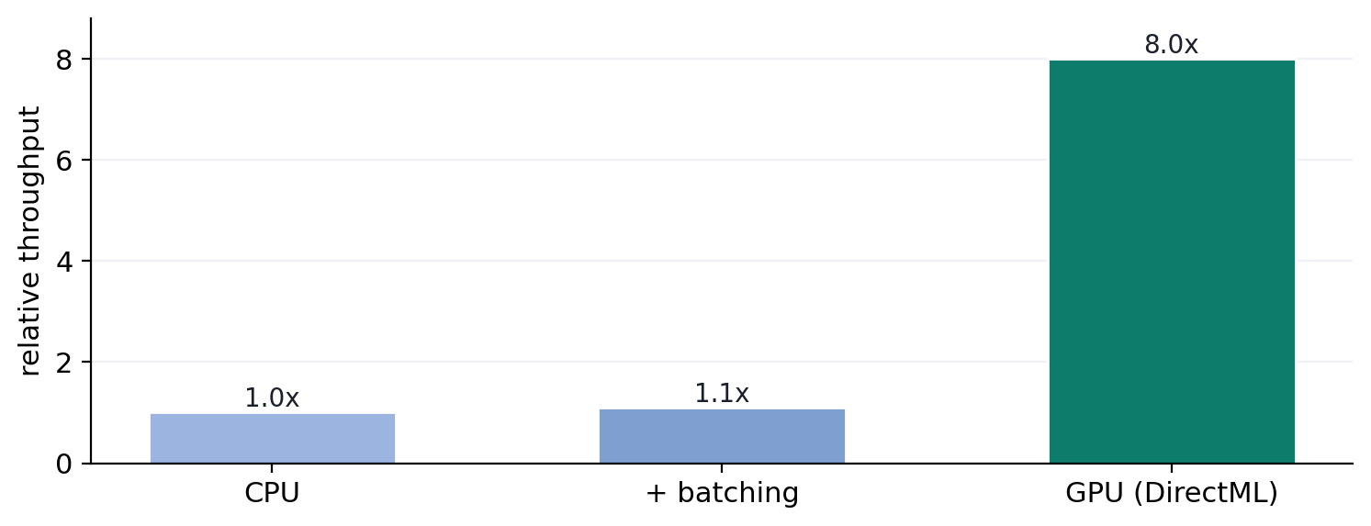
Figure 7 — Relative embedding throughput; the GPU is the dominant lever (numerically equivalent)
5. Discussion
The data show that the dense retrieval layer is not decorative: it substantially outperforms the lexical baseline in both recall and ranking. For natural-language questions semantic retrieval is the working tool; the symbolic stream is neutral on this set but is intended to raise precision on identifier queries not present in the set. Each method improvement (§4) was driven by measurement rather than by an a priori assumption, which illustrates the embedding of the evaluation harness into the engineering loop. With two shards the clustering mechanism does not affect the result and begins to matter only across many layers. The architectural choices (§2) target maintainability rather than benchmark scores: the source-vs-derived split with provenance keeps drift detectable, and the shared-model marker removes per-base duplication without changing retrieval behavior.
6. Limitations and Threats to Validity
The following limitations are established:
- the small query set (n = 15) leads to wide confidence intervals; the numbers indicate direction, not a precise value;
- the results are obtained on a single corpus; generalization to other domains is untested;
- relevance labels are a proxy (required sources of a regression set), which may bias the recall estimate;
- in the evaluation 2 of 6 layers are indexed, and fewer distractor documents make retrieval easier than in full deployment;
- recall@5 = 0.633 implies a loss of about 37% of relevant material in the top-5; raising recall requires a larger k, query expansion, or a change of representation rather than re-ranking;
- high indexing speed needs a GPU and an appropriate runtime build, otherwise CPU fallback applies;
- provenance makes divergence detectable but does not remove the dual source of truth between code and derived pages.
7. Conclusion
In this work a layered, self-validating knowledge-base architecture is described in detail and an often-asserted assumption about the effectiveness of a dedicated retrieval layer is turned into a measured fact: on a real deployed knowledge base a layered hybrid retrieval engine substantially outperforms the lexical baseline (recall@5 0.633 against 0.333, MRR 0.718 against 0.435). A measurement-driven refinement loop is demonstrated: two ranking corrections (+12% MRR) and the choice of chunking strategy (+7.8% MRR) were adopted after confirmation by data, and the speed optimizations (eight-fold GPU speed-up, batching) were introduced after proven numerical equivalence. The architecture contributes a source-vs-derived split with content-hash provenance and a machine-shared, marker-resolved embedding model that eliminates per-base duplication. The limitations are documented and mapped to concrete directions for further experiments. All results are reproducible with the accompanying harness.
References
1. Chase H. et al. LangChain: RecursiveCharacterTextSplitter — structure-aware text splitting. Documentation, 2023. URL: python.langchain.com.
2. Gao Y. et al. Retrieval-Augmented Generation for Large Language Models: A Survey. arXiv:2312.10997, 2023.
3. Johnson J., Douze M., Jégou H. Billion-scale similarity search with GPUs (FAISS) // IEEE Transactions on Big Data. 2019. arXiv:1702.08734.
4. Karpukhin V. et al. Dense Passage Retrieval for Open-Domain Question Answering // EMNLP. 2020. arXiv:2004.04906.
5. Lewis P. et al. Retrieval-Augmented Generation for Knowledge-Intensive NLP Tasks // NeurIPS. 2020. arXiv:2005.11401.
6. Manning C. D., Raghavan P., Schütze H. Introduction to Information Retrieval. Cambridge University Press, 2008. 482 p.
7. Järvelin K., Kekäläinen J. Cumulated Gain-based Evaluation of IR Techniques // ACM TOIS. 2002. Vol. 20, no. 4. P. 422–446.
8. Sturua S. et al. jina-embeddings-v3: Multilingual Embeddings with Task LoRA. arXiv:2409.10173, 2024.
9. Microsoft. ONNX Runtime Execution Providers: DirectML. Documentation, 2023. URL: onnxruntime.ai/docs/execution-providers.
10. Hugging Face. Transformers.js — ONNX-runtime inference in JavaScript. 2023. URL: github.com/huggingface/transformers.js.

