1 | Model | TY-FC270D-01A
2 | General specification | motherboard | SV1a-H8112P-B
2 | General specification | RAM | 4G
2 | General specification | Storage memory | 64GB SSD
2 | General specification | OS | Windows 10
2 | General specification | Network support | 1 * Realtek GbE LAN Chip (10/100/1000 Mbps)
3 | panel specification | Panel specs | 27inch
3 | panel specification | Panel type | TFT-LCD
3 | panel specification | Backlight type | WLED
3 | panel specification | Panel size | 597.888*336.312mm（W*H）
3 | panel specification | Resolution | 1920*1080
3 | panel specification | Contrast(typ) | 1000:1
3 | panel specification | Visual angle | H:178°, V:178°
3 | panel specification | Brightness (typ)/(min) | 300nits
3 | panel specification | Touch Technology | Capacitive
3 | panel specification | Touch points | 10 points
3 | panel specification | working voltage | DC 5v
3 | panel specification | Operating temperature | 0°C ~ 50°C, 20% ~ 80% RH
3 | panel specification | Storage temperature | -20°C~ 60°C, 10% ~ 95% RH
3 | panel specification | Interface | VGA , HDMI，USB, LAN
4 | motherboard specs | processor | Intel Pentium/ Celeron/ 4th Generation Core i5 CPU, LGA1150
4 | motherboard specs | Chipset | Intel® H81，TDP 4.1 W
4 | motherboard specs | Memory type | Support DDR3 1600/1333 MHz, 2 * SO-DIMM Slot, Up to 16GB
4 | motherboard specs | interface | 8 * USB: 2 * Rear I/O(USB3.0/USB2.0) + 2 * Rear I/O(USB2.0) +  4 * Header(USB2.0)  8 * GPIO  1 * PS/2  2 * Mini PCI-E [4]  2 * DC19V In Connector [5]
4 | motherboard specs | BIOS | AMI UEFI BIOS
4 | motherboard specs | Audio | Realtek ALC662 5.1 Channel HDA Codec , Support MIC/Line-out Ports  1 * Amplifier, 6-W(per channel) into an 8-Ω Loads

5 | Printer | Printing method | Thermal printing
5 | Printer | Resolution | 576 dpi (8 dots/mm)
5 | Printer | Paper width | 80（mm）
5 | Printer | Printing width | 72（mm）
5 | Printer | interface | USB
5 | Printer | printing speed | 150（mm/s）max
5 | Printer | Detection function | temperature detection and PNE sensor
5 | Printer | working voltage | 24V DC
5 | Printer | working temperature | ’-10℃~+50℃/10% RH ~ 80% RH
5 | Printer | TPH life | 50km
6 | Scanner | working voltage | 5v DC
6 | Scanner | working temperature ` | -20°C to 60°C
6 | Scanner | working current | 75mA-100mA
6 | Scanner | Support code system | 1D SUPPORT: industrial 25、 standard、 matrix 25、  china post 25、code 11、codabar、 MSI/Plessey、  code39(standard 39 & full ASCII code 39)、code 32、code  93、code128、UPCA、UPCE、EAN13、EAN8、UPC/EAN、  add-on 2/5、ISBN、ISSN、GS1(RSS) RSS-14、LIMITED、  EXPENDED、include GS1 STACK  2D SUPPORT: pdf417, data matrix ,qr code . ect.
6 | Scanner | Reading mode | CMOS
6 | Scanner | Reading accuracy | ≥8mil
6 | Scanner | lighting | LED (6000K) 90lux @100mm
6 | Scanner | luminous intensity | 265 LUX (130 mm)
6 | Scanner | Scanning angle | Omnidirection scan
6 | Scanner | Scanning speed | 30 times / s
6 | Scanner | Resolution | 640*480 pixel
6 | Scanner | feedback | Buzzer

7 | Environment Specs | work environment | Indoor
7 | Environment Specs | working temperature | 0°C - 40°C
7 | Environment Specs | Operating humidity | 10%-90%(No condensation)
7 | Environment Specs | Storage temperature | ‘-20°C - 50°C
7 | Environment Specs | Storage humidity | 10%-90%(No condensation)
8 | accessories | setscrew | 4
8 | accessories | keys | 2
8 | accessories | certificate of qualification | 1
8 | accessories | Warranty card | 1
8 | accessories | setscrew | 4
9 | Electrical parameter | input voltage | Rated voltage： 90（V/ac）~264（V/ac），50/60（Hz）
9 | Electrical parameter | Maximum power | ≦155
10 | Mechanical characteristics | appearance | Front white spray, black spray, with black stand
10 | Mechanical characteristics | Cabinet material | Mild Steel front shell + galvanized mounting plate + Mild Steel rear shell
10 | Mechanical characteristics | outline dimension | 462*191*1812.9(mm)
10 | Mechanical characteristics | Packing size | Kiosk(wooden package）：120*30*68cm  Pole(carton package）：87*31*33cm
10 | Mechanical characteristics | Product weight | GW：kiosk 65KGS  Pole 15KGS
11 | Host port description | 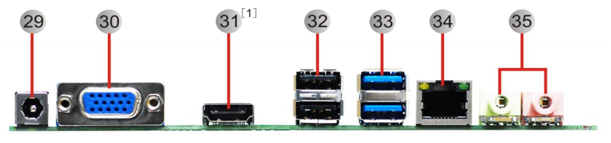
11 | Host port description | .DC19V Power Input Connector 1  .VGA Connector  .HDMI Connector [1]  .USB 2.0 Connectors  USB 3.0 Connectors  LAN Connector  Audio Connectors

Photo：
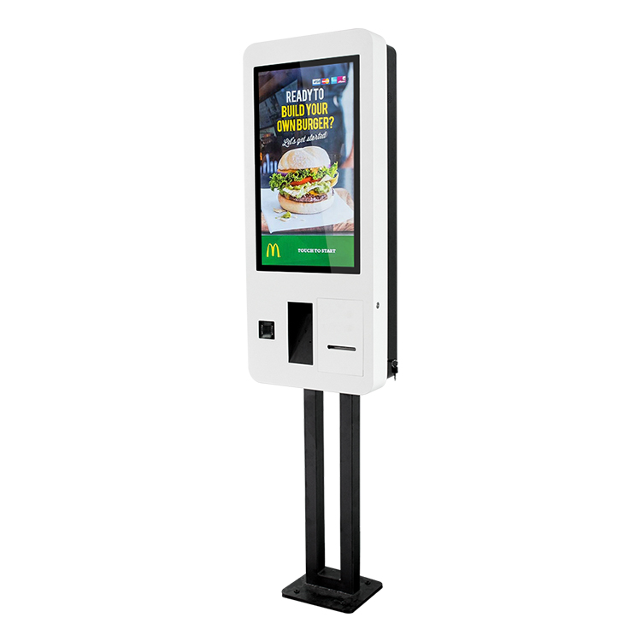

Drawing：
