**EXERCISE: 10**

**DATE: 22.11.2020**

**AIM:**

To write a Python function that accepts a string and calculate the number of upper case letters and lower case letters .

**PROGRAM:**

def string_test(s):

d={"UPPER_CASE":0, "LOWER_CASE":0}

for c in s:

if c.isupper():

d["UPPER_CASE"]+=1

elif c.islower():

d["LOWER_CASE"]+=1

else:

pass

print("No. of Upper case characters : ",d["UPPER_CASE"])

print("No. of Lower case characters : ",d["LOWER_CASE"])

s = input()

string_test(s)

**LINK:**

<http://103.53.53.18/mod/vpl/forms/edit.php?id=325&userid=1699>

**OUTPUT:**

: 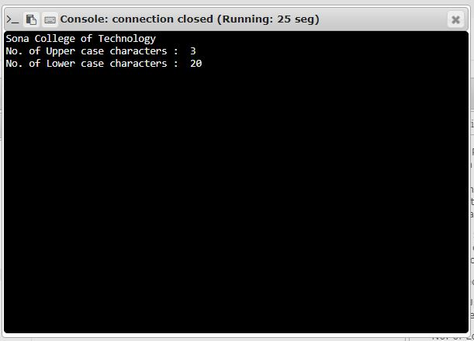

**RESULT**: The oputput for the given class diagram is obtained successfully.