**EXERCISE NO: 4**

**REGISTER NO: 1518102091**

**DATE:15.10.2020**

AIM:

To print a single string from two set of strings received from user and swap the first two characters of each string.

PROGRAM:

**a = input()**

**b = input()**

**s1 = a.strip()**

**s2 = b.strip()**

**x = a[0:2]**

**a = a.replace(a[0:2],b[0:2])**

**b = b.replace(b[0:2],x)**

**if(len(s1)>=2 and len(s2)>=2):**

**print(a,b)**

**else:**

**print("Invalid")**

**LINK:**

[**http://103.53.53.18/mod/vpl/forms/edit.php?id=234&userid=1699**](http://103.53.53.18/mod/vpl/forms/edit.php?id=234&userid=1699)

**OUTPUT:**

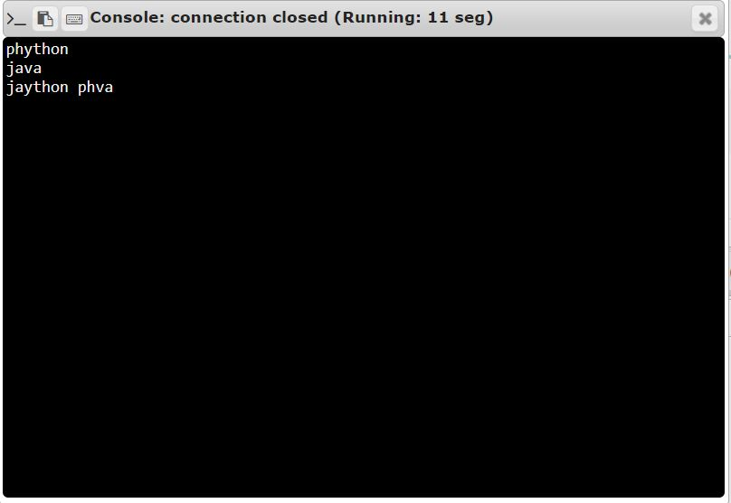

RESULT:

Thus, the code has been successfully executed and output is verified