**EXERCISE NO: 5**

**REGISTER NO: 1518102091**

**DATE:15.10.2020**

AIM:

To print the missing characters to make string pangram

PROGRAM:

a = input()

a = set(a.strip())

a.remove(chr(32))

b = "abcdefghijklmnopqrstuvwxyz"

b = set(b)

b = b.difference(a)

b = list(b)

b.sort()

print("".join(b))

LINK:

<http://103.53.53.18/mod/vpl/forms/edit.php?id=235&userid=1699>

OUTPUT:

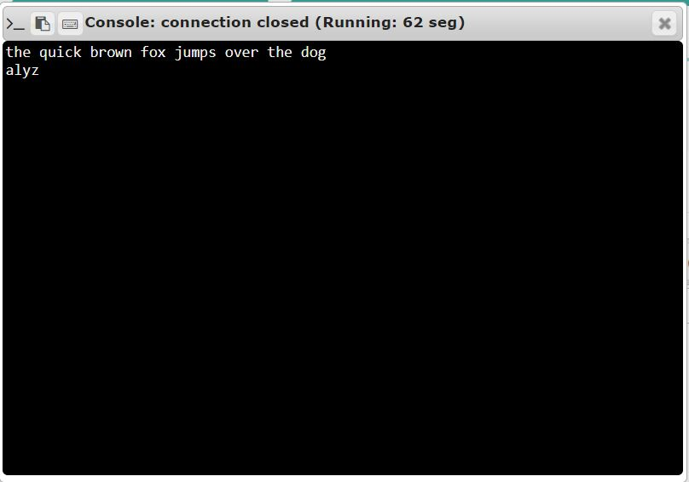

RESULT:

Thus, the code has been successfully executed and output is verified