**EXERCISE NO: 1**

**REGISTER NO: 1518102091**

**DATE:15.10.2020**

AIM:

To print the calendar of a given month and year

PROGRAM:

import calendar

month=int(input("Enter Month:"))

year=int(input("Enter Year:"))

if(999<year<10000):

if(1<=month<=12):

print(calendar.month(year,month))

else:

print("Invalid Input")

else:

print("Invalid Input")

LINK:

<http://103.53.53.18/mod/vpl/forms/edit.php?id=229&userid=1699>

OUTPUT:

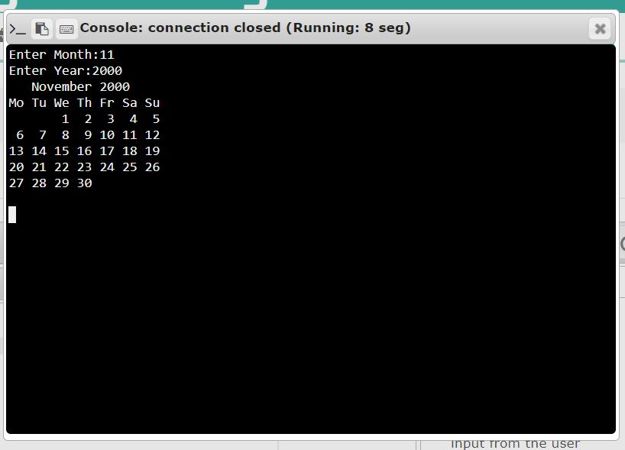

RESULT:

Thus, the code has been successfully executed and output is verified