**EXERCISE NO: 2**

**REGISTER NO: 1518102091**

**DATE:15.10.2020**

AIM:

To print the count number x in a given list of numbers

PROGRAM:

def countX(lst,x):

count = 0

for ele in lst:

if ele == x:

count = count + 1

return(count)

lst = [5,7,5,4,8,6,5,5]

x = 5

print("{} has occured {} many times".format(x,countX(lst,x)))

LINK:

<http://103.53.53.18/mod/vpl/forms/edit.php?id=230&userid=1699>

OUTPUT:

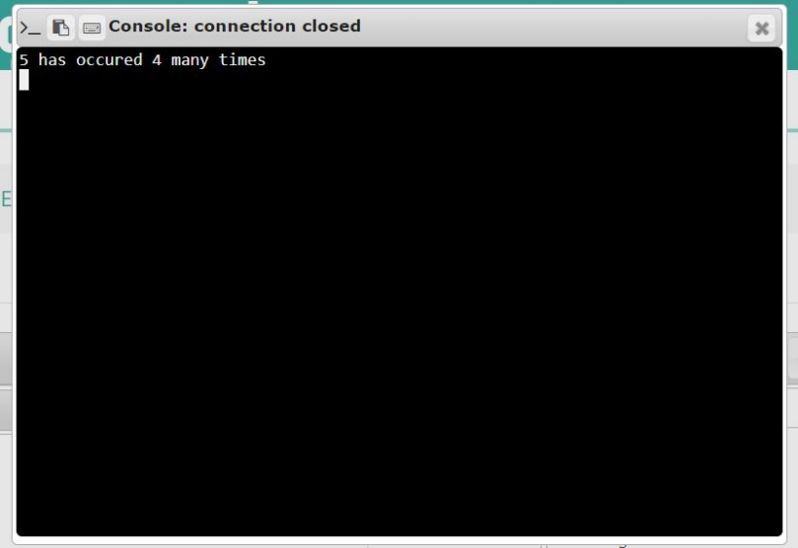

RESULT:

Thus, the code has successfully executed and output is verified