proj09: Robot Simulation

**Specifications**

**i**Robot is a company that sells the Roomba vacuuming robot (watch one of the product videos to see these robots in action). Roomba robots move about a floor, cleaning the area they pass over. You will design a simulation to estimate how much time a group of Roomba-like robots will take to clean the floor of a room.

The following simplified model of a single robot moving in a square 5×5 room should give you some intuition about the system we are simulating.

The robot starts out at some random position in the room, and with a random direction of motion.

The illustrations below show the robot’s position (indicated by a black dot) as well as its direction (indicated by the direction of the red arrowhead).

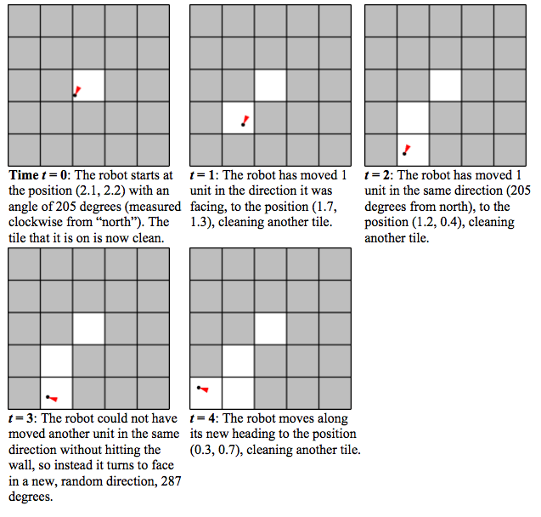

**Simulation Details**

Here are additional details about the simulation model. Read these carefully.

• Multiple robots. In general, there are N > 0 robots in the room, where N is given. For simplicity, assume that robots are points and can pass through each other or occupy the same point without interfering.

• The room. The room is rectangular with some integer width w and height h, which are given. Initially the entire floor is dirty. A robot cannot pass through the walls of the room.

A robot may not move to a point outside the room.

• Robot motion rules:

* Each robot has a position inside the room. We’ll represent the position using coordinates (x, y) which are floats satisfying 0 ≤ x < w and 0 ≤ y < h. In our program we’ll use instances of the Position class to store these coordinates.
* A robot has a direction of motion. We’ll represent the direction using an integer d satisfying 0 ≤ d < 360, which gives an angle in degrees.
* All robots move at the same speed s, which is given and is constant throughout the simulation. Every time-step, a robot moves in its direction of motion by s units.
* If a robot would’ve ended up hitting the wall within the time-step, it instead picks a new direction at random. The robot continues in that direction until it reaches another wall.

• Tiles. You will need to keep track of which parts of the floor have been cleaned by the robot(s). We will divide the area of the room into 1×1 tiles (there will be w * h such tiles).

When a robot’s location is anywhere in a tile, we will consider the entire tile to be cleaned (as in the pictures above). By convention, we will refer to the tiles using ordered pairs of integers: (0, 0), (0, 1), …, (0, h-1), (1, 0), (1, 1), …, (w-1, h-1).

• Termination. The simulation ends when a specified fraction of the tiles in the room have been cleaned.

If you find any places above where the specification of the simulation dynamics seems ambiguous, it is up to you to make a reasonable decision about how your program/model will behave, and document that decision in your code.

**Part I: The Rectangular Room and Robot classes**

You will need to design two classes to keep track of which parts of the room have been cleaned as well as the position and direction of each robot.

In Proj09.py, we’ve provided skeletons for the following two classes, which you will fill in in

**Problem #1**

***RectangularRoom***

Represents the space to be cleaned and keeps track of which tiles have been cleaned.

***Robot***

Stores the position and heading of a robot.

We’ve also provided a complete implementation of the following class:

***Position***

Stores the x- and y-coordinates of a robot in a room.

Read Proj09.py carefully before starting, so that you understand the provided code and its capabilities.

**Problem #1**

In this problem you will implement two classes.

For the RectangularRoom class, decide what fields you will use and decide how the following operations are to be performed:

• Initializing the object

• Marking an appropriate tile as cleaned when a robot moves to a given position

• Determining if a given tile has been cleaned

• Determining how many tiles there are in the room

• Determining how many cleaned tiles there are in the room

• Getting a random position in the room

• Determining if a given position is in the room

For the Robot class, decide what fields you will use and decide how the following operations are to be performed:

• Initializing the object

• Accessing the robot’s position

• Accessing the robot’s direction

• Setting the robot’s position

• Setting the robot’s direction

**Part II: Creating and using the simulator**

**Problem #2**

Each robot must also have some code that tells it how to move about a room, which will go in a method called updatePositionAndClean.

Ordinarily we would consider putting all the robot’s methods in a single class. However, later in this problem set we’ll consider robots with alternate movement strategies, to be implemented as different classes with the same interface. These classes will have a different implementation of updatePositionAndClean but are for the most part the same as the original robots. Therefore, we’d like to use inheritance to reduce the amount of duplicated code.

We have already refactored the robot code for you into two classes: the Robot class you completed above (which contains general robot code), and a StandardRobot class inheriting from it (which contains its own movement strategy). Complete the updatePositionAndClean method of StandardRobot to simulate the motion of the robot after a single time-step (as described above in the simulation dynamics).

**Problem #3**

In this problem you will write code that runs a complete robot simulation.

Recall that in each trial, the objective is to determine how many time-steps are on average needed before a specified fraction of the room has been cleaned. Implement the following function:

def runSimulation(num_robots, speed, width, height, min_coverage, num_trials,

robot_type):

"""

Runs NUM_TRIALS trials of the simulation and returns the mean number of

time-steps needed to clean the fraction MIN_COVERAGE of the room.

The simulation is run with NUM_ROBOTS robots of type ROBOT_TYPE, each

with

speed SPEED, in a room of dimensions WIDTH x HEIGHT.

"""

The first six parameters should be self-explanatory. For the time being, you should pass in StandardRobot for the robot_type parameter, like so:

avg = runSimulation(10, 1.0, 15, 20, 0.8, 30, StandardRobot)

Then, in runSimulation you should use robot_type(...) instead of StandardRobot(...) whenever you wish to instantiate a robot. (This will allow us to easily adapt the simulation to run with different robot implementations, which you’ll encounter in Problem #5.)

Feel free to write whatever helper functions you wish.

For your reference, here are some approximate room cleaning times. These times are with a robot speed of 1.0.

• One robot takes around 150 clock ticks to completely clean a 5×5 room.

• One robot takes around 190 clock ticks to clean 75% of a 10×10 room.

• One robot takes around 310 clock ticks to clean 90% of a 10×10 room.

• One robot takes around 3250 clock ticks to completely clean a 20×20 room.

(These are only intended as guidelines. Depending on the exact details of your implementation, you may get times different from ours.)

You should also check your simulation’s output for speeds other than 1.0. One way to do this is to take the above test cases, change the speeds, and make sure the results are sensible.

**Extension/Debugging tool: Visualizing robots**

We’ve provided some code to generate animations of your robots as they go about cleaning a room. These animations can also help you debug your simulation by helping you to visually determine when things are going wrong.

Download proj09_visualize.py and save it in the same directory as your Proj09.py. Add the following line to the top of your proj09.py:

import proj09_visualize

Here’s how to run the visualization:

1. In your simulation, at the beginning of a trial, do the following to start an animation:

anim = proj09_visualize.RobotVisualization(num_robots, width, height)

(Pass in parameters appropriate to the trial, of course.) This will open a new window to display the animation and draw a picture of the room.

2. Then, on each time-step, do the following to draw a new frame of the animation:

anim.update(room, robots)

Pass in a RectangularRoom object and a list of Robot objects representing the current state of the room and the robots in the room.

3. When the trial is over, call the following method:

anim.done()

The resulting animation will look like this:

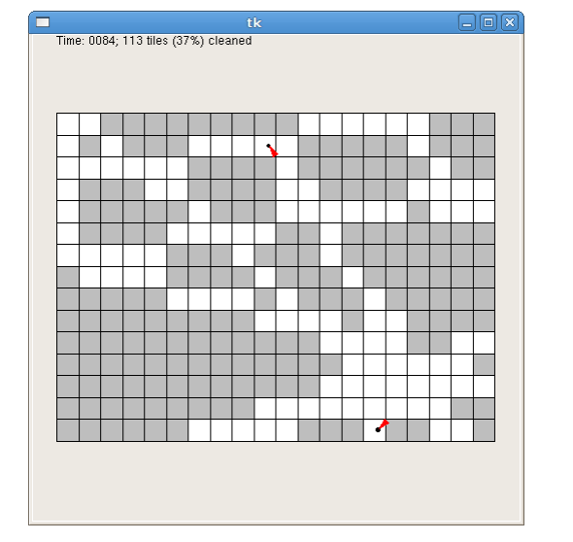

The visualization code slows down your simulation so that the animation doesn’t zip by too fast (by default, it shows 5 time-steps every second).

Naturally, you will want to avoid running the animation code if you are trying to run many trials at once (for example, when you are running the full simulation). For purposes of debugging your simulation, you can slow down the animation even further. You can do this by changing the call to RobotVisualization, as follows:

anim = proj09_visualize.RobotVisualization(num_robots, width, height, delay)

The parameter delay specifies how many seconds the program should pause between frames. The default is 0.2 (that is, 5 frames per second). You can raise this value to make the animation slower.

For problems 4 and 6, you will want to make calls to runSimulation() to get simulation data and plot it. However, you don’t want the visualization getting in the way. If you choose to do this visualization exercise, before you get started on problems 4 and 6, make sure to comment the visualization code out of runSimulation().

**Problem #4**

Now, use your simulation to answer some questions about the robots’ performance.

Follow the instructions in this write up!

In order to do this problem, you will be using a Python tool called pylab.

For both of the questions below, write code which will generate a plot using pylab. Put your code inside the corresponding skeleton functions in Proj09.py (showPlot1 and showPlot2).

Each plot should have a title and descriptive labels on both axes.

1. How long does it take to clean 80% of a 20×20 room with each of 1-10 robots? Output a figure that plots the mean time (on the Y-axis) against the number of robots.

2. How long does it take two robots to clean 80% of rooms with dimensions 20×20, 25×16, 40×10, 50×8, 80×5, and 100×4? (Notice that the rooms have the same area.) Output a figure that plots the mean time (on the Y-axis) against the ratio of width to height.

Experiment with the number of trials. For your plots, use a number of trials which is large enough that you think the output is reliable.

Here is an example of a good plot:

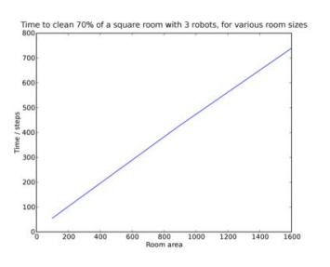

As you can see, when keeping the number of robots fixed, the time it takes to clean a square room is basically proportional to the area of that room.

**Problem #5**

iRobot is testing out a new robot design. The proposed new robots differ in that they change direction randomly after every time step, rather than just when they run into walls. You have been asked to design a simulation to determine what effect, if any, this change has on room cleaning times.

Write a new class RandomWalkRobot that inherits from Robot (like StandardRobot) but implements the new movement strategy. RandomWalkRobot should have the same interface as StandardRobot.

Test out your new class. Perform a single trial with the new RandomWalkRobot implementation and watch the visualization to make sure it is doing the right thing. Once you are satisfied, you can call runSimulation again, passing RandomWalkRobot instead of StandardRobot.

**Problem #6**

Generate an appropriate plot (of your own design) that compares the performance of the two types of robots. Add your code to showPlot3(). As always, your plot should have an appropriate title, axis labels, and (if applicable) legend. Within comments in showPlot3, comment briefly on how the two types of robots compare.