**LAB 6**

1. create table confirmation (pnr number ,name varchar(20),seat number ,amount number);

insert into confirmation values(&pnr ,'&name',&seat,&amount);

select * from confirmation;

PNR NAME SEAT AMOUNT

1001 a 10 2000

1002 b 12 1000

1003 c 14 2000

1004 d 16 1000

2. declare cursor p is

select * from confirmation where pnr=&pnr;

a p%rowtype;

begin

open p;

fetch p into a;

if (p%found) then

dbms_output.put_line('a.name');

insert into cancel values(a.pnr,a.name,a.seat);

insert into refund values(a.pnr, a.name,a.amount/2);

delete from confirmation where pnr = a.pnr;

else

dbms_output.put_line('not found');

end if;

close p;

end;

cancel table :

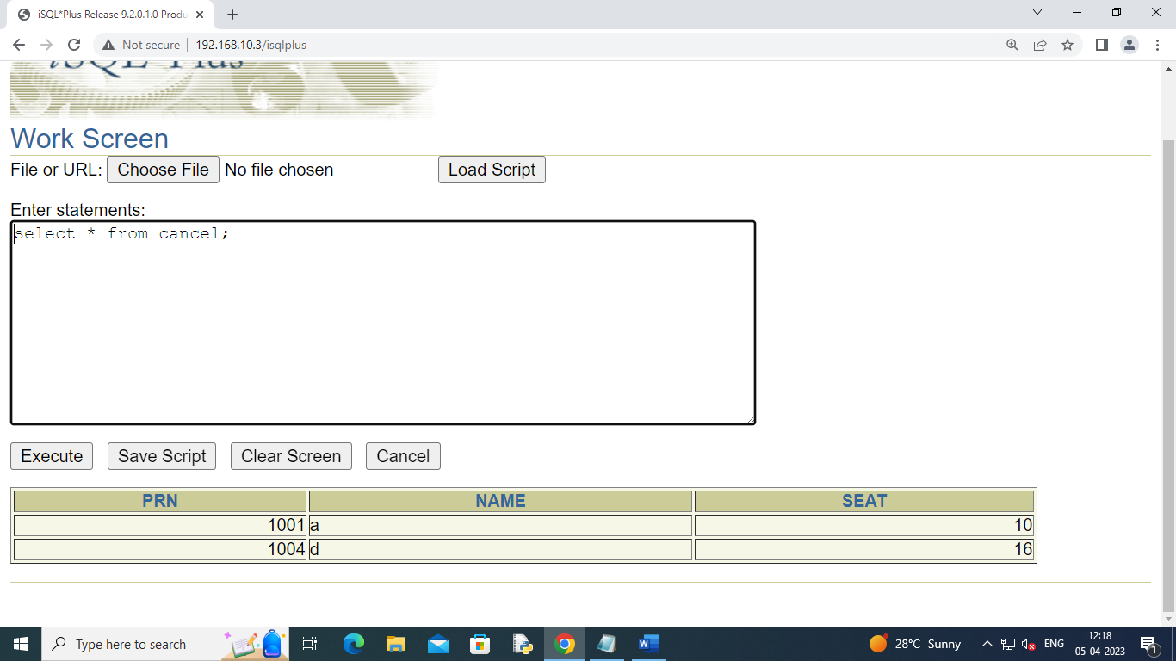

Refund table :

Confitmation table :

