**LAB 4**

**Create 3 tables – Sailors, Reserves and Boats**

create table sailors(sid number(2), sname varchar(7),rating number(2),age number(2));

insert into sailors values(&sid,'&sname',&rating,&age);

create table Reservers(sid number(2),bid number(3),days date);

create table Boats (bid number(3),bname varchar(9),color varchar(5));

insert into Boats values(&bid,'&bname','&color');

insert into Reserves values(&sid,&bid,&day);

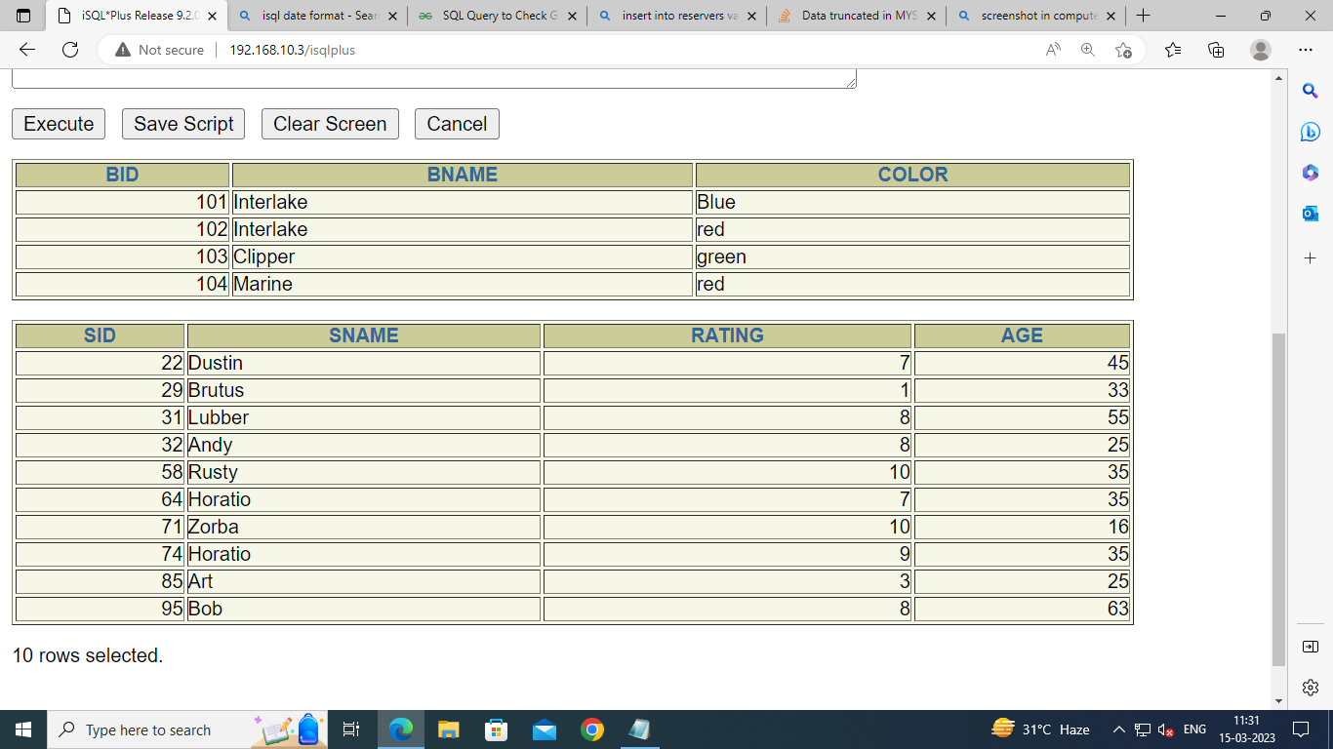

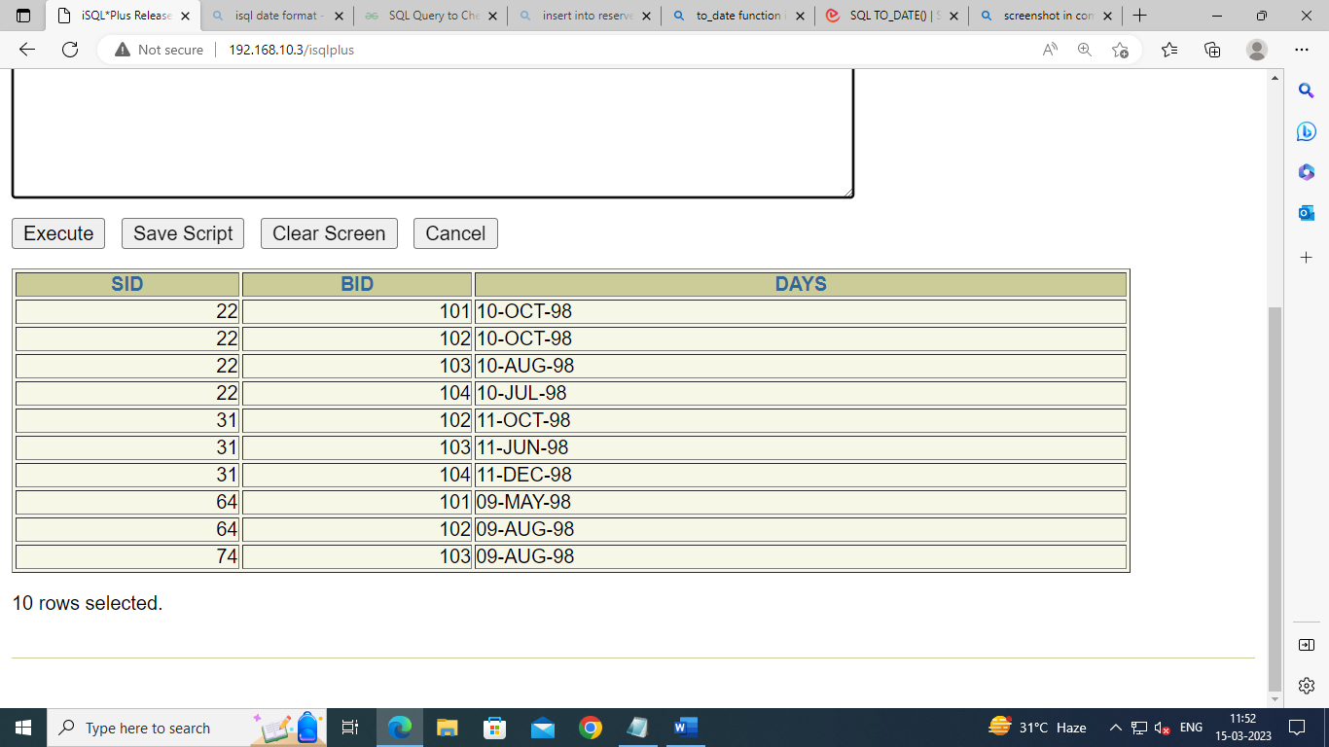

**Query 1 : Find the names of sailors who have reserved boat 103.**

select sailors.sname,Reserves.bid from sailors inner join Reserves on Reserves.sid=Sailors.sid where Reserves.bid=103;

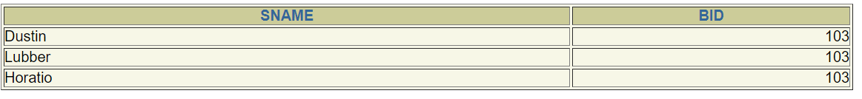

**Query 2 : Find the names of sailors who have reserved a red boat.**

select unique sid from Reserves inner join Boats on Reserves.bid=Boats.bid where Boats.color='red';

select unique sname from Reserves inner join Sailors on Reserves.sid=Sailors.sid;

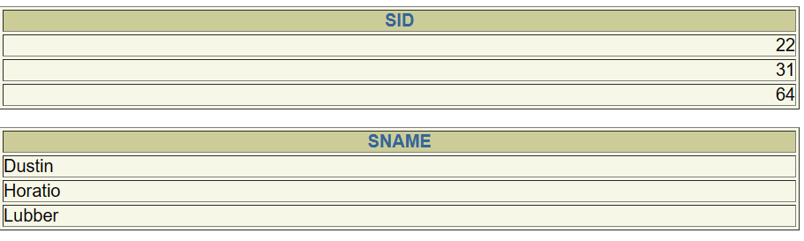

**Query 3 : Find the colours of boats reserved by Lubber.**

select unique color,Sailors.sname from Boats

Inner join Reserves on Reserves.bid=Boats.bid

Inner join Sailors on Sailors.sid=Reserves.sid

where sname='Lubber';

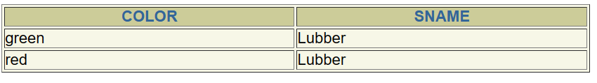

**Query 4 : Find the names of sailors who have reserved at least one boat.**

select unique Sailors.sid,Sailors.sname from Reserves inner join Sailors on Sailors.sid=Reserves.sid ;

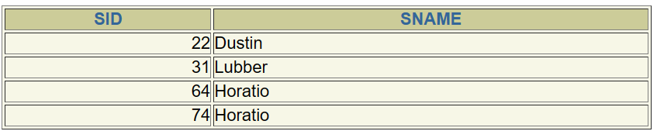

**Query 5 : How many sailors are there within the range of 40-60 who have reserved a red boat?**

select Sailors.sid,bid from Reserves inner join sailors on Sailors.sid=Reserves.sid where age between 40 and 60;

select count(unique Reserves.bid) from reserves inner join Boats on Reserves.bid=Boats.bid where color='red';

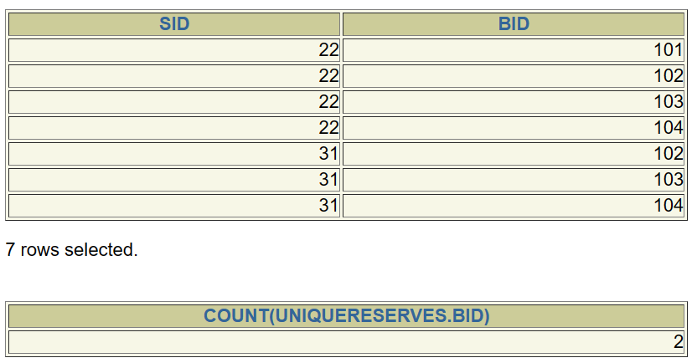

**Query 6 : Find the names of sailors who have reserved a red or a green boat.**

SELECT unique Sailors.sname FROM Reserves

INNER JOIN Sailors ON Reserves.sid = Sailors.sid

INNER JOIN Boats ON Reserves.bid = Boats.bid

WHERE color = 'red' OR color = 'green';

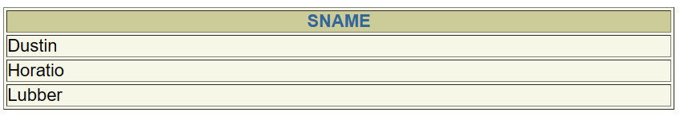

**Query 7 : Find the name of sailors who have reserved a red and a green boat.**

SELECT unique s.sname FROM Sailors s

INNER JOIN Reserves r1 ON s.sid = r1.sid

INNER JOIN Boats b1 ON r1.bid = b1.bid AND b1.color = 'red'

INNER JOIN Reserves r2 ON s.sid = r2.sid

INNER JOIN Boats b2 ON r2.bid = b2.bid AND b2.color = 'green';

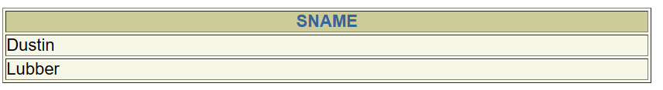

**Query 8 : Find the name of sailors who have reserved at least two boats.**

SELECT s.sname FROM Sailors s

INNER JOIN Reserves r ON s.sid = r.sid

GROUP BY s.sid, s.sname

HAVING COUNT(DISTINCT r.bid) >= 2;

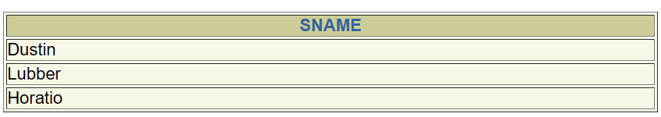

**Query 9 : On which date, boat 102 was reserved by Dustin?**

SELECT days from Reserves

Inner join Sailors on Reserves.sid=Sailors.sid

where bid=102 and sname='Dustin';

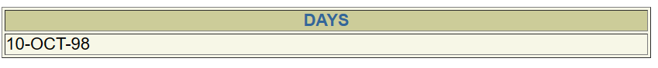

**Query 10 : How many sailors are there who have same rating?**

SELECT count(sname),rating from Sailors

group by rating HAVING COUNT(sname)>1;

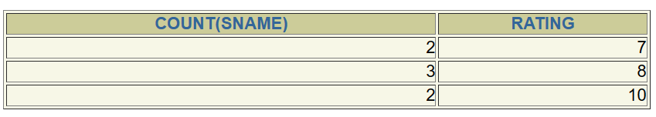

**Query 11 : Find the sids of sailors with age over 20 who have not reserved a red boat.**

SELECT sid FROM Sailors

WHERE age > 20

AND sid NOT IN (

SELECT r.sid FROM Reserves r

INNER JOIN Boats b ON r.bid = b.bid

WHERE b.color = 'red');

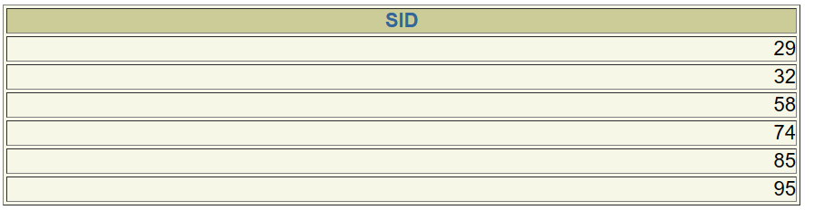

**Query 12 : Find the names of sailors who have reserved all boats.**

SELECT s.sname FROM Sailors s

WHERE NOT EXISTS (

SELECT b.bid FROM Boats b

WHERE NOT EXISTS (

SELECT r.bid FROM Reserves r

WHERE r.sid = s.sid AND r.bid = b.bid));



**Query 13 : Find the names of sailors who have reserved all boats call Interlake.**

SELECT s.sname FROM Sailors s

WHERE NOT EXISTS (

SELECT b.bid FROM Boats b

WHERE b.bname = 'Interlake'

AND NOT EXISTS (

SELECT r.bid FROM Reserves r

WHERE r.sid = s.sid AND r.bid = b.bid));

