**LAB 7**

select * from xyz;

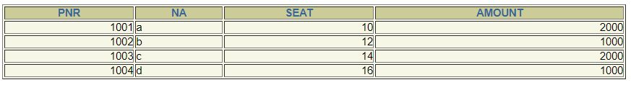

Trigger operations

create table xyx(table_name varchar2(10),tran_type varchar2(10),tran_date date);

CREATE OR REPLACE TRIGGER xx

AFTER INSERT OR UPDATE OR DELETE ON xyz

FOR EACH ROW

DECLARE

tran VARCHAR2(10);

BEGIN

tran := CASE

WHEN UPDATING THEN 'update'

WHEN DELETING THEN 'delete'

WHEN INSERTING THEN 'insert'

END;

INSERT INTO xyx (table_name, tran_type, tran_date)

VALUES ('xyx', tran, SYSDATE);

END;

**UPDATE**

update xyz set AMOUNT=AMOUNT+100 where PNR=1002;

select * from xyz

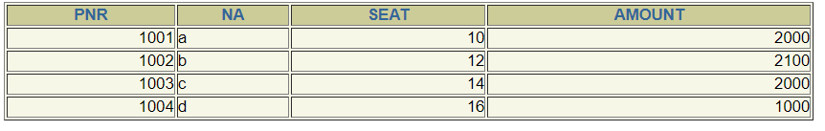

**INSERT**

insert into xyz values(1005,'e',18,2500);

select * from xyz

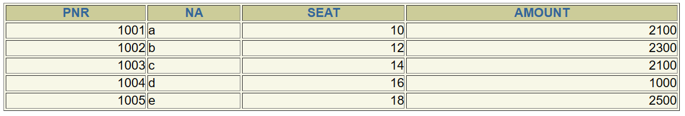

**DELETE**

delete from xyz where PNR=1003;

select * from xyz

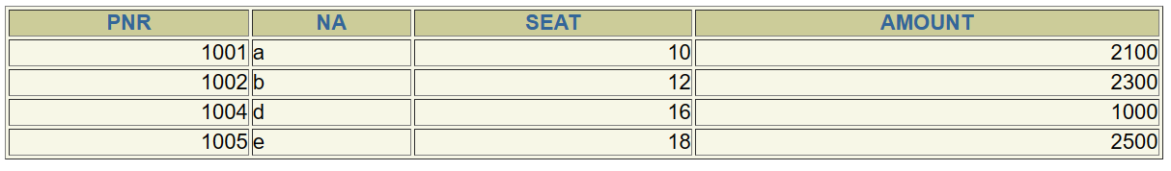

**Trigger Table**



