Search X

Your task is to implement the basics of a search engine client using ReactJS. You don’t need to go into details, the **must have** **requirements** are:

1. You need an input where you can type.
2. The input should support autocompletion.
3. You need to show all the results (list of results) on selection (by clicking on a result item or by pressing the Enter key).

The points above are similar to Google search behaviour but really far from the real complex one, you can follow their behaviour if you want (not needed to be the same, just a simple version).

**Search autocomplete feature**:

By typing you need to check your local DB (**feel free to hardcode some data and use it as a fake/local DB**) for entries which **title** starts with the value of the input and then to render all of them like on the screenshot bellow (You don’t need to bold the letters).

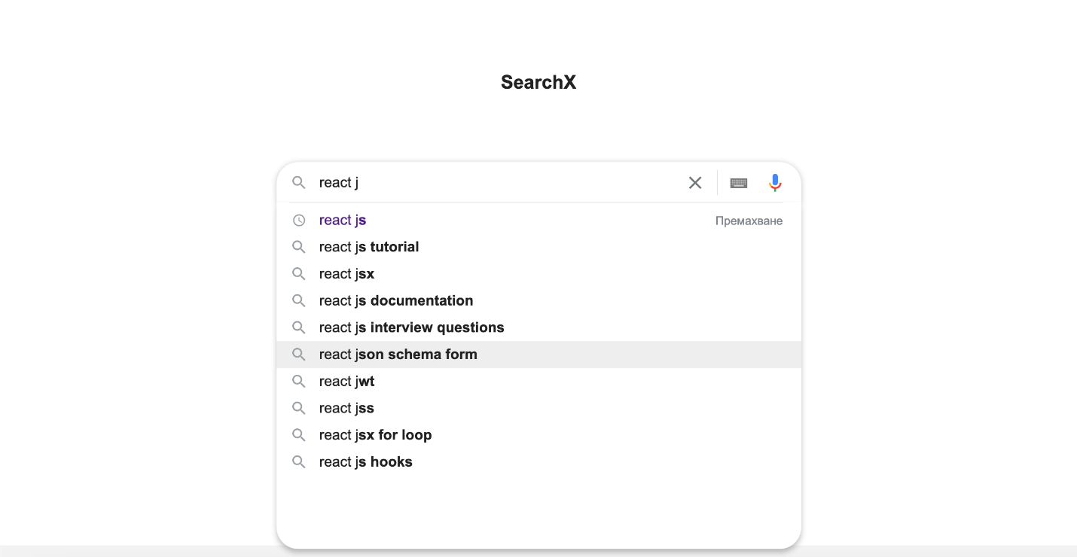

In addition you need to indicate which of the autocompleted items are already in your searching history (recently searched items), please check the 1st item of the results autocompletion.

**Notice**: Once the screen loads you need to auto focus the search input

**Notice:** Once you focus out the input you’ve to close/make invisible the list with the autocompleted items **BUT** you still need to keep the items in your memory (just hide the list).

**Notice:** Once you focus the input you need to check if there are autocomplete items in memory and if yes then you need to show them like on the screenshot above.

**Notice:** You have to limit the autocomplete items to 10 rows/elements.

Take a look also that there is “Remove” / ”Премахване” button – by clicking it you have to remove the relevant item from your searching history, the item colour should change from purple to black/dark because the item won’t be in your searching history anymore.

**Results list feature**:

Once you select an item from the autocomplete shown on the previous screenshot **OR** press enter, you need to take the input value/text and check again your DB for items which **title** contains the value/text.

**Mandatory data** **to render** is:

1. Keep the search input (you are still able to type and perform a new search)
2. Result meta data (below the search input it tells you how many results you have and how long it takes to perform the search)
3. A list of results where each result has:

* **Title** (which is a clickable real link/URL)
* **Description**

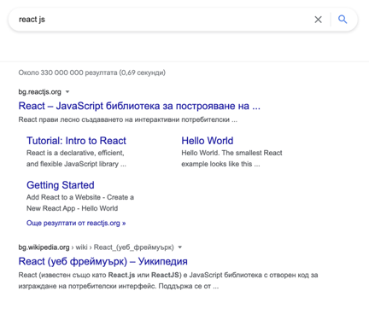

**Please use git and push all your code to a remote git provider (GitHub/Bitbucket), make sure that the repository is public so the source would be free for read/download.**

You are not allowed to use 3rd parties for the search/autocompletion.

Please avoid ES6 classes and try to use React hooks.

Feel free to use a real database/storage if you want.

Everything which extends the **must have requirements (like pagination)** and is close to Google search behaviour will be considered as a bonus.

The UI should follow the screenshots (as a design) but is not needed to be perfect, however a good styling would be considered as a bonus.

All the screen elements not mentioned in the requirements (like the microphone icon for voice search) are not mandatory.

Good luck!