**AI CRYPTO TRACKER**

**SYNOPSIS**

OF MINI PROJECT

**MASTER OF COMPUTER APPLICATIONS**

SUBMITTED BY

Saumy Kumar Singh

Batch Year –2022-24

Enrollment No. – U2249021

**PROJECT GUIDE – Ms. Farha**



Centre of Computer Education & Training

**Institute of Professional Studies**

**University of Allahabad, Prayagraj**

**Uttar Pradesh**

**INTRODUCTION**

Crypto currency, sometimes called crypto-currency or crypto, is form of currency that exists digitally or virtually and uses cryptography to secure transactions Crypto currency nowadays is in most demand and many people are investing in these currencies to get high returns. Crypto currencies are digital assets and decentralized systems that allow for secure online payments. To track one’s favorite crypto currency price in order to get to know it’s performance, prices, etc. Cryptocurrency tracker is a real tine web application. The cryptocurrency web application monitors and provides the latest updates, value statistics, market cap, supply and news regarding the cryptocurrencies market. digital means of exchange that uses cryptography for security. The word 'crypto' comes from the ancient greek word, 'kryptos', which means hidden or private. A digital currency that is created and used by private individuals or groups has multiple benefits. It was launched in 2009 by someone (or a group of people) that goes by the pseudonym Satoshi Nakamoto. It was created in the wake of the 2008 global financial crisis as a way for people to control their money themselves, without having to rely on companies, banks, or governments and their fees and controls. AI Crypto Tracker is a price-tracking website for AI crypto assets in the rapidly growing cryptocurrency space. Its mission is to make crypto discoverable and efficient globally by empowering retail users with unbiased, high quality and accurate information for drawing their own informed conclusions.

**SYSTEM REQUIREMENTS**

**1**.**Software Specifications**

* Operating system: Windows 11
* Browser: Google chrome/Safari/Edge
* Internet

**2**.**Hardware Specifications**

* Processor: Intel core i3
* Ram: 2GB
* Storage: 128GB

**PROBLEM DEFINITION**

There are public discussions of cryptocurrencies worldwide because of frequent changes of prices time to time. When it comes to crypto currencies, investors routinely spend a lot of time searching for latest coins, the one with most exciting prospects and the ones which are undervalued. Savvy investors also look for different cryptocurrency exchanges, applications, and services to maximize their investment potential. There is a need for investors to compare currency prices on multiple exchanges, at the same allowing them to determine the best options for buying or selling.

**MOTIVATION**

Cryptocurrencies are digital or virtual currencies underpinned by cryptographic systems. They enable secure online payments without the use of third party intermediaries. The benefits of virtual currencies – more anonymity, easier transactions. What motivates people to invest in crypto? Digital currencies have grown far beyond the imagination of anyone, but there is still a lot of doubt about it. The spelling of cryptocurrencies begins with the popularity of crypto coins like bitcoin, and now, digital tokens exist everywhere. However, no one is sure about the primary reason for spreading cryptocurrencies everywhere. Still, everyone is quite determined to know that cryptocurrencies got famous because they provide exponential growth prospects. Apart from that, many initial coin offerings are nowadays available in the market. They are not only the digital tokens like bitcoins, but there are other digitalized options which offers you decentralized finance on Bitcoin.

**OBJECTIVE**

* To understand the basic concept of crypto currency that how it works.
* To develop the ability to invest in crypto currencies.
* To develop the ability how to select best crypto from huge number of existed crypto currency.
* To make simple and easy to use this platform.

**REQUIREMENT ANALYSIS**

**TOOLS & TECHNOLOGIES TO BE USED :**

**WINDOWS 11 64-bit:** Windows 11 is a personal computer operating system that is part of the Windows NT family.

**ReactJs:** ReactJs is an open-source JavaScript library that is used for building user interfaces specifically for single-page applications.

**Material-UI:** Material-UI is simply a library that allows us to import and use different components to create a user interface in our React applications.

**ChartJS:** Chart.js is a free JavaScript library for making HTML-based charts. It is one of the simplest visualization libraries for JavaScript, and comes with built-in chart types: Scatter Plot, Line Chart.

**API:** API is the acronym for Application Programming Interface, which is a software intermediary that allows two applications to talk to each other.

**STUDY DESIGN:**

• A cryptocurrency price tracker monitors the current value of digital currencies, in addition to information about market capitalization, trading volume, price charts, and other types of data.

• The tracker's accuracy can have a significant bearing on an investor's decisions; because of this, investors should choose their price tracker carefully.

• Cryptocurrency price trackers should use reliable data and consistently update their data.

• Both live and historical data of various currencies can be scraped from multiple websites.

Architecture

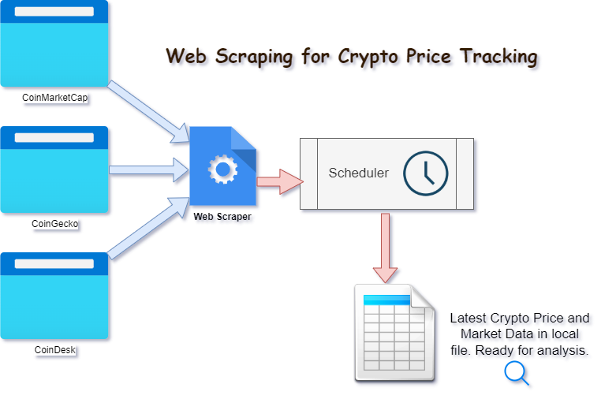

Image Source: WebHarvy

**Data Flow Diagram**

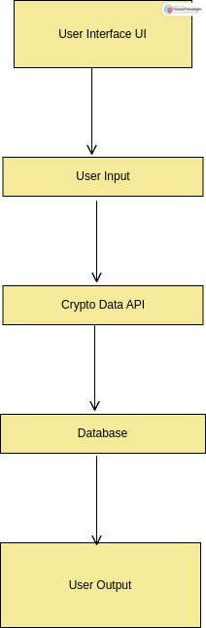

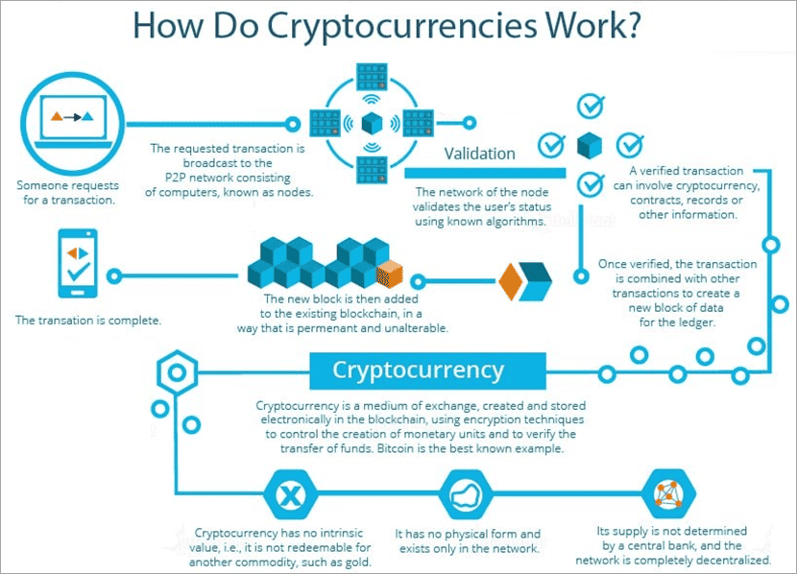

Image source: softwaretestinghelp.com

**MILESTONE**

|  |  |  |  |
| --- | --- | --- | --- |
| **S.No.** | **Project Activity** | **Estimated Start Date** | **Estimated End Date** |
| **1.** | **Synopsis submission** |  |  |
| **2.** |  |  |  |
|  |  |  |  |
|  |  |  |  |
|  |  |  |  |
|  |  |  |  |
|  |  |  |  |
|  |  |  |  |
|  |  |  |  |
|  |  |  |  |

**MEETING WITH THE SUPERVISOR**

|  |  |  |  |
| --- | --- | --- | --- |
| Date of the meet | Mode | Comments by the supervisor | Signature of the Supervisor |
|  |  |  |  |
|  |  |  |  |
|  |  |  |  |
|  |  |  |  |
|  |  |  |  |
|  |  |  |  |
|  |  |  |  |
|  |  |  |  |
|  |  |  |  |

**Bibliography & References**

Resources used:

• Youtube

• React JS

• Material UI

• Chart JS

• Coin Geco API