Data Analysis and Visualization
Project Report
(Project Semester January-May 2026)

Data-Driven Analysis of Electricity Generation, Consumption and Energy Mix using Power BI

Submitted by

Aprameyya Garg
Registration No. – 12406209

Programme – P132: B.tech.
Section – 4M029
Course Code – INT 387

Under the Guidance of
Dr. Baljinder Kaur

Discipline of CSE/IT
Lovely School of Computer Science and Technology
Lovely Professional University, Phagwara

CERTIFICATE

This is to certify that Aprameyya Garg bearing Registration no. 12406209 has completed
INT 387 project titled, “Data-Driven Analysis of Electricity Generation, Consumption and Energy Mix using Power BI” under my guidance and supervision. To the best of my knowledge, the present work is the result of his/her original development, effort and study.

Signature and Name of the Supervisor
Designation of the Supervisor
School of …………………………………………….
Lovely Professional University
Phagwara, Punjab.

Date:

DECLARATION

I, Aprameyya Garg, student of Data Analysis and Visualization under CSE/IT Discipline at, Lovely Professional University, Punjab, hereby declare that all the information furnished in this project report is based on my own intensive work and is genuine.

Date: 6th April, 2026 Signature
Registration No. 12406209 Aprameyya Garg

Abstract
This project presents a comprehensive analysis of electricity generation, consumption, and revenue trends across different sectors and regions in India. Using Power BI, an interactive dashboard has been developed to visualize key performance indicators, identify patterns, and derive actionable insights.
The dashboard integrates multiple datasets including electricity consumption, installed capacity, state-wise generation, and revenue distribution. It enables users to explore trends over time, compare sector-wise contributions, and evaluate the shift in energy mix. time, compare sector-wise contributions, and evaluate the shift in energy mix.

Summary
This Power BI report delivers a professional, interactive analytics dashboard for India's power sector. It consolidates key metrics on electricity generation, supply-demand balance, revenue, consumption patterns, state-wise performance, and energy mix/installed capacity growth.
The dashboard uses clean visuals, dynamic slicers, bookmarks for chart-type switching (line/area/bar), filled maps, cards, and insightful textboxes.
Key Highlights (embedded in the report):
- Industrial sector drives majority of revenue growth.
- Northern and central states (Uttar Pradesh, Chhattisgarh, Madhya Pradesh) dominate generation.
- Renewables (solar & wind) show exponential growth while coal remains dominant but slowing.
- Domestic users dominate consumer count but not consumption volume.
- Supply deficits and generation gaps are tracked monthly.

Problem statement:
India’s power sector faces challenges in balancing electricity demand and supply across states and time periods. Variations in peak demand, generation capacity, and supply availability can lead to shortages or inefficiencies. However, government datasets are fragmented, incomplete, and inconsistent, making it difficult to derive clear insights.
This project aims to clean, integrate, and analyse electricity-related datasets from official government sources to identify demand-supply gaps, understand generation patterns, and uncover trends in power consumption across India.

Objectives
The primary objectives of this project are:
- To analyse electricity generation and consumption trends over time
- To evaluate sector-wise contribution (Agriculture, Domestic, Industrial, etc.)
- To understand state-wise electricity generation patterns
- To identify revenue distribution across sectors
- To study the shift from conventional to renewable energy sources
- To build an interactive and user-friendly dashboard

Data Model Overview
The report connects to a star-schema-like data model (tables extracted from the .pbix definition):
- Power Generation - Monthwise: Actual Generation, Projected Generation, Month (2023 data).
- Power Supply - Monthwise: Total Requirement, Total Available, Deficit (measures for gap analysis).
- Revenue: Year, Category (Industrial, Domestic, etc.), Revenue (in Rs Crores). Filters exclude “Others”, “Public Services”, “Tariff Subsidy” in several visuals.
- Power Generation - Statewise: State, Actual Generation, Total Gen, State Rank.
- Electricity Consumption: Year, Electricity Consumption (in MU), linked to fact table with Category.
- Electricity_Installed_Capacity: Year, Category (Coal, Solar, Wind, etc.), Value, YearNum, Custom (for grouping).
- April (snapshot measures): Total Generation, Total Revenue, Avg Performance, Energy Gap.
- Power Generation -sector: Sector Category, Generation.
- Number of consumers: Category, No. of Consumers.
DAX Measures (examples inferred from visuals):
- Deficit, Total Requirement, Total Available, Total Gen, State Rank, Growth %, Latest Year Capacity, etc.
- Aggregations: Sum of Revenue, Sum of Actual Generation, etc.
Data is embedded; the report is self-contained.

Dataset Description
The project uses multiple datasets:
1. Electricity Consumption Data
- Year-wise consumption (in MU)
- Categorized by sectors:
  - Agriculture
  - Commercial
  - Domestic
  - Industrial
  - Others
2. Installed Capacity Data
- Power generation capacity (in MW)
- Sources include:
  - Coal
  - Hydro
  - Solar
  - Wind
  - Bio Power
3. State-wise Generation Data
- Total electricity generation per state
- Ranking of states
4. Revenue Data
- Revenue generated from each sector
- Measured in ₹ Crores
Data sources:
https://www.data.gov.in/catalog/monthly-peak-demand-power?page=1
https://www.data.gov.in/catalog/power-supply-position?page=1
https://www.data.gov.in/catalog/power-generation?title=2023&sortby=_score
https://iced.niti.gov.in/energy/electricity/generation/capacity
https://iced.niti.gov.in/energy/electricity/distribution/pages/consumer-profile#no-of-consumers

Data Cleaning and Preprocessing
The datasets used in this project were obtained from official government sources, including electricity generation, power supply, consumption, revenue, and installed capacity data. These datasets were heterogeneous in structure, contained inconsistencies, and required extensive preprocessing before analysis. The following steps were performed to transform raw data into an analysis-ready format.
4.1 Handling Inconsistent Text Encoding
Several datasets contained multilingual entries (Hindi and English) in the same column, often appearing as corrupted text (e.g., à¤ªà¤‚à¤œà¤¾à¤¬ / Punjab).
To address this:
- The English portion of the text was extracted using delimiter-based splitting (/).
- Non-ASCII and corrupted characters were removed using text cleaning functions.
- Special symbols such as # and *, used to denote notes or provisional data, were removed using bulk replace operations.
This ensured consistent and readable categorical data across all tables.
4.2 Removal of Irrelevant and Redundant Data
Government datasets often included:
- Header rows within data
- “Total” or “All India” summary rows
- Footnotes and metadata embedded in tables
These were removed to avoid duplication and distortion in aggregation. Only relevant rows representing actual state-level observations were retained.
4.3 Standardization of Column Names and Units
Column names were standardized across datasets to ensure consistency. For example:
- “Energy Requirement (MU)” → Energy_Requirement
- “Actual Generation” → Actual
- “Program” → Program
Units were carefully handled:
- Energy values were maintained in MU (Million Units)
- Power values in MW (Megawatts) were kept separate
- No mixing of MU and MW was performed in calculations
4.4 Handling Missing and Blank Values
Missing values were identified during preprocessing:
- Blank rows and null entries were removed or filtered out
- In slicers, blank categories were excluded to improve user experience
- Data completeness was verified before visualization
4.5 Transformation of Data Structure
Many datasets were in wide format, such as:
| State | 2021 | 2022 | 2023 |
These were converted into long format using unpivot operations:
| State | Year | Value |
This transformation enabled:
- Efficient time-series analysis
- Compatibility with Power BI visuals
- Easier aggregation and filtering
4.6 Aggregation of Granular Data
Electricity generation data was available at the plant/station level, resulting in thousands of rows per month.
To make the data suitable for analysis:
- Data was grouped by State and Month
- Aggregation was performed using:
  - Sum of “Actual Generation”
  - Sum of “Program Generation” (optional)
This reduced granularity and produced meaningful state-level metrics.
4.7 Creation of Time Dimensions
Time-related inconsistencies were addressed by:
- Extracting Year from financial year strings (e.g., 2009-10 → 2009)
- Creating a Month column for monthly datasets
- Generating a numeric Month_Number column to ensure correct chronological sorting
A separate time structure enabled proper temporal analysis in visualizations.
4.8 Data Integration Across Multiple Sources
Multiple datasets with different structures were integrated:
- Power Supply data (Demand vs Availability)
- Generation data (Actual vs Program)
- Consumption, Revenue, and Consumer datasets
Where direct relationships were not possible (e.g., lack of state-level granularity), datasets were used independently for complementary analysis.
4.9 Derived Metrics and Feature Engineering
New analytical fields were created to enhance insights:
- Deficit / Surplus
$$\text{Deficit}=\text{Energy Available}-\text{Energy Requirement}$$
- State Rank
Based on total generation using ranking functions
- Contribution Percentage
$$\text{Contribution}=\frac{\text{State Generation}}{\text{Total Generation}}×100$$
- Performance (%)
$$\text{Performance}=\frac{\text{Actual}}{\text{Program}}×100$$
These metrics enabled deeper analytical insights beyond raw data.

4.10 Handling Data Limitations
The datasets exhibited several limitations:
- Missing months in certain datasets
- Inconsistent availability across states
- Differences in granularity (state vs national level)
To address this:
- Analysis was restricted to periods with sufficient data
- Missing values were either filtered or acknowledged
- Separate analytical views were created for state-level and national-level insights
Initial State of data
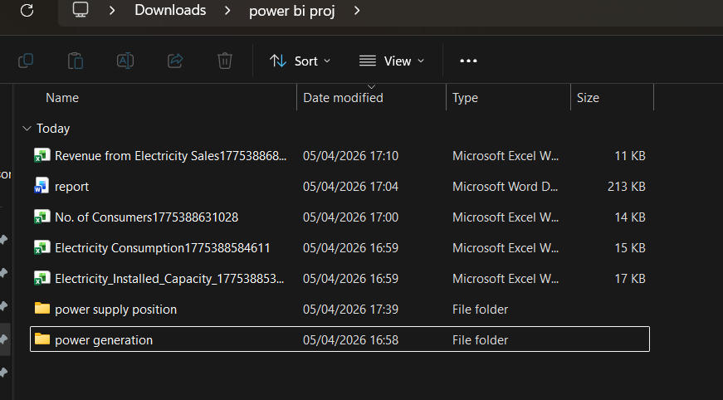
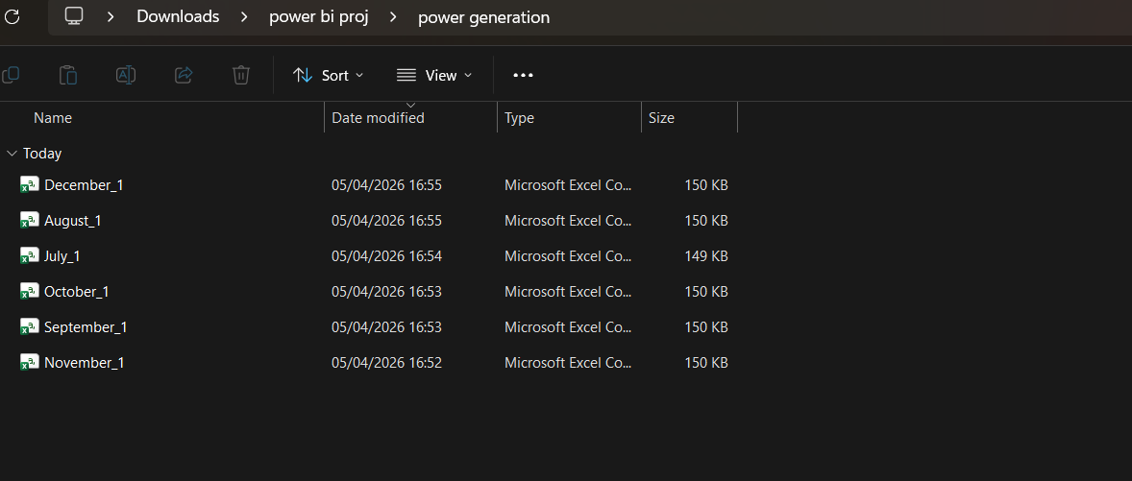
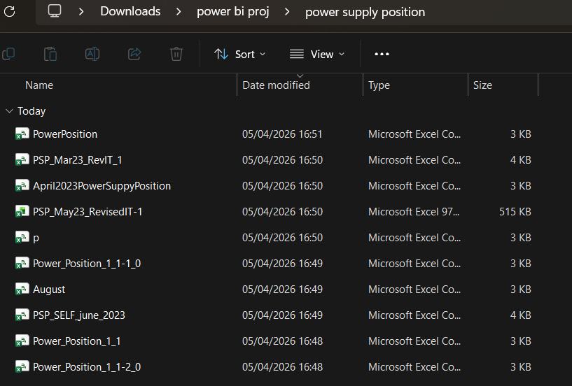

Power Bi:
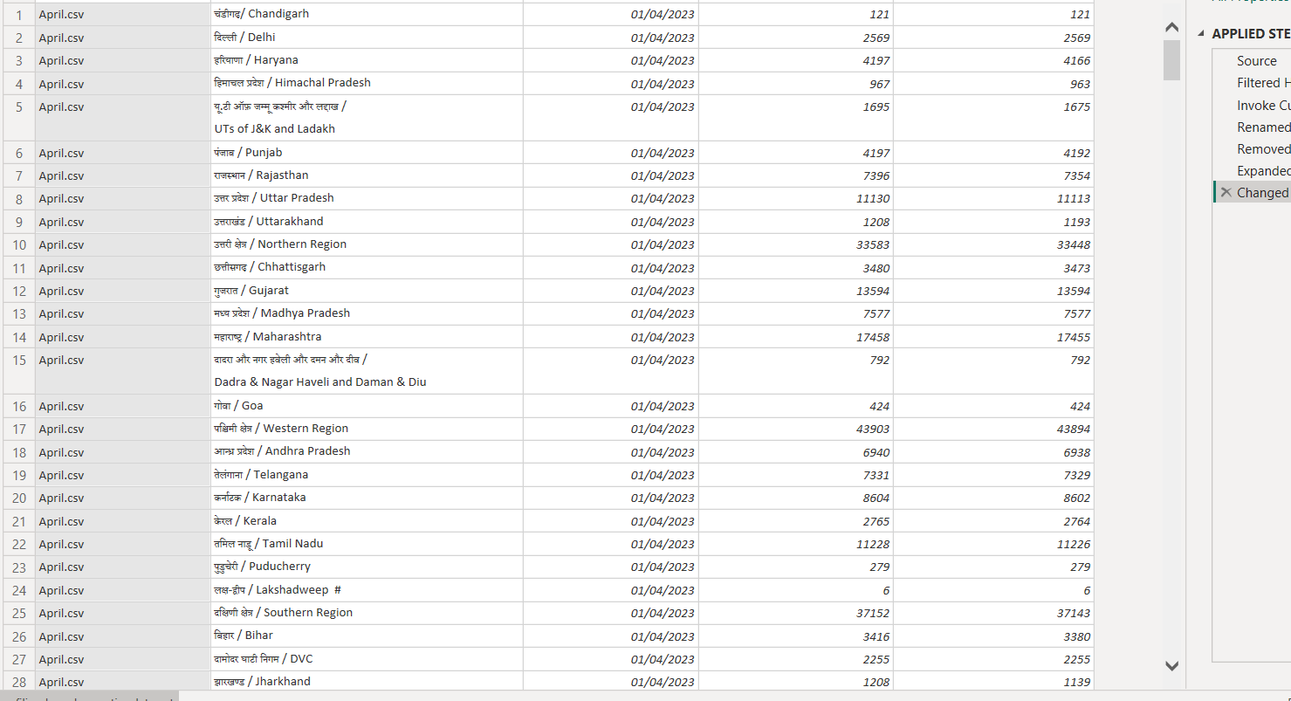
First import of power supply position folder. Combined and transformed data to import all files in the folder.
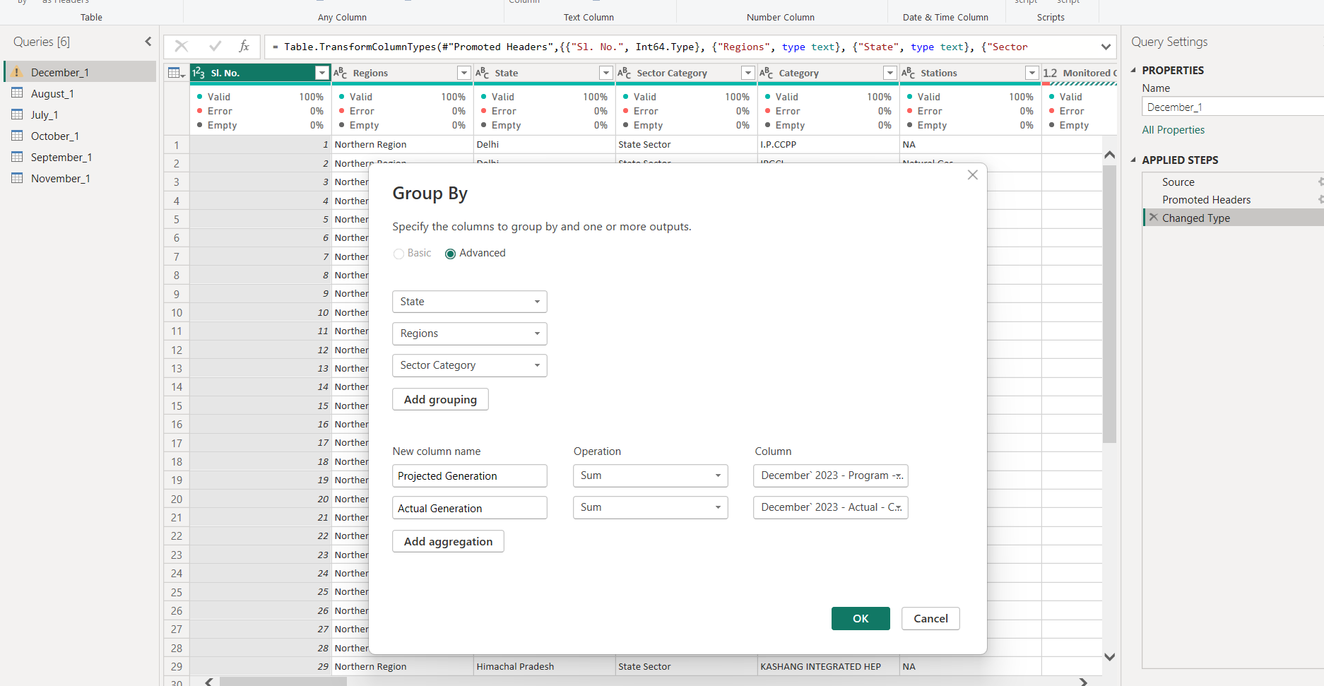

Extracting useful data from the dataset
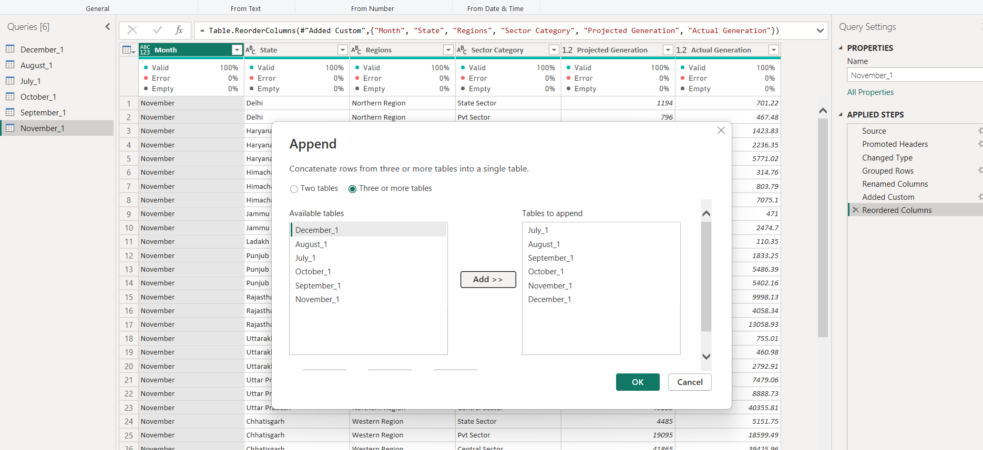

Appending data from tables into one power generation table
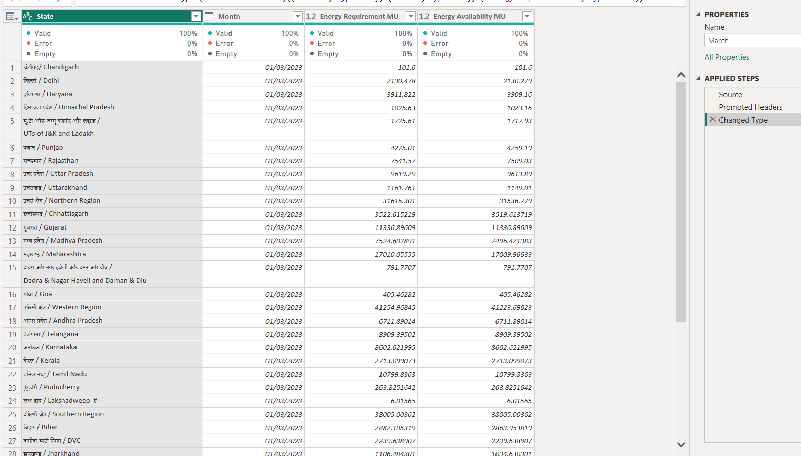

Initial data for power supply
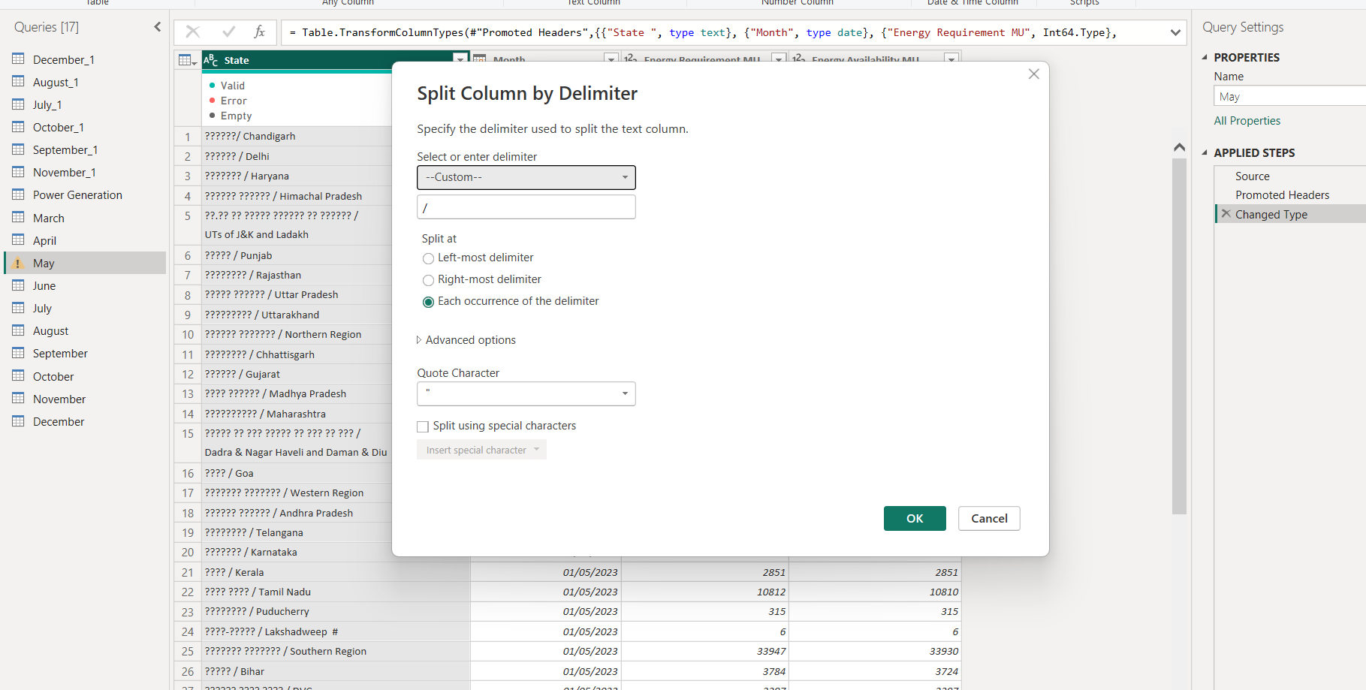

Cleaning
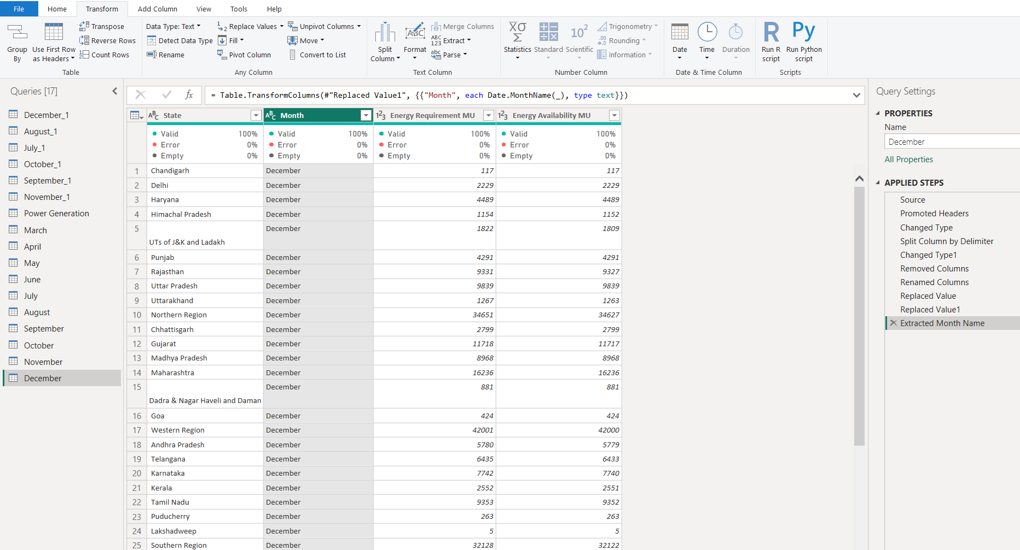

After cleaning
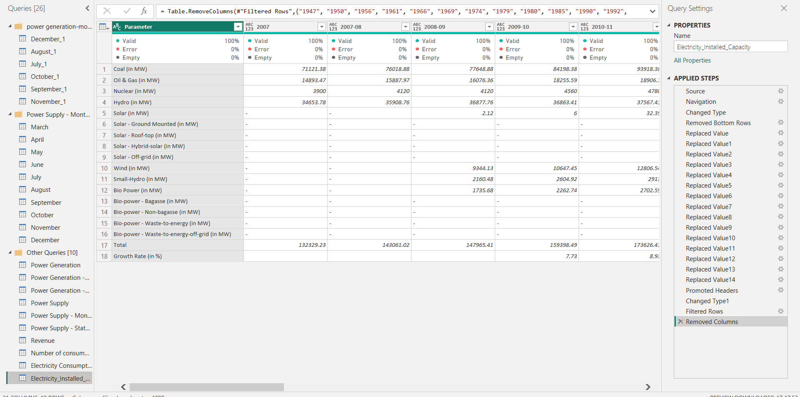
All queries being used for the project

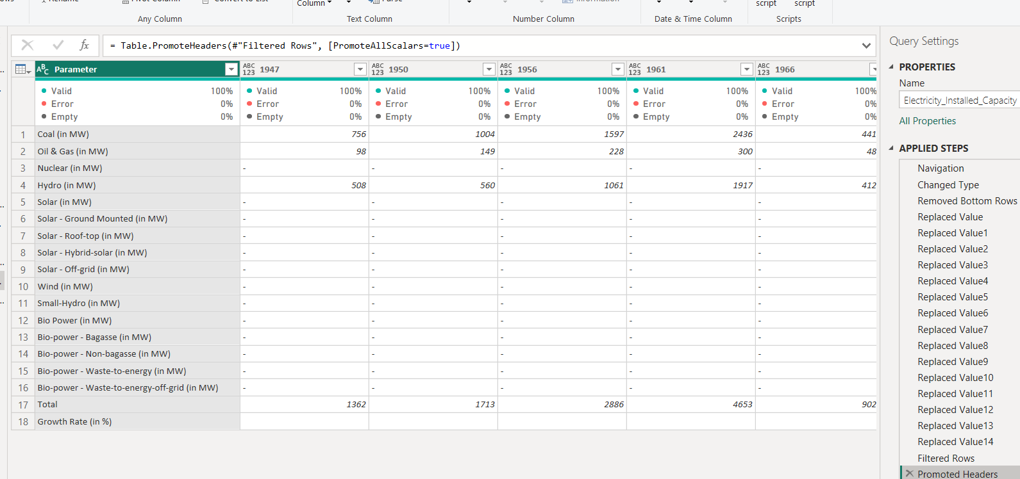
Wide data format
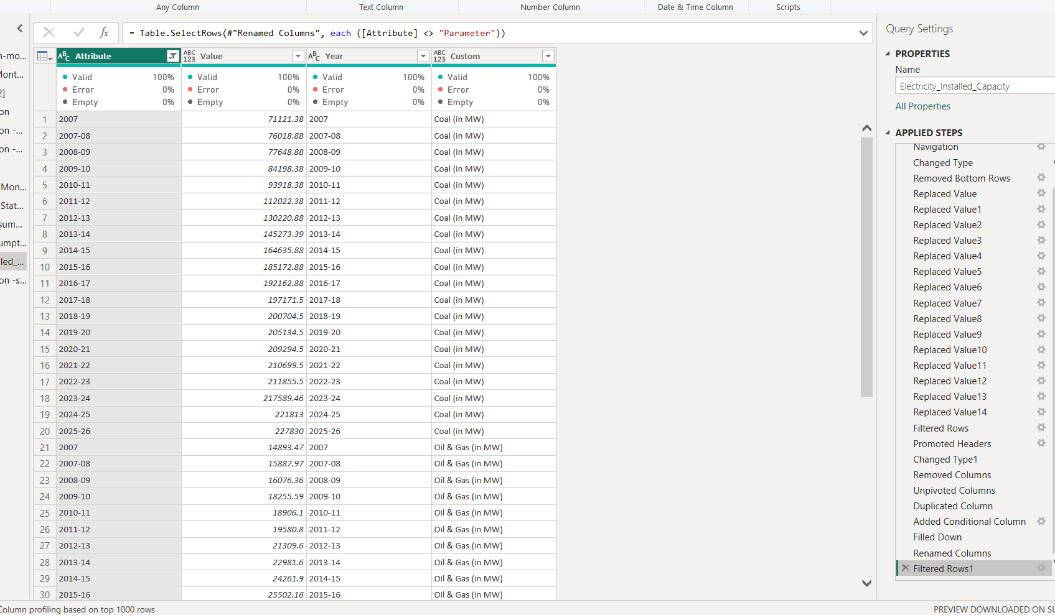
After normalizing

Data Modelling
A star schema approach was used:
- Fact tables:
  - Electricity Consumption
  - Installed Capacity
  - Revenue
- Dimension tables:
  - Category
  - Year
  - State

DAX Measures
🔹 Total Installed Capacity
Total Installed Capacity =
SUM(Electricity_Installed_Capacity[Value])
🔹 Previous Year Capacity
Previous Year MU =
CALCULATE(
[Total Installed Capacity],
FILTER(
ALL(Electricity_Installed_Capacity[YearNum]),
Electricity_Installed_Capacity[YearNum] =
MAX(Electricity_Installed_Capacity[YearNum]) - 1
)
)
Growth %
Growth % =
VAR Prev = [Previous Year MU]
RETURN
IF(
Prev <= 0 || ISBLANK(Prev),
BLANK(),
DIVIDE([Total Installed Capacity] - Prev, Prev)
)
Consumers (in Millions)
Consumers (Mn) =
SUM('Number of consumers'[No. of Consumers]) / 1000000

Dashboard Design
The dashboard is divided into 4 pages, each representing a different analytical perspective:
Page 1: Electricity Generation & Revenue Overview
Features:
- Category slicer (Agriculture, Commercial, etc.)
- Chart type selector (Line, Bar, Area)
- Revenue trends over years
- Monthly actual vs projected generation
- Requirement vs availability analysis
Key KPIs:
- Total Generation
- Total Revenue
- Average Performance
- Energy Gap
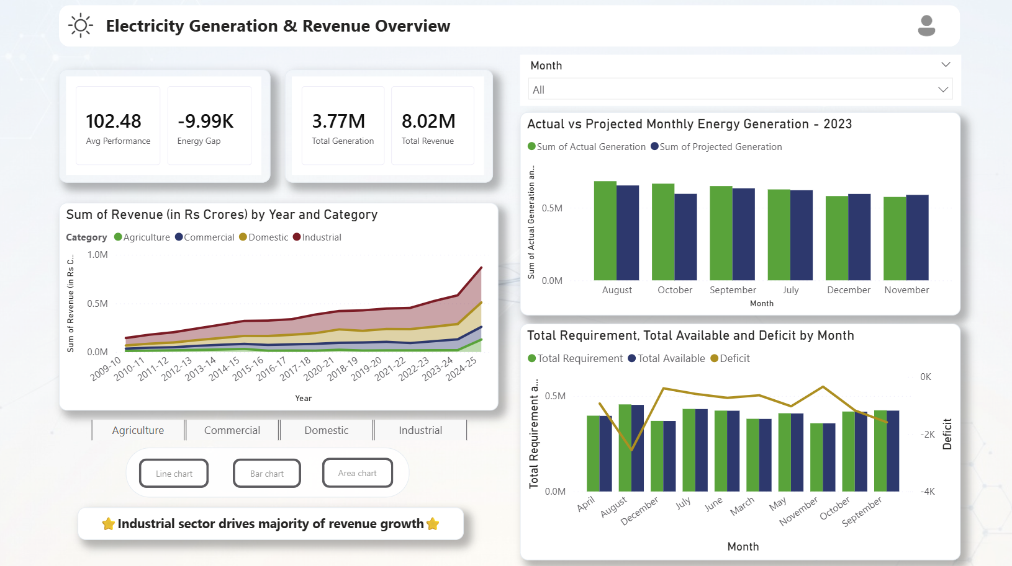
Page 2: State-wise Electricity Generation Analysis
Features:
- State ranking table
- Sector-wise generation pie chart
- Map visualization
- Key insights panel
Highlights:
- Identification of top-performing states
- Regional disparities in generation
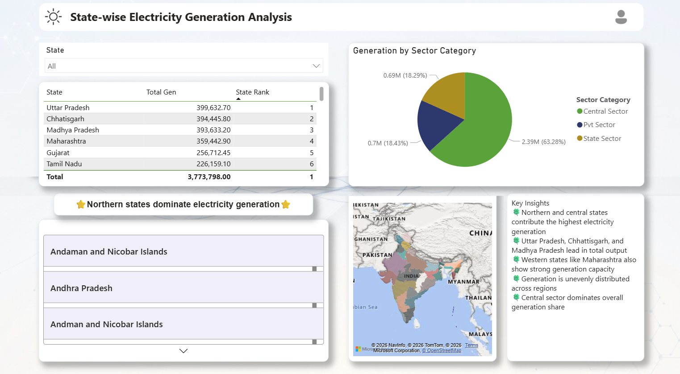
Page 3: Electricity Consumption & Consumer Distribution
Features:
- Consumer distribution by category
- Consumption trends over years
- Revenue comparison across categories
Insights:
- Domestic sector dominates in number of consumers
- Industrial sector contributes most to revenue
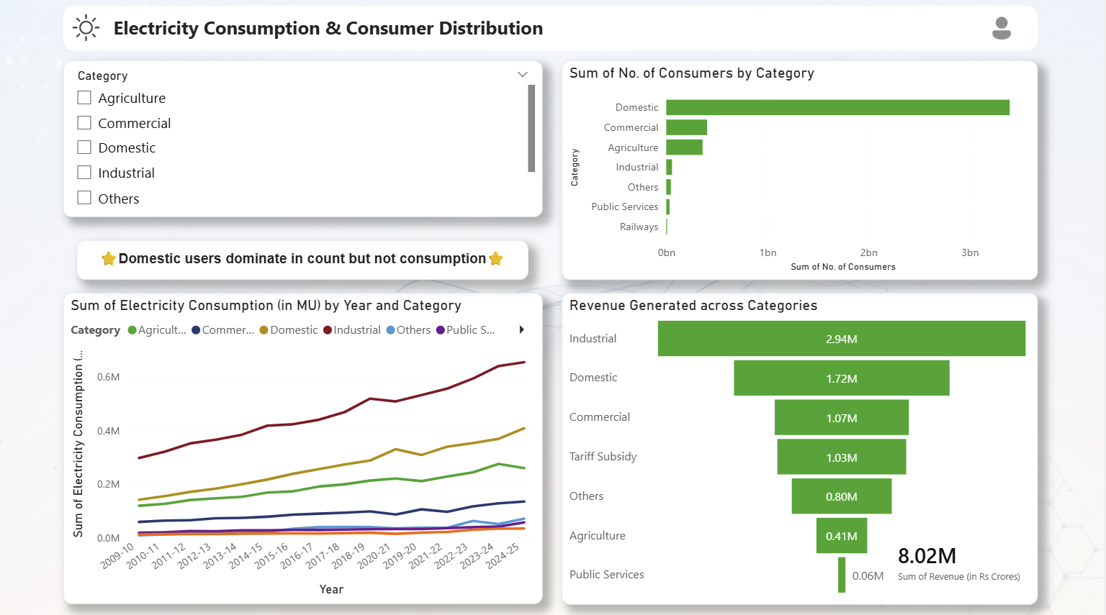
Page 4: Energy Mix & Capacity Growth Trends
Features:
- Installed capacity trends
- Category-wise capacity comparison
- Growth KPI
- Renewable vs fossil fuel trends
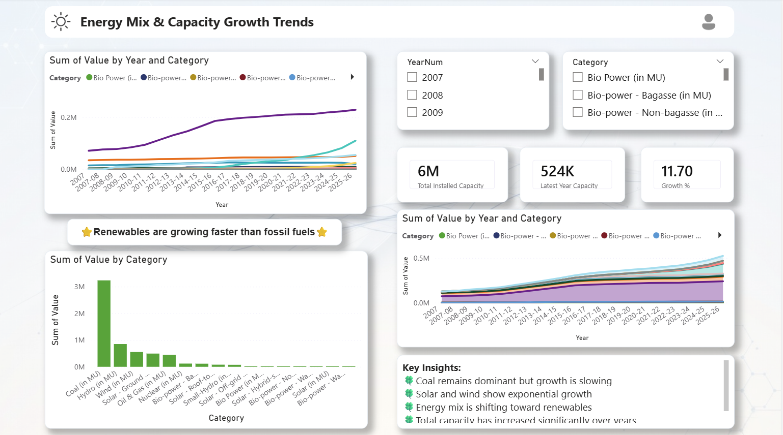

Key Findings & Insights
- Revenue: Industrial category is the primary growth driver; clear category-wise trends visible across years.
- Generation: Actual generation closely tracks (or slightly lags) projections; monthly deficits are quantifiable.
- State Performance: Northern/central states lead; Uttar Pradesh, Chhattisgarh, Madhya Pradesh tops the list.
- Sector Share: Central sector dominates overall generation.
- Consumption: Domestic consumers are numerous but commercial/industrial drive higher MU consumption.
- Energy Transition: Renewables (especially solar/wind) are growing fastest; coal share is stable but not expanding rapidly.
- Capacity: Total installed capacity has grown significantly; latest-year growth % and absolute values are highlighted.

Challenges Faced
- Handling inconsistent year formats
- Removing text values causing aggregation errors
- Designing correct DAX for Year-over-Year growth
- Managing relationships between multiple datasets
- Ensuring slicers affect all visuals correctly

Conclusion
This final project demonstrates advanced Power BI skills: data modelling, DAX measures, interactive design, bookmark navigation, and storytelling through visuals.
Future Enhancements (suggested):
- Add live data connector (SQL/API).
- Include forecasting visuals.
- Mobile layout optimization.
- Power Automate alerts for deficit thresholds.
The .pbix file is production-ready, visually appealing, and insight-rich. It serves as an excellent capstone project for Power BI / Data Analytics

Google Drive link:
https://drive.google.com/drive/folders/1-AFZkFWWVWJzhRoPnlyVtOv0oU4UDqrW?usp=drive_link

Linkedin post:
https://www.linkedin.com/posts/aprameyya-garg-0b0139257_dashboard-powerbi-datascience-activity-7446969633049567232-_vCI?utm_source=social_share_send&utm_medium=member_desktop_web&rcm=ACoAAD8zrEQBA-xkd1Jmx0JXQVgnJ7e5JoEEovg

