DATA SCIENCE TOOLBOX: PYTHON PROGRAMMING
Project Report
(Project Semester January-May 2026)

Data-Driven Analysis of Electricity Generation, Consumption and Energy Mix using Python

Submitted by

Aprameyya Garg
Registration No. – 12406209

Programme – P132: B.tech.
Section – 4M029
Course Code – INT 375

Under the Guidance of
Ms. Savleen Kaur

Discipline of CSE/IT
Lovely School of Computer Science and Technology
Lovely Professional University, Phagwara

CERTIFICATE

This is to certify that Aprameyya Garg bearing Registration no. 12406209 has completed
INT 375 project titled, “Data-Driven Analysis of Electricity Generation, Consumption and Energy Mix using Python” under my guidance and supervision. To the best of my knowledge, the present work is the result of his/her original development, effort and study.

Signature and Name of the Supervisor
Designation of the Supervisor
School of …………………………………………….
Lovely Professional University
Phagwara, Punjab.

Date:

DECLARATION

I, Aprameyya Garg, student of Data Analysis and Visualization under CSE/IT Discipline at, Lovely Professional University, Punjab, hereby declare that all the information furnished in this project report is based on my own intensive work and is genuine.

Date: 23rd April, 2026 Signature
Registration No. 12406209 Aprameyya Garg

ACKNOWLEDGEMENT

I would like to express my sincere gratitude to my project guide for their continuous support, valuable guidance, and encouragement throughout the development of this project. Their insights and suggestions helped me understand the concepts clearly and improve the quality of my work.
I am also thankful to the faculty members of the Lovely School of Computer Science and Engineering, Lovely Professional University, for providing the necessary resources and academic environment to carry out this project successfully.
I would like to extend my appreciation to my peers and friends for their support and helpful discussions during the course of this project.
Lastly, I express my gratitude to my family for their constant encouragement and motivation, which played an important role in the completion of this work.

TABLE OF CONTENTS
- Introduction
- Objectives
- Dataset Source
- Key Insights
- Tools and Technologies Used
- ETL Process
- Analysis
- Results
- Conclusion
- References
- Bibliography

INTRODUCTION
Electricity is one of the most critical components of modern infrastructure and plays a vital role in economic growth, industrial development, and daily life. With the rapid increase in population, urbanization, and industrial activities, the demand for electricity has been continuously rising. Efficient management and analysis of electricity consumption, generation capacity, and supply are therefore essential for sustainable development.
In recent years, data-driven approaches have become increasingly important in understanding patterns and trends in large-scale datasets. Data science techniques enable the extraction of meaningful insights from complex datasets, helping decision-makers optimize resource allocation, improve efficiency, and plan future infrastructure.
This project focuses on the analysis of electricity-related data using Python-based tools. The study includes multiple aspects such as electricity consumption across different sectors, installed capacity of various energy sources, and the comparison between energy requirement and availability. The integration of these datasets provides a comprehensive view of both the demand and supply sides of the electricity ecosystem.
An interactive dashboard has been developed using Python libraries such as Pandas, hvPlot, and Panel. The dashboard allows users to explore the data dynamically through filters and visualizations, making it easier to identify trends, patterns, and gaps. This approach enhances the understanding of electricity usage and infrastructure development over time.
Overall, this project demonstrates how data science techniques can be applied to real-world problems to derive actionable insights and support informed decision-making in the energy sector.

OBJECTIVES
The primary objective of this project is to analyse electricity-related data and develop an interactive dashboard that provides meaningful insights into consumption patterns, infrastructure capacity, and supply-demand dynamics.
The specific objectives of the project are as follows:
- To analyse electricity consumption across different sectors such as agriculture, commercial, domestic, industrial, and others.
- To study the trend of electricity usage over time and identify growth patterns in various categories.
- To evaluate the installed capacity of different energy sources, including renewable and non-renewable sources.
- To compare energy requirement and energy availability in order to identify demand-supply gaps.
- To perform exploratory data analysis (EDA) for better understanding of the dataset.
- To clean and transform raw data using data preprocessing techniques.
- To design and develop an interactive dashboard using Python libraries such as Pandas, hvPlot, and Panel.
- To enable dynamic filtering and visualization for better user interaction and data interpretation.
The scope of this project is limited to the analysis of the provided datasets and does not include predictive modelling or forecasting. The focus is on descriptive analytics and visualization to support data-driven insights.

DATASET SOURCE
The dataset used in this project consists of multiple files related to electricity consumption, installed capacity, number of consumers, revenue from electricity, and power supply position. The data was obtained from publicly available government and statistical sources related to the power and energy sector.
The dataset includes the following components:
- Electricity Consumption data across different sectors such as agriculture, commercial, domestic, industrial, and others.
- Installed Capacity data representing the contribution of various energy sources such as coal, hydro, solar, wind, and nuclear power.
- Number of Consumers data indicating the growth in electricity users over time.
- Revenue from Electricity Sales data representing financial aspects of electricity distribution.
- Power Supply Position data containing monthly records of energy requirement and energy availability.
The data was initially available in different formats, including Excel and CSV files, and was collected from multiple sources. These datasets were later integrated and processed to create a unified structure suitable for analysis.
Sources:
https://www.data.gov.in/catalog/monthly-peak-demand-power?page=1
https://www.data.gov.in/catalog/power-supply-position?page=1
https://www.data.gov.in/catalog/power-generation?title=2023&sortby=_score
https://iced.niti.gov.in/energy/electricity/generation/capacity
https://iced.niti.gov.in/energy/electricity/distribution/pages/consumer-profile#no-of-consumers

PROBLEM STATEMENT
India’s power sector faces challenges in balancing electricity demand and supply across states and time periods. Variations in peak demand, generation capacity, and supply availability can lead to shortages or inefficiencies. However, government datasets are fragmented, incomplete, and inconsistent, making it difficult to derive clear insights.
This project aims to clean, integrate, and analyse electricity-related datasets from official government sources to identify demand-supply gaps, understand generation patterns, and uncover trends in power consumption across India.

KEY INSIGHTS
The analysis of the electricity dataset led to several important insights regarding consumption patterns, infrastructure development, and supply efficiency:
- Industrial Sector Dominance
The industrial sector consistently accounts for the highest share of electricity consumption, indicating its major role in driving overall demand.
- Steady Growth in Domestic Consumption
The domestic sector shows a continuous upward trend, reflecting increasing urbanization and improved access to electricity.
- Expansion in Consumer Base
The number of electricity consumers has increased significantly over the years, highlighting the expansion of electricity infrastructure and rural electrification.
- Dependence on Non-Renewable Sources
Installed capacity is largely dominated by coal-based energy sources, indicating continued reliance on non-renewable energy.
- Growth of Renewable Energy
Renewable sources such as solar and wind are steadily increasing, showing a gradual shift towards sustainable energy solutions.
- Balanced Demand-Supply System
Energy availability closely matches energy requirement, indicating efficient power distribution and management.
- Seasonal Variations in Demand
Monthly analysis shows fluctuations in electricity demand, likely due to seasonal factors such as increased cooling requirements during summer.
- Minimal Demand-Supply Gap
The gap between requirement and availability remains relatively small, suggesting that the system is capable of meeting demand effectively.
These insights demonstrate how data analysis can help understand trends and support decision-making in the power sector.

TOOLS AND TECHNOLOGIES USED
The following tools and technologies were used in this project:
Programming Language
- Python: Used for data analysis, preprocessing, and dashboard development.
Libraries and Frameworks
- Pandas: Used for data manipulation, cleaning, and transformation.
- NumPy: Used for numerical computations and handling large datasets.
- hvPlot: Used for creating interactive visualizations.
- Panel: Used for building the interactive dashboard.
- Bokeh: Used as the backend for rendering visualizations.
Development Environment
- Jupyter Notebook: Used for writing, testing, and executing code interactively.
Data Processing Techniques
- Data cleaning and preprocessing
- Data transformation and reshaping
- Aggregation and grouping
- Feature engineering
Visualization Techniques
- Bar charts for category comparison
- Line charts for trend analysis
- KPI indicators for summary metrics
These tools and technologies enabled efficient data processing, visualization, and development of an interactive analytical dashboard.

ETL PROCESS
The ETL (Extract, Transform, Load) process forms the backbone of this project, ensuring that raw and heterogeneous datasets are converted into a structured and analysis-ready format. Since the data was obtained from multiple sources and formats, a systematic ETL pipeline was implemented using Python.

4.1 Extract
In the extraction phase, data was collected from multiple files in different formats, including Excel (.xlsx) and CSV (.csv). The datasets used in this project include:
- Electricity Consumption dataset
- Installed Capacity dataset
- Number of Consumers dataset
- Revenue from Electricity Sales dataset
- Power Supply Position dataset (monthly data)
Python’s Pandas library was used to load these datasets into dataframes using functions such as read_excel() and read_csv().
For datasets containing multiple CSV files (monthly data), file handling techniques were used to read and combine all files into a single dataframe. This ensured a unified structure for further processing.
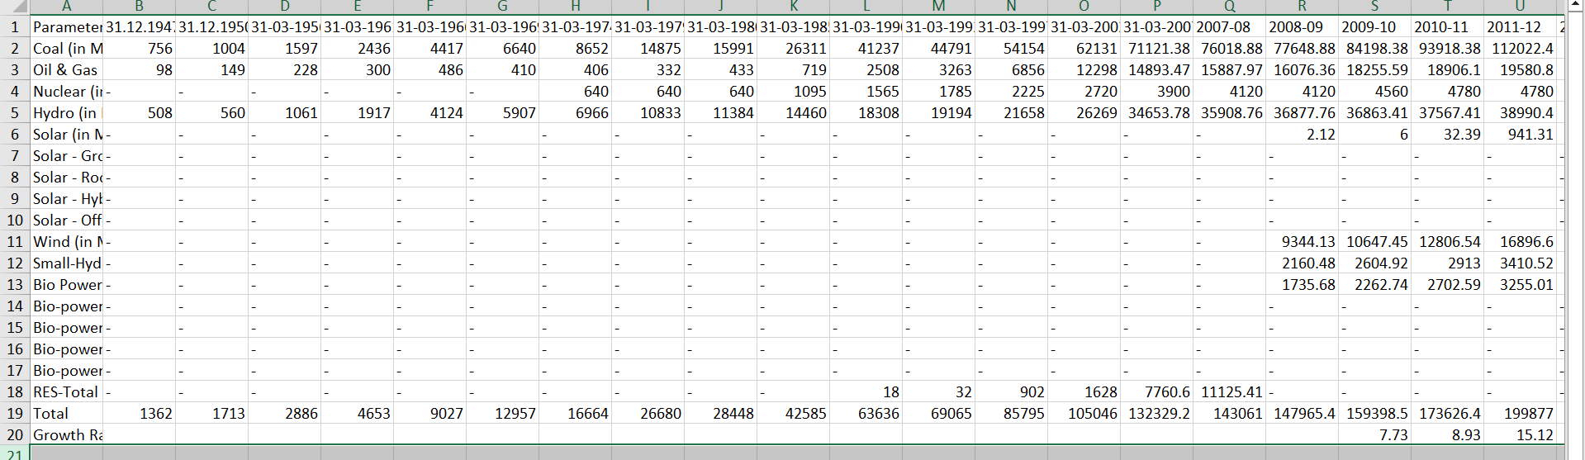

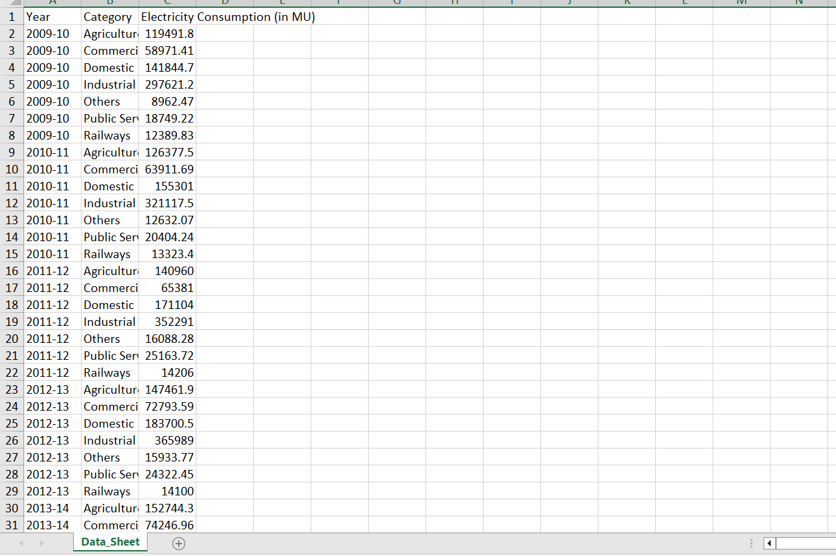

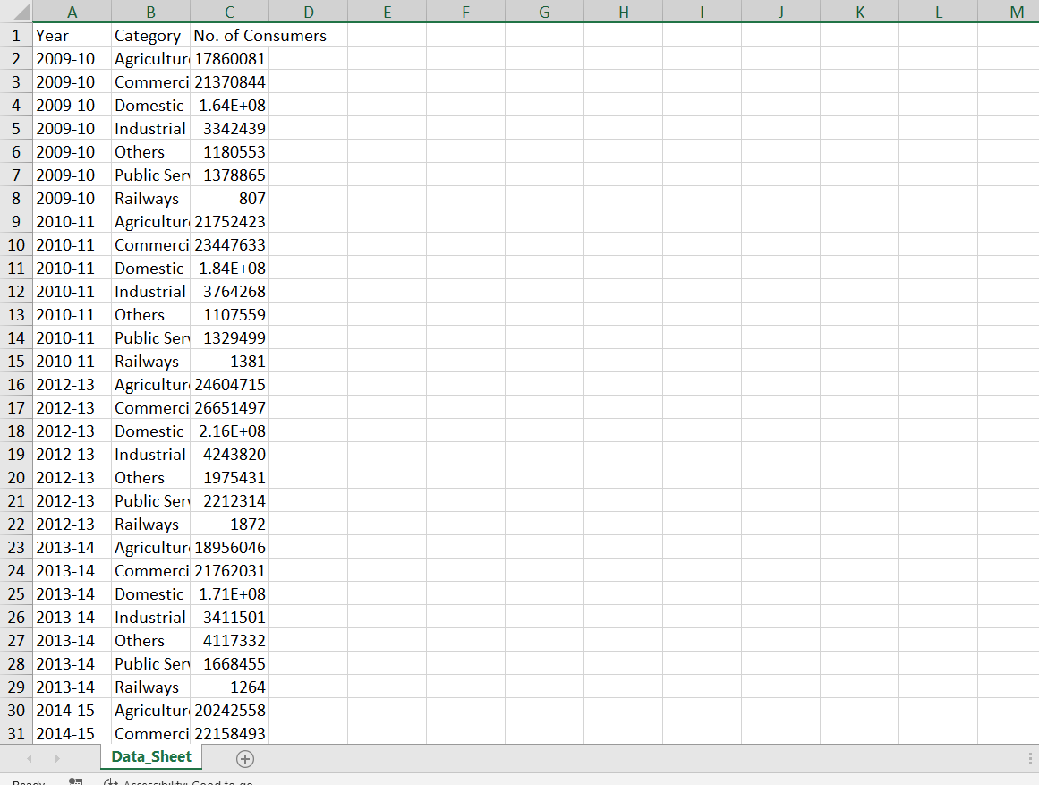

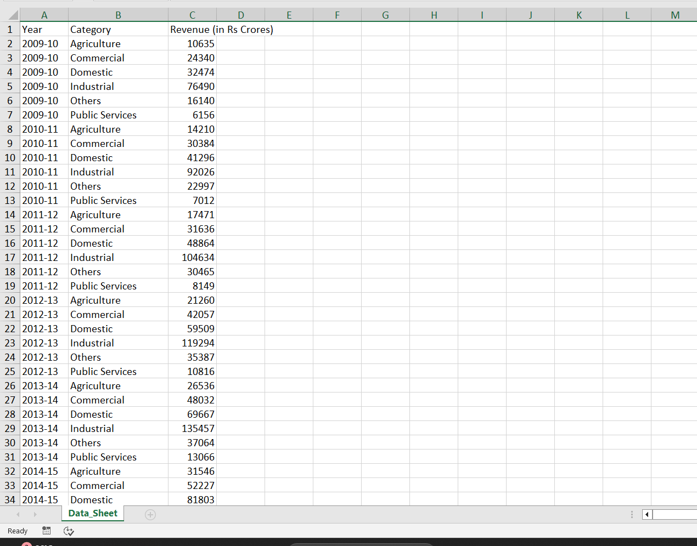

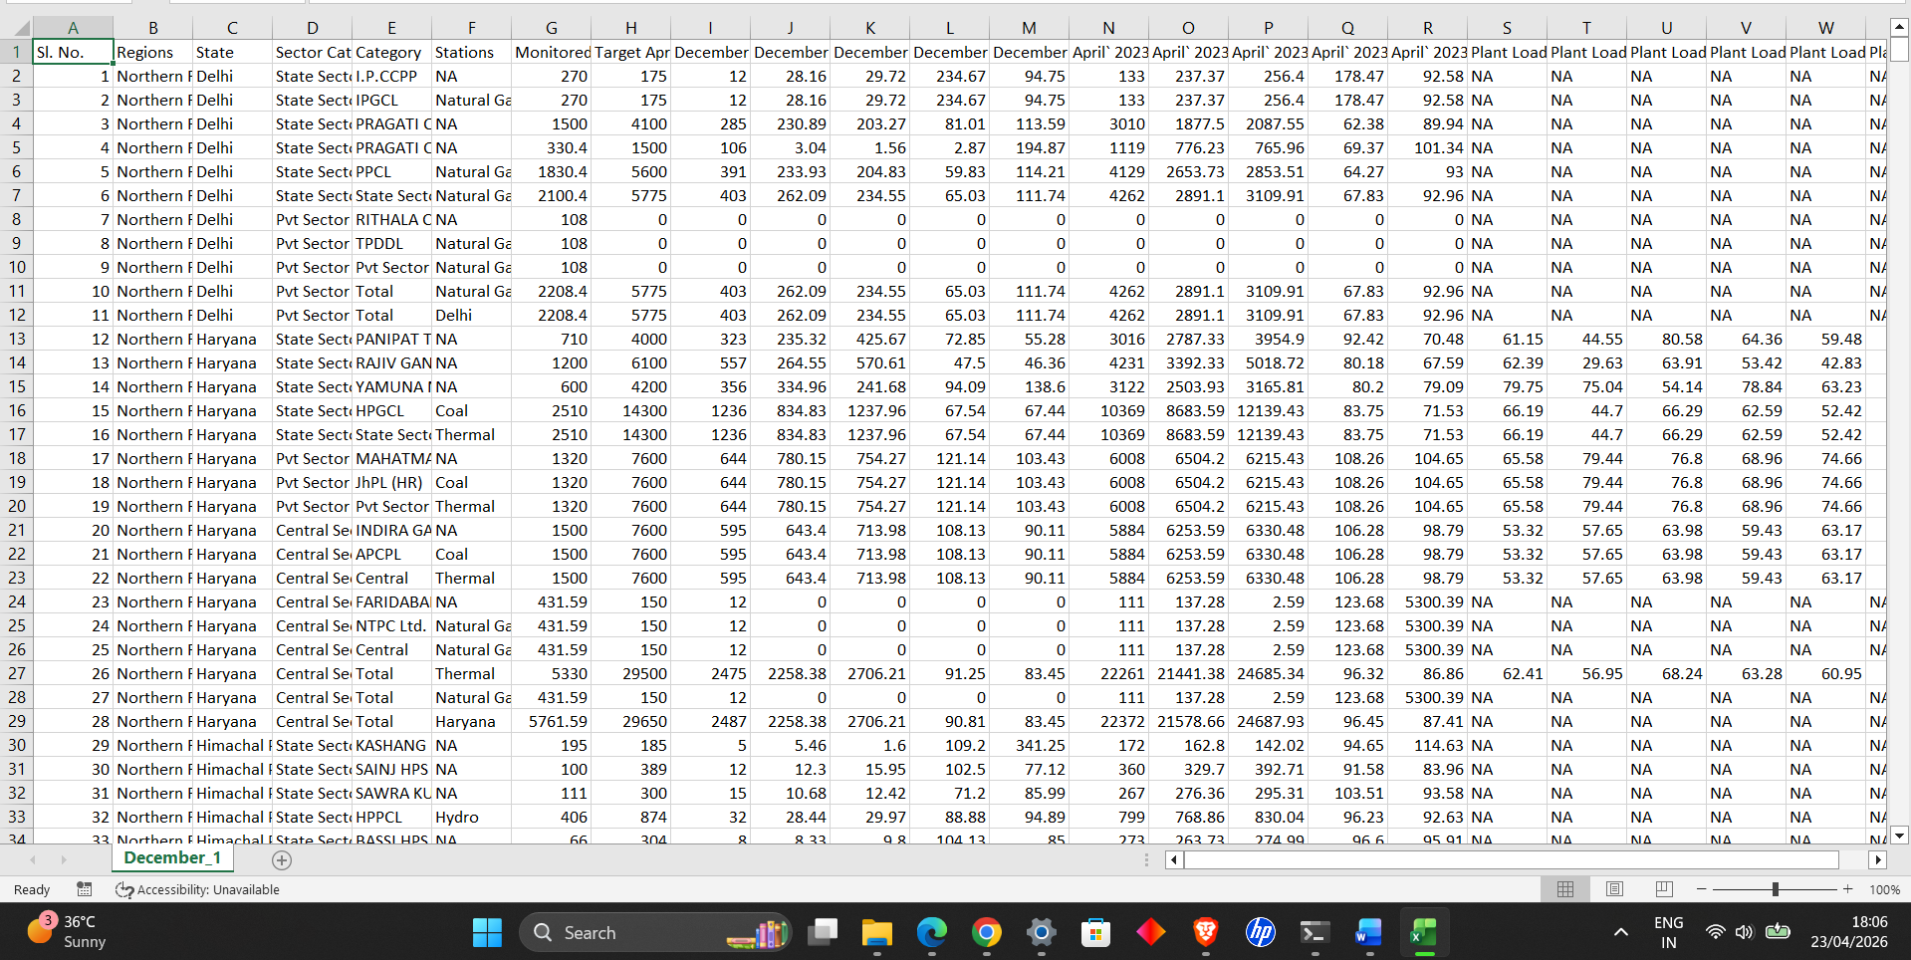

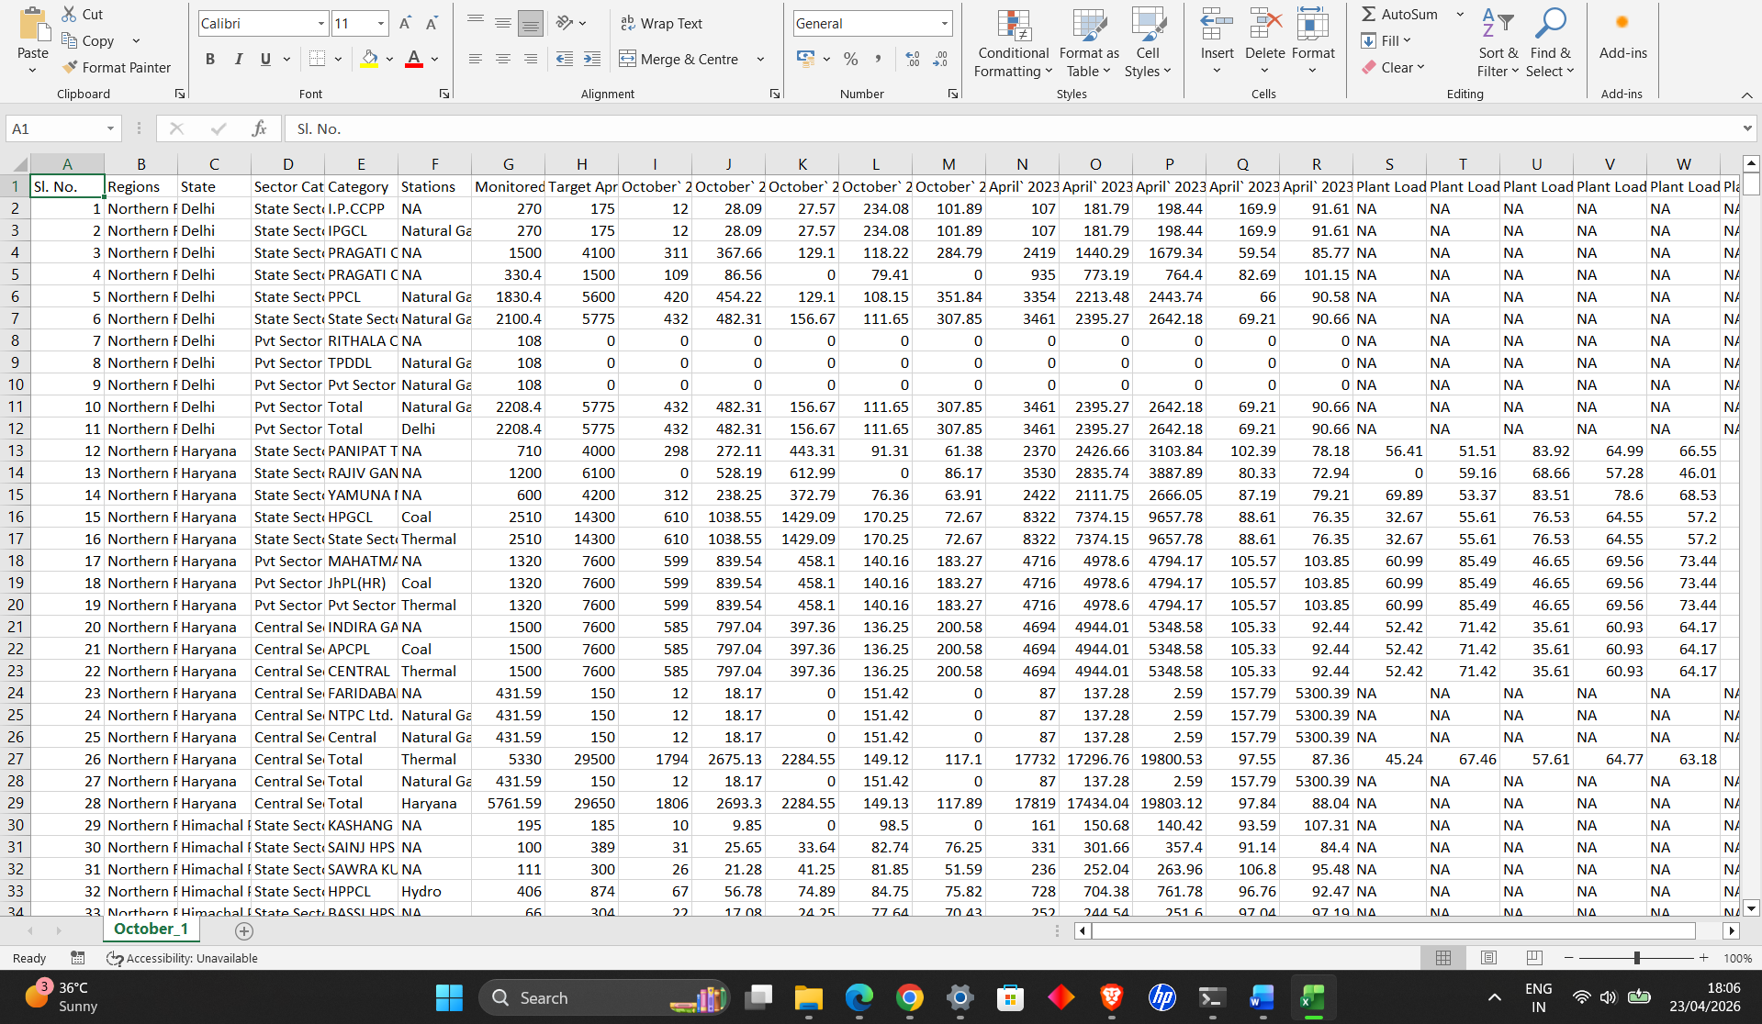

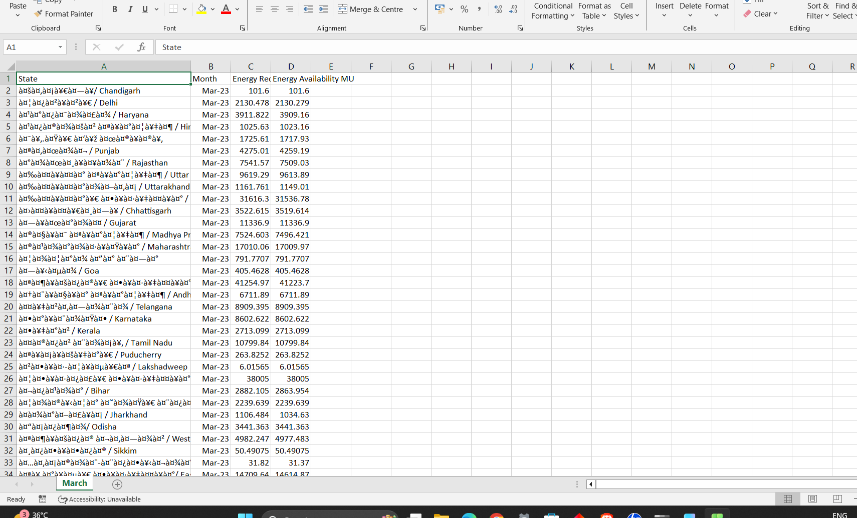

4.2 Transform
The transformation phase involved extensive data cleaning, preprocessing, and restructuring. Since the raw data contained inconsistencies, missing values, and varied formats, several transformation steps were applied:
4.2.1 Data Cleaning
- Column names were standardized using lowercase formatting and removal of extra spaces.
- Unnecessary columns and irrelevant categories such as “Total” and “Growth Rate (%)” were removed.
- Duplicate records were checked and eliminated.
- Missing values were handled using appropriate techniques such as dropping or ignoring incomplete records.

4.2.2 Data Type Conversion
- Year values originally in formats such as “2009-10” were converted into integer format (e.g., 2009).
- Numeric columns stored as strings were converted into appropriate numeric types (int/float).
- Date-related fields (Month column) were converted into datetime format for proper time-series analysis.

4.2.3 Data Reshaping
Some datasets were in wide format, where multiple years were represented as separate columns. These were transformed into long format using the melt() function to create a consistent structure:
- Columns such as Year, Category, and Value were standardized.
- This allowed easier grouping, filtering, and visualization.

4.2.4 Data Integration
Datasets related to demand (consumption, revenue, and number of consumers) were merged using common keys such as Year and Category. This resulted in a unified demand dataset (df_demand).
Other datasets such as installed capacity and supply data were kept separate due to differences in structure and analytical purpose.

4.2.5 Feature Engineering
Additional features were created to enhance analysis:
- Demand-Supply Gap
Gap = Energy Requirement − Energy Availability
- Unit conversions for better readability:
  - Consumption → Million Units (MU)
  - Capacity → Gigawatts (GW)
  - Consumers → Millions
- Sorting of time-series data to ensure chronological order in visualizations.

4.2.6 Data Validation
To ensure data quality, several validation checks were performed:
- Verification of unique categories across years
- Checking for null values using isnull()
- Ensuring consistent number of categories per year
- Cross-verification of aggregated values

4.3 Load
After transformation, the cleaned datasets were stored in structured dataframes:
- df_demand: Contains Year, Category, Consumption, Revenue, and Consumers
- df_supply_clean: Contains Year, Category, and Capacity
- df_supply: Contains Month-wise energy requirement and availability
These datasets were then used for further analysis and visualization.
The processed data was integrated into an interactive dashboard using Python libraries such as Panel and hvPlot, enabling dynamic filtering and real-time data exploration.

4.4 Tools and Technologies Used
- Python (Programming Language)
- Pandas (Data manipulation and transformation)
- NumPy (Numerical operations)
- hvPlot (Visualization)
- Panel (Dashboard development)
- Jupyter Notebook (Development environment)

The ETL process ensured that the data was clean, consistent, and structured, enabling accurate analysis and meaningful insights throughout the project.

ANALYSIS
5.1 Demand Analysis
i. Introduction
Demand analysis focuses on understanding electricity consumption patterns across different sectors over time. It helps in identifying which sectors contribute the most to electricity usage and how consumption trends evolve. This analysis is essential for planning resource allocation and improving energy efficiency.

ii. General Description
The demand dataset consists of the following key attributes:
- Year: Represents the time period of analysis
- Category: Sector of electricity consumption (Agriculture, Commercial, Domestic, Industrial, Others)
- Consumption: Total electricity consumed
- Revenue: Revenue generated from electricity usage
- Consumers: Number of electricity users
The dataset was analyzed over multiple years to observe trends and patterns in electricity consumption across different sectors.

iii. Specific Requirements, Functions and Formulas
The following operations and functions were used:
- Grouping and Aggregation:
  - groupby() was used to aggregate consumption data by year and category
- Filtering:
  - Data was filtered to include only relevant categories
- Sorting:
  - Data was sorted to identify highest contributing sectors
- Correlation Analysis:
  - Relationship between consumption, revenue, and consumers was analyzed
Key formula used:
Consumption Trend = f(Year, Category)
Revenue Relationship = f(Consumption)

iv. Analysis Results
The analysis revealed the following insights:
- The Industrial sector consistently shows the highest electricity consumption among all categories.
- The Domestic sector exhibits a steady increase in consumption over time, indicating growing residential demand.
- The Agriculture sector shows relatively stable consumption with minor fluctuations.
- The Commercial sector demonstrates moderate growth, reflecting urban expansion.
- A strong positive relationship exists between consumption and revenue, indicating that higher electricity usage leads to increased revenue generation.
- The number of consumers has increased over time, suggesting expansion in electricity access and infrastructure.

v. Visualization
The following visualizations were created:
- Bar Chart: Displays electricity consumption by category for a selected year
- Line Chart (Trend Analysis): Shows consumption trends over time for different categories
- KPI Indicators: Highlight total consumption and revenue for a selected year
These visualizations provide a clear and interactive way to understand sector-wise electricity demand and its evolution over time.

5.2 Capacity Analysis
i. Introduction
Capacity analysis focuses on understanding the installed electricity generation capacity from different energy sources. It provides insights into the infrastructure supporting electricity production and helps evaluate the contribution of renewable and non-renewable sources.
This analysis is important for assessing energy sustainability and identifying trends in power generation investments.

ii. General Description
The capacity dataset includes the following attributes:
- Year: Represents the time period
- Category: Type of energy source (Coal, Hydro, Solar, Wind, Nuclear, etc.)
- Capacity: Installed capacity of each energy source
The dataset was analyzed to identify dominant energy sources and observe how capacity has evolved over time.

iii. Specific Requirements, Functions and Formulas
The following techniques were used:
- Data Filtering:
  - Irrelevant categories such as “Total” and “Growth Rate (%)” were removed
- Grouping and Aggregation:
  - groupby() was used to calculate total capacity by category
- Sorting and Ranking:
  - nlargest() was used to identify top contributing energy sources
- Unit Conversion:
  - Capacity values were converted into Gigawatts (GW) for better readability
Formula used:
Capacity Contribution = Total Capacity of Source / Total Installed Capacity

iv. Analysis Results
The capacity analysis revealed the following key insights:
- Coal-based power plants contribute the largest share of installed capacity, indicating reliance on non-renewable energy sources.
- Hydropower and renewable energy sources such as solar and wind are gradually increasing in capacity over time.
- Renewable energy shows a positive growth trend, reflecting a shift towards sustainable energy.
- Some categories contribute relatively small portions, indicating limited adoption or early-stage development.
- The overall installed capacity has increased over the years, showing expansion of power infrastructure.

v. Visualization

The following visualization was created:
- Bar Chart (Top Capacity Sources): Displays the top energy sources based on installed capacity for a selected year
This visualization helps in comparing the contribution of different energy sources and understanding the energy mix in electricity generation.

5.3 Supply Analysis
i. Introduction
Supply analysis focuses on evaluating the relationship between electricity demand (requirement) and electricity supply (availability). It helps in identifying whether the available energy is sufficient to meet the demand and highlights any existing shortages or surpluses.
This analysis is crucial for ensuring energy reliability, efficient distribution, and proper planning of power resources.

ii. General Description
The supply dataset consists of monthly records for a given year and includes the following attributes:
- Month: Represents the time period (monthly data)
- Energy Requirement: Total electricity demand
- Energy Availability: Total electricity supplied
The dataset enables time-series analysis to observe how supply and demand vary across different months.

iii. Specific Requirements, Functions and Formulas
The following techniques were used:
- Datetime Conversion:
  - Month values were converted into datetime format using to_datetime() for proper time-series analysis
- Sorting:
  - Data was sorted chronologically to ensure correct visualization
- Feature Engineering:
  - A new column was created to calculate the demand-supply gap
Formula used:
Demand-Supply Gap = Energy Requirement − Energy Availability
- Unit Conversion:
  - Values were scaled into Million Units for better readability

iv. Analysis Results
The supply analysis revealed the following insights:
- Electricity supply generally follows the trend of demand, indicating effective management of power distribution.
- The gap between requirement and availability is relatively small, suggesting that the system is able to meet demand efficiently in most months.
- Certain months show slight fluctuations in the gap, which may be due to seasonal variations such as increased demand during summer.
- The overall trend indicates improved stability in supply, with minimal shortages.

v. Visualization
The following visualizations were created:
- Line Chart (Requirement vs Availability): Shows monthly comparison between energy demand and supply
- Gap Analysis Chart: Displays the difference between requirement and availability over time
These visualizations help in understanding supply stability and identifying any mismatch between demand and availability.

RESULTS
6. List of Analysis with Results
The following analyses were performed on the dataset, along with their key findings:
- Sector-wise Electricity Consumption Analysis
  - Industrial sector has the highest electricity consumption.
  - Domestic sector shows steady growth over time.
  - Agriculture consumption remains relatively stable.
- Year-wise Consumption Trend Analysis
  - Overall electricity consumption has increased over the years.
  - Growth is consistent across most sectors, indicating rising demand.
- Revenue and Consumers Analysis
  - Revenue is directly proportional to electricity consumption.
  - The number of consumers has increased significantly, reflecting expansion in electricity access.
- Installed Capacity Analysis
  - Coal-based energy contributes the largest share of installed capacity.
  - Renewable energy sources such as solar and wind are growing steadily.
  - Overall capacity has increased over time.
- Energy Requirement vs Availability Analysis
  - Energy availability closely matches energy requirement in most cases.
  - Minor fluctuations exist due to seasonal demand variations.
- Demand-Supply Gap Analysis
  - The gap between demand and supply is minimal, indicating efficient energy distribution.
  - Occasional variations are observed during peak demand periods.
These analyses collectively provide a comprehensive understanding of electricity consumption patterns, infrastructure development, and supply-demand dynamics.

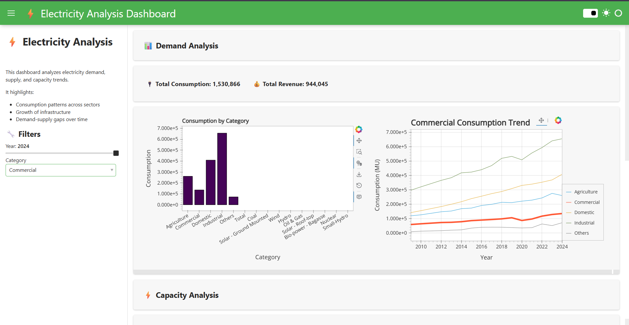
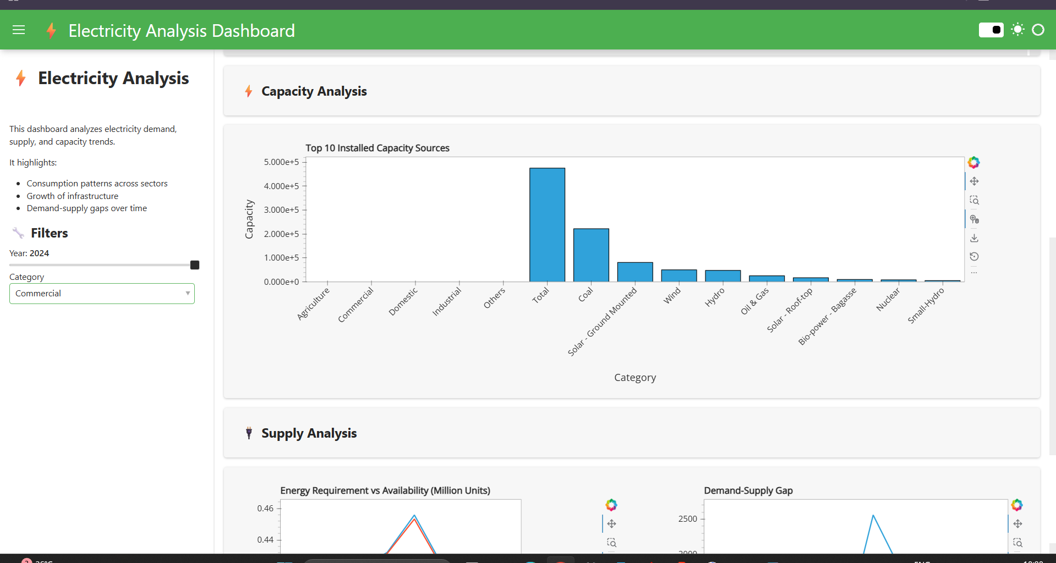

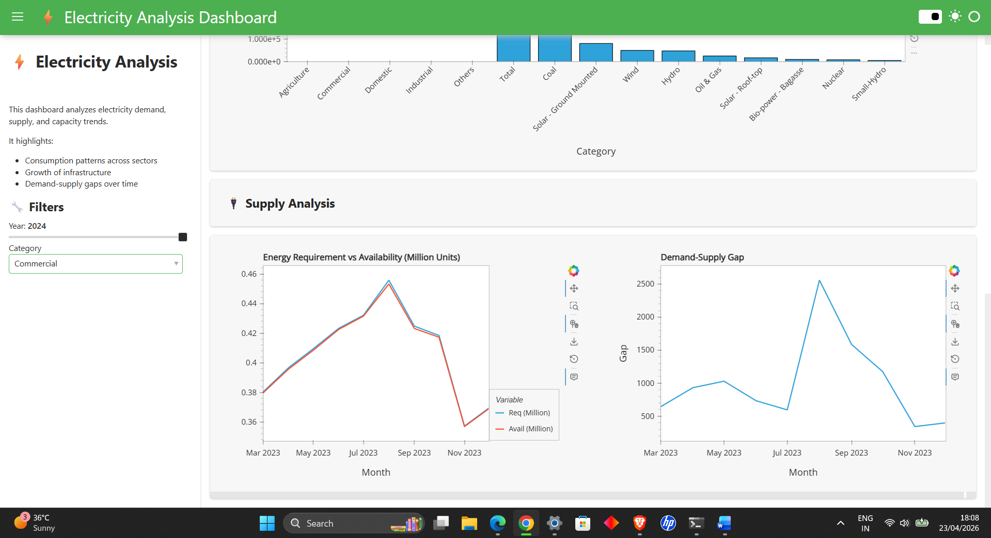

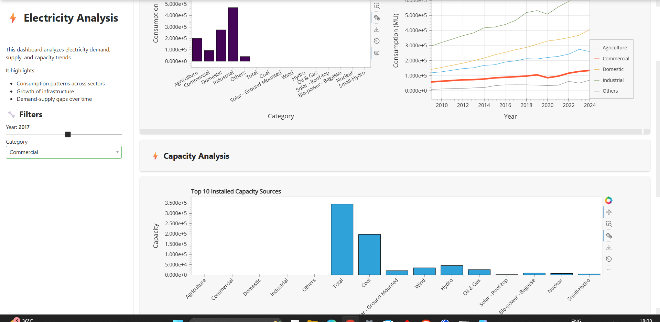

Updated values by slider

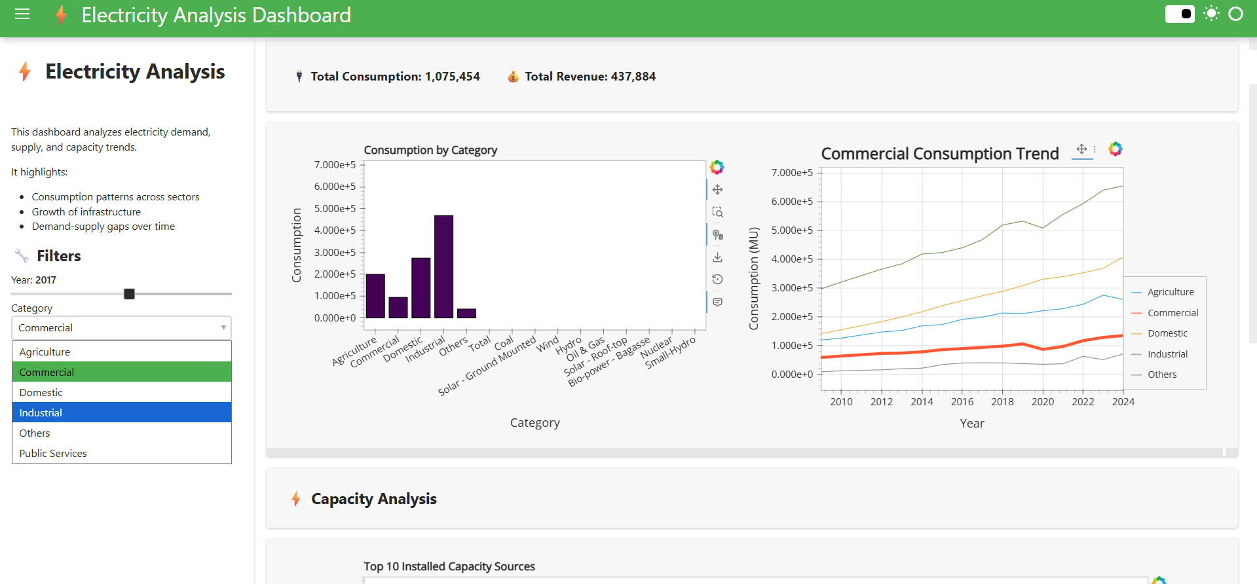

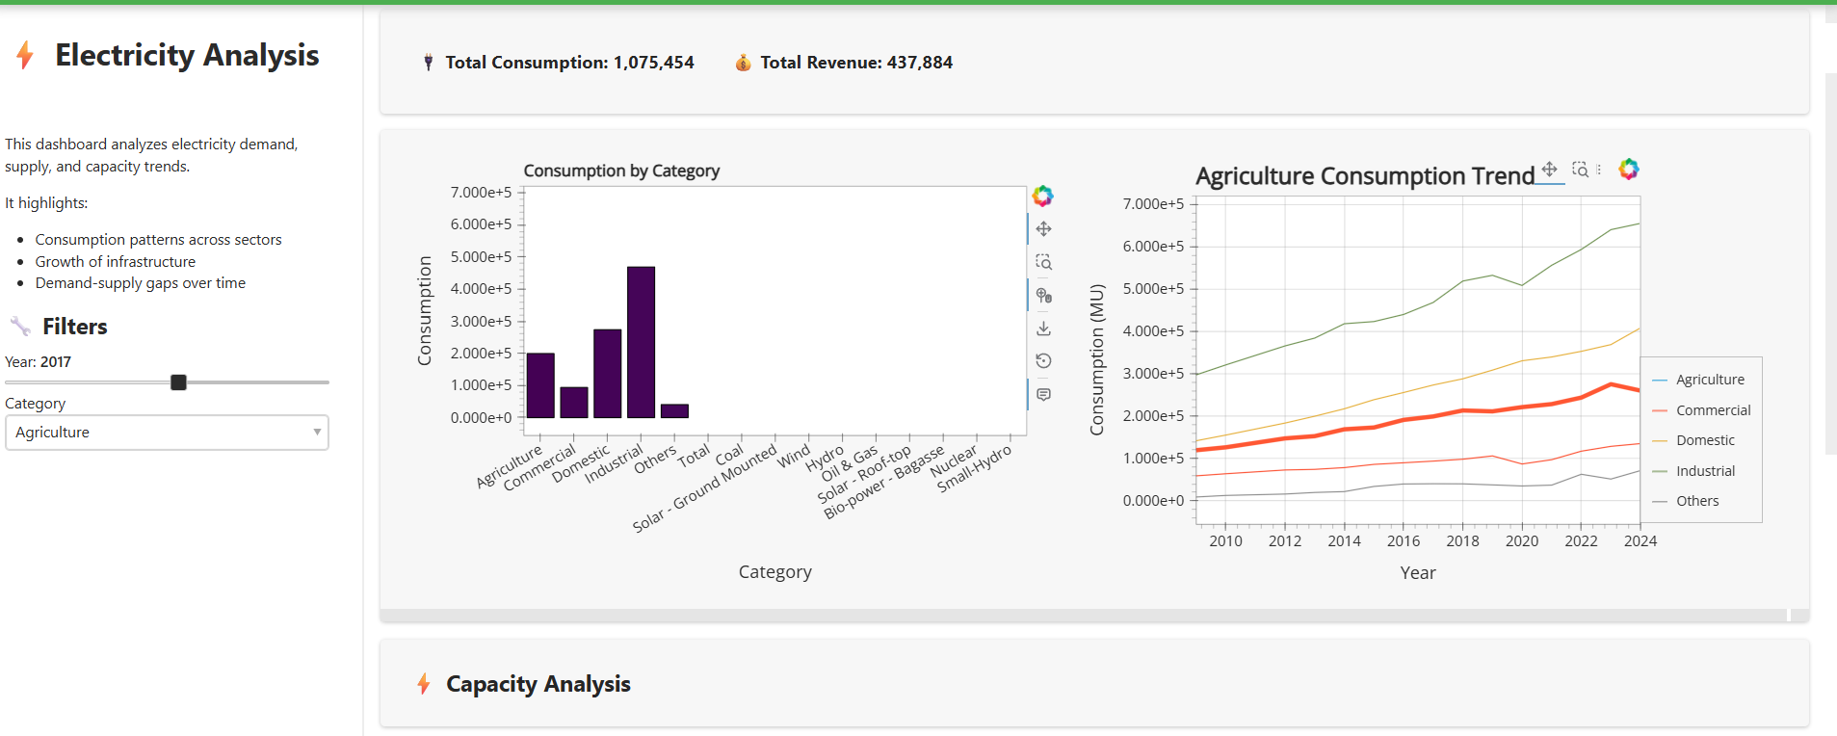

CONCLUSION
This project successfully demonstrated the application of data science techniques to analyze electricity-related datasets and derive meaningful insights. By integrating multiple datasets covering electricity consumption, installed capacity, revenue, and power supply, a comprehensive understanding of both demand and supply aspects of the electricity sector was achieved.
The analysis revealed that electricity consumption has been consistently increasing over the years, with the industrial and domestic sectors contributing significantly to the overall demand. The growth in the number of consumers indicates expansion in electricity access and infrastructure. On the supply side, installed capacity has shown steady growth, with coal remaining the dominant source while renewable energy sources such as solar and wind are gradually gaining importance.
The comparison between energy requirement and availability highlighted that the supply system is generally efficient, with only minor fluctuations observed across different months. The demand-supply gap remains relatively small, indicating effective management of energy resources.
An interactive dashboard was developed using Python libraries such as Pandas, hvPlot, and Panel, allowing dynamic exploration of the data through filters and visualizations. This enhances usability and enables better interpretation of trends and patterns.
Overall, the project highlights the importance of data-driven analysis in understanding complex systems like the power sector. It also demonstrates how visualization and dashboarding can support informed decision-making and provide valuable insights for planning and resource optimization.
Future work can include predictive modeling and forecasting techniques to anticipate future electricity demand and improve energy planning strategies.

REFERENCES
[1] Government of India, “Electricity Statistics and Power Sector Data,” Ministry of Power, [Online]. Available: https://powermin.gov.in
[2] Central Electricity Authority (CEA), “All India Installed Capacity and Generation Reports,” [Online]. Available: https://cea.nic.in
[3] Python Software Foundation, “Python Documentation,” [Online]. Available: https://docs.python.org
[4] Wes McKinney, Python for Data Analysis, 2nd ed., O’Reilly Media, 2017.
[5] J. VanderPlas, Python Data Science Handbook, O’Reilly Media, 2016.
[6] HoloViz, “hvPlot Documentation,” [Online]. Available: https://hvplot.holoviz.org
[7] HoloViz, “Panel Documentation,” [Online]. Available: https://panel.holoviz.org
[8] Pandas Development Team, “Pandas Documentation,” [Online]. Available: https://pandas.pydata.org

BIBLIOGRAPHY
The following resources were referred to during the course of this project for understanding concepts related to data science, data analysis, and visualization:
- McKinney, Wes. Python for Data Analysis. O’Reilly Media.
- VanderPlas, Jake. Python Data Science Handbook. O’Reilly Media.
- Official documentation of Python libraries such as Pandas, NumPy, hvPlot, and Panel.
- Various online tutorials and educational resources related to data cleaning, exploratory data analysis (EDA), and dashboard development.
- Government and institutional reports related to electricity consumption and power sector statistics.
These resources provided conceptual clarity and technical guidance required for successful completion of the project.

Google drive link :
https://drive.google.com/drive/folders/14HSBRTLRWpsfuijzEBk1YuhZraaTlk6_?usp=drive_link

LinkedIn Post Link:
https://www.linkedin.com/posts/aprameyya-garg-0b0139257_python-dashboard-datascience-activity-7453062436837961729-9eMb?utm_source=social_share_send&utm_medium=member_desktop_web&rcm=ACoAAD8zrEQBA-xkd1Jmx0JXQVgnJ7e5JoEEovg

