$ rails routes

Prefix Verb URI Pattern Controller#Action

post_comments GET /posts/:post_id/comments(.:format) comments#index

POST /posts/:post_id/comments(.:format) comments#create

new_post_comment GET /posts/:post_id/comments/new(.:format) comments#new

edit_post_comment GET /posts/:post_id/comments/:id/edit(.:format) comments#edit

post_comment GET /posts/:post_id/comments/:id(.:format) comments#show

PATCH /posts/:post_id/comments/:id(.:format) comments#update

PUT /posts/:post_id/comments/:id(.:format) comments#update

DELETE /posts/:post_id/comments/:id(.:format) comments#destroy

posts GET /posts(.:format) posts#index

POST /posts(.:format) posts#create

new_post GET /posts/new(.:format) posts#new

edit_post GET /posts/:id/edit(.:format) posts#edit

post GET /posts/:id(.:format) posts#show

PATCH /posts/:id(.:format) posts#update

PUT /posts/:id(.:format) posts#update

DELETE /posts/:id(.:format) posts#destroy

root GET / posts#index

Wed Oct 12 17:36:43 /users/MICHAELS_MAC/wdi/homework/week6/scribble (master *)

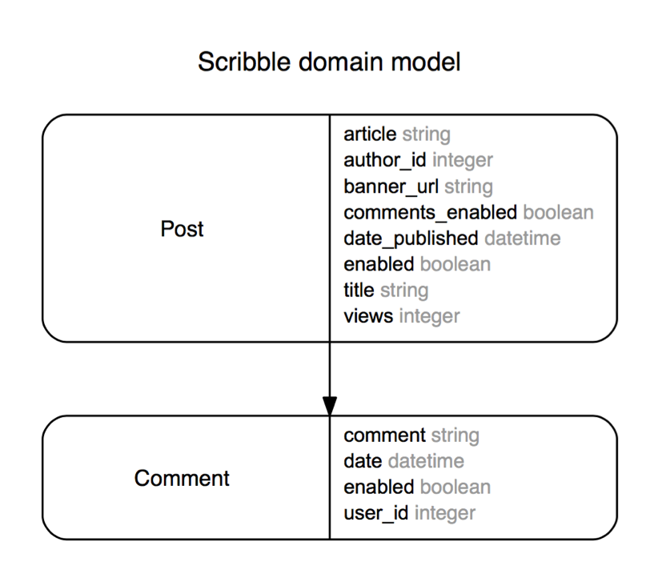

create_table "comments", force: :cascade do |t|

t.string "comment"

t.integer "user_id"

t.boolean "enabled"

t.datetime "date"

t.integer "post_id"

t.index ["post_id"], name: "index_comments_on_post_id", using: :btree

end

create_table "posts", force: :cascade do |t|

t.string "title"

t.string "article"

t.integer "author_id"

t.boolean "comments_enabled"

t.datetime "date_published"

t.string "banner_url"

t.integer "views"

t.boolean "enabled"

end