RESEARCH BRIEF

Northern Arizona Infant Care Gap: 2026 Research Brief
Commissioned by the First Steps Infant & Toddler Fund · September 2026

Key findings
- Northern Arizona has about 16,900 infants and toddlers under age three and about 3,190 licensed infant and toddler care slots: one slot for every 5.3 children.
- Apache County has one licensed slot for every 10.8 infants and toddlers, the steepest shortage in the region.
- Infant care costs an average of $13,900 per year in Coconino County, about 19 percent of the county's median household income.
- Six in ten parents interviewed had turned down a job, cut work hours, or left school because they could not find infant care.
- Early childhood educators in the region earn a median wage of $15.40 per hour, and 38 percent of providers reported an open position they could not fill.

Supply and demand by county
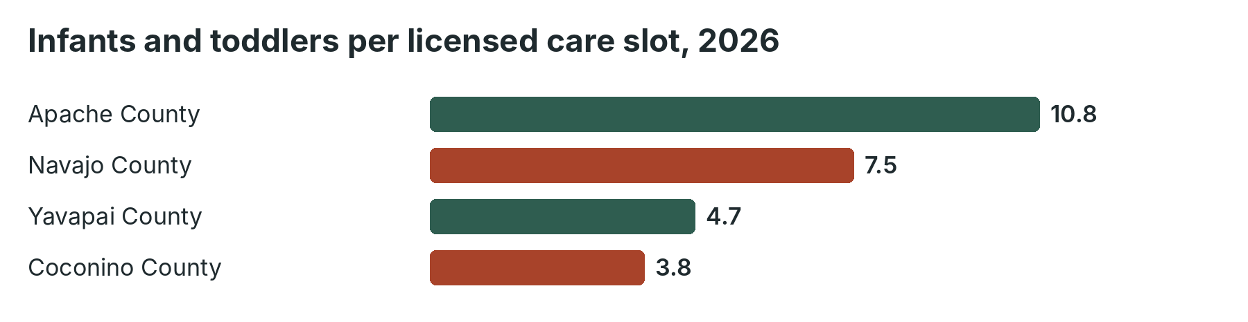
County | Children under 3 (est.) | Licensed infant and toddler slots | Children per slot
Coconino County | 4,300 | 1,120 | 3.8
Yavapai County | 6,100 | 1,310 | 4.7
Navajo County | 3,900 | 520 | 7.5
Apache County | 2,600 | 240 | 10.8
Four-county region | 16,900 | 3,190 | 5.3

Sources: fictional estimates prepared for this demonstration, modeled on public licensing and census data structures.

What parents and providers told us
Researchers interviewed 64 parents, grandparents, and child care providers in 11 communities. Three themes emerged:
- Distance. Families on the Navajo Nation and in rural Yavapai County described driving more than 40 miles each way to the nearest licensed infant program.
- Cost. Even families who found care often could not afford it without a subsidy, and subsidy waiting lists averaged four months.
- Workforce. Providers described losing trained staff to retail and hospitality jobs that pay more and offer predictable hours.

Recommendations
1. Fund licensing support and start-up grants for home-based infant care in Apache and Navajo counties.
2. Invest in wage supplements and credential pathways for infant and toddler educators.
3. Support kin caregivers, who provide most infant care in rural and tribal communities.
4. Coordinate with tribal child care programs to align licensing, training, and funding.
These recommendations shape the First Steps Infant & Toddler Fund 2027 Request for Proposals: https://example.github.io/cinder-peaks-community-foundation/documents/guidelines/cpcf-first-steps-infant-toddler-fund-2027-rfp.pdf

