ANNUAL REPORT

2025 Annual Report
January 1 – December 31, 2025

A letter from our President and Board Chair
Dear friends,
In 2025, the people of northern Arizona showed again what generosity looks like at elevation. When post-fire floods reached homes in the Timberline area, neighbors arrived with shovels before the water had receded. When federal funding for rural child care faltered, 61 new donors joined the First Steps Infant & Toddler Fund. And when our Plateau Indigenous Communities Fund advisory council asked for more resources for language revitalization, donors answered with the largest single year of gifts in the fund's history.
Across all of our funds, the Foundation granted $7.85 million in 2025 to more than 600 nonprofits, schools, and tribal programs. Our assets grew to $168.4 million, and 22 families and businesses opened new charitable funds. Behind every number in this report is a person who chose to invest in this place for the long term.
Thank you for being part of that choice.
Renata Holloway, President & CEO
Gloria Atcitty, Chair, Board of Directors

2025 at a glance
Measure | 2025
Total grants paid | $7,846,000
Organizations receiving grants | 614
Competitive grants awarded | $1,986,000
Donor-advised fund grants | $4,912,000
Designated and agency fund grants | $948,000
New charitable funds established | 22
Total charitable funds | 310
Total assets (December 31, 2025) | $168.4 million

Grantmaking by focus area
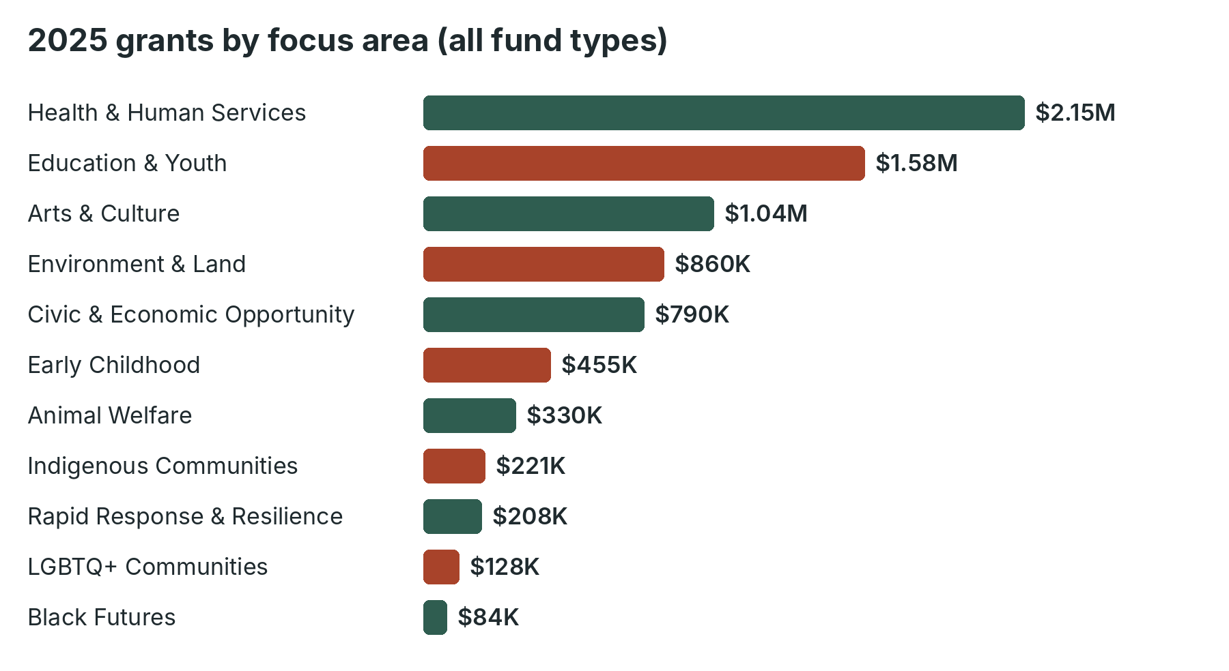
Grants from all fund types, including donor-advised funds, classified by the primary focus area of the recipient organization.

Highlights
- Community Impact Grants: $1.21 million in unrestricted support to 97 organizations across the Spring and Fall cycles.
- First Steps Infant & Toddler Fund: $455,000 to 14 programs, adding 86 licensed infant and toddler care slots in the region.
- Plateau Indigenous Communities Fund: $221,000 to 29 tribal programs and Native-led organizations, including nine language programs.
- Rapid Response & Resilience: $208,000 to 23 organizations responding to wildfire, flooding, and a January blizzard on the Navajo Nation.
- Nonprofit Learning Hub: 412 nonprofit staff and board members attended 38 workshops and cohort sessions.

Financial summary
Revenue | 2025
Contributions received | $14,200,000
Investment return, net | $16,800,000
Other income | $300,000
Total revenue | $31,300,000

Expenses | 2025
Grants paid | $7,846,000
Community programs and Learning Hub | $1,120,000
Management and general | $940,000
Fundraising and donor services | $610,000
Total expenses | $10,516,000

Complete figures appear in the Financial Summary, Fiscal Year 2025, available at https://hufsa-stack.github.io/cinder-peaks-community-foundation/documents/reports/cpcf-fy2025-financial-summary.pdf

Board of directors
Name | Role | Community
Gloria Atcitty | Chair | Tuba City
Raymond Kessler | Vice Chair | Prescott
Fiona Marchetti | Treasurer | Flagstaff
Desmond Achebe-Ross | Secretary | Sedona
Lorraine Haskie | Director | Chinle
Benjamin Okoro | Director | Flagstaff
Carmen Delgado-Price | Director | Cottonwood
Ingrid Sorensen | Director | Show Low
Walter Chee | Director | Winslow
Annika Patel | Director | Flagstaff
Jeremiah Lomayestewa | Director | Kykotsmovi
Teresa Murillo | Director | St. Johns

Staff
Name | Title
Renata Holloway | President & CEO
Simone Okafor | Vice President, Philanthropy & Donor Relations
Marcus Tsosie | Vice President, Grants & Community Impact
Elena Brightwater | Senior Program Officer, Health & Economic Opportunity
Joaquín Arviso | Program Officer, Education, Arts & Environment
Priya Raman-Locke | Program Officer, Early Childhood & Families
Theo Lindqvist | Grants Manager
Dana Whitehorse | Program Officer, Indigenous Communities
Wren Castellano | Nonprofit Learning Coordinator
Corinne Abernathy, CPA | Chief Financial Officer
Hal Pemberton | Director of Communications
Maya Ruelas | Office & Operations Manager

