COMMUNITY IMPACT REPORT

2025 Community Impact Report
Stories and results from grants made in 2025
Every grant the Foundation makes is an investment in a person, a place, or an idea. This report shares what our grantees accomplished in 2025, in their words and in numbers. All organizations named in this report are fictional and are used for demonstration purposes.

Where our grants went
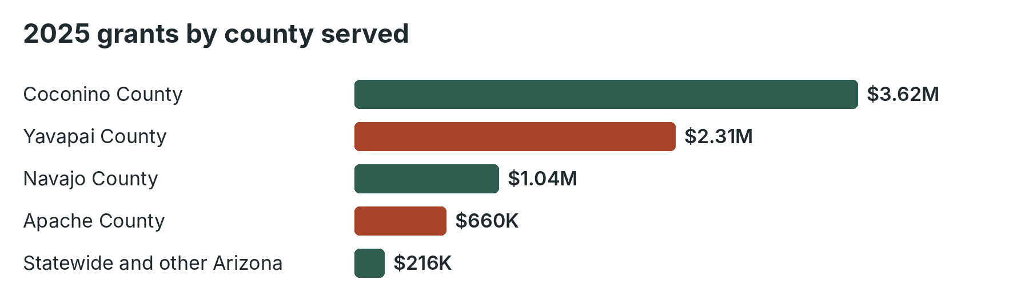
County served | Grants | Organizations
Coconino County | $3,620,000 | 268
Yavapai County | $2,310,000 | 187
Navajo County | $1,040,000 | 86
Apache County | $660,000 | 52
Statewide and other Arizona | $216,000 | 21
Total | $7,846,000 | 614

Grantee stories

Health & Human Services
Juniper Path Recovery House, Prescott
A $15,000 Community Impact Grant helped Juniper Path keep its doors open while a state contract was delayed. Forty-one women completed residential recovery programs during the grant year, and 33 moved into stable housing.

Civic & Economic Opportunity
High Country Worker Center, Flagstaff
Seasonal workers at Grand Canyon lodges used the center's mobile benefits clinic to file 380 tax returns and claim $412,000 in refunds and credits.

Education & Youth
Red Mesa Reading Circle, Teec Nos Pos
Volunteer elders read with 120 children each week in Diné bizaad and English. Participating second-graders gained an average of 1.4 grade levels in reading.

Environment & Land Stewardship
Upper Verde Springs Alliance, Chino Valley
Volunteers restored fencing and native plantings at nine springs, and monitoring shows flow has returned to two springs that were dry in 2022.

Arts & Culture
Little Colorado Youth Orchestra, Winslow
Seventy-two students received free instruments and weekly lessons, and the orchestra performed at the Navajo County Fair for the first time.

Animal Welfare
Mogollon Rim Paws Alliance, Show Low
Mobile clinics provided 1,640 low-cost spay and neuter surgeries in rural Navajo and Apache county communities.

Early Childhood
Painted Desert Family Resource Center, Holbrook
A First Steps grant funded licensing support for six home-based infant care providers, adding 28 infant slots in a county with fewer than one slot per seven infants.

Indigenous Communities
Third Mesa Seed Keepers, Kykotsmovi
Youth and elders planted and harvested 11 heritage crop varieties and distributed seed to 140 families.

LGBTQ+ Communities
Rimrock Pride Center, Sedona
Peer support groups for LGBTQ+ older adults grew to 85 regular participants across three Verde Valley towns.

Black Futures
Southside Heritage Project, Flagstaff
The project recorded 24 oral histories with descendants of Black families who came to Flagstaff to work in the lumber mills in the 1940s.

What grantees told us
- 94% said unrestricted funding allowed them to respond to unexpected needs.
- 88% said the story-based report took less than two hours to complete.
- 71% of rural grantees said CPCF was their only foundation funder.

