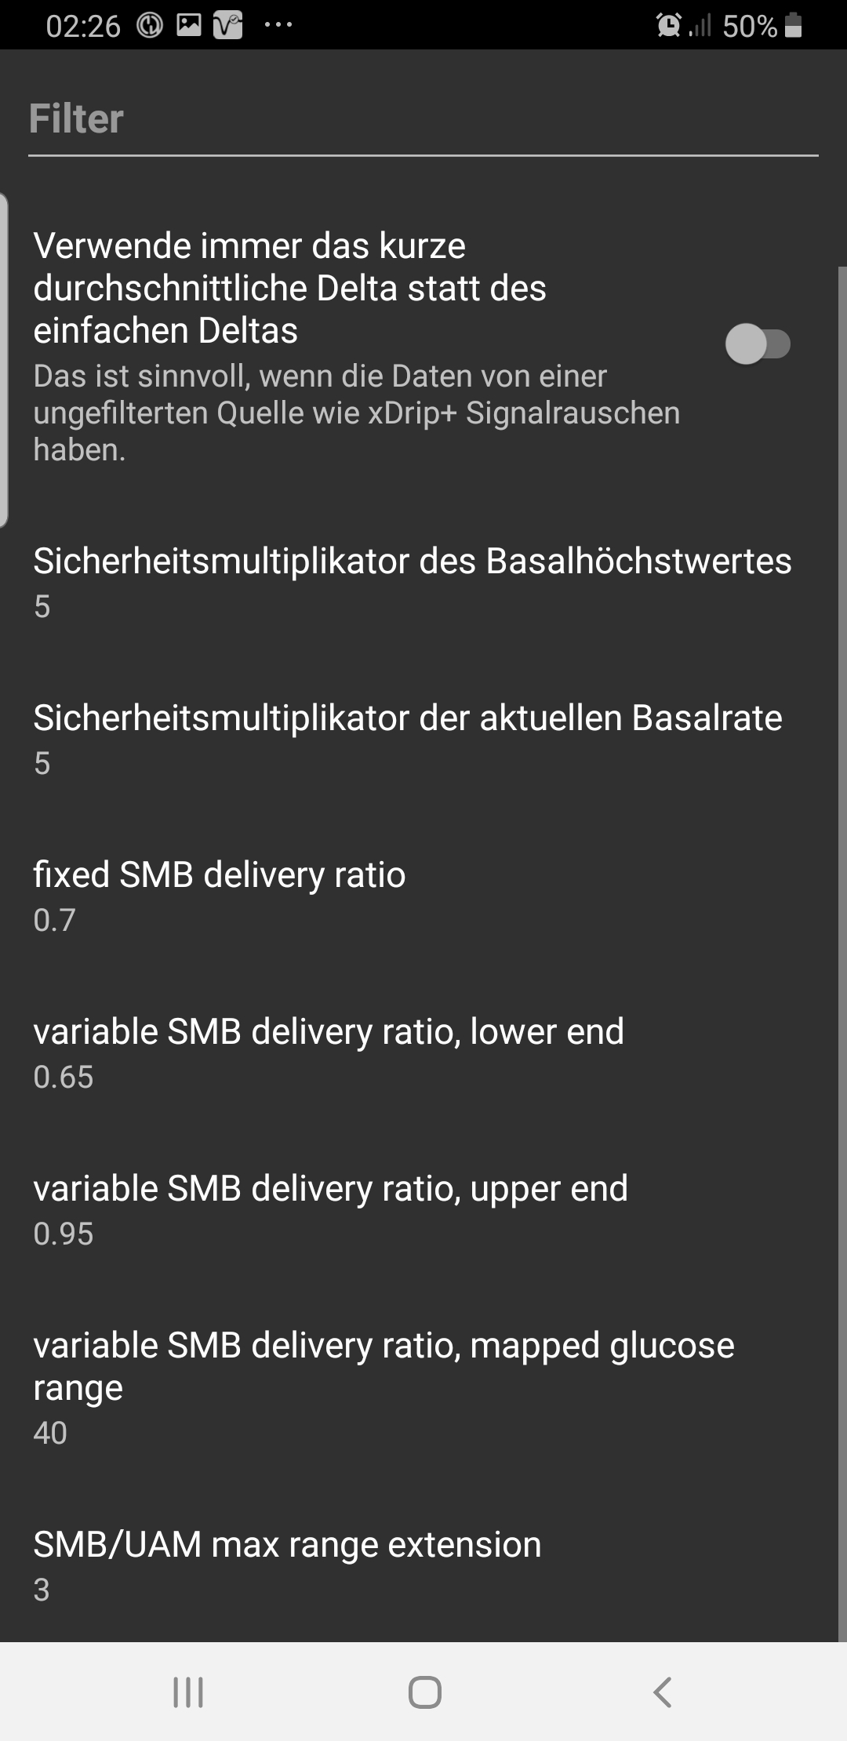
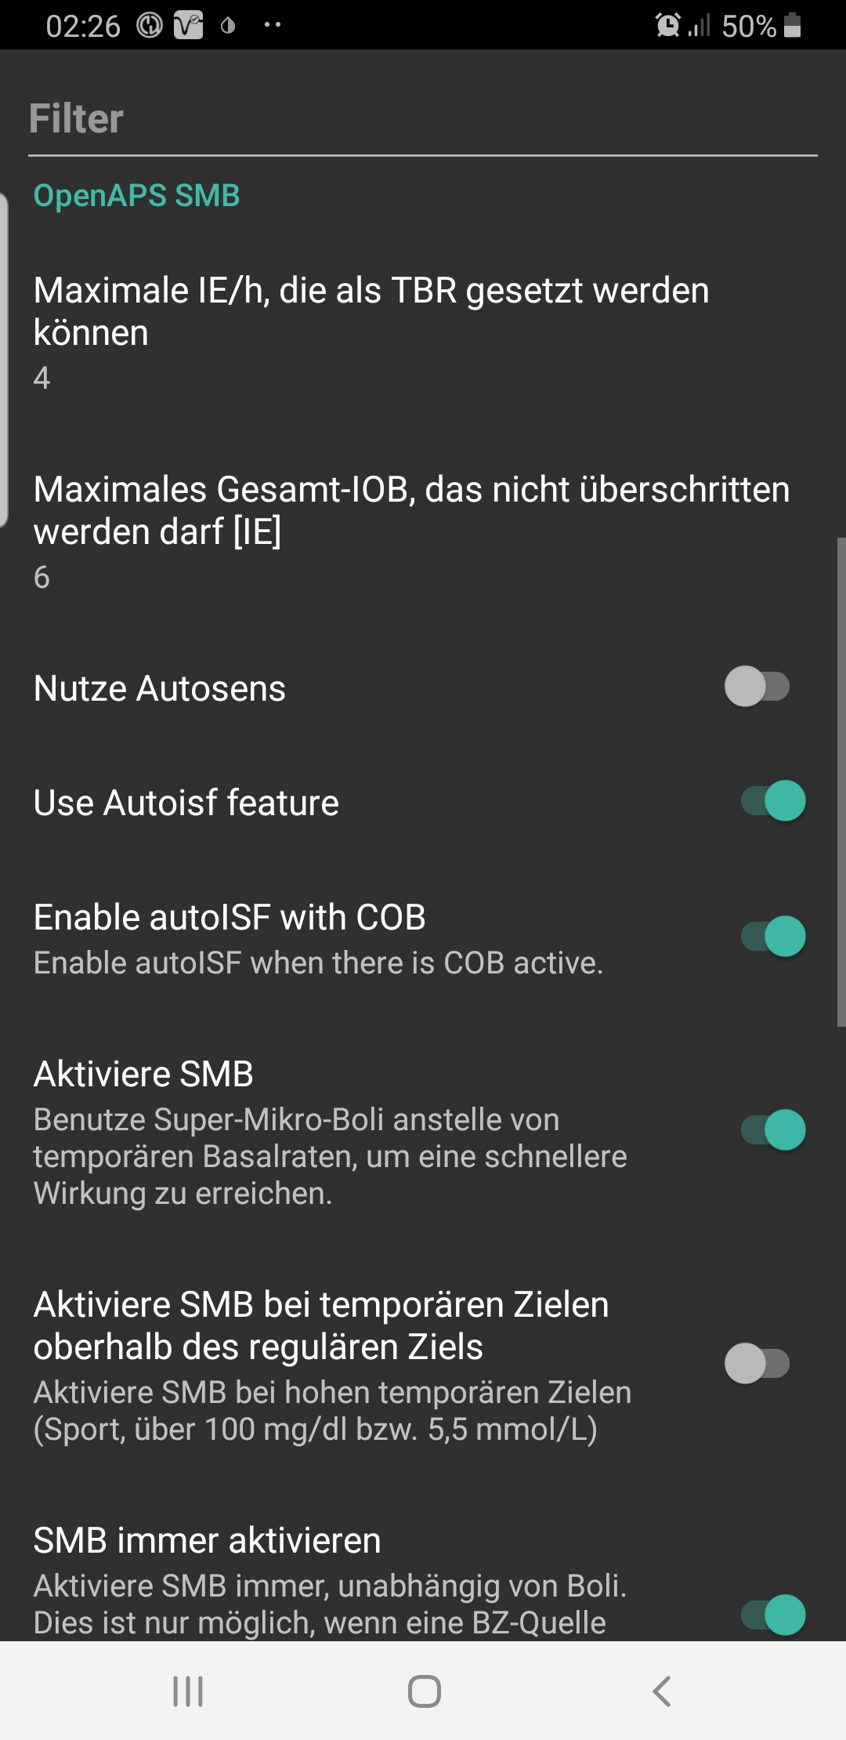
Additions to the traditiönal autoISF with SMB extensions

The new feature for enabling autoISF even with COB present was added and can be enabled in the SMB settings.

The option to raise the ratiö of SMB to be delivered was extended. There is an alternative option to define a minimum ratiö (example here 65%) and a maximum ratiö (example here 95%). The minimum will be used at target_bg and the maximum at target_bg+range (example here 40mg/dl). The actual value is interpolated between these limits. With range=0 the previous fixed delivery ratio will be used all the time. The SMB-Tab will tell you the value used when the lööp executed.

