**Deliverable 1 Document**

**ONLINE PHARMACY STORE**

**By Gayatri sravani Akella**

**Chahnitha Chandu**

**Nikhitanjali Dodla**

**Subramanya Soujanya Akella**

**Section 1.** **Project Title** – Web-Based Online Pharmacy Store

**Section 2.** The **main idea of this project** is to ease the whole process of buying medicines or related commodities that are of high importance and might come of use during emergencies.

This project will be a **web-based online Pharmacy Portal**. We have decided that the following will be the features we will enable on this website as part of the Project.

* There will be a single admin user and we can create multiple regular users (Customers).
* There will be an initial home page which will have Login or signup options
* The Customer User ID's can be used to order medicines.
* The admin user will be able to update the medicines in the database, view and update the status of orders or decline any in case of discrepancies.
* There will be a cart functionality for each user before ordering any medicines.
* All the medicines will be delivered to the address provided while ordering.
* The customers can pay via COD or PayPal.
* For any medicines that are not Over the counter, the Customer has to provide the Doctor’s email ID who prescribed it. An email will be sent to the doctor for confirmation.
* For any order, an Order ID will be generated. Once the status is updated to Shipping a FedEx/USPS/Airmail tracking number will be generated and hence can be tracked in their site.
* There will no be no returns/exchanges once the order is shipped.

**Languages Used:** PHP, Bootstrap, CSS, SQL

**Server Used:** Xampp

**Development environment:** Visual Studio Code

**FLOWCHARTS:**

**1. Initial Flow:**

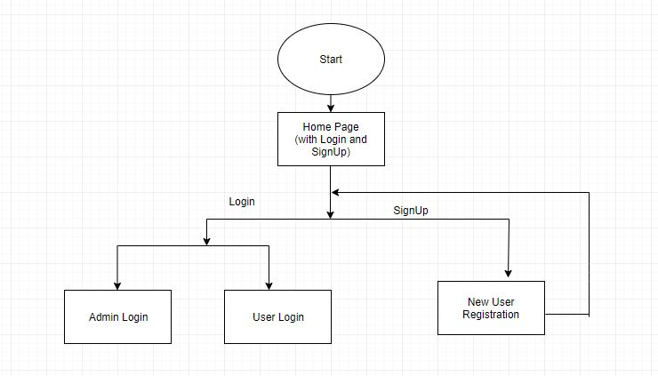

**Figure 1: Initial Flow**

This will be the initial flow of the project before the users or admin login and just open our website. In the New User Registration, the website will save the details of the User like Name, Age, Gender, DOB, Address and payment details are optional.

**2. Admin Flow**

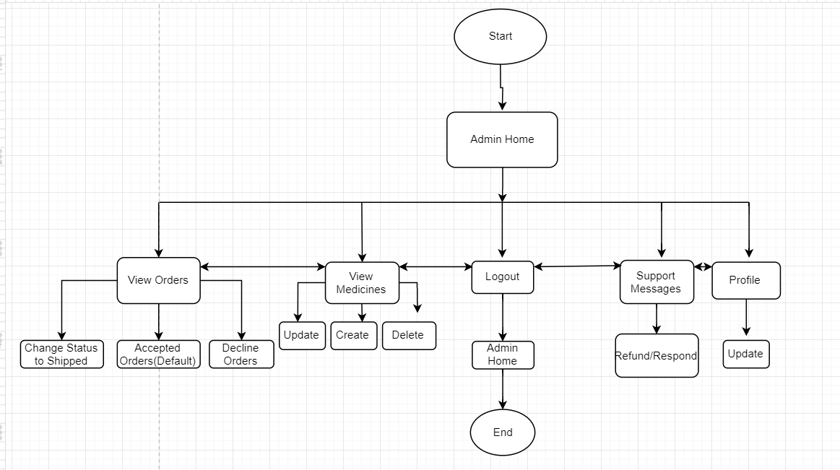

**Figure 2: Admin Flow**

The above flow diagram describes the admin Flow:

* The admin has 5 main options on his Nav Bar –

i) View Orders

ii)View Medicines

iii)Logout

iv)Support Messages

v)Profile

* The admin can update the database with new medicines or delete the older ones.
* The admin also has the power to update or review any orders and change their status.
* He can also change his profile settings.

**3. User Flow**

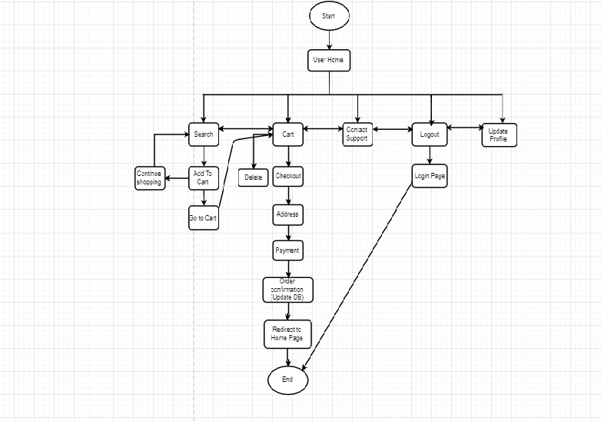

**Figure 3: User Flow**

The above flow diagram describes the User Flow:

* The user can search for the required medicine using its’ name or problem.
* There is a cart functionality into which he can add and delete items.
* To order items the user needs to provide address and payment details.
* Similar to the Admin even the user can update his profile information.

**Section 6.**

**Project Management Tool** is Used to manage the tasks and schedule and assign tasks is **RedBooth**. Currently, with the available dates for submission, we have identified the following tasks and made a Gantt chart based on these. In the later stages, we will create subtasks for these and we will update the Gantt chart.

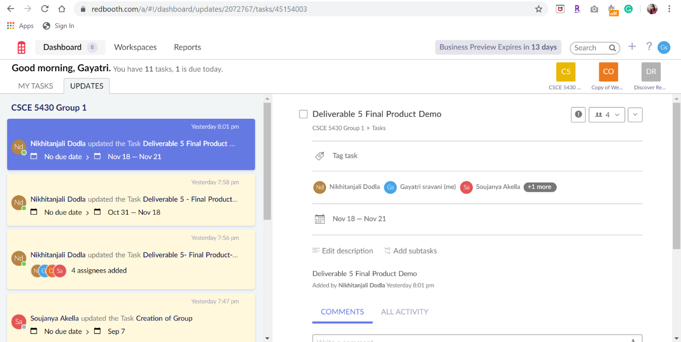

**Figure4: Home Page of RedBooth**

**Project Tasks:**

1. Deliverable 1 Document

2. Deliverable 1 Presentation

3. Deliverable 2 System Specifications and Requirements

4. Deliverable 3 Front End Code Development (Document and Code)

5. Deliverable 3 Demo

6. Deliverable 4 Database connections (Doc and Code)

7. Deliverable 4 – Demo

8. Deliverable 5 – The Final Product (Code and Report)

9. Deliverable 5 - Demo

The screenshot of the schedule(Gantt Chart) made using Redbooth is as follows:

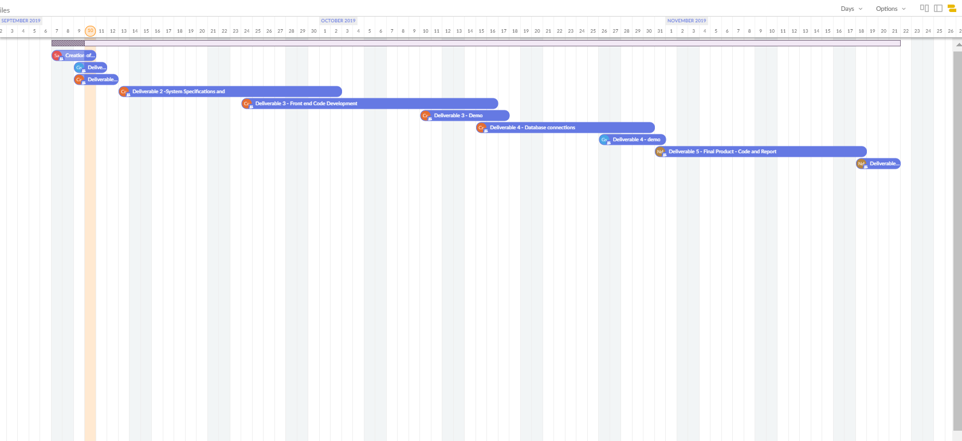

**Figure 5: Gantt Chart of our Project with the above tasks**

**Section 7.**

The risks may change as we progress in our project that may be due to some minor changes in adding other functionalities. We will ensure to monitor these risks and reevaluate the risks as the semester progresses. Below are the top 3 risks that we identified in our project till now:

* **Medicines returns:** The Medicines cannot be strictly returned once they are shipped. The customers may try to return the medicines after they recover by using some amount in medicines like ordering 20 medicines and using 10 of them and trying to return the rest of 10. There arises a risk for the health of the other customers if we accept the returns and deliver the returned products.
* **User account security:** Cybersecurity is one of the important factors to assess in regard to consumer protection. There is a chance for the user account or admin account to be hacked which allows an unauthorized user to place an order.
* **Fake IDs:** For the drugs that fall under the FERPA act there is a need to upload the customer's ID. But, there is no way to be sure that the order was placed by the same person whose ID is being provided. It can be the case wherein an identity was stolen.

**Contingency plans:**

* Prevent the risk of accepting returned products by adapting to the strict policies of not accepting the returns of used products. Customers also have to right to reject the order at the time of delivery if the medicine was not what was ordered or if an expired product is delivered
* In order to prevent user account security risk, we are adding a feature of sending an automated email for any suspicious activity that is observed either in the user account or admin account. The customer is provided with an option to report this issue to admin.
* To safeguard from Fake IDs attacks we need to ensure that the customer shows their physical ID proof at the time of delivery. The medicines will only be delivered to the person who is in the ID. The order confirmation email also notifies the customers about their order status, so it easily allows the user to report it if it is not placed by them.

**Section 8.**

**Team member’s roles** and project repository check-out and update policies (Might be modified Later):

* The owner of the project repository is Gayatri sravani Akella. Nikhitanjali, Chahnitha and Soujanya are the collaborators in this project.
* Nikhitanjali and Chahnitha will be responsible for the development of all the User Interfaces using PHP.
* Gayatri sravani and Soujanya will be responsible implementing for Database connections and Login/logout logic.
* Nikhitha and Soujanya will also implement the cart functionality while Gayatri and Chahnitha will implement the validations in ordering medicines that need special permissions. (Not Over the Counter)
* Testing will be performed by each member in the project separately to ensure there are no bugs.
* Documentation will be divided between all 4 of us. Nikhitanjali and Soujanya will be responsible for compiling the final draft in any submission.