Models

Palm Detection Model

To detect initial hand locations, we designed a [single-shot detector](https://arxiv.org/abs/1512.02325) model optimized for mobile real-time. Detecting hands is a decidedly complex task: our [lite model](https://storage.googleapis.com/mediapipe-assets/palm_detection_lite.tflite) and [full model](https://storage.googleapis.com/mediapipe-assets/palm_detection_full.tflite) have to work across a variety of hand sizes with a large scale span (~20x) relative to the image frame and be able to detect occluded and self-occluded hands. Whereas faces have high contrast patterns, e.g., in the eye and mouth region, the lack of such features in hands makes it comparatively difficult to detect them reliably from their visual features alone. Instead, providing additional context, like arm, body, or person features, aids accurate hand localization.

Our method addresses the above challenges using different strategies. First, we train a palm detector instead of a hand detector, since estimating bounding boxes of rigid objects like palms and fists is significantly simpler than detecting hands with articulated fingers. In addition, as palms are smaller objects, the non-maximum suppression algorithm works well even for two-hand self-occlusion cases, like handshakes. Moreover, palms can be modelled using square bounding boxes (anchors in ML terminology) ignoring other aspect ratios, and therefore reducing the number of anchors by a factor of 3-5. Second, an encoder-decoder feature extractor is used for bigger scene context awareness even for small objects (similar to the RetinaNet approach). Lastly, we minimize the focal loss during training to support a large amount of anchors resulting from the high scale variance.

With the above techniques, we achieve an average precision of 95.7% in palm detection. Using a regular cross entropy loss and no decoder gives a baseline of just 86.22%.

Hand Landmark Model

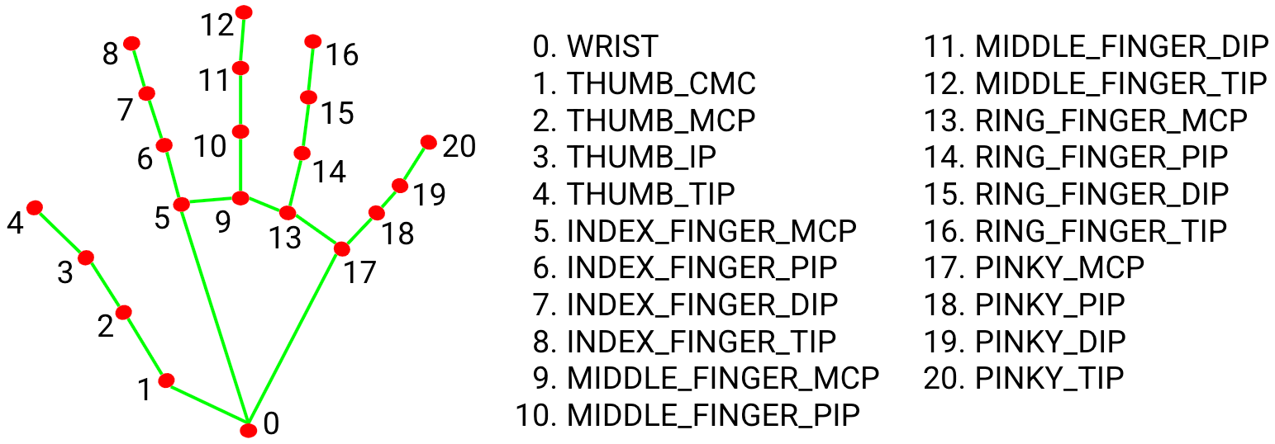

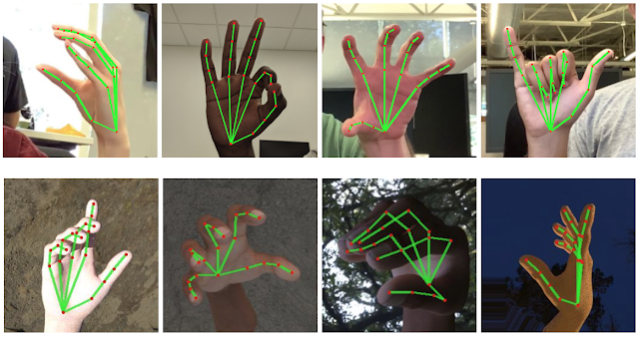

After the palm detection over the whole image our subsequent hand landmark [model](https://storage.googleapis.com/mediapipe-assets/hand_landmark_full.tflite) performs precise keypoint localization of 21 3D hand-knuckle coordinates inside the detected hand regions via regression, that is direct coordinate prediction. The model learns a consistent internal hand pose representation and is robust even to partially visible hands and self-occlusions.

To obtain ground truth data, we have manually annotated ~30K real-world images with 21 3D coordinates, as shown below (we take Z-value from image depth map, if it exists per corresponding coordinate). To better cover the possible hand poses and provide additional supervision on the nature of hand geometry, we also render a high-quality synthetic hand model over various backgrounds and map it to the corresponding 3D coordinates.

