**Project 2**

Author:

**Guillermo Acuna**

Title:

**A Night of Trials V.2**

Course:

**CSC-5**

Section:

**47982**

Due:

**12/9/13**

**Technical Changes:**

Code changes were made from version one to version 2

to include the use of arrays. The arrays main use was for the parameters of the player and enemy. This made it much easier to store, use, and keep track of all the parameters.

A very important change added to this version is the random number generator. This was added to the attack and defense structures so as to add more difficulty. It's possible to miss your attack now. Also, its possible to get critical hits, and cause more damage.

Also, for more of a fun feel, I included another display function. This one is for when the player loses, and is documented in the pseudocode.

For layout, and reading improvement, the spacing issues within the text were fixed, and it is easier to read and look at now.

All changes are documented within the peudocode.

**Introduction:**

Video games have come a long way in, what seems, like a very short time.

Looking through old DOS- Box game websites, one can find old style R.P.G.’s. This type of game is called a Role Playing Game. The player simply takes on the role of whatever character the story centers on, and the game takes them through some adventure. Interestingly enough, the old R.P.G.’s were all text based.

Seeing that a fun game can be made from pure words and choices, this game titled *A Night of Trials*, is inspired by those old games. It is very simplistic, as this is my first time trying anything like this, but is based completely on text storyline and player choices.

The player reads the story, and chooses paths to follow. Each path leads to one fight, which if won, grants the player stat boosts in the form of rewards. These prepare the player for the final boss.

**Simple Game Format:**

**Menu**

**|**

**|**

**Start of game**

**Choice of character type**

**|**

**Choice**

**|**

**Battle**

**(This involves attack and defense choices)**

**|**

**Repeat till Boss**

**Game Mechanics:**

*A Night of Trials* is a completely text based game. There are no visuals, except for the title. The game works by telling a story. The player reads the story, making different choices when they are prompted to do so. Their choices effect what kind of enemy they fight, the reward bonuses to the player’s parameters, and whether they attack or defend in battle. The goal of the game is to progress the story, beat the boss, and end the story. At this point the player name is put in the records folder for completing the game, where it can be viewed from the main menu.

Since this game is text based, it’s all played through reading storyline and using imagination. The player will see paragraphs of story, which they read. The story focuses around the player facing trials. Each piece of story will prompt for a choice, which will then lead to a battle.

Each battle is simplistic, choosing of attacking or defending, reading, then choosing again till the player wins or loses. The strategy is in using the character type effectively. After winning, player is awarded in game as a part of the story. The rewards grant percentage boosts to the players parameters. This is to prepare for the final boss fight.

**Character Types:**

In many R.P.G.’s, the player chooses a class or play style for their character. These classes or types usually involve differences in stats that mirror the style in which the class was meant to be played.

This game utilizes a similar idea. I use a switch statement in the beginning and prompt the player to choose from the attack based, defense based, or a balanced character. In fighting, this makes a difference because the choices of attacking and defending are structured to help specialization. This is explained in more detail in the battle mechanic section. Defense characters do best by defending, attackers by attacking. The balanced can go either way.

There are three parameters to for the player, Attack, Defense, and Health.

They are initialized when player chooses play style, and modified as game progresses. They are completely hidden, and the player is unaware of values.

**(The starting stats are distributed from a pool of 30 points)**

**Starting Parameters(stats):**

**Attacker Defender Balanced**

Atk 15 7 10

Def 7 12 10

Hlth 8 11 10

Boost +12% Atk +12%Def +10%All

**Beginning Flowchart(Created early,so slightly modified in pseudocode)**

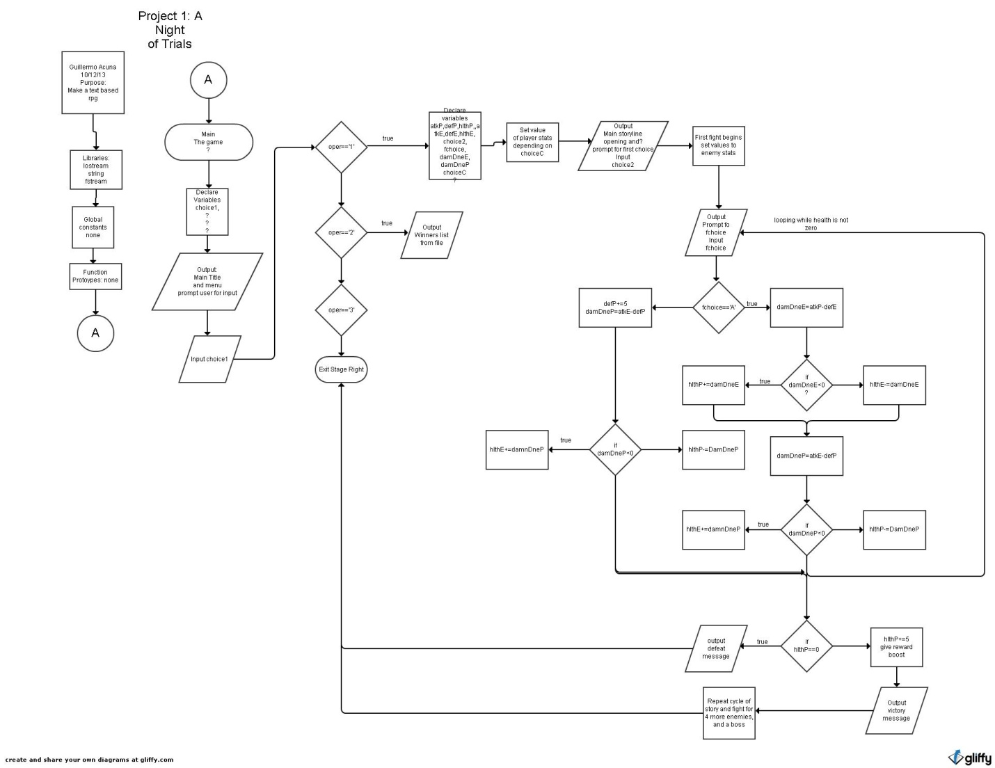

**Main System:**

**(**This is the pseudo code for the main functions)

Main Title and Menu Function:

*Call title function, and display*

*Do*

*{ Spacing to center the menu*

*Display menu*

*Prompt user for menu choice*

*Switch*

*{*

*Case1: call main game function*

*Case2:call records function*

*Case3:exit program*

*}while(menu choice!=3)*

Main Game function:

*Prompt user to choose character type*

*Switch*

*{ case1:apply attacker parameters*

*case2:apply defender parameters*

*case3:apply balanced parameters*

*}while(choice!=3)*

*Act one*

*Display storyline*

*Fight 1*

*Repeat until boss fight(four fights total)*

*If(health of player>0)*

*Display message confirming completion of game,*

*Prompt user for input of name*

*Output name to record file*

Title function:

*Display a stylized title of game*

*Using on character to draw*

Record function:

*Declare file stream object*

*output from file*

*Winner’s names*

Losing function:

*Display losing message*

**Battle system:**

(This is the pseudo code for the battle functions)

Main Battle Function:

*Do*

*{ Prompt user for choice*

*of Attack or Defense*

*Switch, statement for choice*

*{*

*Case of attack*

*Call Attack function*

*Obtain player health and enemy health*

*Case of Defense*

*Call Defense function*

*Obtain player health and enemy health*

*Default: error message*

*}while (the player health!=0 and the enemy health!=0)*

*If (health of player is 0): display defeat message and end game*

*Otherwise: display victory message, give health back, and reward.*

Attack Function:

*Display message confirming attack option*

*Generate random numbers and compare for player*

*if(player wins){*

*Calculate damage inflicted by player*

*Damage inflicted=attack of player – defense of enemy*

*If (damage inflicted <0):player takes damage, display confirmation*

*If (damage inflicted>0): enemy takes damage, display confirmation*

*If (damage inflicted==0): no damage, display confirmation*

*}*

*Generate random numbers and compare for enemy*

*if(enemy wins){*

*Calculate damage inflicted by enemy*

*Damage taken=attack of enemy – defense of player*

*If (damage taken <0):enemy takes damage, display confirmation*

*If (damage taken>0): player takes damage, display confirmation*

*If (damage taken==0): no damage, display confirmation*

*}*

*Global variable: enemy health*

*Returns player health*

Defense Function:

*Display message defense option*

*Augment players defense*

*Generate random numbers and compare for enemy*

*if(enemy wins){*

*Calculate damage inflicted by enemy*

*Damage taken=attack of enemy – defense of player*

*If (damage taken <0):enemy takes damage, display confirmation*

*If (damage taken>0): player takes damage, display confirmation*

*If (damage taken==0): no damage, display confirmation*

*}*

*Global variable: enemy health*

*Returns player health*

**Reward system:**

Most R.P.G’s offer rewards for defeating enemies, and this one works the same way. After defeating enemies, the player will see story text explaining the victory, and continuing the story. It will also inform of prizes earned in fights.

Some parts of the game make you choose your reward. These rewards, though text and story based, have actual effects on the player’s chosen parameters of attack and defense. Exactly what kind of effects our outlined below.

Attack Based Defense Based

First Fight(Longsword

Or Shield) +5%Atk +5%Def

Second Fight(Armblade

Buckler or Dagger) +10%Atk;+5%Def +5%Atk;+10%Def

Third Fight(Great

Hammer or Horned helmet) +15%Atk +15%Def

Game Story Gift(Spiked

Leather Armor or Steel plate) +15%Atk;+5%Def +15%Def;+5%Atk