This program is a simple web project. It can be hosted on your localhost, with a local web server. Flask was used for this project.

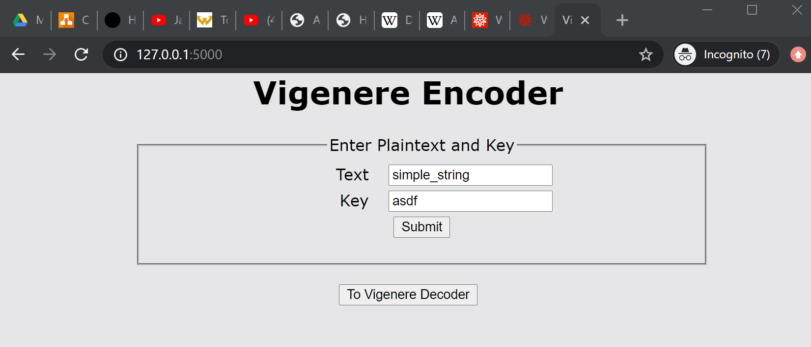

Encryption 1

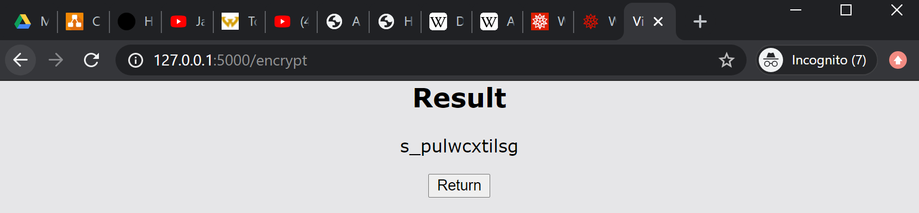

Encryption 1 Result

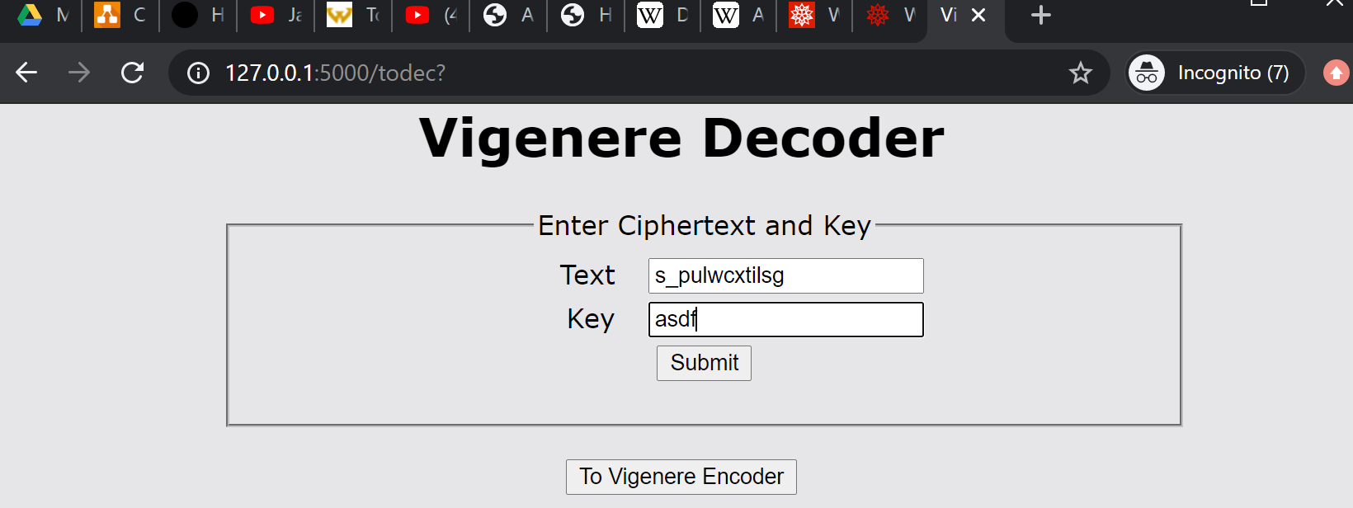

Decryption 1

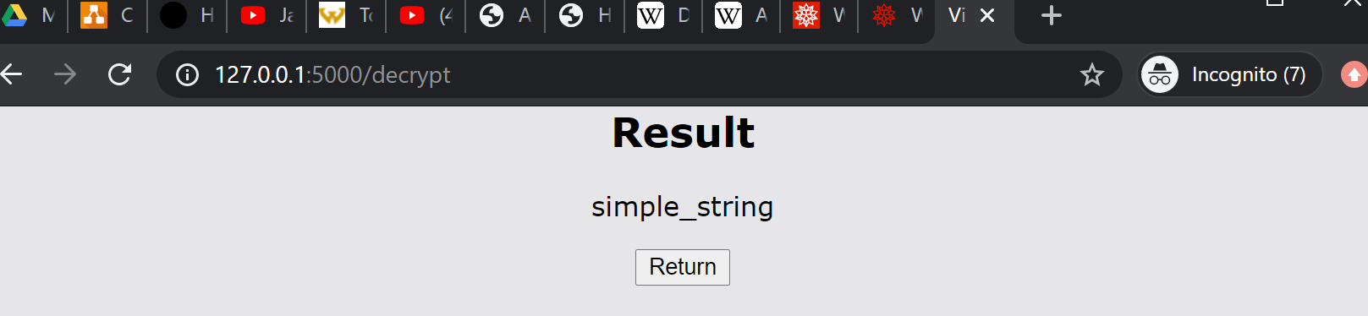

Decryption 1 Result

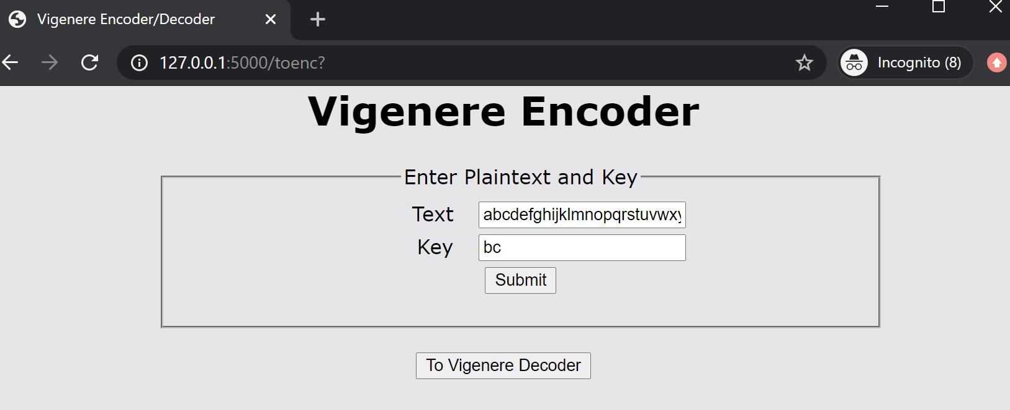

Encryption 2 (entire alphabet from A to _)

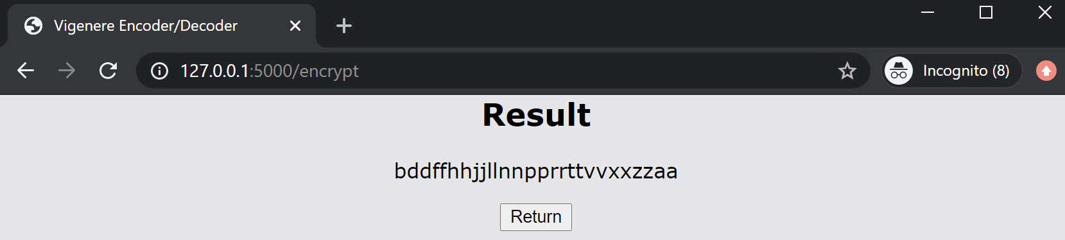

Encryption 2 Result

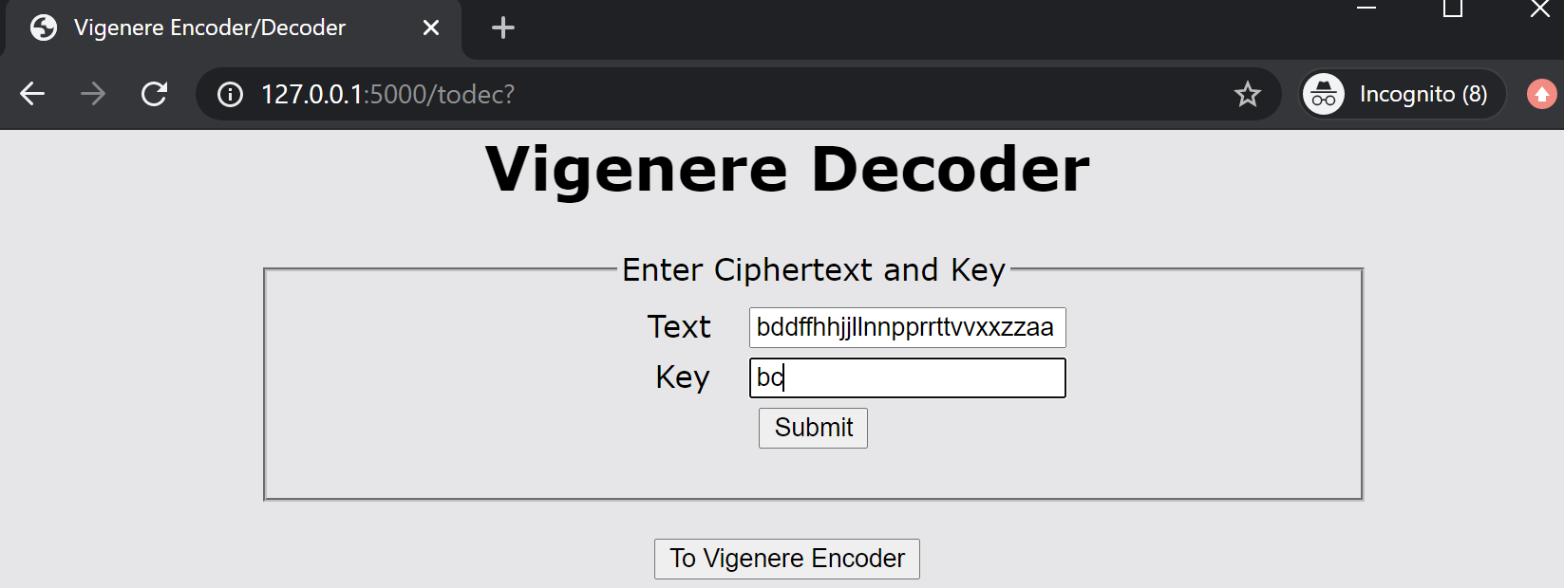

Decryption 2

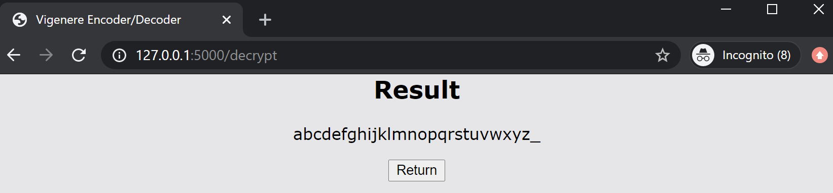

Decryption 2 Result