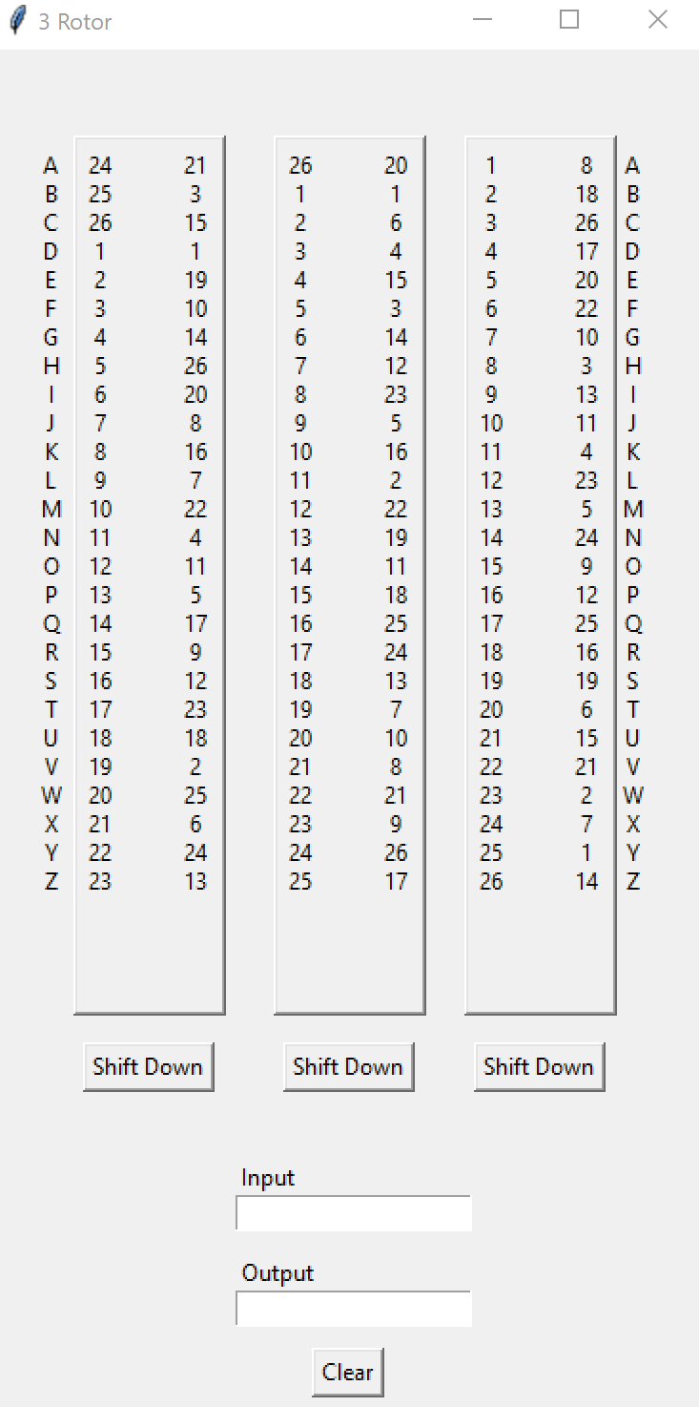

Initial

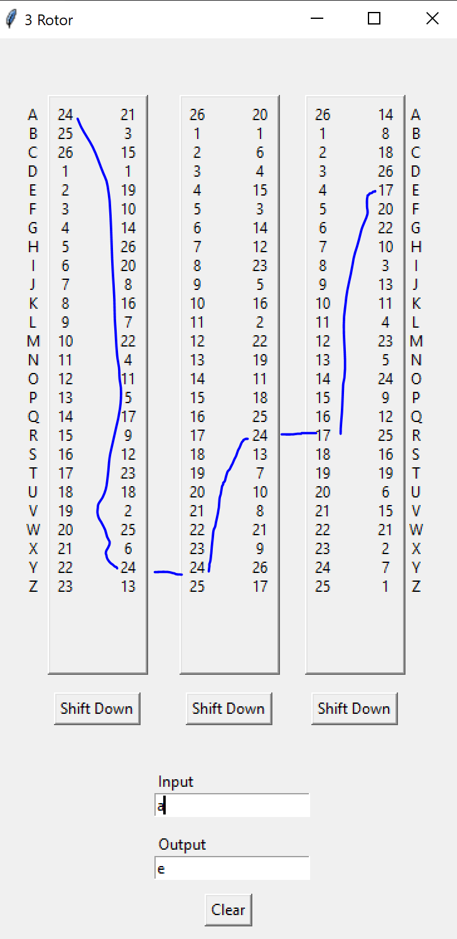

After one input, the last rotor shifts down.

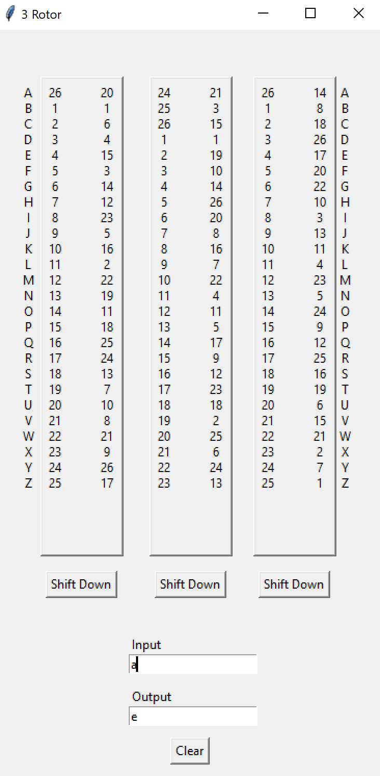

Clicking the left rotor switched the left and middle rotor

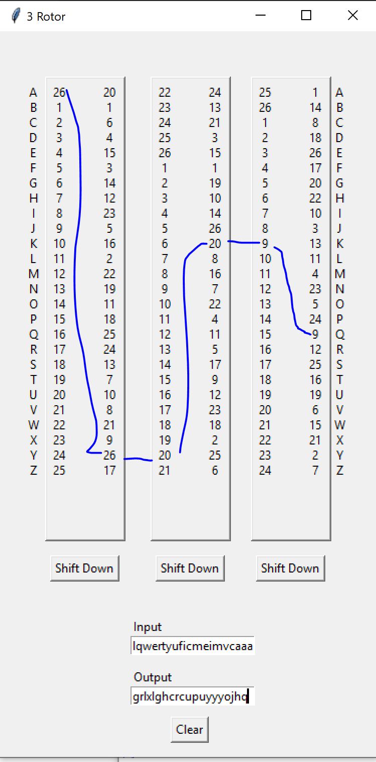

Pressing at least 26 letters cause the middle to shift down one. Last input “a”, matches with “q”