User Manual

**Game Description**

Welcome to the Python Memory Game!

In Memory, several cards are displayed face down on a board. Each card has a matching pair. The goal of a single player game is to match pairs until all cards on the board are matched. Players will flip up two cards at a time. If the cards do not match, they will flip back over. Be sure to remember their positions! If the cards do match, then points are added to the score, the cards will disappear, and the score multiplier is increased. The score multiplier helps add bonus points onto your score and will increase for every pair you match in a row. However, if you lose your matching streak, the multiplier will reset. Try to get the highest score possible! After a single player game, you can save your score, as well as view other people’s scores.

In multiplayer, the rules are the same as a single player game, but players will take turns matching two cards at a time. The player with the highest score at the end wins the round.

The following parts of this document will help you navigate through each menu.

**Starting Terminal**

1. Opening main.py opens up a Python terminal.
2. Type one of the given options to directly jump to a page.
   1. Type “main” to go to the main page.
   2. Type “single” to go to the single player page.
   3. Type “multi” to go to the multiplayer page.
   4. Type “quit” to close the project.
3. Game display will open in background.

**Main Menu**

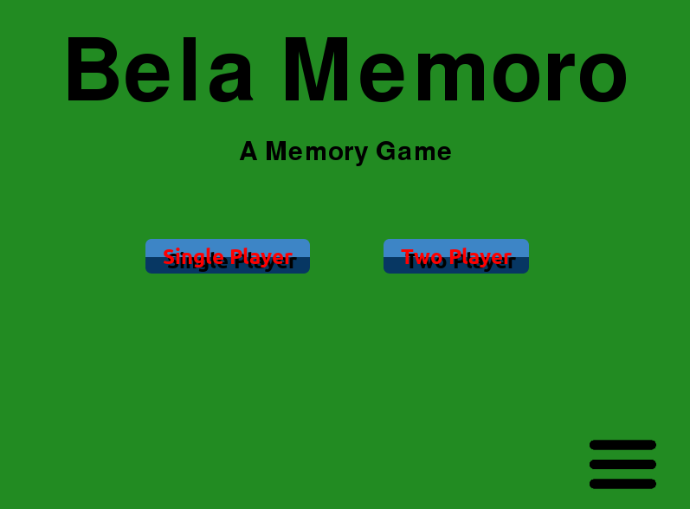

1. Single Player Button: Choose for a single player game. Takes you to the Single Player Menu.
2. Multiplayer Button: Choose for a multiplayer game. Takes you to the Multiplayer Menu.
3. Options Button: Adjust options. Takes you to the Options Menu.

**Single Player Menu**

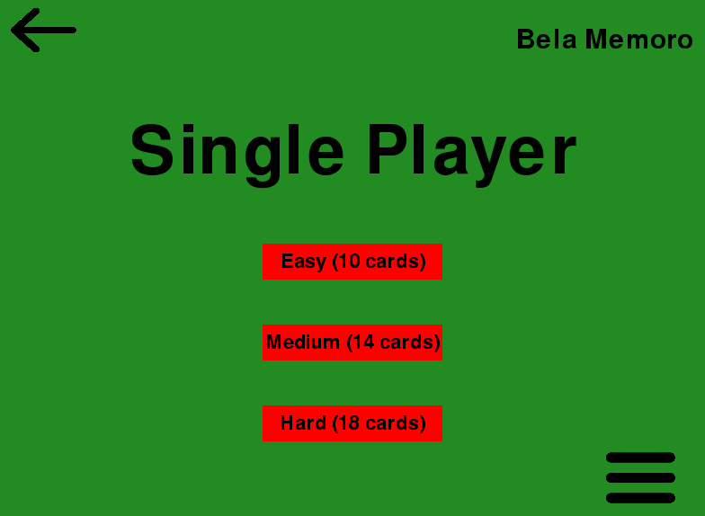

1. Back Button: Go back to the previous page. Takes you to the Main Menu.
2. Easy Button: Start a game with 10 cards. Takes you to Gameplay Menu (Single Player).
3. Medium Button: Start a game with 14 cards. Takes you to Gameplay Menu (Single Player).
4. Hard Button: Start a game with 18 cards. Takes you to Gameplay Menu (Single Player).
5. Options Button: Adjust options. Takes you to the Options Menu.

**Gameplay Menu (Single Player)**

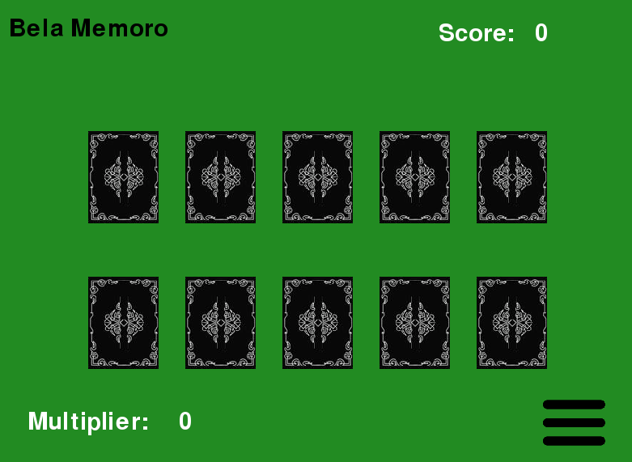

1. Back Button: Go back to the previous page. Takes you to the Single Player Menu.
2. Cards: Click on a card to flip it. When two cards are flipped, their images are compared. If they match, they clear, but if they don’t match, they flip back down. If all cards are matched, you are immediately sent to the Results/Congratulations Menu.
3. Score: Current score.
4. Multiplier: Current score multiplier.
5. Options Button: Adjust options. Takes you to the Options Menu.

**Results/Congratulations Menu**

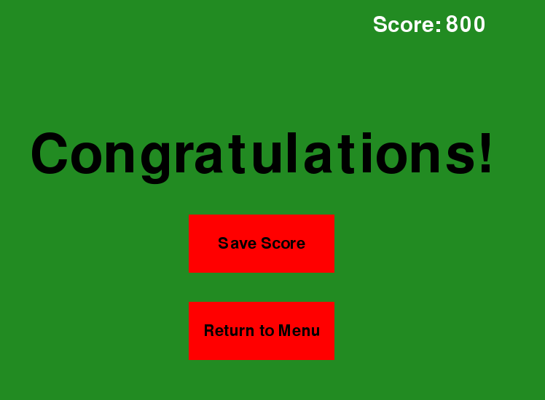

1. Save Score Button: Allows you to save your game score. Takes you to the Enter Your Name Menu.
2. Return to Menu Button: Takes you to the Main Menu.

**Enter Your Name Menu**

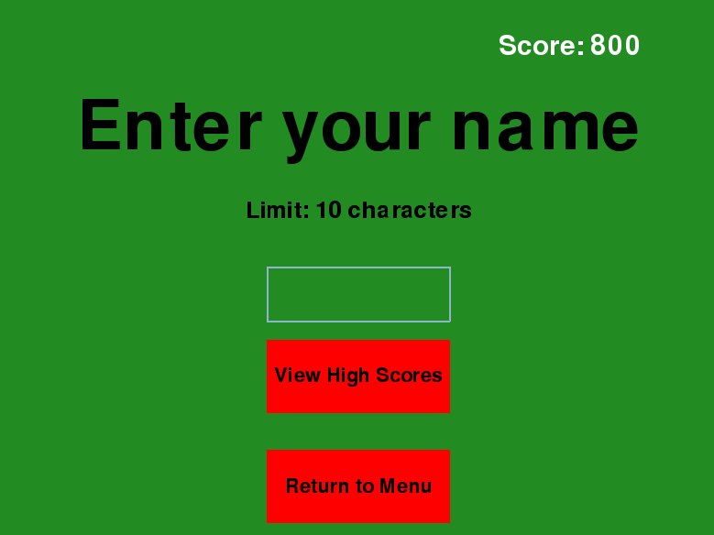

1. Input Box: Type your name (limit of 10 characters), and press the “enter” key to save your name and score. Takes you to the High Score Menu.
2. View High Scores Button: Click to view all high scores for the current card setting. Takes you to the High Scores Menu.
3. Return to Menu Button: Takes you to the Main Menu.

**High Scores Menu**

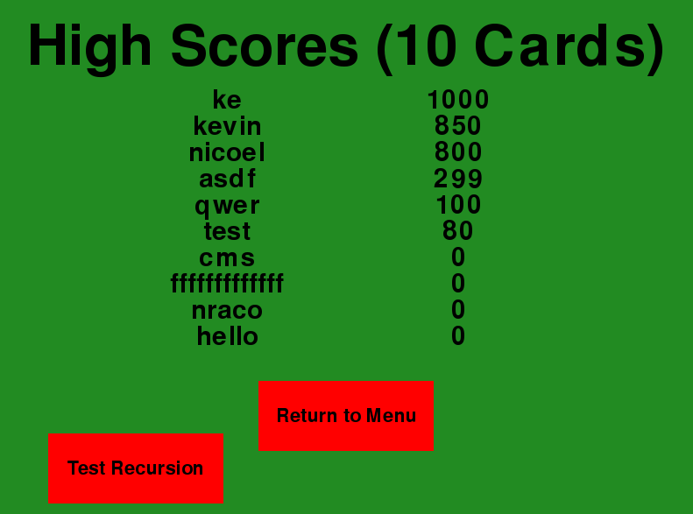

1. Scores: A list of top 10 high scores over the lifetime of the game. If there are less than 10 scores, the remaining entries are filled with “N/A.”
2. Return to Menu Button: Takes you to the Main Menu.
3. Test Recursion Button: Shows the use of recursion in the project. Sorts list of scores by name, asks for a name **in the terminal**, and returns the index of the name through binary search. After the task is finished, control returns to the game display.