To Make Aggregation Queries, That Enable Us To Make Statistics, We Can use:

from django.db.models.aggregates import Count, Sum, Max, Min, Avg

from store.models import Product, OrderItem, Order

def say_hello_26(request):

    products_count = Product.objects\

        .aggregate(

            Count('id'),

            count=Count('id'),

            min_price=Min('unit_price'),

            max_price=Max('unit_price'),

        )

    return render(request, 'hello.html', {

        'products_count': products_count,

        'name': 'Jafar-Loka',

    })

def say_hello_27(request):

    result_1 = Order.objects.aggregate(count=Count('id'))

    result_2 = OrderItem.objects.filter(product__id = 1).aggregate(units_sold=Sum('quantity'))

    result_3 = Order.objects.filter(customer__id=1).aggregate(count=Count('id'))

    result_4 = Product.objects.filter(collection__id = 3)\

    .aggregate(

        min_price   =Min('unit_price'),

        avg_price   = Avg('unit_price'),

        max_price   =Max('unit_price'))

    return render(request, 'hello.html', {

        'name': 'Jafar Loka',

        'result_1': result_1,

        'result_2': result_2,

        'result_3': result_3,

        'result_4': result_4

    })

********************************************************************************

If We Want To Add New Fields To The Model Object, We Can Use annotate-Method, That Return Also queryset-object:

**Note 1**: We Must Pass Expression Object To The New Field.

**Note 2**: We Can Pass Mixed Of Expressions To The New Field.

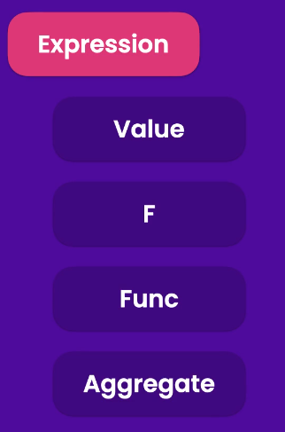

*************************************************************************************

The Code Like This:

from django.db.models import Q, F, Value

def say_hello_28(request):

    queryset = Customer.objects.annotate(is_new=Value(True), new_id=F('id') + 1)

    return render(request, 'hello.html', { 'name': 'Jafar Loka', 'customers': queryset })

*************************************************************************************

We Can Use annotate-Method, For Creating New Mixed Value Of Fields:

**Note**: We Can Also, Use Django Database Functions To Make The Same Result.

from django.db.models import Q, F, Value, Func

from django.db.models.functions import Concat

def say_hello_28(request):

    queryset = Customer.objects.annotate(

        is_new=Value(True),

        new_id=F('id') + 1,

        full_name= Func(F('first_name'), Value(' '), F('last_name'), function='CONCAT'),

        full_name_02 = Concat('first_name', Value(' '), 'last_name')

    )

    return render(request, 'hello.html', { 'name': 'Jafar Loka', 'customers': queryset })

*************************************************************************************

If We Set Aggregation Function Like: Count, Inside The annotate-Method, Then Django Will Group The Results By The Fields That We Use.

def say_hello_29(request):

    queryset = Customer.objects.annotate(

        is_new=Value(True),

        new_id=F('id') + 1,

        full_name= Func(F('first_name'), Value(' '), F('last_name'), function='CONCAT'),

        full_name_02 = Concat('first_name', Value(' '), 'last_name'),

        order_count = Count('order')

    )

    return render(request, 'hello.html', { 'name': 'Jafar Loka', 'customers': queryset })

*************************************************************************************

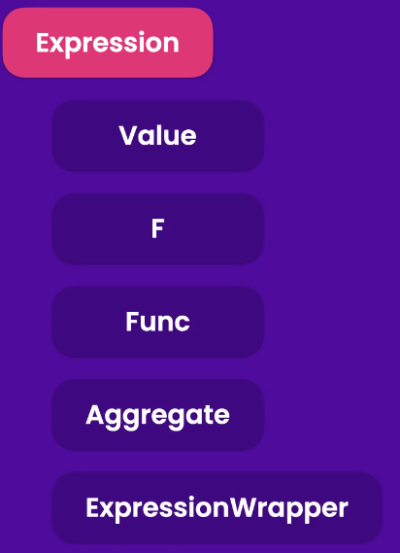

*************************************************************************************

To Make Calculation Between Different Types Of Models:

from django.db.models import Q, F, Value, Func, ExpressionWrapper, DecimalField

def say_hello_30(request):

    queryset = Product.objects.annotate(

        discount_price = ExpressionWrapper(

            F('unit_price') * 0.8,

            output_field=DecimalField())

    )

    return render(request, 'hello.html', { 'name': 'Jafar Loka', 'products_02': queryset })

*************************************************************************************

To Get The Data From ContentType Fields:

from django.contrib.contenttypes.models import ContentType

from tags.models import TaggedItem

def say_hello_31(request):

    content_type = ContentType.objects.get_for_model(Product)

    # Here We Use select_related To Avoid The Problems Of

    # Loading Many Tags

    tagItems = TaggedItem.objects\

        .select_related('tag')\

        .filter(

            content_type = content_type,

            object_id=1

    )

    return render(request, 'hello.html', {'name': 'Jafar Loka', 'tagsItem': tagItems})

*************************************************************************************

We Must Understand The Query Set Cache.

Cache Will Be Happened Only When The Entire QuerySet Evaluated, **Ex**:

*list(queryset)*

*queryset[0]*

*************************************************************************************

To Create Custom Manger For Specific Model:

**Note**: get_tags_for Is Custom Method For Getting The Data That We Want.

class TaggedItemManager(models.Manager):

    def get_tags_for(self, obj_type, obj_value):

        content_type = ContentType.objects.get_for_model(obj_type)

        # Here We Use select_related To Avoid The Problems Of

        # Loading Many Tags

        return TaggedItem.objects\

            .select_related('tag')\

            .filter(

                content_type = content_type,

                object_id=obj_value

        )

*************************************************************************************

Then We Override The Objects-Attribute Of The Model:

class TaggedItem(models.Model):

    objects = TaggedItemManager()

*************************************************************************************

To Save The Collection Data, That Maybe Come With Request OR From Coder:

**Note 1**: Like Laravel; Collection-Class Has Also create-Method, But It Doesn’t Have Auto-Complete For Attributes

**Note 2:** Also; For Saving Featured Product, We Can use collection_featured_product_id=1

def save_collection_example_1(request):

    collection = Collection()

    collection.title = "Video Games"

    collection.featured_product = Product(pk=1)

    collection.save()

    return render(request, 'hello.html', { 'name': 'Jafar Loka' })

*************************************************************************************

**Note**: This Will Raise An Error: Manager isn't accessible via Collection instances

# collection = collection.objects.select_related('featured_product')

*************************************************************************************

To Update The Collection-Class With Reading Data, To Populate It:

    collection = Collection.objects\

        .select_related('featured_product')\

        .get(pk=16) # In This Way We Can Populate All Fields

    collection.title = "New Video Games-07"

    collection.save()

*************************************************************************************

To Update The Object Using Managers, Then We Need To Filter First, Else Every Thing Will Be Updated:

**Note**: Here Update-Method Will Return The Number Of Rows That Updated.

def update_collection_example_2(request):

    Collection.objects.filter(pk=18).update(

        title="New Video Games-18",

        featured_product=None

    )

    return render(request, 'hello.html', { 'name':'Jafar Loka' })

*************************************************************************************

For Deleting Object/Objects From Table, We Can use *delete-Method* For Objects OR QuerySets.

If We Use QuerySets, Then We Should Use *Filter()-Method*.

*************************************************************************************

To Create Transactions, That Can Be Used For Committing OR Rollbacking:

from django.db import transaction

# This Can Be Used AS Decorator OR Using With-Keyword

@transaction.atomic()

def test_transaction_example_1(request):

    order = Order()

    order.customer_id = 1

    order.save()

    orderItem = OrderItem()

    orderItem.order = order

    orderItem.product_id = 1

    orderItem.quantity = 1

    orderItem.unit_price = 1

    orderItem.save()

    return render(request, 'hello.html',{ 'name': 'Jafar Loka' })

*************************************************************************************

For More Control On The Transaction Operator, We Use Context Manger Using with-Keyword:

# This Can Be Used AS Decorator OR Using With-Keyword

def test_transaction_example_1(request):

    with transaction.atomic():

        order = Order()

        order.customer_id = 1

        order.save()

        orderItem = OrderItem()

        orderItem.order = order

        orderItem.product_id = 1

        orderItem.quantity = 1

        orderItem.unit_price = 1

        orderItem.save()

    return render(request, 'hello.html',{ 'name': 'Jafar Loka' })

*************************************************************************************

To Execute RAW SQL, We Can Use raw-Method, That Return Raw QuerySet Object, Not Query Set Object.

def test_raw_sql(request):

    products = Product.objects.raw('SELECT * FROM store_order')

    return render(request, 'hello.html', {'name': 'Jafar Loka', 'raw_result': products})

*************************************************************************************

To Use Stored Procedure We Can Use Cursor:

from django.db import connection

def test_raw_sql_2(request):

    # cursor = connection.cursor()

    # products = cursor.execute('SELECT id, title FROM store_product')

    # row = cursor.fetchone() # In This Way We Return The Result

    # cursor.close() # In Production We Use try-except-finally Block,

    # And Close The Cursor In Finally-Block, OR We Can Use

    # with-Keyword For Context Manager.

    # The Best Way To Use Cursor, By Using with-Keyword

    with connection.cursor() as cursor:

        cursor.callproc('Procedure Name Here', params=[1, 2, 'a'])

    return render(request, 'hello.html', {'name': 'Jafar Loka'})

*************************************************************************************

To Access The Admin Interface Of Our Project, Go To URL: <http://project.url.com:port_if_exists/admin>

* Ex: <http://localhost:8000/admin>

*************************************************************************************

To Create User For Admin Interface, Run Command: *python manage.py createsuperuser*





