To Change The Number Of Items Per Page For Specific Model:

class ProductAdmin(admin.ModelAdmin):

    list_display = [ 'id', 'title', 'unit_price', ]

    list_editable = [ 'unit_price' ]

    list_per_page = 10 # We Use This

***************************************************************

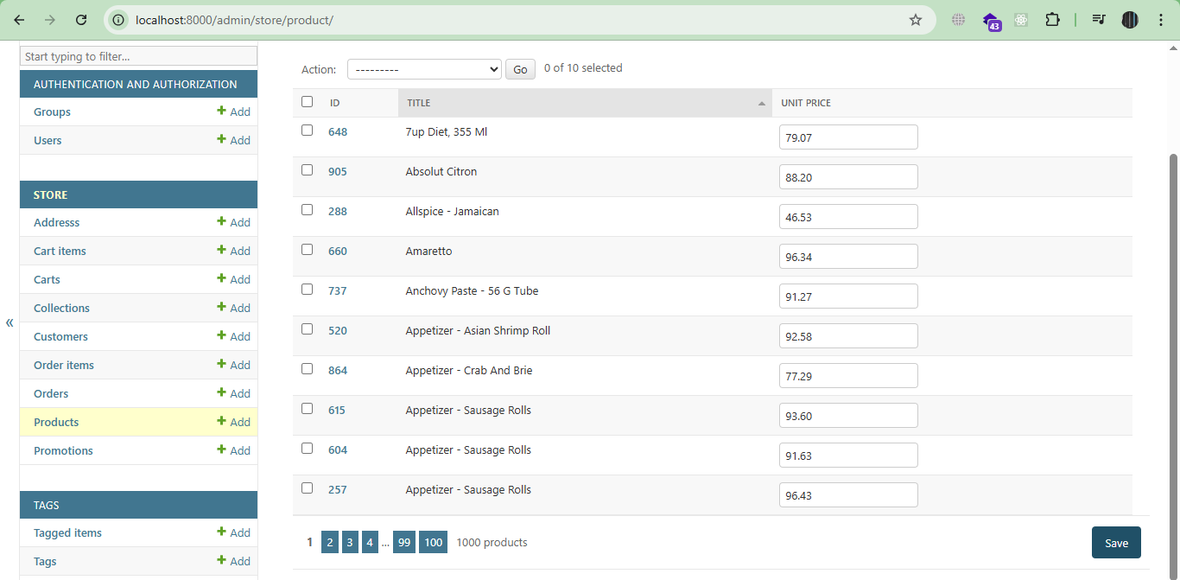

***************************************************************

To Define Computed Columns:

class ProductAdmin(admin.ModelAdmin):

    list_display = [ 'id', 'title', 'unit_price', 'inventory_status']

    list_editable = [ 'unit_price' ]

    list_per_page = 10

# This Is The Computed Column AS Method

    @admin.display(ordering='inventory')

    def inventory_status(self, product: models.Product):

        if product.inventory < 10:

            return 'Low'

        return 'OK'

***************************************************************

In ModelAdmin-Classes We Can’t Use __ To Show Attributes From Related Objects

***************************************************************

To Use The Related Objects With The Current One That Are Displayed To Admin Panel.

First, We Use list_select_realted = ['Objects Are Here']

Then, Define The Method For The Object:

class ProductAdmin(admin.ModelAdmin):

    list_display = [ 'id', 'title', 'unit_price', 'inventory_status', 'collection_title']

    list_editable = [ 'unit_price' ]

    list_per_page = 10

    list_select_related = ['collection']

    @admin.display(ordering='inventory')

    def inventory_status(self, product: models.Product):

        if product.inventory < 10:

            return 'Low'

        return 'OK'

    @admin.display(ordering='collection__title')

    def collection_title(self, product: models.Product):

        return product.collection.title

***************************************************************

In This Way, We Can Override The Default Query Set Of Specific Model:

@admin.register(models.Collection)

class CollectionAdmin(admin.ModelAdmin):

    list_display = [ 'id', 'title', 'products_count' ]

    list_per_page = 5

    @admin.display(ordering='products_count')

    def products_count(self, collection):

        return collection.products_count

    # In This Way We Can Override The Default Query Set

    def get_queryset(self, request):

        return super().get_queryset(request).annotate(

            products_count=Count('product')

        )

***************************************************************

To Build URL For Specific End-Point, We Can Use reverse-Function From urls-util:

**Note 1**: The reverse-Function Parameter Is: admin:app_model_page

* For Product Page In Store App Will Be: admin:store_product_changelist

**Note 2**: To Create Safe HTML, We Can use format_html-Util

**Note 3**: To Build The Query Section Of URL, We Can use urlencode-Method.

from django.utils.html import format_html, urlencode

from django.urls import reverse

@admin.register(models.Collection)

class CollectionAdmin(admin.ModelAdmin):

    list_display = [ 'id', 'title', 'products_count' ]

    list_per_page = 5

    @admin.display(ordering='products_count')

    def products_count(self, collection):

        url = (

            reverse('admin:store_product_changelist')

            + '?'

            + urlencode({

                'collection__id': collection.id

            })

        )

        return format_html('<a href="{}">{}</a>', url, collection.products_count)

    # In This Way We Can Override The Default Query Set

    def get_queryset(self, request):

        return super().get_queryset(request).annotate(

            products_count=Count('product')

        )

***************************************************************

To Add Search Functionality To Customer Admin Page, We Use *search_fields*:

@admin.register(models.Customer)

class CustomerAdmin(admin.ModelAdmin):

    list_display = [ 'first_name', 'last_name', 'membership', 'orders' ]

    list_editable = [ 'membership' ]

    list_per_page = 10

    search_fields = [ 'first_name', 'last_name' ]

    def get_queryset(self, request):

        return super().get_queryset(request).annotate(

            orders=Count('order')

        )

    def orders(self, customer):

        url = (

            reverse('admin:store_order_changelist')

            + '?'

            + urlencode({

                'customer__id': customer.id

            })

        )

        return format_html('<a href="{}">{}</a>', url, customer.orders)

***************************************************************

To Add Lookup Fields To Search Fields:

**Note (To Remember)**: This Is Case Sensitive Search

search_fields = [ 'first_name__startswith', 'last_name__startswith' ]

***************************************************************

To Add Filters, For Specific Admin Model:

class ProductAdmin(admin.ModelAdmin):

    list_display = [ 'id', 'title', 'unit_price', 'inventory_status', 'collection_title']

    list_editable = [ 'unit_price' ]

    list_filter = [ 'collection', 'last_update' ]

    list_per_page = 10

    list_select_related = ['collection']

    @admin.display(ordering='inventory')

    def inventory_status(self, product: models.Product):

        if product.inventory < 10:

            return 'Low'

        return 'OK'

    @admin.display(ordering='collection__title')

    def collection_title(self, product: models.Product):

        return product.collection.title

***************************************************************

To Add Custom Filter In Django:

from django.db.models import QuerySet

class InventoryFilter(admin.SimpleListFilter):

    title = "Inventory"

    parameter_name = "Inventory"

    def lookups(self, request, model_admin):

        return [

            ('<10', 'Low'),

            ('>=10', 'OK')

        ]

    def queryset(self, request, queryset: QuerySet):

        if self.value() == '<10':

            return queryset.filter(inventory__lt=10)

        elif self.value() == '>=10':

            return queryset.filter(inventory__gte=10)

***************************************************************

And To Register The Custom Filter For Admin Model, We Only Set The Name Of Filter Inside The list_filter-List:

class ProductAdmin(admin.ModelAdmin):

    list_display = [ 'id', 'title', 'unit_price', 'inventory_status', 'collection_title']

    list_editable = [ 'unit_price' ]

    list_filter = [ 'collection', 'last_update', InventoryFilter ]

    list_per_page = 10

    list_select_related = ['collection']

    @admin.display(ordering='inventory')

    def inventory_status(self, product: models.Product):

        if product.inventory < 10:

            return 'Low'

        return 'OK'

    @admin.display(ordering='collection__title')

    def collection_title(self, product: models.Product):

        return product.collection.title

***************************************************************

To Define Custom Actions For Specific Model, We Need actions-list of ModelAdmin, And We Must Use @admin.action(…):

from django.contrib import admin, messages

class ProductAdmin(admin.ModelAdmin):

    actions = ['clear_inventory']

    @admin.action(description="Clear Inventory")

    def clear_inventory(self, request, queryset: QuerySet):

        update_count = queryset.update(inventory=0)

        self.message_user(

            request,

            message=f"{update_count} Has Been Cleared",

            level=messages.SUCCESS

        )

***************************************************************

To Populate Fields With Specific Values:

class ProductAdmin(admin.ModelAdmin):

    prepopulated_fields = {

        'slug': ['title']

    }

***************************************************************

**Note 1**: The Previous Way, Only Work If We Don’t Set Any Value OR Change The Slug Field.

***************************************************************

To Define Auto Complete Fields (To Avoid Any Problems With Related Relation), We Need:

* First, The ***autocomplete_fields***
* Second, In The Related ModelAdmin-Class, We Need: ***search_fields***

class ProductAdmin(admin.ModelAdmin):

    autocomplete_fields = ['collection']

@admin.register(models.Collection)

class CollectionAdmin(admin.ModelAdmin):

    list_display = [ 'id', 'title', 'products_count' ]

    list_per_page = 5

    search_fields = ['title']

***************************************************************

***Note 1***: To Add Nullable Fields For Admin Panel, We Use blank=True

***Note 2***: To Add Validator For Unit price We Can Use Validators Of Django

from django.core.validators import MinValueValidator

class Product(models.Model):

    title = models.CharField(max_length=255)

    slug  = models.SlugField()

    description = models.TextField(null=True, blank=True)

    unit_price = models.DecimalField(

        max_digits=6,

        decimal_places=2,

        validators=[

            MinValueValidator(limit_value=1, message="Unite Price Must Be Bigger Than Or Equal 1$")

        ]

    )

    inventory = models.IntegerField()

    last_update = models.DateTimeField(auto_now=True)

    collection = models.ForeignKey(to=Collection, on_delete=models.PROTECT)

    # promotions = models.ManyToManyField(to=Promotion, related_name='products')

    promotions = models.ManyToManyField(to=Promotion)

    def __str__(self):

        return str(self.id) + ' - ' + self.title

    class Meta:

        ordering = ['title']

***************************************************************

**Note 1**: To Add Inline Form For Specific Model With Other One (The Inline One):

**Note 2**: We Have Also StackedInline That Represent The Children With Form For Each One, Not Row

class OrderItemInline(admin.TabularInline):

    autocomplete_fields = ['product']

    model = models.OrderItem

    # The Minimum And Maximum Of OrderItems To Add With Order

    min_num = 1

    max_num = 10

    extra = 1 # The Number Of Extra Fields To Add With Order

@admin.register(models.Order)

class OrderAdmin(admin.ModelAdmin):

    list_display = [ 'id', 'placed_at', 'customer' ]

    list_per_page = 10

    autocomplete_fields = [ 'customer' ]

    inlines = [ OrderItemInline ]

***************************************************************

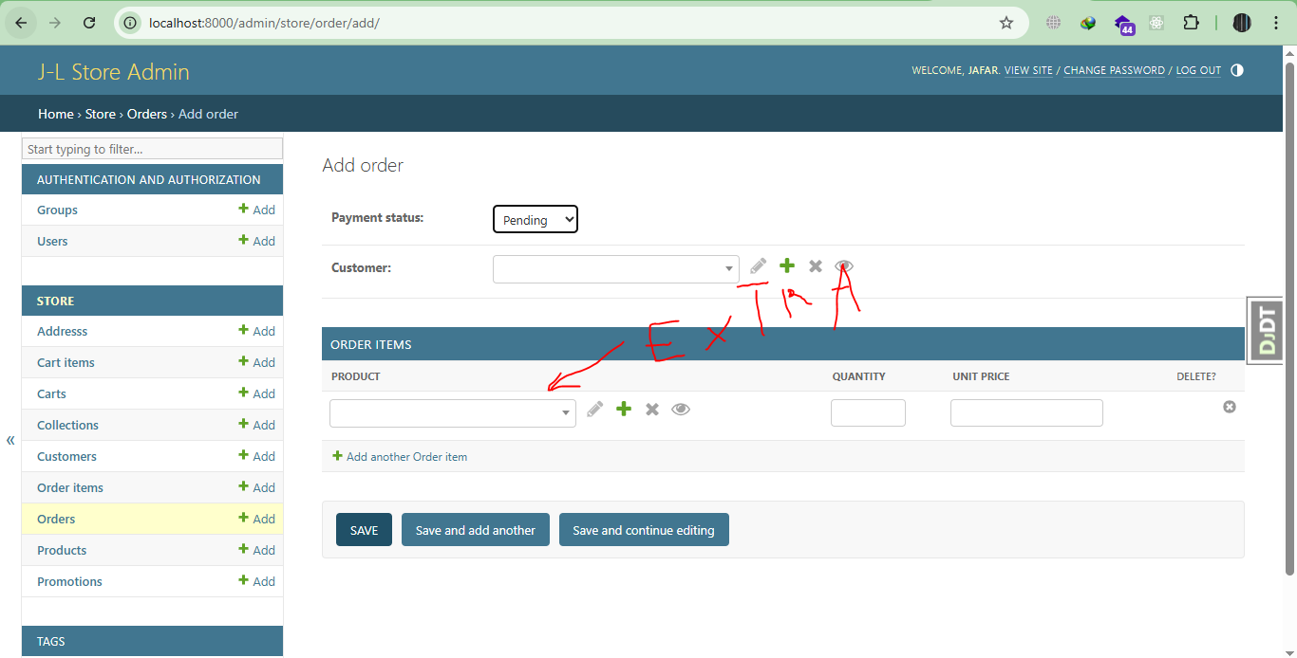

***************************************************************

To Add Generic Inline Item Like TagItem-Model:

admin.site.register(models.Tag)

admin.site.register(models.TaggedItem)

Then In Store Admin:

from django.contrib.contenttypes.admin import GenericTabularInline

class TagInline(GenericTabularInline):

    model = tags.models.TaggedItem

    min_num = 1

    max_num = 10

    extra = 0

class ProductAdmin(admin.ModelAdmin):

    list_display = [ 'id', 'title', 'unit_price', 'inventory_status', 'collection_title']

    list_editable = [ 'unit_price' ]

    list_filter = [ 'collection', 'last_update', InventoryFilter ]

    list_per_page = 10

    list_select_related = ['collection']

    actions = ['clear_inventory']

    prepopulated_fields = {

        'slug': ['title']

    }

    autocomplete_fields = ['collection']

    search_fields = ['title']

    inlines = [ TagInline ]

***************************************************************



