To Remove The Running Container By Force:

* *Run Command*: *docker rm -f container-name|container-id*

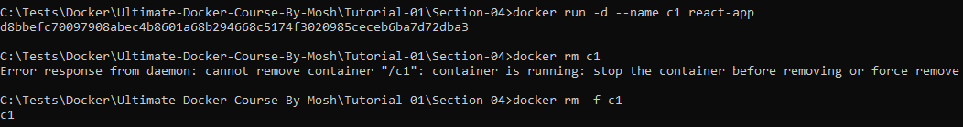

*********************************************************

*Note (To Remember)*: To Show The Stopped Containers:

* *Run Command*: *docker ps -a*

*Note (To Remember)*: Alpine Linux Doesn’t have *useradd OR groupadd*, And For Adding User OR Group We Need *adduser && addgroup*

*Note (To Remember):* We Need To Define The User, Use It, Then Define The Working Directory.

*Note (To Remember)*: When Using Shell Form For *CMD-Instruction* Of Docker File, It Will Use *Shell Process* OR *CMD Process* To Execute The CMD, So For Fasting Building We Need *Exec Form*.

*Note (To Remember)*: The *Latest Image Tag* May Not Point To *Latest Image ID*, We Must Link Them *Explicitly*.

*********************************************************

*Note (To Remember)*: To Show The Logs Of Specific Container:

* Run Command: *docker logs container-id-or-some-of-it*

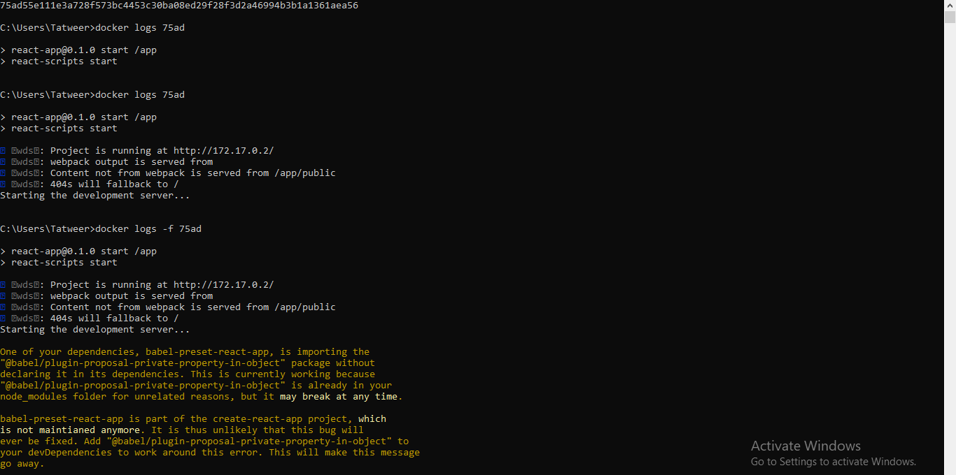

*********************************************************

*Note 1 (To Remember)*: Docker *Start-Command* Used To Start Stopped Container **(No New Process Will Be Created)**.

*Note 2 (To Remember)*: Docker *Run-Command* Used To Run New Container **(New Process Will Be Created)**.

*********************************************************

*Note*: To Run The Shell Session From Git-Bash Shell We Use winpty:

*winpty docker exec -it f14a30 sh*

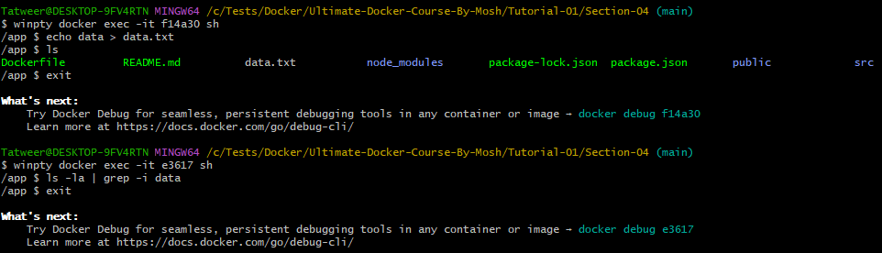

*********************************************************

*Note*: When We Delete The Container, Also The *FileSystem Of Container* Will Be Deleted, So We Must Store The Data Of Containers Inside Volumes.

********************************************************

To Create New Volume We Can Use: *docker volume create* ***name-here***

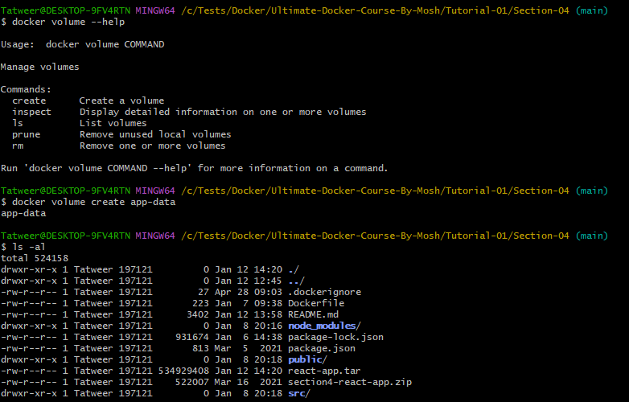

********************************************************

For Inspecting The Created Volume, We Can Run: ***docker volume inspect volume-name-here***

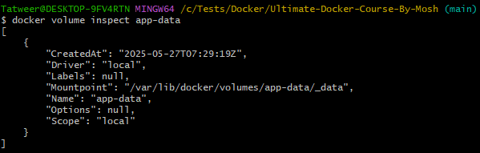

********************************************************

To Attach The Volume With Container:

* If The Volume Doesn’t Exists, Then Docker Will Create It

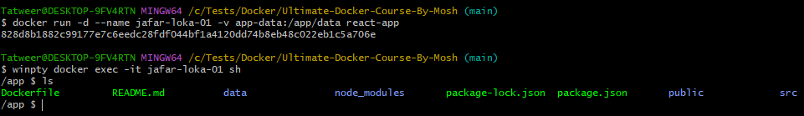

********************************************************

If We Want To Create Any File Inside The *Data-Directory*, Then We Will Get Permission Denied:

**Note**: The Reason About That, Is That Docker Will Create Data-Directory With *Root-Permission If Not Exists*.

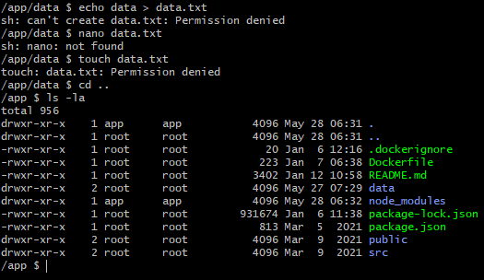

********************************************************

To Solve The Above Problem, We Need To Create The Data-Directory From Docker-File.

FROM node:14.16.0-alpine3.13

RUN addgroup app && adduser -S -G app app

USER app

WORKDIR /app

COPY package*.json .

RUN npm i

RUN ["mkdir", "data"]

COPY . .

ENV API_URL=https://jafar.loka.com/

EXPOSE 3000

# Exec Form

CMD ["npm", "start"]

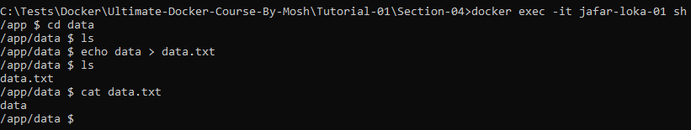

********************************************************

***Note***: The Benefit Of Using This Way To Create Volumes, Is That: We Can Share Volumes Between Multiple Containers.

***Note (From Me)***: We Can Use It As Simple Shared Memory Between *Microservices Applications*.

********************************************************

To Copy File From Container To Current Directory (From Container To Host)

Run Command: ***docker cp container-id:/path/to/file .***

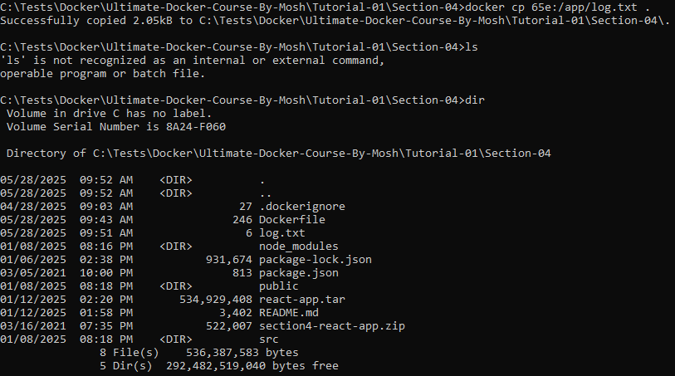

********************************************************

Also, We Can Copy The Files From Host To Container Using The Same Command:



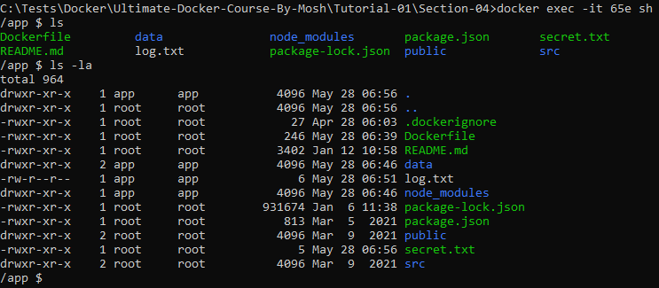

********************************************************

For Linux/Mac OS we can clear our working space using:

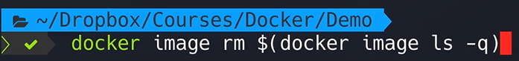

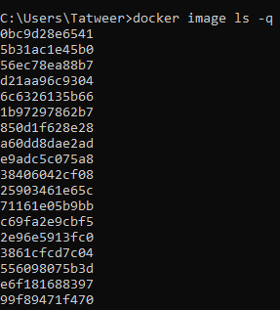

********************************************************

The same for containers:

**Note**: Here we set -a for stopped container also



********************************************************

If we have running containers, then we need to supply -f:



********************************************************

For cleaning all data from Troubleshooting Of Docker Desktop:

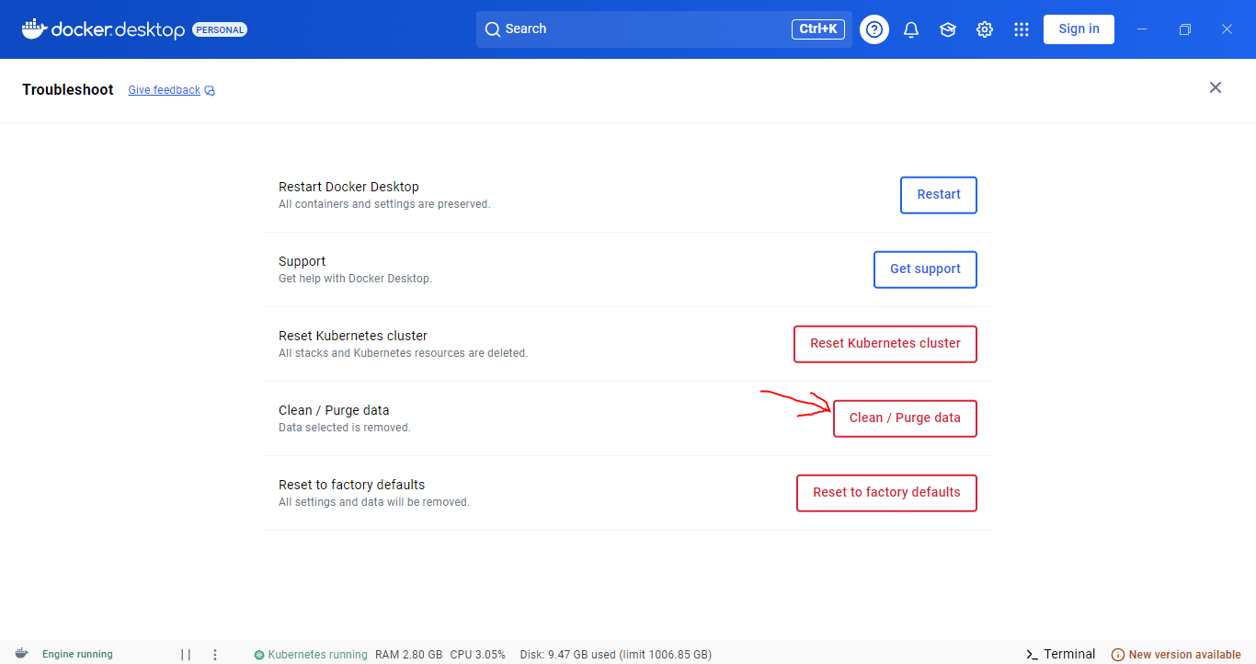

********************************************************

To indicate the start of .yml OR .yaml Files, we set: **---**

********************************************************

The *standard name for docker compose file*, is: ***docker-compose.yml***

********************************************************

In this way, we represented array in ***yml-files***:

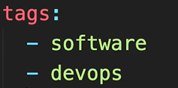

********************************************************

In this way, we represented objects in ***yml-files***:



