To Use FastAPI With Our Project:

* Run Command: ***pip install fastapi uvicorn[standard]***

*******************************************************************************

To Start Using FastAPI We Import It Then Use Decorators:

from fastapi import FastAPI;

app = FastAPI();

@app.get("/")

async def getHelloMessage():

    return { "Message": "Hello" };

*******************************************************************************

To Run The Server That Make FastAPI Work With Async-Capabilities:

* **Run Command In CMD**: *uvicorn python-file:fast-api-app*
  + **Ex**: uvicorn main:app
  + **Note**: In Development, For Each Change: *uvicorn main:app --reload*

*******************************************************************************

For Defining The Shape Of Models That We Can Use In Our App, We Need BaseModel From pydantic-Module:

from pydantic import BaseModel

# This Is For Our Request Content From User

class UserPostIn(BaseModel):

    body: str

# This Is For Our Output Response For User

class UserPost(UserPostIn):

    id: int

*******************************************************************************

To Define The Shape Of Response Model, We Can Use: response_model-attribute:

post_table = {}

@app.post("/post", response_model=UserPost)

async def create_post(post: UserPostIn):

    data = post.model_dump()

    last_record_id = len(post_table)

    new_post = {**data, "id": last_record_id}

    post_table[last_record_id] = new_post

    return new_post

@app.get("/post", response_model=list[UserPost])

async def get_all_posts():

    # return post_table.values()

    # OR We Can Use

    return list(post_table.values())

*******************************************************************************

For Adding The Routes Folder For Each Related Data; We Can Use: **APIRouter**

from fastapi import APIRouter

from models.post import UserPost, UserPostIn

router = APIRouter()

@router.get("/")

async def getHelloMessage():

    return {"Message": "Hello"}

post_table = {}

@router.post("/post", response_model=UserPost)

async def create_post(post: UserPostIn):

    data = post.model_dump()

    last_record_id = len(post_table)

    new_post = {**data, "id": last_record_id}

    post_table[last_record_id] = new_post

    return new_post

@router.get("/post", response_model=list[UserPost])

async def get_all_posts():

    # return post_table.values()

    # OR We Can Use

    return list(post_table.values())

*******************************************************************************

Then Inside The Main File That Use FastAPI-App Variable, And We Set The Prefix For The Route:

from fastapi import FastAPI

from routes.post import router as post_router

app = FastAPI()

app.include_router(post_router, prefix="/post")

*******************************************************************************

In This Way We Can Nest Models, To Use Each Other In Request OR Response Shape:

from pydantic import BaseModel

from post import UserPost

class UserCommentIn(BaseModel):

    body: str

    post_id: int

class UserComment(UserCommentIn):

    id: int

class UserPostWithComments(BaseModel):

    post: UserPost

    comments: list[UserComment]

*******************************************************************************

In This Way We Can Raise The Exceptions From FastAPI:

**Note**: The Details Can Be Dictionary That Contains Many Useful Information.

from fastapi import APIRouter, HTTPException

raise HTTPException(status_code=404, details="Post Not Found")

*******************************************************************************

For Adding ***The Status Code*** For Any Operation:

@router.post("/", response_model=UserComment, status_code=201)

*******************************************************************************

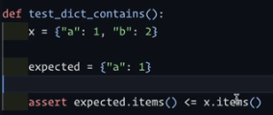

*******************************************************************************

To Begin Testing The FastAPI-Client:

from typing import AsyncGenerator, Generator

import pytest

from fastapi.testclient import TestClient

from httpx import AsyncClient

from main import app

from routes.post import post_table

from routes.comment import comment_table

*******************************************************************************

To Write The Test Client, We Use yield With The Function:

def client()-> Generator:

    yield TestClient(app=app)

*******************************************************************************

To Make Sure That Fixture Run With Every Test, We Can Use **autouse=True**:

@pytest.fixture(autouse=True)

async def db() -> AsyncGenerator:

    comment_table.clear()

    post_table.clear()

    yield post_table, comment_table

*******************************************************************************

If We Run Pytest With Async/Await Then It Will Fail:

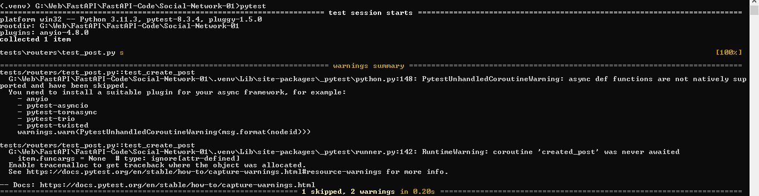

*******************************************************************************

To Run The **Async/Await Code** With FastAPI, We Need To Mark Tests With: *@pytest.mark.anyio*

*******************************************************************************

@pytest.mark.anyio

async def test_create_post(created_post):

    assert created_post[0] == 201

    assert {"body": "J-L-Test-01 Post"}.items() <= created_post[1].items()

*******************************************************************************

But We Need To Define:

@pytest.fixture(scope="session")

def anyio_backend():

    return "asyncio"

*******************************************************************************

# Note Here: If We Don't Set created_post, Then The Test Will Fail

# Because db-fixture use autouse, so foreach test the db will be empty

# and no post will found

@pytest.mark.anyio

async def test_create_comment(created_post: tuple, created_comment: tuple):

    status_code, data = created_comment

    assert status_code == 201

    assert { "body": "J-L-Test-01 Comment", "post_id": 0}.items() <= data.items()

*******************************************************************************

@pytest.fixture()

async def created_comment(async_client: AsyncClient):

    return await create_comment("J-L-Test-01 Comment", 0, async_client=async_client)

*******************************************************************************

async def create_comment(body: str, post_id: int, async_client: AsyncClient):

    response = await async_client.post(url='/comment/', json={"body": body, "post_id": post_id})

    # For Debugging Only

    # print("The Status Code Is: ", response.status_code)

    # print("The Response Body Is: ", response.json())

    return response.status_code, response.json()

*******************************************************************************

To Make Pydantic Read The Configuration From .env Variables File:

* **Run The Command**: *pip install pydantic-settings*

Then We Define Our Config Settings Class That Represent The Main Class For OUR Configuration Classes That Are Used For Our Project

from pydantic_settings import BaseSettings, SettingsConfigDict

class BaseConfig(BaseSettings):

    ENV_STATE: Optional[str] = None

    model_config = SettingsConfigDict(env_file='.env', extra="ignore")

*******************************************************************************

Then To Define OUR Configuration Classes:

class GlobalConfig(BaseConfig):

    DATABASE_URL: Optional[str] = None

    DB_FORCE_ROLL_BACK: bool = False

*******************************************************************************

class DevConfig(GlobalConfig):

    model_config = SettingsConfigDict(env_prefix='DEV_')

*******************************************************************************

class ProdConfig(GlobalConfig):

    model_config = SettingsConfigDict(env_prefix='PROD_')

*******************************************************************************

class TestConfig(GlobalConfig):

    # If We Want To Override These Variables We Can Add Them

    # To .env-File

    DATABASE_URL: Optional[str] = "sqlite:///test.db"

    DB_FORCE_ROLL_BACK: bool = True

    model_config = SettingsConfigDict(env_prefix='TEST_')

*******************************************************************************

Then To Get The Values Of Our Class Depending On Env State:

**Note**: To Cache Functions Depending On Parameters, We Can Use lru cache from *functools-module*.

from functools import lru_cache

@lru_cache()

def get_config(env_state: str):

    configs = {"dev": DevConfig, "prod": ProdConfig, "test": TestConfig}

    if env_state not in configs.keys():

        raise Exception("Invalid Value For env_state Variable")

    return configs[env_state]()

*******************************************************************************

Then To Get The Object Of Our Configuration:

config = get_config(BaseConfig().ENV_STATE)

*******************************************************************************

To Create The Database, With Its Tables, We Need MetaData-Object:

import databases

import sqlalchemy

from config import config

metadata = sqlalchemy.MetaData()

*******************************************************************************

Then We Create The Tables That We Need, And Combine Them With MetaData-Object.

First, It’s The Name Of Table.

Second, It’s The MetaData-Object.

Third, A List Of Columns That Table Contain, Without []

### Create The Posts Table ###

post_table = sqlalchemy.Table(

    "posts",

    metadata,

    sqlalchemy.Column("id", sqlalchemy.Integer, primary_key=True),

    sqlalchemy.Column("body", sqlalchemy.String),

)

### Create The Comments Table ###

comments_table = sqlalchemy.Table(

    "comments",

    metadata,

    sqlalchemy.Column("id", sqlalchemy.Integer, primary_key=True),

    sqlalchemy.Column("body", sqlalchemy.String),

    # Here We Don't Need To Tell The Type Of Column, Because It's ForeignKey

    # So It Will Give It The Same Type Of Id Of Posts Table.

    sqlalchemy.Column("post_id", sqlalchemy.ForeignKey("posts.id"),nullable=False, ),

)

*******************************************************************************

Then We Will Create The Engine That Will Make The Database With MetaData-Object:

# connect_args = { "check_same_thread": False } --> This Only Required For Sqlite

engine = sqlalchemy.create_engine(

    url = config.DATABASE_URL, connect_args={ "check_same_thread": False }

)

*******************************************************************************

# Tell The Engine To Use The MetaData Object

# So, When We Run The Code, All The Tables That Are Combine

# With The metadata-object, Will Be Created

metadata.create_all(engine)

*******************************************************************************

database = databases.Database(

    url=config.DATABASE_URL, force_rollback=config.DB_FORCE_ROLL_BACK

)

*******************************************************************************

In Python **ContextManager** Do The *Setup And TearDown*, Like We Use with-keyword.

*******************************************************************************

To Use The ContextManager With FastAPI LifeSpan:

**Note**: The Old Way Of Using Starup And Down With FastAPI Can Be Used Also, But This Is The Perfect Way Now.

from contextlib import asynccontextmanager

from database import database

@asynccontextmanager

async def lifespan(app: FastAPI):

    await database.connect()

    yield

    await database.disconnect()

app = FastAPI(lifespan=lifespan)

*******************************************************************************

from contextlib import asynccontextmanager

from fastapi import FastAPI

from routes.post import router as post_router

from routes.comment import router as comment_router

from database import database

@asynccontextmanager

async def lifespan(app: FastAPI):

    await database.connect()

    yield

    await database.disconnect()

app = FastAPI(lifespan=lifespan)

app.include_router(post_router, prefix="/post")

app.include_router(comment_router, prefix="/comment")

*******************************************************************************

The Best Way To Use Config In Test Environment, Before We Load Our App, We Override The **ENV_STATE-Variable**:

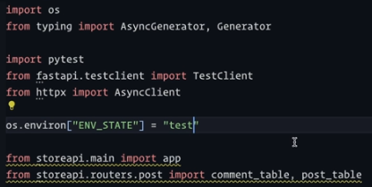

*******************************************************************************

@pytest.fixture(autouse=True)

async def db() -> AsyncGenerator:

    # comment_table.clear()

    # post_table.clear()

    await database.connect()

    yield

    await database.disconnect()

*******************************************************************************