**Note**: To Show The Changes In Working Directory, Not In Staging Area, We Can Use:

* **Run Command**: ***git diff***

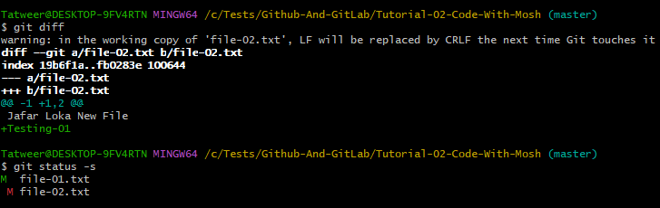

*********************************************************

To Set VSCode AS The Diff Tool In Global Config Of Git:

* **Run Command** (This Will Give The Name Only Of Diff Tool): *git config --global diff.tool vscode*
* **Run Command**: *git config --global diff.tool.vscode.cmd "code --wait --diff $LOCAL $REMOTE"*
* **Note:** Here We Set $LOCAL And $REMOTE Inside The .gitconfig Manually.

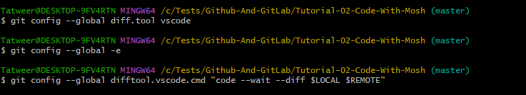

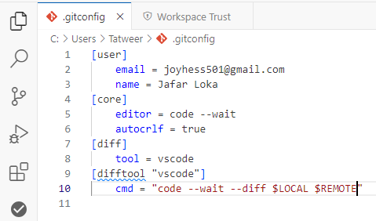

*********************************************************

Note: To Start The Diff Tool Of VSCode, We Can Use:

* Run Command: *git diff.tool*
  + In This Way We Show Only Working Area

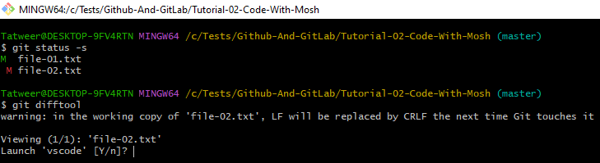

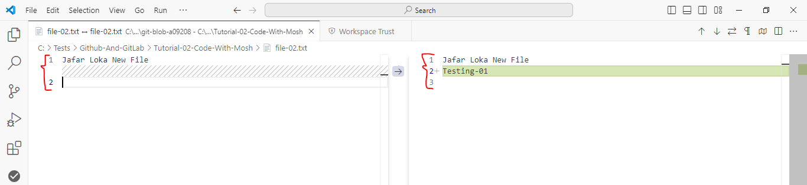

*********************************************************

For Staging Area, We Can Run:

* Run Command: *git difftool --staged*

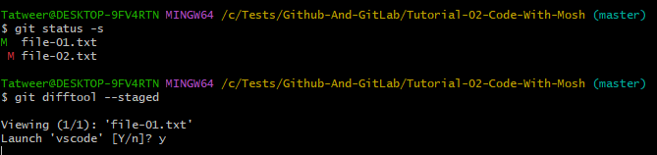

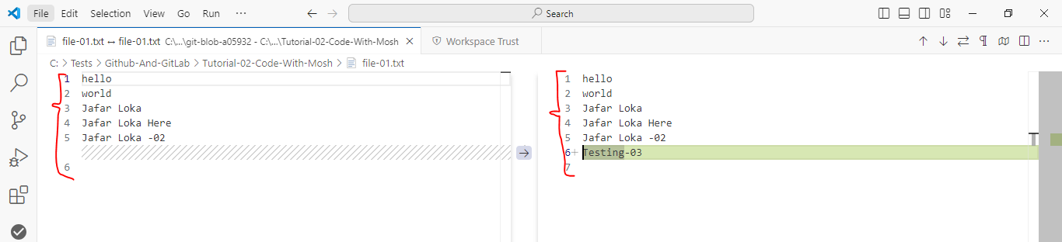

*********************************************************

**Note (To Remember)**: To View The Commit History Of Our Project, We Can Use:

* **Run Command**: *git log*

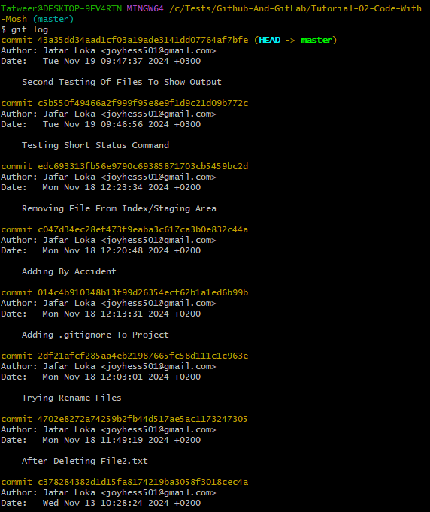

*********************************************************

**Note**: To Show The Short Summary Of Commit History, We Can Use:

* **Run Command**: *git log –oneline*
* **Note:** This Command Show The Commands From End To Start.

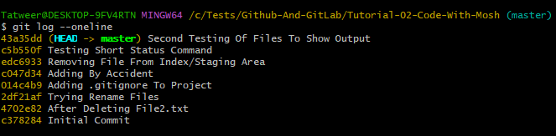

*********************************************************

**Note**: To Show The Short Summary Of Commit History In Reverse Order From Begin To End, We Can Use:

* **Run Command**: *git log --online --reverse*

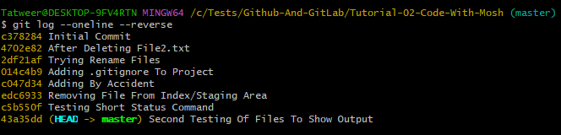

*********************************************************

To Show Details Of Specific Commit, We Can Use:

* Run Command: *git show short-commit-id-here*
  + Ex: *git show* edc6933

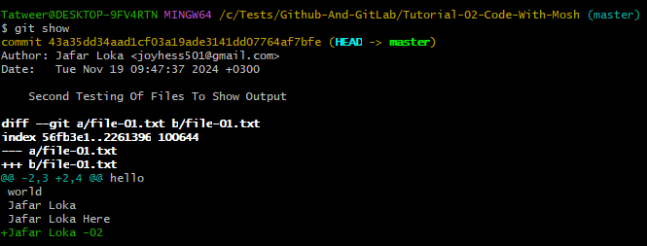

*********************************************************

To Show Specific Commit After The Head Commit We Can Use:

* Run Command: *git show HEAD~Number-Here*
  + Ex: git show HEAD~2
    - Note: This Will Go 2-Step Back From HEAD Commit.

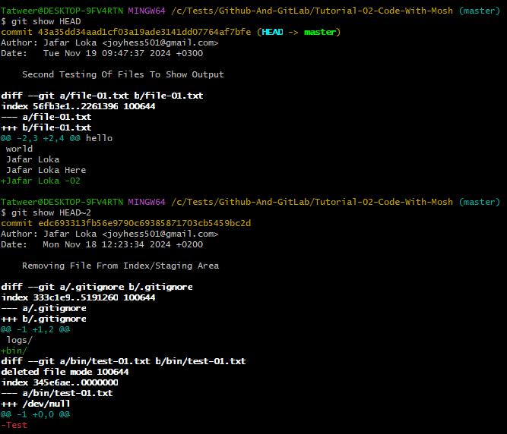

*********************************************************

To Show The Detail Of Specific File For Specific Version Of Project, We Can Use:

* Run Command: *git show HEAD~2:.gitognore*
  + Here .gitignore is The File That We Want To Show.

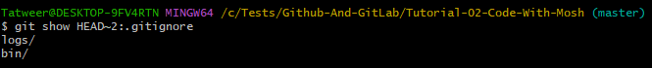

*********************************************************

To Show All Files And Directories That Are Stored In The Commit:

* Run Command: *git ls-tree commit-id-here*
  + Ex: *git ls-tree HEAD*
  + Note: Here Files Represented AS Blob, And Folders Represented AS Tree.



