To Get The Data Of All Commits That Has Files Contain Specific Keyword:

* **Run Command**: *git log --oneline -S"Text-Here"*
  + **Ex**: *git log --oneline -S"Jafar"*
  + **Note:** Here We Can Add --patch To get Full Information About Data.

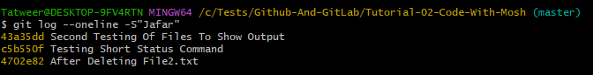

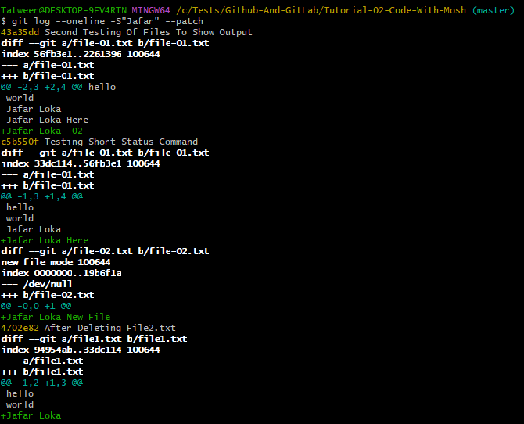

************************************************

**Note (To Remember)**: If We Want To Get The Data Of Specific Range Between Two Commit:

* Run Command: *git log --oneline commit-id-01..commit-id-02*

************************************************

To Get The Commits That Change Specific File:

* **Run Command**: *git log --oneline file-name-here.extension*

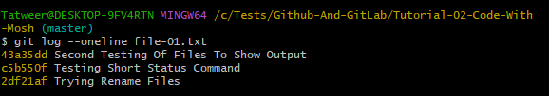

************************************************

To Separate The File Name From Command:

* **Run Command**: *git log --oneline -- file-name-here*

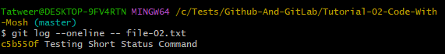

************************************************

To Get The Full Change Of Specific File:

* Run Command: ***git log --oneline --patch file-name-here.extension***

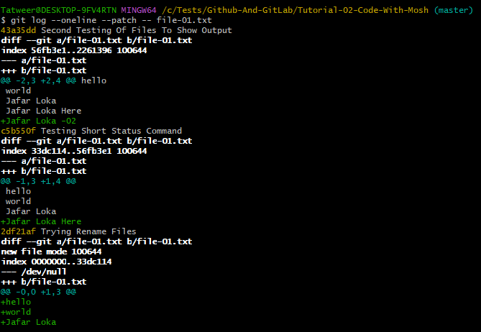

************************************************

To Create Alias Name For Command In Git:

* **Run Command**: *git config --global alias.cmd-name-here "Long Git Command Here"*
  + **Ex**: *git config --global alias.simple "log --oneline"*

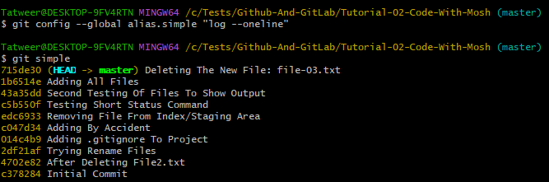

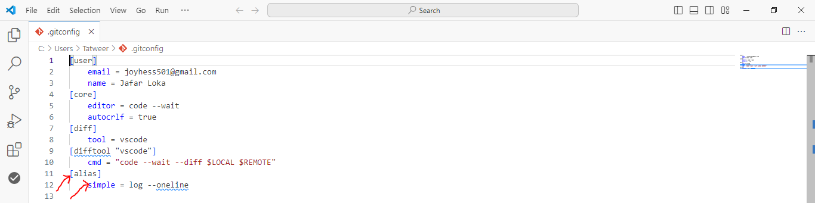

************************************************

**Note (To Remember)**: To Show The Information About Specific Commit, We Can Use:

* **Run Command**: *git show HEAD~2*

************************************************

**Note (To Remember)**: To Show The Information About Specific File, In Specific Commit, We Can Use:

* **Run Command**: *git show HEAD~2:file-name-here.extension*

************************************************

To Show Only The Name Of Files, That Are Changed Of Specific Commit:

* **Run Command**: *git show HEAD~2 --name-only*

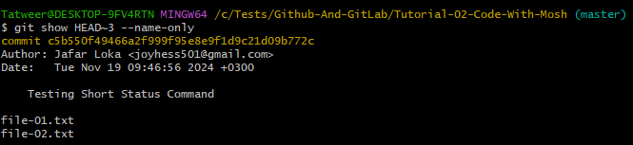

************************************************

To Get The Status Of Files In Specific Commit:

* **Run Command**: *git show HEAD~2 --name-status*

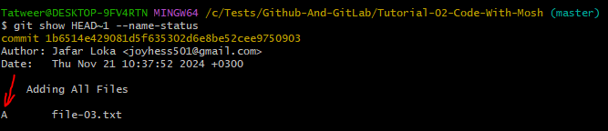

************************************************

To See The Changes Between Specific Two Commits:

* **Run Command**: *git diff commid-id-01 commit-id-02*

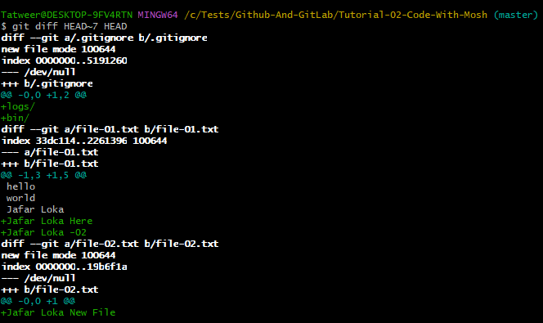

************************************************

To See The Results Of Changes Between Two Commit, For Specific File:

* **Run Command**: ***git diff HEAD~7 HEAD File-Name-Here.extension***

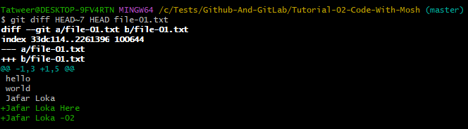

************************************************

**Note**: For Previous Command, We Can Also Use **--name-only** && **--name-status**

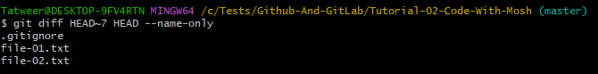

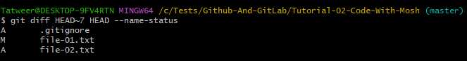

************************************************

**Note**: This Problem Occur When **HEAD && Master** Point To Different Commit.

* In This Way We May Have Commit Point That Are Not Reachable When ***HEAD && Master*** Refer To The Same Commit.
* In This Way We Have Dead Commit.

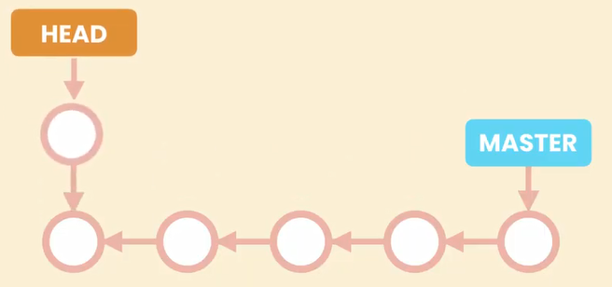

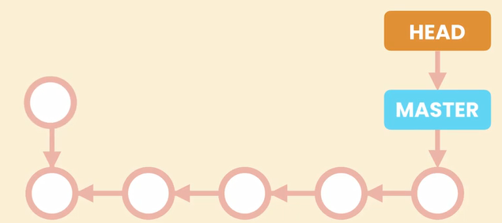

************************************************

**Note**: Here we Use checkout To Check The Problem:

* *Run Command*: *git checkout commit-id-here*
  + *Ex*: *git checkout HEAD~3*

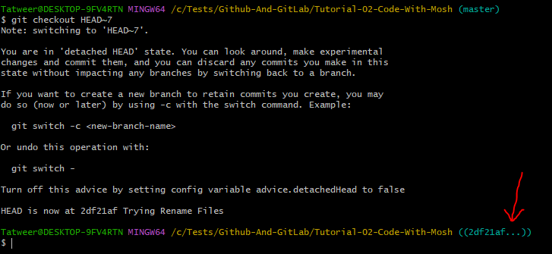

After We Checkout We Can **Run Command**: *git log --oneline*, To See The Changes.

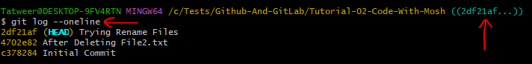

************************************************

To See All The Commits After We Checkout:

* Run Command: git log --oneline --all

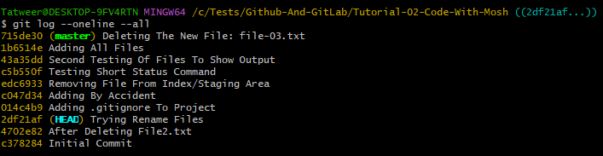

************************************************

To Return To Master Branch:



