If We Want To Share Our Packages Of Our Projects With Other:

* Run: *pip freeze > requirements.txt*

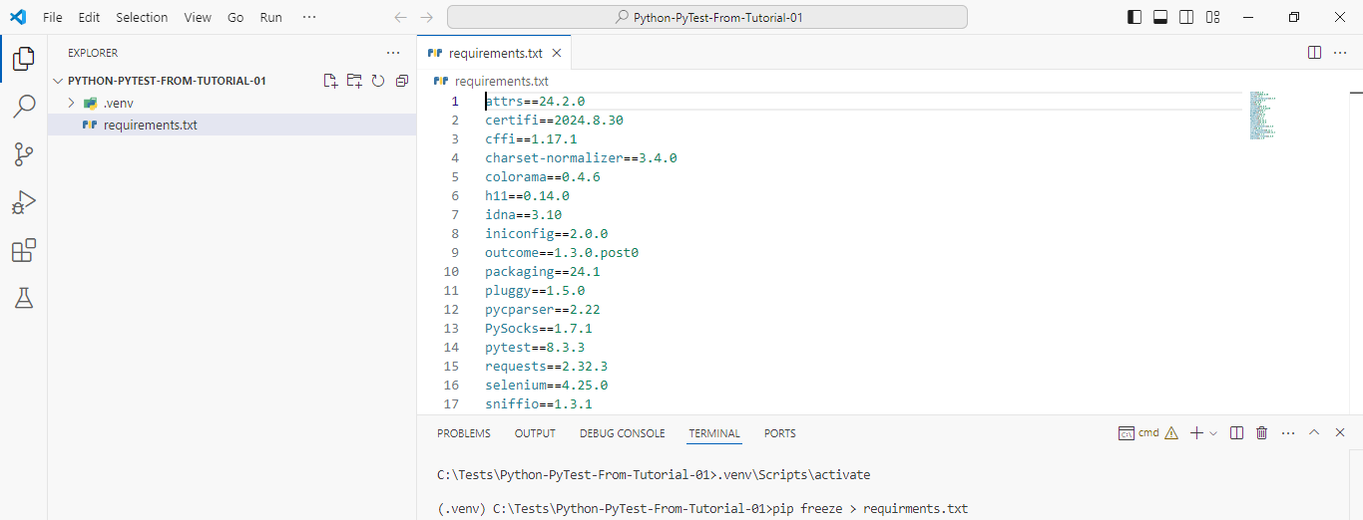

*************************************************

**Note 1**: We Must Name All Test Modules: *test_name_here.py*.

**Note 2**: We Must Name All Test Functions: *test_func_name_here*.

**Note 3**: We Must Name All Test Classes: *Test<Name_Here>.*

*************************************************

To Show The Percentage Of Test Completeness:

* Run: pytest -vv

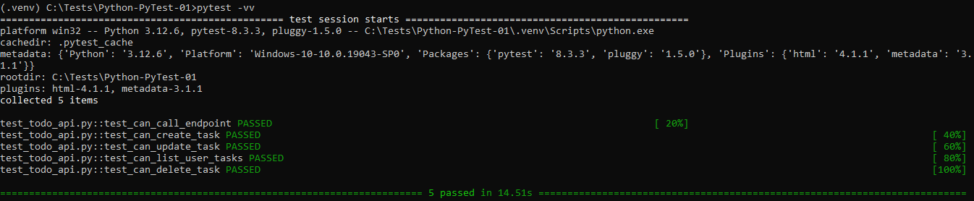

*************************************************

**Note 1**: In PyTest, We Can Run The Fail Tests Using Arguments.

*************************************************

Understanding Test Outputs :

• --lf, --last-failed : only re-run the failures.

• --ff, --failed-first : to run the failures first and then the rest of the tests.

• Ref doc pytest_cache: <https://docs.pytest.org/en/latest/cache.htm>

*************************************************

When We Want To Make Test Cases Using Classes:

* The Name Of Class Must Start With *Test*
* The Class Must Not Contain Constructor: *__init__(self)*
* The Test Cases (Functions) Must Start With: *test_*

class TestClass:

    def test_t1(self):

        assert 1 == 1;

*************************************************

If We Want To Check The Exceptions Using The Test Cases Then We Can Use:

* Import: *import pytest*.
* Use raises: *with pytest.raises(Exception):*
* Set The Logic: *assert (1/0)*

**Note 1**: In This Way We Can Catch The Exceptions In Run-Time.

def test_t2(self):

        with pytest.raises(Exception):

            assert (1/0);

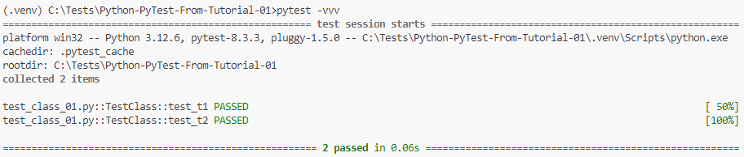

*************************************************

If We Want To Skip Some Of The Tests That We Don’t Want To Run:

* Import: import pytest
* Annotate The Skipped Test With: @pytest.mark.skip(reason='Reason Will Be Here')

@pytest.mark.skip(reason="Skip Reason Will be Here")

def test_skip_test(self):

assert type(1) == int;

*************************************************

Also, We Can Use Conditional Skipping:

**Note 1**: Here We Must Set The Reason.

@pytest.mark.skipif(sys.version_info.major>=3, reason="No Reason Here")

def test_t1(self):

assert 1 == 1;

*************************************************

If We Want To Skip The Full Module, We Add This At The First Line:

pytestmark = pytest.mark.skipif(sys.platform == 'win32', reason="No Reason Here")

*************************************************

If We Want To Mark The Test Function:

* Import: *import pytest*
* Add Annotation With Specific Name: *@pytest.mark.name_will_be_here*
* Create New File: *pytest.ini*
* Add The Marker Name To It, As Displayed In The Picture.

**Note 1**: Marker Name Can Be Used Multiple Times In The Same File OR Other Files.

**Note 2**: Test Function Can Have Multiple Marker Names.

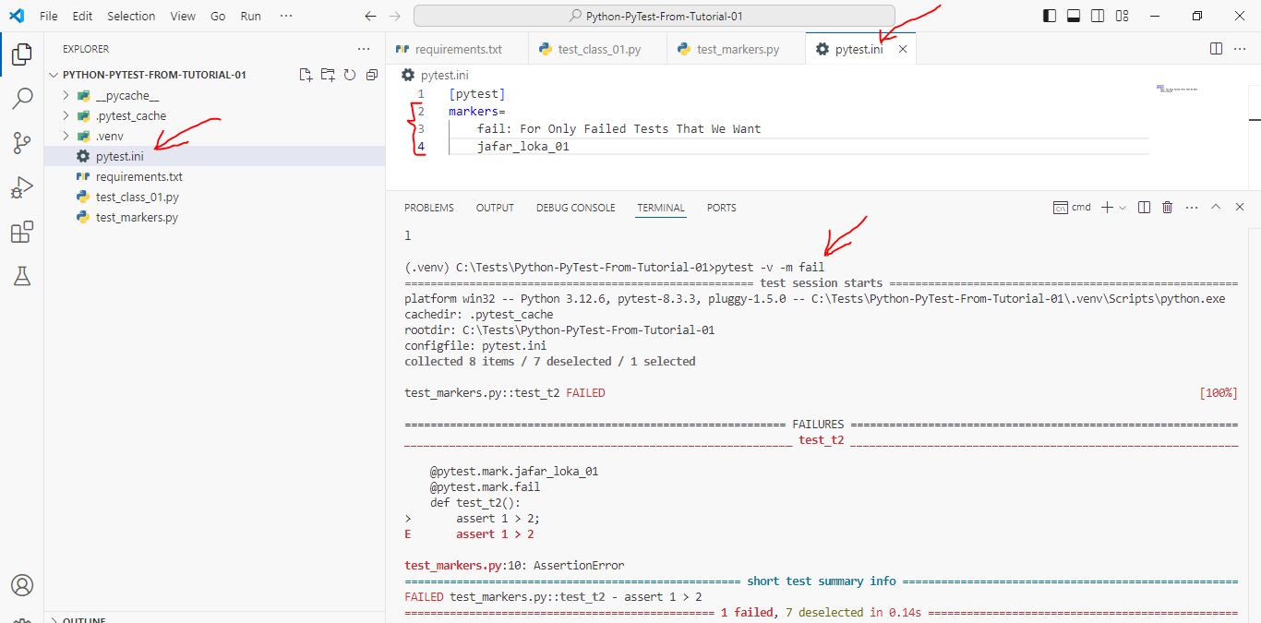

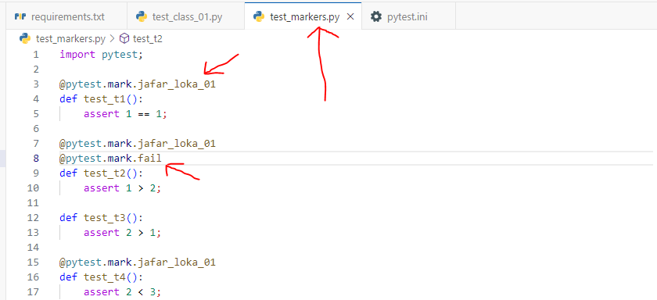

*************************************************

For Markers, We Can Run Tests Using Conditional Statements:

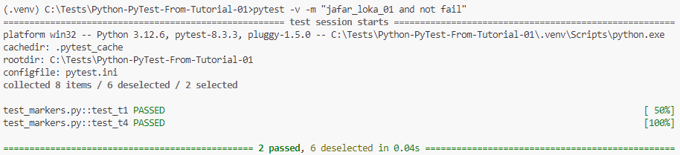

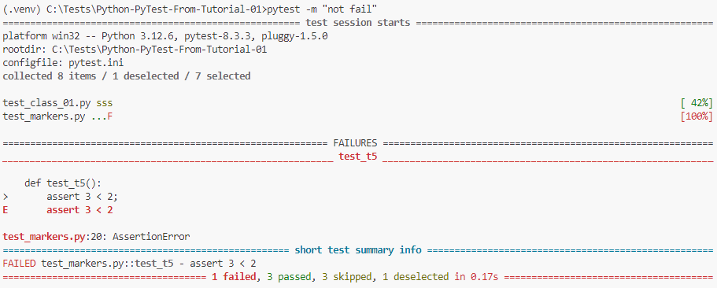

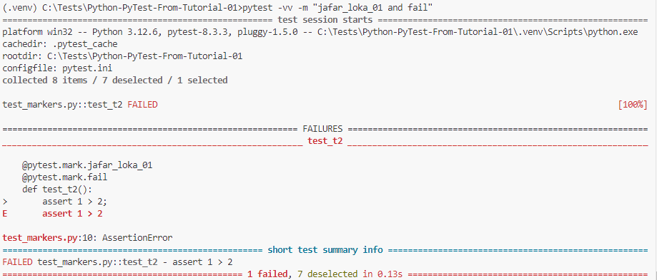

*************************************************

If We Want To Mark The Complete Module With Specific Mark:

* Import: *import pytest*.
* Add The Line: pytestmark=[…Marks Will Be Here…]
* Create New File: pytest.ini
* Add The Conf. To The *pytest.ini-File*
* Run The Tests.

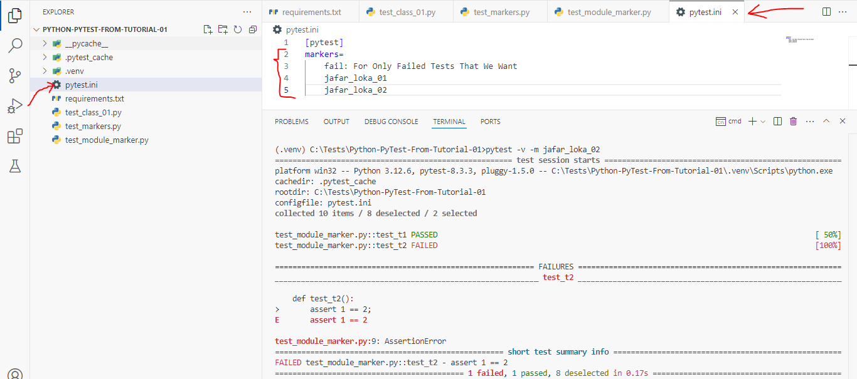

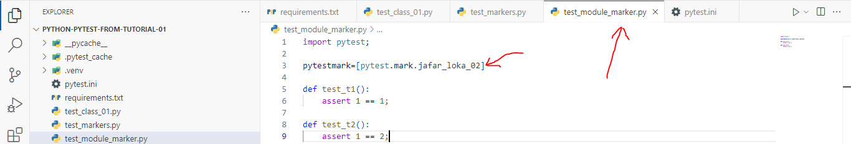

*************************************************

**Note**: We Must Define The pytest.ini-File At The Root Of The Folder, Else It Will Not Worked.

*************************************************

If We Want To Test Any Function That We Know It Will Fail, Then We Use *xfail*.

**Note**: We Use Here The Same Steps.

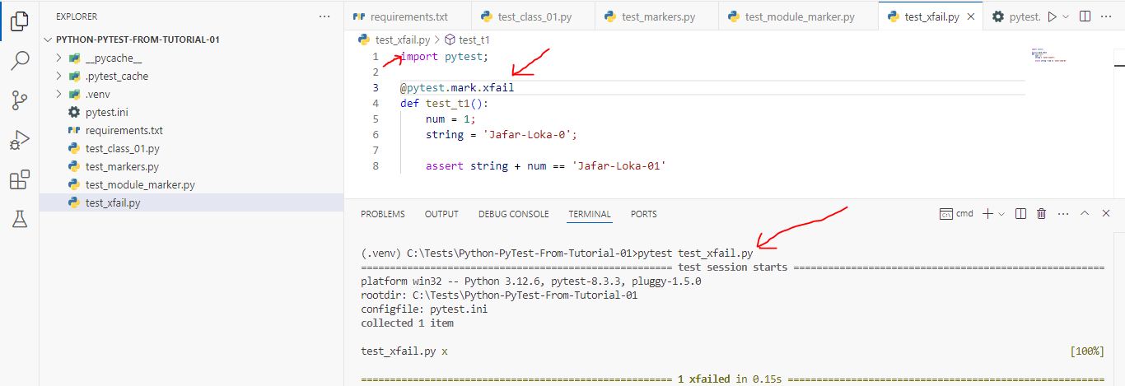

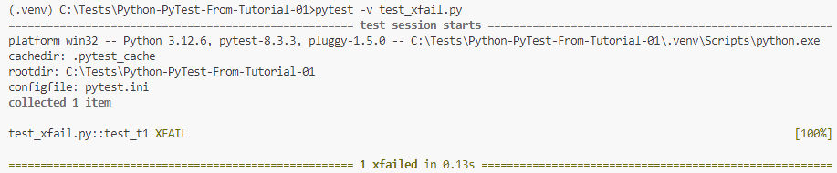

*************************************************

**Note**: If Any Test Function Marked With xfail, And The Result is Passed, Then The Final Result Of Testing is *XPass*, Not *XFAIL*.

*************************************************

**Note**: We Can Add Reason To xfail-Annotation.

*************************************************

**Note**: We Can Also Use Conditional Statement With XFail.

*************************************************

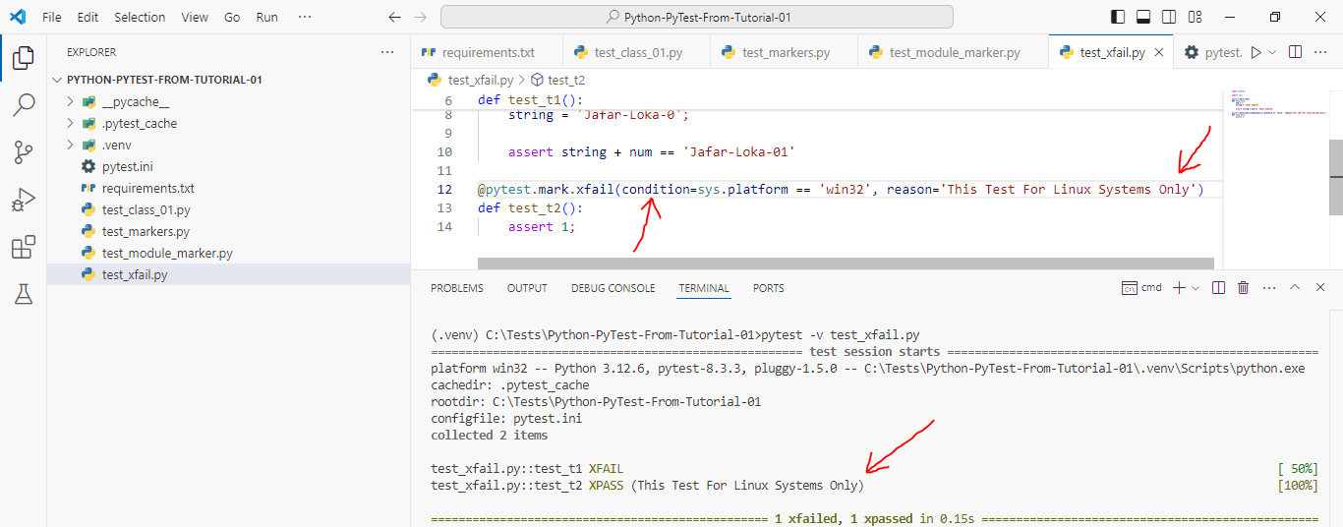

*************************************************

**Note**: If The Condition Is Not True, Then The Test Will Run As Any Normal Test.

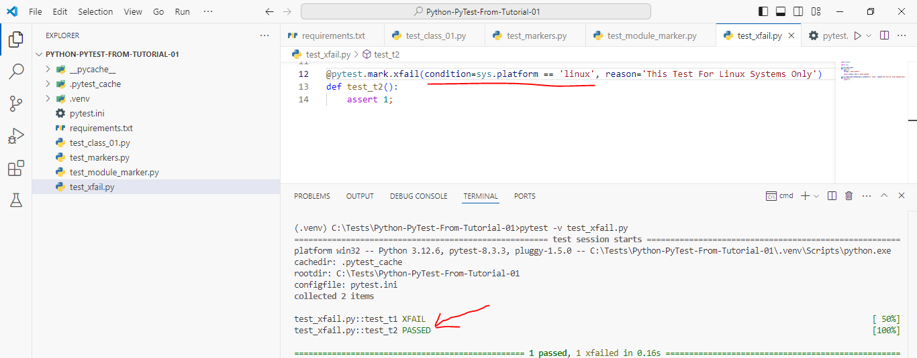

*************************************************

**Note 1**: We Can Also Add raises To Xfail-Marker Annotation, And it Work As Same As Condition.

*************************************************



