**Fixtures**: Functions That Run Before (Some Of Them After) The Test Functions.

The Most Value Of Them: Using For DB Initialization, WebDriver Initialization, And …etc.

*************************************************

**Note**: If We Set The Fixture Inside Any File, It Then Will Run For That File Only.

*************************************************

**Note**: If We Set Fixtures Inside The conftest.py-File It Will Be Then Available To All Directories And Sub-Directory.

*************************************************

import pytest;

@pytest.fixture()

def setup_names():

    print("=" * 15);

    print("\n ... Setup From Fixtures ...\n");

    print("=" * 15);

    return ["Jafar", "Loka", "Jafar-Loka-01"];

def test_len_of_names(setup_names):

    assert len(setup_names) == 3;

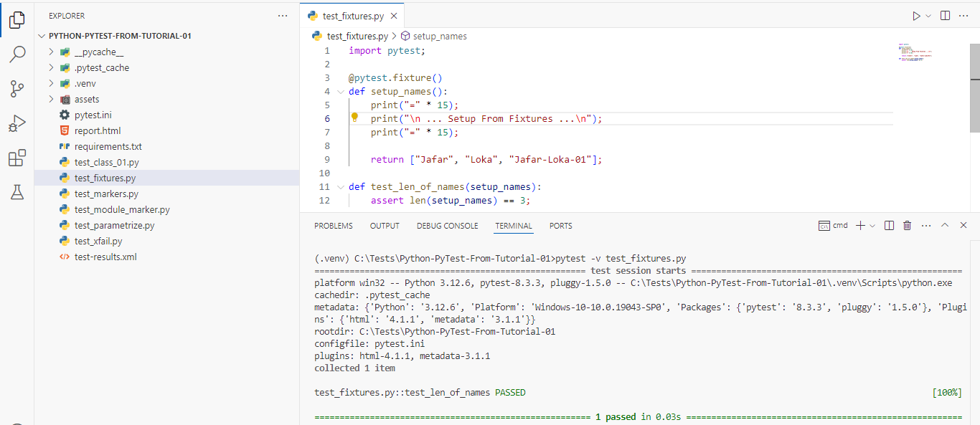

*************************************************

If We Use Fixtures With Markers, Then The Returned Value From Fixtures Can’t Be Used.

We Can Use Fixtures Using Markers, By This Way:

@pytest.mark.usefixtures("setup_names")

def test_use_fixtures():

    assert 1 == 1;

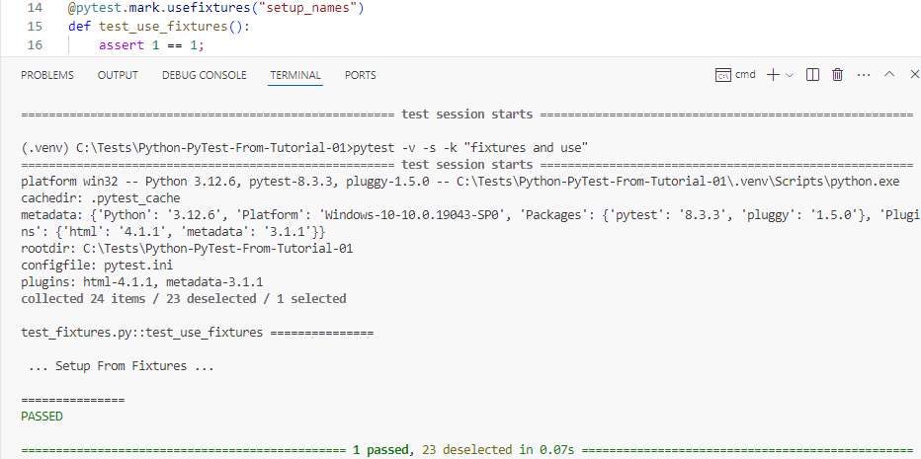

*************************************************

If We Want To Close The:

* Connection To DB.
* The Driver Page.
* The File.
* Any Thing That We Returned From Fixture

Then We Must Use Yield.

days1 = ["Sat", "Sun", "Mon"];

days2 = ["Tue", "Wed", "Thu"];

@pytest.fixture()

def setup_days1():

    wk1 = days1.copy();

    wk1.append('Fri');

    yield wk1;

    print("\n After Yield Wk1 \n");

    # wk1.clear();

    wk1.pop();

def test_wk1(setup_days1):

    assert len(setup_days1) == 4;

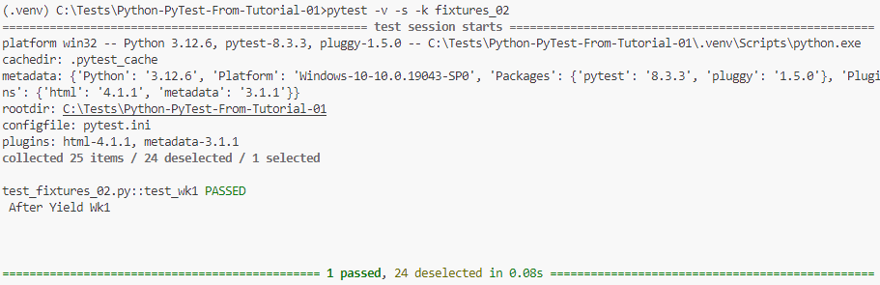

*************************************************

We Can Also, Use Multiple Fixtures For The Same Test:

def test_wk1_wk2(setup_days1, setup_days2):

    assert len(setup_days1) + len(setup_days2) == 7;

*************************************************

We Can Use This Way To Handle DB Connection Open, File Open, …etc.

@pytest.fixture()

def setup_days1():

    wk1 = days1.copy();

    wk1.append('Fri');

    yield wk1;

    wk1.pop();

@pytest.fixture()

def setup_days2():

    wk2 = days2.copy();

    yield wk2;

    wk2.clear();

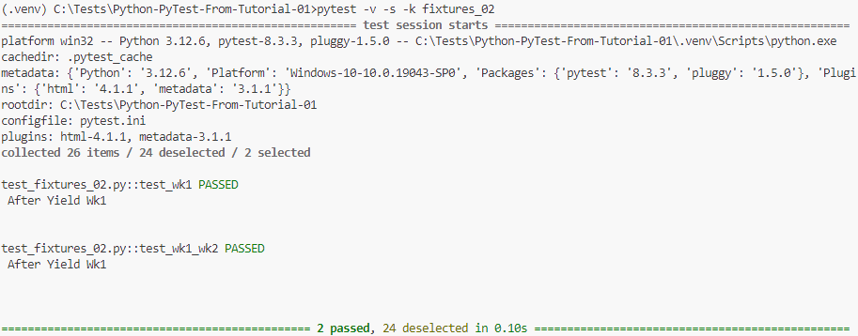

*************************************************

The conftest.py File Used To Share The Fixtures Across The Test Files.

We Can Set Multiple conftest.py Files In All Subdirectories.

It Shouldn’t Import The conftest.py-Files From The Test Files.

The conftest.py File Is Python Module.

*************************************************

**Note**: If We Used Files Using Fixtures And Generators (Yield), We Must Close Them Before Remove Them From Directories.

*************************************************

To Create Global Variables For Fixtures, To Use Them We Can Use: *pytest_configure.py*:

def pytest_configure():

    pytest.weekdays1 = ['sat', 'sun', 'mon'];

    pytest.weekdays2 = ['tue', 'wed', 'thu'];

*************************************************

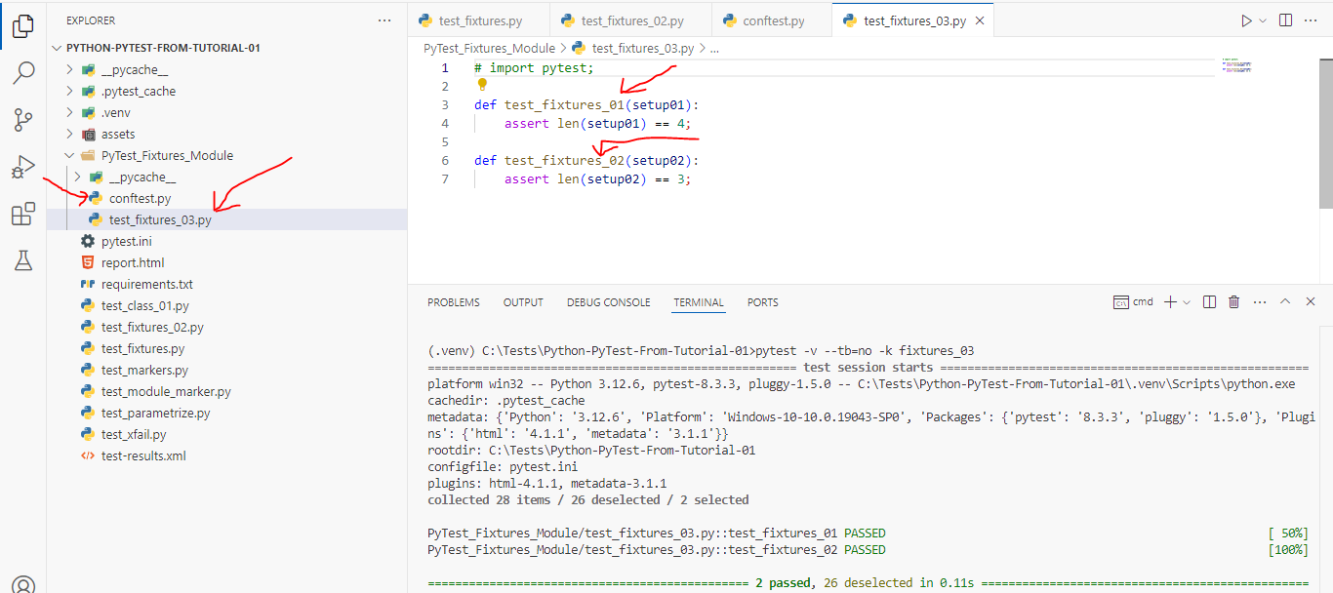

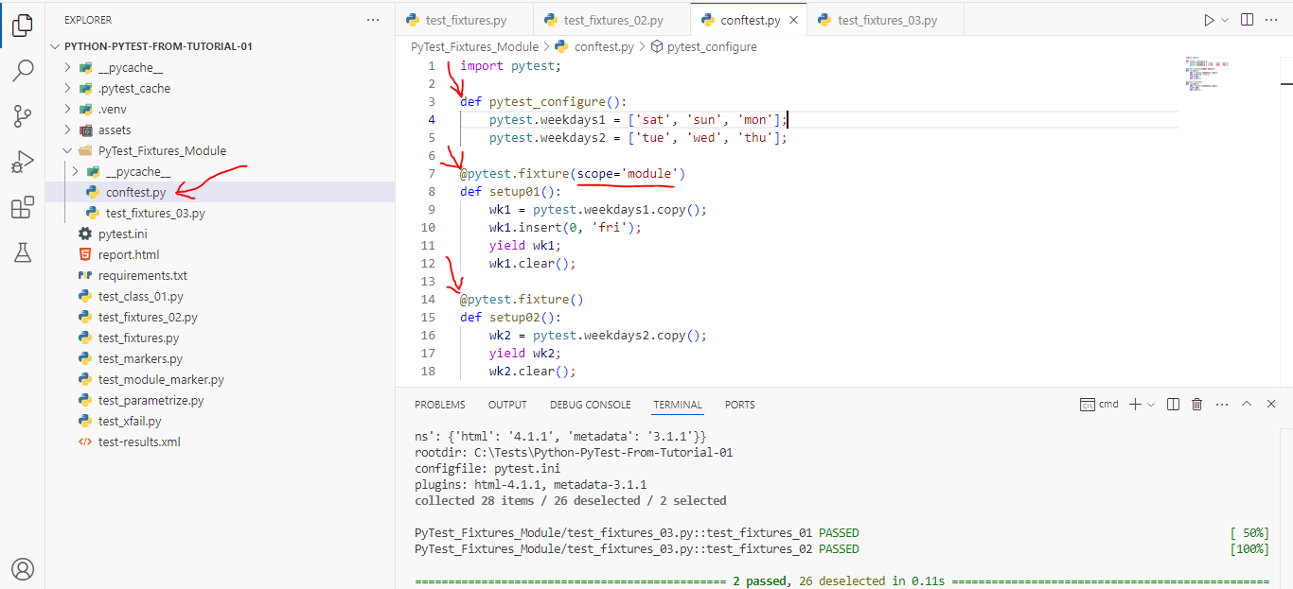

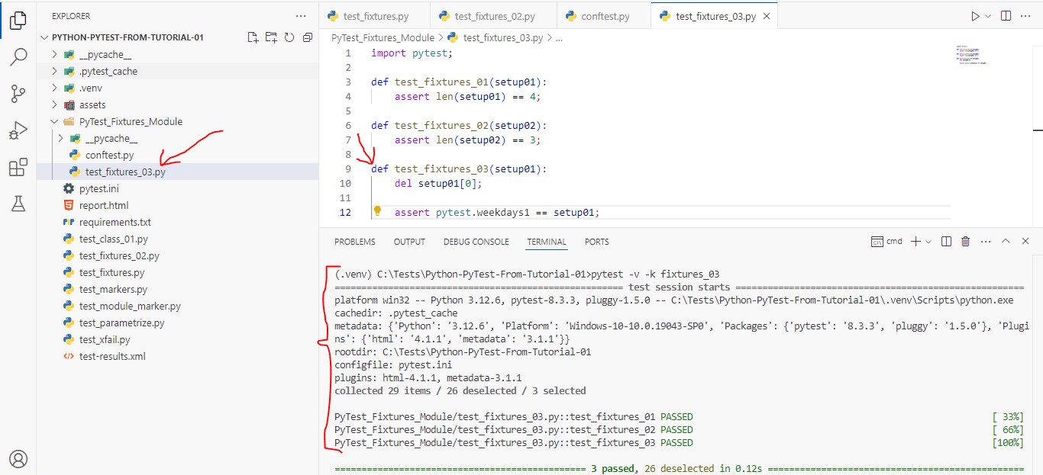

*************************************************

**Note**: Fixtures Can Be Overridden From Test Module Level.

*************************************************

If We Want To Show The Fixtures That We Use We Can Use: --setup-show With Pytest:

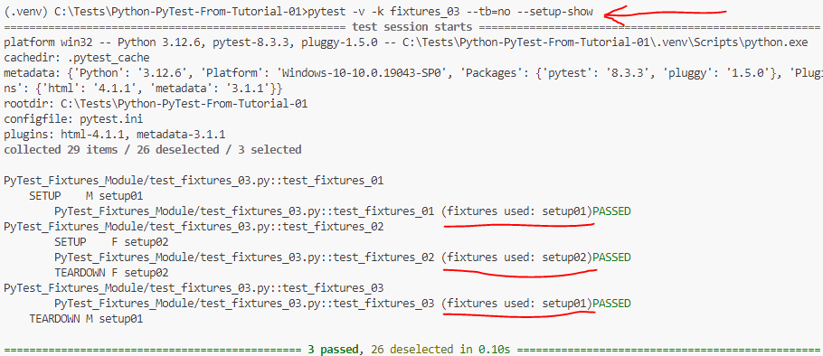

*************************************************

We Can Use Fixtures To Intercept The Test Function Calling:

**Note**: Here The Months Are Inside The Test Function That Use This Fixture.

@pytest.fixture()

def setup04(request):

    months = getattr(request.module, "months");

    print("\n The Setup04 Fixture");

    print("\n Fixture Scope: ", str(request.scope));

    print("\n Calling Function: ", request.function.__name__);

    print("\n Calling Module: ", request.module.__name__);

    print("\n The Months Of Function Are: ", months);

    months.append("April");

    yield months;

    months.pop();

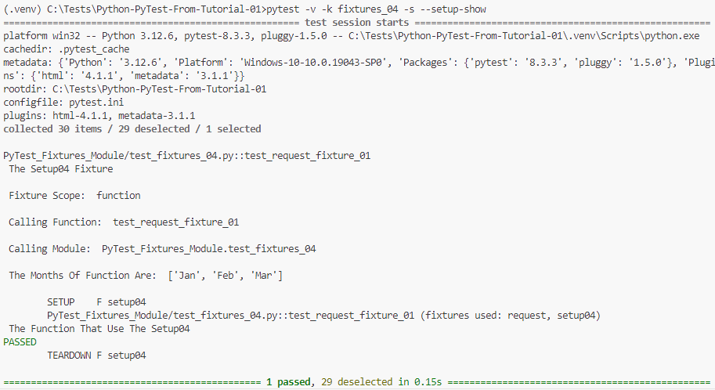

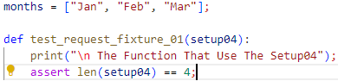

*************************************************

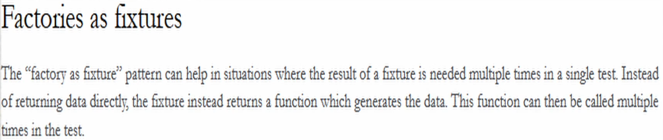

*************************************************

In This Way We Can Define Fixture As Factory:

@pytest.fixture()

def setup05():

    def get_structure(name):

        if name == 'list':

            return [1, 2, 3];

        elif name == 'tuple':

            return (1, 3, 4);

    return get_structure;

And In This Way We Can Call Our Fixture That Used Factory:

def test_fixtures_list_05(setup05):

    list = setup05('list');

    assert 'list' in str(type(list));

def test_fixtures_tuple_05(setup05):

    tuple = setup05('tuple');

    assert 'tuple' in str(type(tuple))

*************************************************

**Note (From Me)**: We Can Use Factory As Fixture To Generate The List Of Data That Represent The Test Parametrization Data.

*************************************************

**Note**: This Function Will Be Called 2-Times, For Each Test Cases:

import pytest;

@pytest.fixture(params=[(3, 4), [3, 5]])

def fixture01(request):

    return request.param;

*************************************************



