To Use React Hook Form, We Can Import It:

import { useForm } from 'react-hook-form'

************************************************************************************

Then We Destruct What We Want:

const {

    register,

    handleSubmit,

    formState: { errors, isSubmitting },

    reset,

    getValues

  } = useForm();

************************************************************************************

The FormState Contain Multiple Properties That We Can Use For Validation.

************************************************************************************

To Make The Field is Required We Can Use:

<input { ...register('email', { required: 'The Email Is Required'}) } type='email' placeholder='Entre Your Email'

          className='px-4 py-2 rounded outline-none' />

************************************************************************************

To Check More Validation Like Min-Length:

<input

          { ...register('confirm',

            {

              required: 'The Confirm Password is Required',

              minLength: {

                value: 5,

                message: "The Confirm Must Be 5-Chars At Least"

              }

            })

          }

        type='password' placeholder='Confirm Your Password'

          className='px-4 py-2 rounded outline-none' />

************************************************************************************

The Basic For Handling Form Submitting Using React Hook Form is:

const onSubmit = (data: FieldValues) => {

    console.log('Data is: ', data);

    console.log('The Error is: ', errors);

    console.log('The isSubmitting is: ', isSubmitting);

    console.log('The getValues is: ', getValues());

    reset();

  }

<form onSubmit={handleSubmit(onSubmit)} className='flex flex-col gap-y-2 w-[450px]'>

************************************************************************************

To Handle The Form Error Without Any Problem:

**Note**: Here We Set The Message Between `` To Avoid Any Compilation Error.

{errors.confirm && <p className='text-red-700'>{`${errors.confirm.message}`}</p>}

************************************************************************************

To Define Custom Error Rule We Set:

 <input

{ ...register('confirm', {

              required: 'The Confirm Password is Required',

              minLength: {

                value: 5,

                message: "The Confirm Must Be 5-Chars At Least"

              },

              validate: (value) => value !== getValues('password') && 'Password And Confirm Must Match'

            })

          }

        type='password' placeholder='Confirm Your Password'

          className='px-4 py-2 rounded outline-none' />

************************************************************************************

To Use Zod With React-Hook-Form:

import { z } from 'zod';

Then We Define The Shape Of Data That We Want To Use:

const registerSchema = z.object({

  email: z.string()

    .min(5, 'Email Must Be At Least 5-Characters')

    .email('Enter Valid Email Address Please'),

  password: z.string().min(5, 'Password Must Be At Least 5-characters'),

  confirm: z.string().min(5, 'Confirm Password Must Be At Least 5-Characters'),

});

We Can Extract The Type Of Our Schema using z.infer:

type registerType = z.infer<typeof registerSchema>;

Then We Can Use Our Resolver With useForm Like That:

const {

    register,

    handleSubmit,

    formState: { errors, isSubmitting },

    reset,

    getValues

  } = useForm({ resolver: zodResolver(registerSchema)});

************************************************************************************

To Validate The Submitted Data We Use Refine-Method:

**Note 1**: The Message is The Msg That We Want To Display To User.

**Note 2**: The Path is The Element That We Want To Bind The Message To Its Properties, It Can Be Multiple Elements.

**Note 3**: By This Way We Don’t Need **getValues()-Method**.

const registerSchema = z.object({

  email: z.string()

    .min(5, 'Email Must Be At Least 5-Characters')

    .email('Enter Valid Email Address Please'),

  password: z.string().min(5, 'Password Must Be At Least 5-characters'),

  confirm: z.string().min(5, 'Confirm Password Must Be At Least 5-Characters'),

}).refine(data => data.password === data.confirm, {

  message: 'Confirm Password Must Match Password',

  path: ['confirm']

});

************************************************************************************

**Note**: We Can Use Multiple Schema Instead Of One Schema, Where the zodResolver Accept Async Function.

************************************************************************************

To Select The Type Of Our Form:

type RegisterType = z.infer<typeof registerSchema>;

const {

    register,

    handleSubmit,

    formState: { errors, isSubmitting },

    reset,

  } = useForm<RegisterType>({ resolver: zodResolver(registerSchema)});

************************************************************************************

**Note 1**: By Setting The Type Of Our Form, We Don’t Need import FieldValues From react-hook-form

import { useForm } from 'react-hook-form';

const onSubmit = async (data: RegisterType) => {

    await new Promise(resolve => setTimeout(resolve, 2000));

    console.log('Data is: ', data);

    console.log('The Error is: ', errors);

    console.log('The isSubmitting is: ', isSubmitting);

    reset();

  }

************************************************************************************

**Note 1**: With Zod And React Hook Form, We Can Handle The Server Errors Like:

**Note 2**: We Can use setError From React-Hook-Form:

**Note 3**: The responseData Here is From fetch-JS-API:

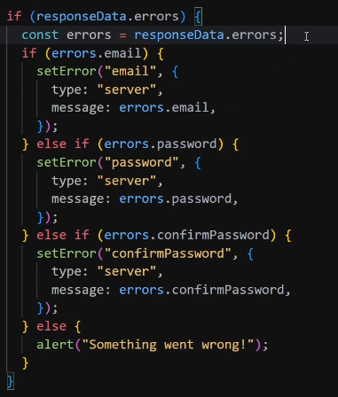

************************************************************************************

**Note 1**: In The Server Side We Can Use Our Schema By Re-Define It, Our Export It

registerSchema.safeParse(data);

************************************************************************************



