If we want to generate three heading with specific content: h${Heading $}*3; then the result would be:

<h1>Heading 1</h1>

<h2>Heading 2</h2>

<h3>Heading 3</h3>

************************************************

Here, we have margin collapsing:

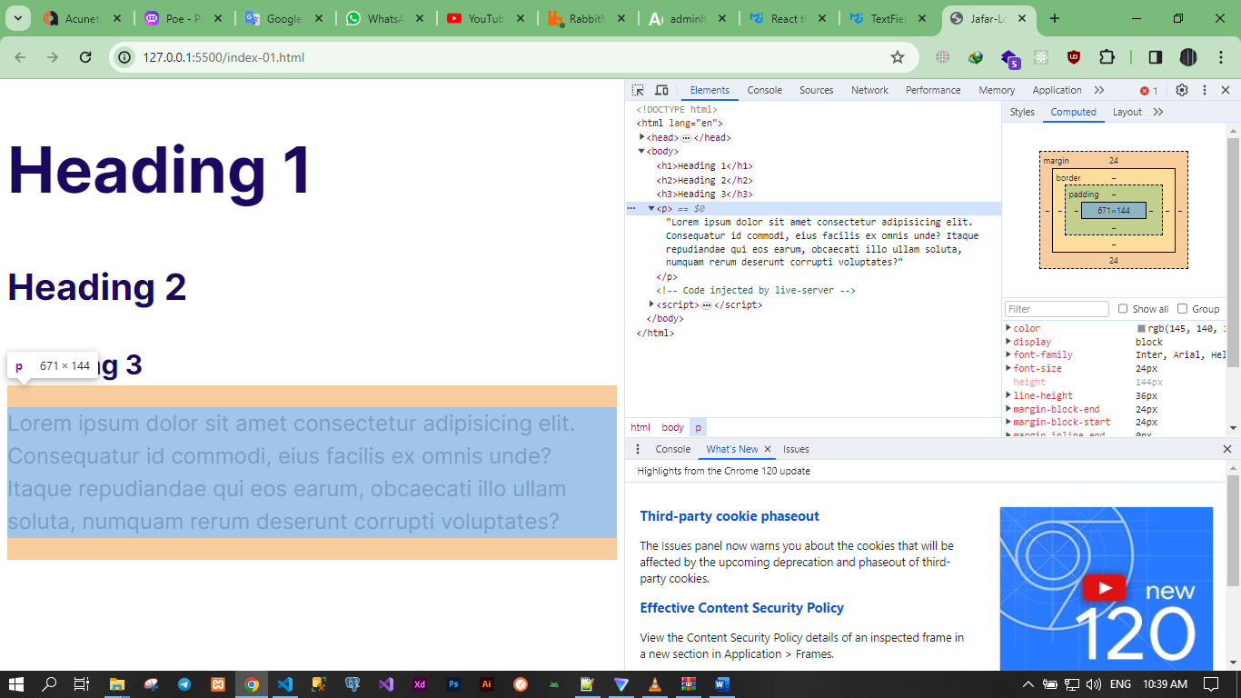

************************************************

Sometimes; depending on font type that we are using for display texts; the font adds spaces for characters above, bottom, …etc. Then to solve the problem we must decrease the margin of elements.

************************************************

To change the color of svg-icon we use fill-property of css.

************************************************

.icon--primary {

    fill: var(--color-primary);

}

************************************************

.icon-container {

    border-radius: 100%;

    -webkit-border-radius: 100%;

    -moz-border-radius: 100%;

    -ms-border-radius: 100%;

    -o-border-radius: 100%;

    background: #f3f9fa;

    width: 64px;

    height: 64px;

    display: inline-flex;

    justify-content: center;

    align-items: center;

}

************************************************

.list--tick {

    list-style-image: url(../images/tick.svg);

    padding-left: 15px;

}

************************************************

The Browser set the ***box-sizing*** to ***border-box*** for buttons.

But for the anchor-links a-element is ***content-box***.

************************************************

When the border-radius hide from the container we should see the overflow-property of the container and the child.

Like the card and plan components of the 3rd section.

************************************************

To change the opacity of the text we can use: ***opacity-property*** of css3.

************************************************

The ::before selector is inline element.

************************************************

To make the grid-columns span over the page with same size, we give each of them size of: 1fr.

    .grid--1x2 {

        grid-template-columns: 1fr 1fr;

    }

************************************************

@media screen and (min-width: 1024px) {

    .grid--1x3 {

        grid-template-columns: repeat(3, 1fr);

    }

}

************************************************

When we set images in grid, we must test them by change the size of browser window.

We must set the right break-points for media query to make them responsive.

In this case we must define the width of the image that we set inside any component or container.

************************************************

For align the item of grid we have:

* The justify-self.
* The align-self.

************************************************

Sometimes we need the grid to get all the available space for one column or two, …etc. then we define the other column as auto:

.callout .grid--1x2 {

grid-template-columns: 1fr auto;

}

************************************************

We can’t ***animate display-property***.

************************************************

If we want to hide the content using height we can use ***max-height*** with ***overflow-property***.

************************************************

.collapsible__content {

    max-height: 0;

    overflow: hidden;

    transition: max-height 0.5s;

    -webkit-transition: max-height 0.5s;

    -moz-transition: max-height 0.5s;

    -ms-transition: max-height 0.5s;

    -o-transition: max-height 0.5s;

}

************************************************

By Defining the max-height to 100vh we make the browser determine the height of the container.

.collapsible--expanded .collapsible__content {

    max-height: 100vh;

}

************************************************

In this way we can animate all properties:

transition: all 0.5s;

-webkit-transition: all 0.5s;

-moz-transition: all 0.5s;

-ms-transition: all 0.5s;

-o-transition: all 0.5s;

************************************************

To represent a block of content in html we use section-element.

************************************************

If we want to distribute the margin in equal size block we can use: auto.

************************************************

If we want to select element based on 2-classes then we set the classes together:

.nav.collapsible--expanded .nav__toggler {

    opacity: 1;

}

************************************************

***Note(To Remember):*** To make image responsive in grid or flex we should set the width to 100%.

************************************************

We must order the classes from the most generic to most specifics.

************************************************

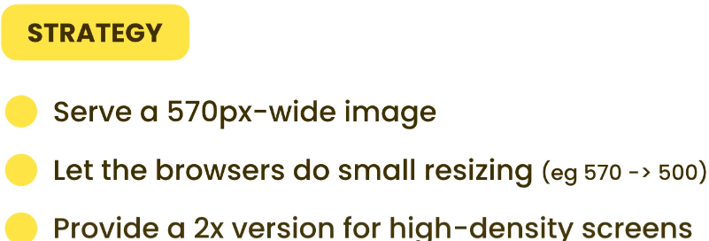

************************************************

To check the size of element in grid:

* First check the values of justify-items && align-items.
* OR Wrap the elements inside inline-element like span.

************************************************

*Note (From Me)*: When we want our design to keep in the same size on big screen, we should lock the width of the container of the element.

************************************************

To make the browser decide the number of columns in grid we can use auto-fit, but it will not work with fraction.

To solve the problem, we can use minmax-function of css to define the range of each slice in grid.

.block-domain__prices {

/* grid-template-columns: repeat(6, 1fr); */

grid-template-columns: repeat(auto-fit, minmax(100px, 1fr));

}

************************************************

*Note (To Remember)*: To make the container horizontally in center we can add horizontal margin to auto, so in constrained container we make the children in center equally in wide, small, medium, …etc. screens.

.block-domain__prices {

    display: grid;

    grid-template-columns: repeat(3, 1fr);

    grid-template-rows: repeat(2, 6rem);

    font-size: 2rem;

    font-weight: 600;

    justify-items: center;

    align-items: center;

    max-width: 700px;

    margin: 0 auto;

}

************************************************

**Note (To Remember)**: The box-sizing For Buttons is border-box.

**Note 2 (To Remember)**: The Best Way For Applying box-sizing by using universal selector, with pseudo elements.

************************************************