Note (For Remember): The box-shadow property can take 5-argumenets: x, y, softness, spread, color.

box-shadow: 0 0 0 1px gold;

*************************************************

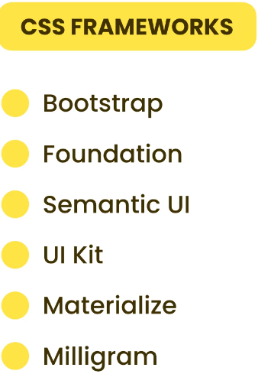

*************************************************

textarea {

    resize: none;

}

*************************************************

For Text-Field elements we have many attributes that we can apply:

* The placeholder.
* The value.
* The maxlength && minlength: for String fields like text, email, …etc.
* The disabled; also, can be used for checkbox && Radio.
* The readonly.
* The autofocus.
* The list.
* The autocomplete="off".
* The selected for select-element.
* The multiple for select-element && file.
* The checked for checkbox && Radio.
* The accept for file.
* The min && max for numbers.

The textarea-element doesn’t have value-attribute, we should set the text between the element and closed element: ***<textarea>Value Here</textarea>***.

*************************************************

<input type="text" list="my-country" autocomplete="off">

        <datalist id="my-country">

            <option>Syria</option>

            <option>Damascus</option>

            <option>Lattakia</option>

            <option>Tartous</option>

        </datalist>

*************************************************

***Note:*** we must set the value-attribute like: ***value=""*** to tell the browser this is only message.

<select required multiple>

            <option value="">Default</option>

            <option value="1">NodeJS</option>

            <option value="2">React</option>

            <option value="3">Flask</option>

</select>

*************************************************

<select required>

            <option value="">Select a Course...</option>

            <optgroup label="Front-End">

                <option value="1">HTML</option>

                <option value="2">React</option>

                <option value="3">Next.JS</option>

            </optgroup>

            <optgroup label="Back-End">

                <option value="4">NodeJS</option>

                <option value="5">Flask</option>

                <option value="6">FastAPI</option>

                <option value="7">Strapi</option>

                <option value="8">Laravel</option>

            </optgroup>

        </select>

*************************************************

The name-attribute is used to group the radio buttons.

*************************************************

To make multiple files selected by type, we separate them by comma.

<div>

            <input type="file" name="" id="" accept=".pdf">

</div>

Note: we can use mime-type to select the files:

<div>

<input type="file" name="" id="" accept="image/*, application/json, application/pdf">

</div>

*************************************************

The other approach to grouping the elements, is using ***section-element*** instead of ***fieldset-element***, and ***h2-element*** instead of ***legend-element***.

*************************************************

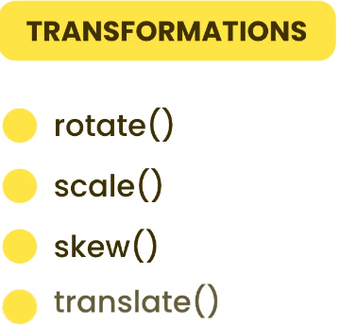

*************************************************

The positive values for rotating in clock wise.

The Negative Values for rotating in

.box:hover{

    transform: rotate(15deg);

    -webkit-transform: rotate(15deg);

    -moz-transform: rotate(15deg);

    -ms-transform: rotate(15deg);

    -o-transform: rotate(15deg);

}

.box{

    width: 100px;

    height: 100px;

    background-color: lightgreen;

    padding: 10px;

    /*box-sizing: border-box;*/

    transition: transform 0.5s;

    -webkit-transition: transform 0.5s;

    -moz-transition: transform 0.5s;

    -ms-transition: transform 0.5s;

    -o-transition: transform 0.5s;

}

*************************************************

.box:hover{

    transform: rotate(15deg) scale(1.5);

    -webkit-transform: rotate(15deg) scale(1.5);

    -moz-transform: rotate(15deg) scale(1.5);

    -ms-transform: rotate(15deg) scale(1.5);

    -o-transform: rotate(15deg) scale(1.5);

}

*************************************************

.box:hover{

    transform: translate(15px);

    -webkit-transform: translate(15px);

    -moz-transform: translate(15px);

    -ms-transform: translate(15px);

    -o-transform: translate(15px);

}

*************************************************

Here if we supply one value it will for horizontal-axis.

If we supply two values, they will for ***horizontal-axis*** && ***vertical-axis***.

.box:hover{

    transform: translate(15px, 15px);

    -webkit-transform: translate(15px, 15px);

    -moz-transform: translate(15px, 15px);

    -ms-transform: translate(15px, 15px);

    -o-transform: translate(15px, 15px);

}

*************************************************

For transform we have many Values or Attributes:

* The rotate function: this is for rotating on z-axis.
* The rotateX function.
* The rotateY function.
* The rotate function rotate the object from center.
* The translate function.
* The skew function.
* The scale function.
* The translateX function.
* The translateY function.
* The translateZ function.

***Note:*** The order of these functions is important, the browser will execute the transform in sequential order.

*************************************************

When we set the translateZ, we must define the perspective-function:

The positive values will make it closer to screen.

The negative values will make it away from screen.

.box:hover {

    transform: perspective(200px) translateZ(50px);

    -webkit-transform: perspective(200px) translateZ(50px);

    -moz-transform: perspective(200px) translateZ(50px);

    -ms-transform: perspective(200px) translateZ(50px);

    -o-transform: perspective(200px) translateZ(50px);

}

*************************************************

In this way we can make 3d-slider: (search for it)

.box:hover {

    transform: perspective(200px) translateZ(50px) rotateY(45deg);

    -webkit-transform: perspective(200px) translateZ(50px) rotateY(45deg);

    -moz-transform: perspective(200px) translateZ(50px) rotateY(45deg);

    -ms-transform: perspective(200px) translateZ(50px) rotateY(45deg);

    -o-transform: perspective(200px) translateZ(50px) rotateY(45deg);

}

*************************************************

The ***transform-origin*** to change the **point of rotation**.

The ***default point*** is **center**.

The ***0 0 points*** are for **top left corner**.

We can set different units for transform-origin like px, %, …etc.

.box:hover {

    transform: perspective(200px) translateZ(50px) rotateY(45deg);

    -webkit-transform: perspective(200px) translateZ(50px) rotateY(45deg);

    -moz-transform: perspective(200px) translateZ(50px) rotateY(45deg);

    -ms-transform: perspective(200px) translateZ(50px) rotateY(45deg);

    -o-transform: perspective(200px) translateZ(50px) rotateY(45deg);

    transform-origin: 10px 10px;

}

*************************************************

To make group of animation:

<div class="container">

        <div class="box">

            Lorem ipsum dolor sit amet consectetur adipisicing elit.

        </div>

        <div class="box">

            Lorem ipsum dolor sit amet consectetur adipisicing elit.

        </div>

</div>

.container {

    transition: transform 0.5s;

    -webkit-transition: transform 0.5s;

    -moz-transition: transform 0.5s;

    -ms-transition: transform 0.5s;

    -o-transition: transform 0.5s;

}

.container:hover {

    transform: perspective(200px) translateZ(50px) rotateY(45deg);

    -webkit-transform: perspective(200px) translateZ(50px) rotateY(45deg);

    -moz-transform: perspective(200px) translateZ(50px) rotateY(45deg);

    -ms-transform: perspective(200px) translateZ(50px) rotateY(45deg);

    -o-transform: perspective(200px) translateZ(50px) rotateY(45deg);

    transform-origin: 10px 10px;

}

*************************************************

For make clean code we should add .box.

For make main perspective for all container children:

.container {

    transition: transform 0.5s;

    -webkit-transition: transform 0.5s;

    -moz-transition: transform 0.5s;

    -ms-transition: transform 0.5s;

    -o-transition: transform 0.5s;

    perspective: 200px;

}

.container:hover .box {

    transform: rotateY(45deg);

    -webkit-transform: rotateY(45deg);

    -moz-transform: rotateY(45deg);

    -ms-transform: rotateY(45deg);

    -o-transform: rotateY(45deg);

    transform-origin: 10px 10px;

}

*************************************************

.container:hover .box-special{

    transform: rotateX(45deg);

    -webkit-transform: rotateX(45deg);

    -moz-transform: rotateX(45deg);

    -ms-transform: rotateX(45deg);

    -o-transform: rotateX(45deg);

}

<div class="container">

        <div class="box">

            Lorem ipsum dolor sit amet consectetur adipisicing elit.

        </div>

        <div class="box box-special">

            Lorem ipsum dolor sit amet consectetur adipisicing elit.

        </div>

</div>

*************************************************