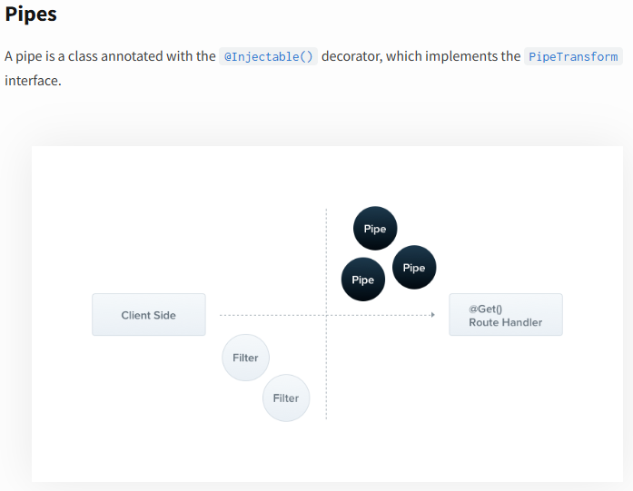
**********************************************************************
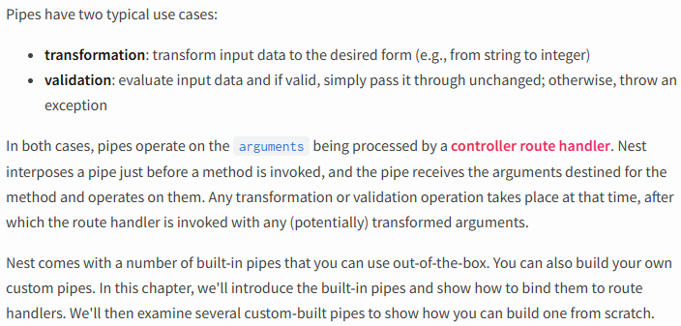
**********************************************************************
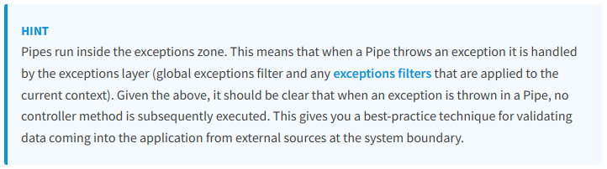
**********************************************************************
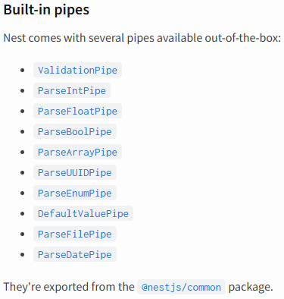
**********************************************************************
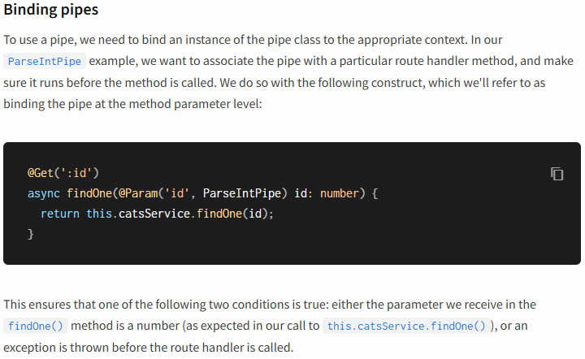
**********************************************************************
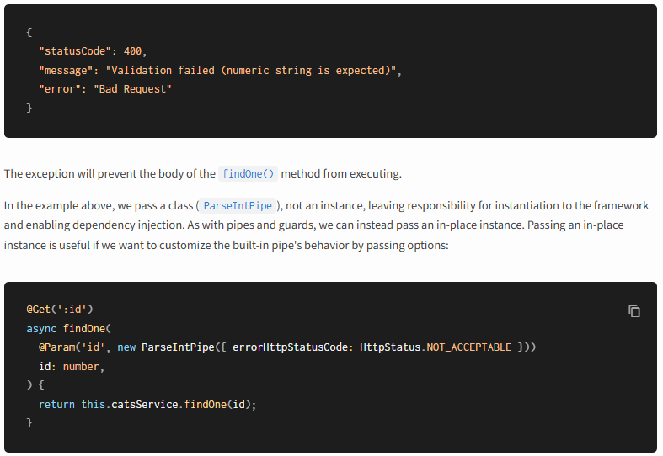
**********************************************************************
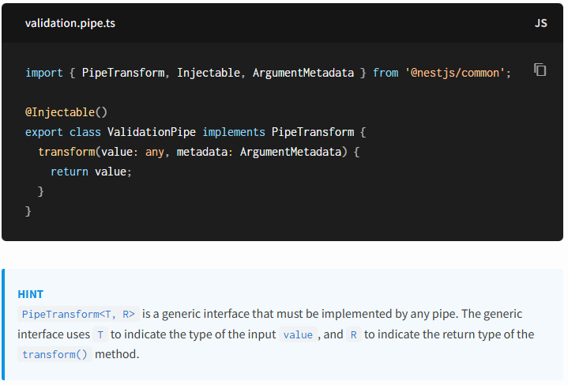
**********************************************************************
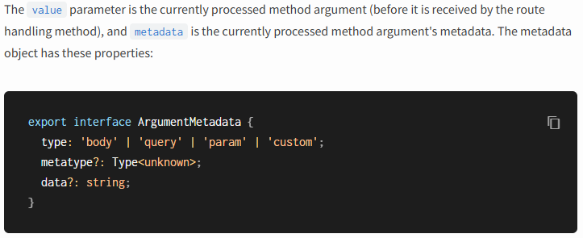
**********************************************************************
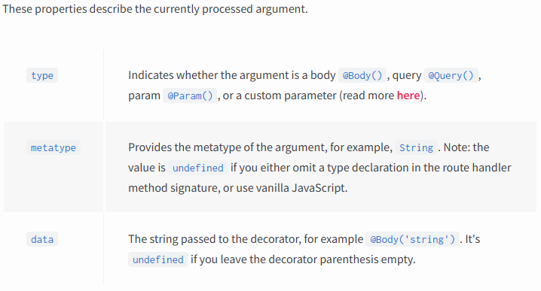
**********************************************************************
Warning
TypeScript interfaces disappear during transpilation. Thus, if a method parameter's type is declared as an interface instead of a class, the metatype value will be Object.
**********************************************************************
import { NestFactory } from '@nestjs/core';
import { AppModule } from './app.module';
import { CatsFilter } from './cats/cats.filter';
import { ValidationPipe } from '@nestjs/common';
async function bootstrap() {
const app = await NestFactory.create(AppModule)
app.enableCors()
app.useGlobalFilters(new CatsFilter())
app.useGlobalPipes(new ValidationPipe({
whitelist: true,
transform: true,
forbidNonWhitelisted: true,
}))
await app.listen(process.env.PORT ?? 3000)
}
bootstrap();
--------------------------------------------------------
import {IsString, IsInt, IsNotEmpty, Min, Max} from 'class-validator'
export class CreateCatDto {
@IsString()
@IsNotEmpty()
name: string;
@IsInt()
@Min(1)
@Max(50)
age: number;
@IsString()
@IsNotEmpty()
breed: string;
}
**********************************************************************



