The matchers of the jest:
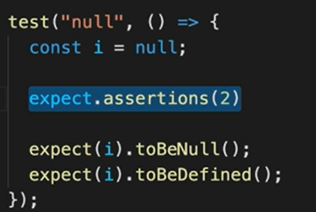
*************************************************************
const animals = ['Lion', 'Tiger']
test('array', () => {
expect(animals).toContain('Lion')
})
*************************************************************
test('exception', () => {
expect(() => getData()).toThrow('Not Found')
})

function getData() {
throw new Error('Not Found')
}
*************************************************************

