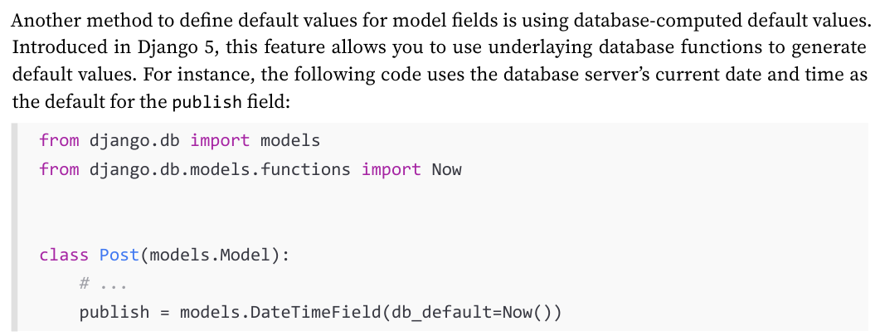
--------------------------------------------------------------
from django.db import models
from django.utils import timezone

# Create your models here.
class Post(models.Model):
class Status(models.TextChoices):
DRAFT = 'DF', 'Draft'
PUBLISHED = 'PB', 'Published'

title = models.CharField(max_length=250)
slug = models.SlugField(max_length=250)
body = models.TextField()
publish = models.DateTimeField(default=timezone.now)
created = models.DateTimeField(auto_now_add=True)
updated = models.DateTimeField(auto_now=True)
status = models.CharField(max_length=2, choices=Status, default=Status.DRAFT)
class Meta:
ordering = ['-publish']
indexes = [
models.Index(fields=['-publish'])
]

def __str__(self):
return self.title
--------------------------------------------------------------
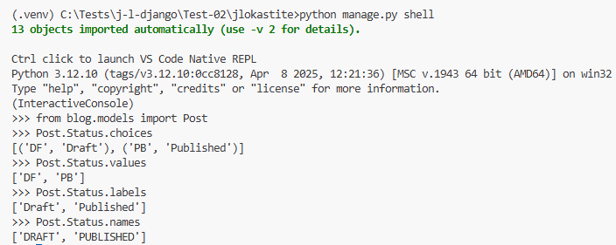
--------------------------------------------------------------
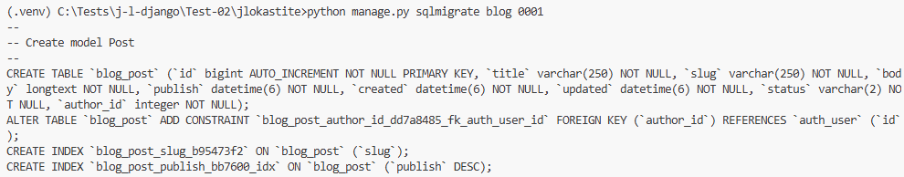
************************************************************************

To register in admin site:
from django.contrib import admin
from .models import Post
# Register your models here.
# admin.site.register(Post)
@admin.register(Post)
class PostAdmin(admin.ModelAdmin):
list_display = ['title', 'slug', 'author', 'publish', 'status']
list_filter = ['status', 'created', 'publish', 'author']
search_fields = ['title', 'body']
prepopulated_fields = {'slug': ('title',)}
raw_id_fields = ['author']
date_hierarchy = 'publish'
ordering = ['status', 'publish']
show_facets = admin.ShowFacets.ALWAYS
************************************************************************
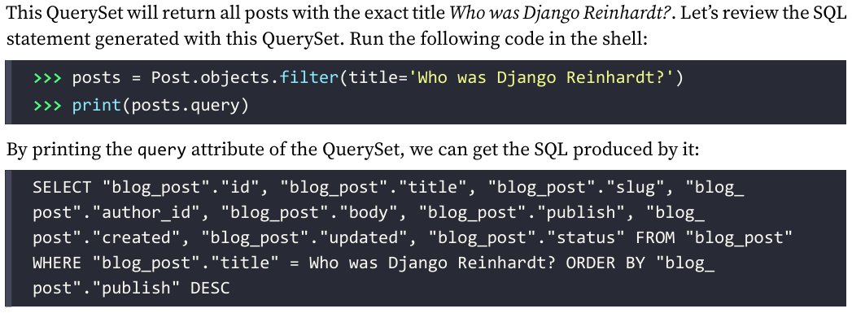
************************************************************************
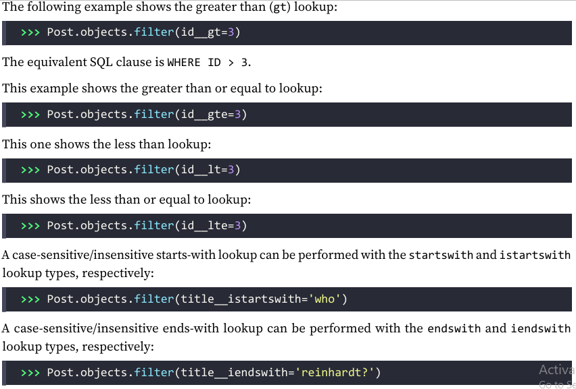
************************************************************************
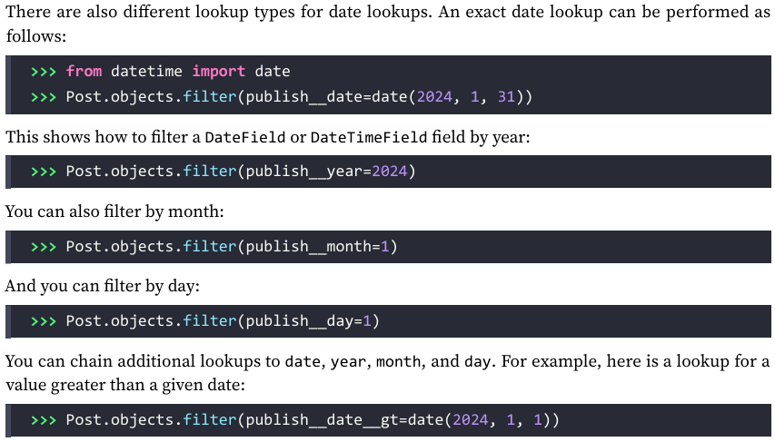
************************************************************************
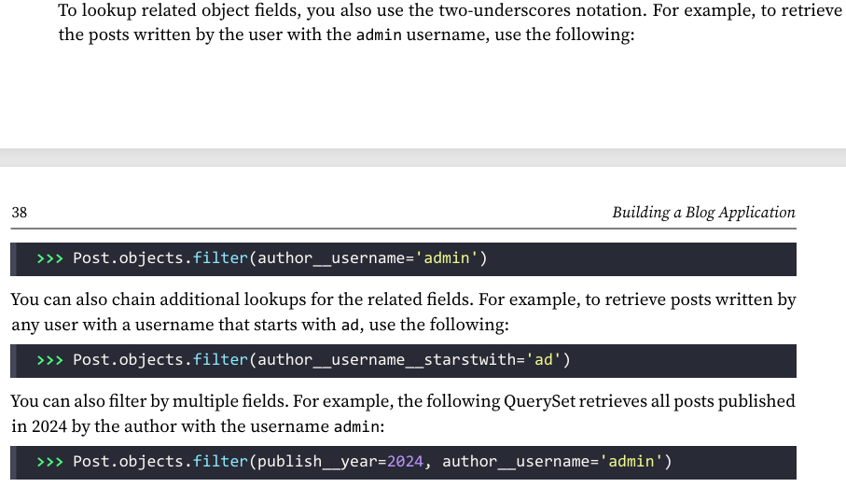
************************************************************************
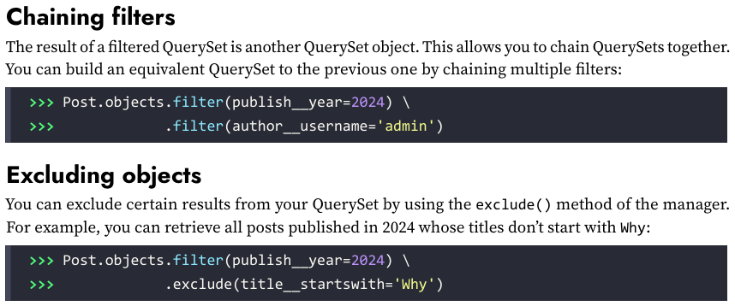
************************************************************************
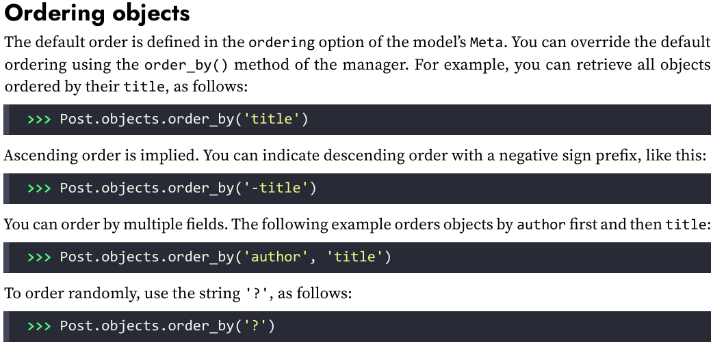
************************************************************************
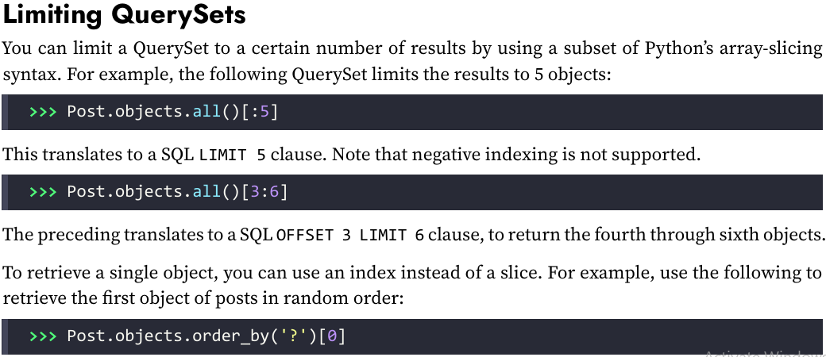
************************************************************************
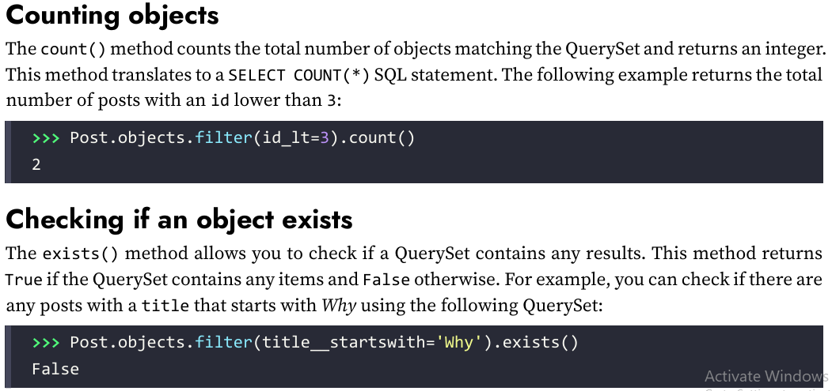
************************************************************************
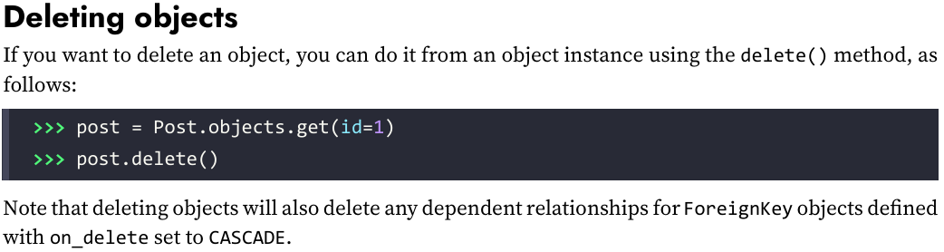
************************************************************************
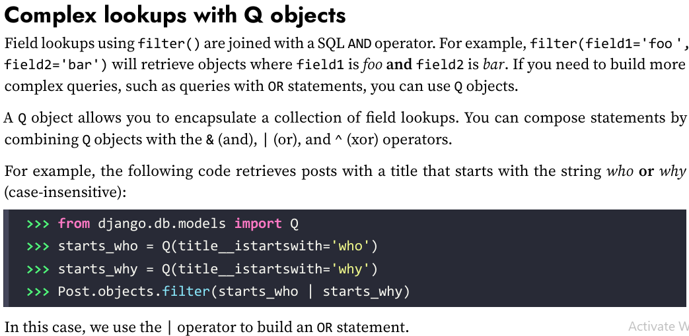
************************************************************************
from django.db import models

class PublishedManager(models.Manager):
def get_queryset(self):
return super().get_queryset().filter(status = Post.Status.PUBLISHED)

# Create your models here.
class Post(models.Model):
class Status(models.TextChoices):
DRAFT = 'DF', 'Draft'
PUBLISHED = 'PB', 'Published'

objects = models.Manager()
published = PublishedManager()
************************************************************************
The first manager declared in a model becomes the default manager. You can use the Meta attribute default_manager_name to specify a different default manager. If no manager is defined in the model, Django automatically creates the objects default manager for it. If you declare any managers for your model but you want to keep the objects manager as well, you have to add it explicitly to your model.
************************************************************************
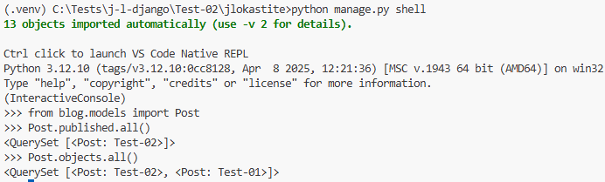
************************************************************************
The view for list all published posts:
from django.shortcuts import render
from .models import Post

# Create your views here.
def post_list(request):
posts = Post.published.all()
# in this way we avoid positional arguments error
return render(request, 'blog/post/list.html', {'posts': posts});
----------------------------------------------------------------------------------------------------
The view for post detail:
from django.shortcuts import get_object_or_404, render
from django.http import Http404
from .models import Post

def post_detail(request, id: int):
try:
# post = Post.publish.get(pk=id)
post = get_object_or_404(Post, id=id, status=Post.Status.PUBLISHED)
except Post.DoesNotExist:
raise Http404("No post found")
return render(
request, 'blog/post/detail.html', {'post': post}
)
----------------------------------------------------------------------------------------------------
The urls.py for blog-app is:
from django.urls import path
from . import views

app_name = 'blog'
urlpatterns = [
path('', views.post_list, name='post_list'),
path('<int:id>', views.post_detail, name='post_detail'),
]
----------------------------------------------------------------------------------------------------
We define an application namespace with the app_name variable. This allows us to organize URLs by application and use the name when referring to them.
----------------------------------------------------------------------------------------------------
from django.contrib import admin
from django.urls import include, path

urlpatterns = [
path('admin/', admin.site.urls),
path('blog/', include('blog.urls', namespace='blog'))
]
----------------------------------------------------------------------------------------------------
Namespaces have to be unique across your entire project. We will refer to our blog URLs easily by using the namespace followed by a colon and the URL name, for example, blog:post_list and blog:post_detail.
----------------------------------------------------------------------------------------------------
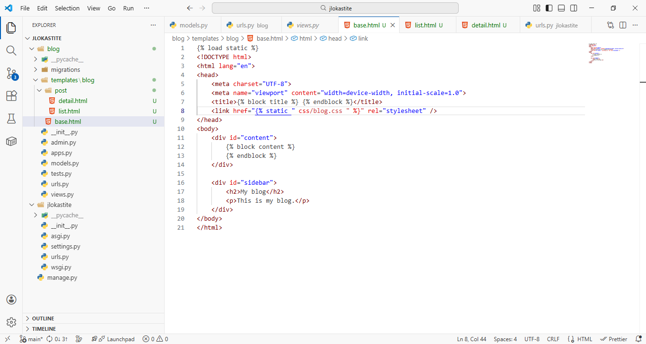
----------------------------------------------------------------------------------------------------
{% load static %} tells Django to load the static template tags that are provided by the django.contrib.staticfiles application, which is contained in the INSTALLED_APPS setting. After loading them, you can use the {% static %} template tag throughout this template. With this template tag, you can include the static files
----------------------------------------------------------------------------------------------------

{% load static %}
<!DOCTYPE html>
<html lang="en">
<head>
<meta charset="UTF-8">
<meta name="viewport" content="width=device-width, initial-scale=1.0">
<title>{% block title %} {% endblock %}</title>
<link href="{% static "css/blog.css" %}" rel="stylesheet" />
</head>
<body>
<div id="content">
{% block content %}
{% endblock %}
</div>

<div id="sidebar">
<h2>My blog</h2>
<p>This is my blog.</p>
</div>
</body>
</html>
----------------------------------------------------------------------------------------------------
{% extends "blog/base.html" %}

{% block title %} My block {% endblock %}

{% block content %}
<h1>My Blog</h1>
{% for post in posts %}
<h2>
<a href="{% url 'blog:post_detail' post.id %}">
{{ post.title }}
</a>
</h2>

<p class="date">
Published {{ post.publish }} by {{ post.author }}
</p>

{{ post.body|truncatewords:30|linebreaks }}
{% endfor %}
{% endblock %}
----------------------------------------------------------------------------------------------------

{% extends "blog/base.html" %}

{% block title %} {{ post.title }} {% endblock %}

{% block content %}
<h1>{{ post.title }}</h1>
<p class="date">
Published {{ post.publish }} by {{ post.author }}
</p>
{{ post.body|linebreaks }}
{% endblock %}

