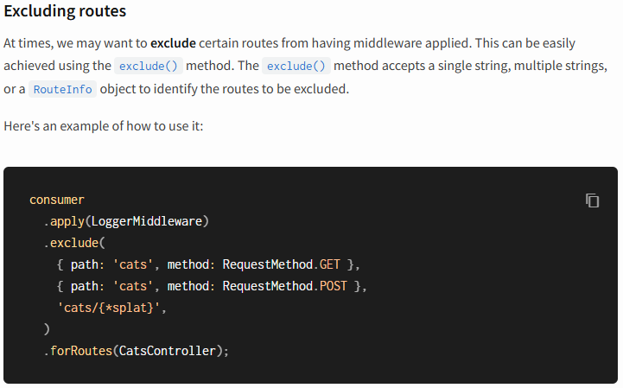
************************************************************************
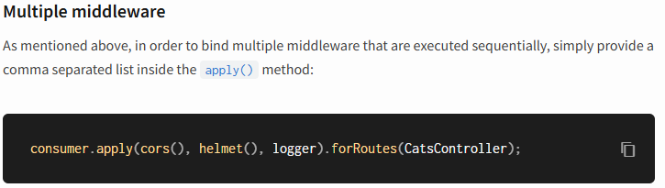
************************************************************************
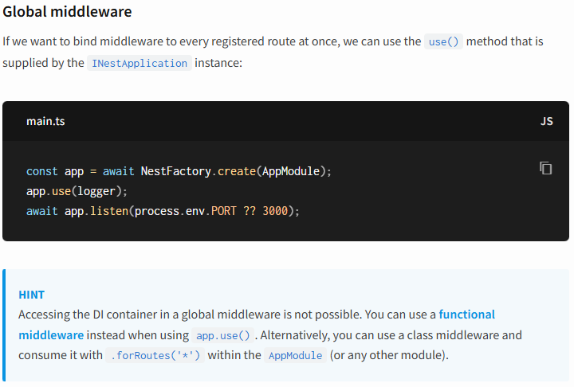
************************************************************************
Nest comes with a built-in exceptions layer which is responsible for processing all unhandled exceptions across an application. When an exception is not handled by your application code, it is caught by this layer, which then automatically sends an appropriate user-friendly response.
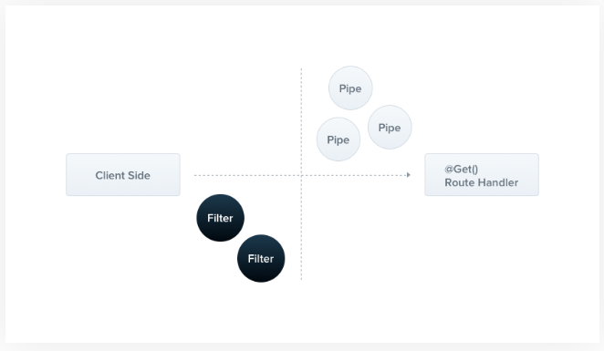
************************************************************************
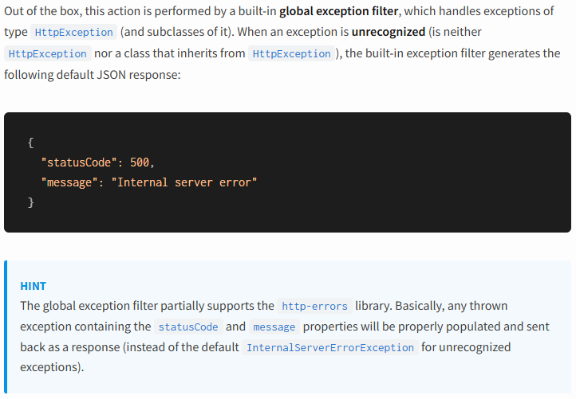
************************************************************************
import { Body, Controller, Get, HttpException, HttpStatus, Post } from '@nestjs/common';

@Controller('cats')
export class CatsController {
@Get()
async findAll(): Promise<Cat[]> {
// return this.catsService.findAll();
// throw new HttpException('FORBIDDEN', HttpStatus.FORBIDDEN);
throw new HttpException(
{ status: HttpStatus.FORBIDDEN, message: 'This is custom message'},
HttpStatus.FORBIDDEN,
{ cause: 'Custom Reason'}
)
}
}
************************************************************************
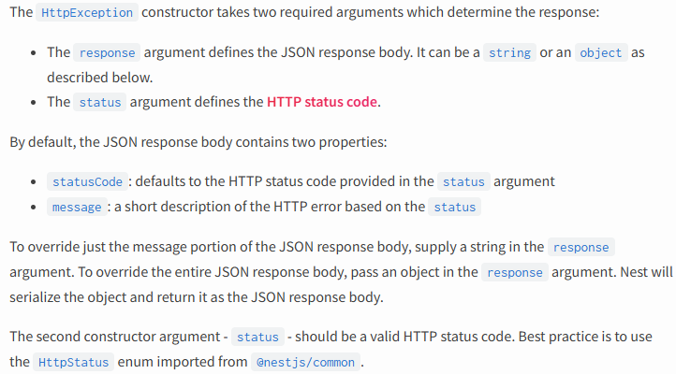
************************************************************************
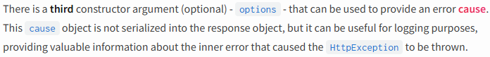
************************************************************************
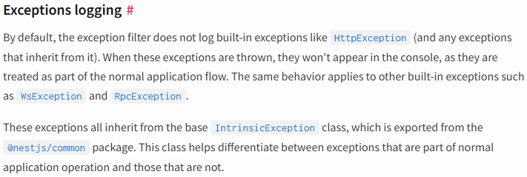
************************************************************************
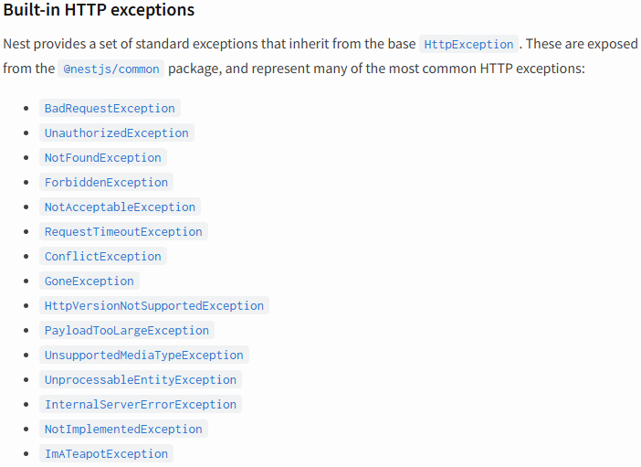
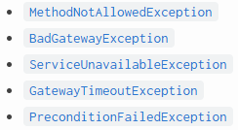
************************************************************************
@Get()
async findAll(): Promise<Cat[]> {
throw new BadRequestException('Error-01',
{ cause: new Error(), description: 'Simple description about Error-01'}
)
}
************************************************************************

To use exception filters:
import { ArgumentsHost, Catch, ExceptionFilter, HttpException } from '@nestjs/common';
import { Request, Response } from 'express';

@Catch(HttpException)
export class CatsFilter implements ExceptionFilter {
catch(exception: HttpException, host: ArgumentsHost) {
const ctx = host.switchToHttp()
const response = ctx.getResponse<Response>();
const request = ctx.getRequest<Request>();
const status = exception.getStatus();

response.status(status).json({
statusCode: status,
timestamp: new Date().toISOString(),
path: request.url,
})
}
}
-----------------------------------------------------------------------------------------------------
import { NestFactory } from '@nestjs/core';
import { AppModule } from './app.module';
import { CatsFilter } from './cats/cats.filter';

async function bootstrap() {
const app = await NestFactory.create(AppModule)
app.enableCors()
app.useGlobalFilters(new CatsFilter())
await app.listen(process.env.PORT ?? 3000)
}
bootstrap();
************************************************************************
The @Catch(HttpException) decorator binds the required metadata to the exception filter, telling Nest that this particular filter is looking for exceptions of type HttpException and nothing else. The @Catch() decorator may take a single parameter, or a comma-separated list. This lets you set up the filter for several types of exceptions at once.
************************************************************************
import { BadRequestException, Controller, Get, UseFilters } from '@nestjs/common';
import { CatsFilter } from './cats.filter';

@Controller('cats')
export class CatsController {
@Get('/catsFilter')
@UseFilters(new CatsFilter())
async getException() {
throw new BadRequestException()
}
}
************************************************************************
We have used the @UseFilters() decorator here. Similar to the @Catch() decorator, it can take a single filter instance, or a comma-separated list of filter instances.
************************************************************************
@Get('/catsFilter')
// @UseFilters(new CatsFilter())
@UseFilters(CatsFilter)
async getException() {
throw new BadRequestException()
}
************************************************************************
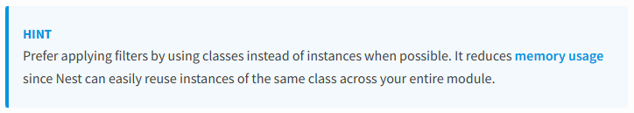
************************************************************************

Exception filters can be scoped at different levels: method-scoped of the controller/resolver/gateway, controller-scoped, or global-scoped.
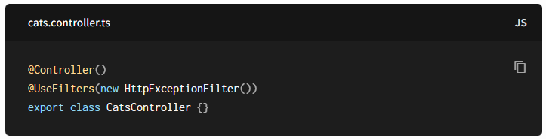
************************************************************************
Warning
The useGlobalFilters() method does not set up filters for gateways or hybrid applications.
************************************************************************
Catch everything
In order to catch every unhandled exception (regardless of the exception type), leave the @Catch() decorator's parameter list empty, e.g., @Catch().
************************************************************************
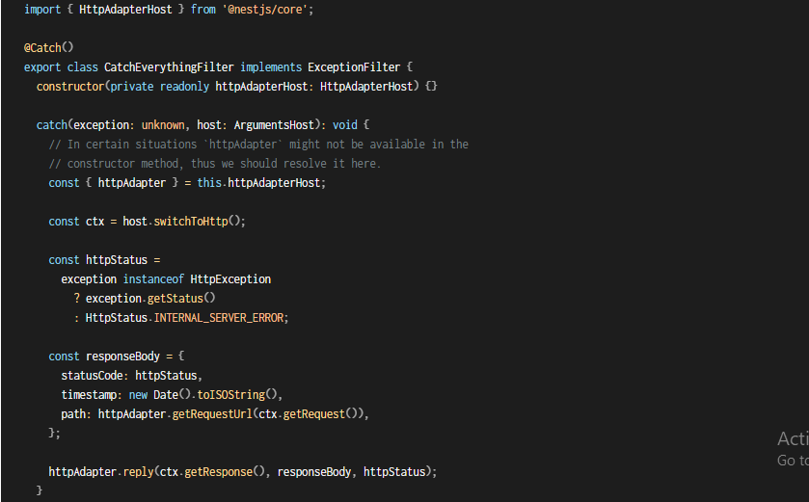
************************************************************************
Warning
When combining an exception filter that catches everything with a filter that is bound to a specific type, the "Catch anything" filter should be declared first to allow the specific filter to correctly handle the bound type.
************************************************************************


