To create simple decorator: nest g decorator Roles
import { Reflector } from '@nestjs/core';

export const Roles = Reflector.createDecorator<String[]>()

****************************************************
import { CanActivate, ExecutionContext, Injectable } from '@nestjs/common';
import { Reflector } from '@nestjs/core';
import { Observable } from 'rxjs';
import { Roles } from './roles.decorator';

@Injectable()
export class RolesGuard implements CanActivate {
constructor(private readonly reflactor: Reflector) {}

canActivate(
context: ExecutionContext,
): boolean | Promise<boolean> | Observable<boolean> {
const roles = this.reflactor.get(Roles, context.getHandler())
if(!roles) {
return true
}

const request = context.switchToHttp().getRequest()
const t1 = request.headers['roles']
console.log("the roles of the user is: ", t1)
return true;
}
}
****************************************************
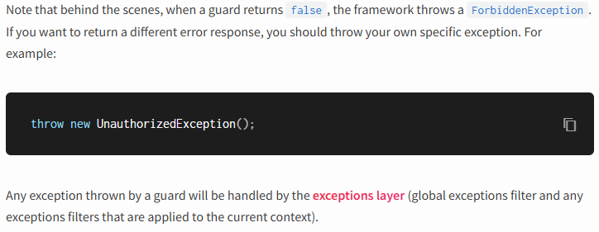
****************************************************
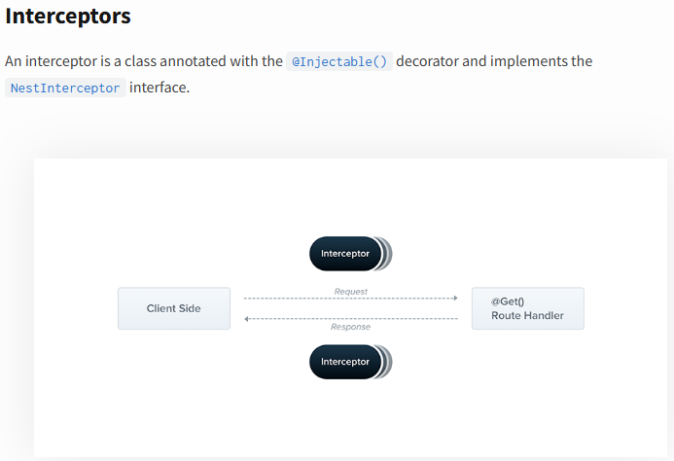
****************************************************
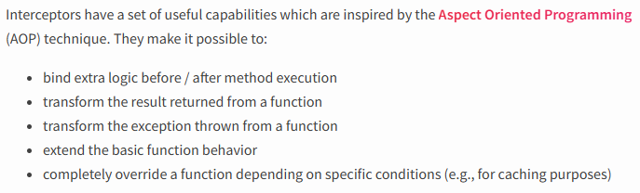
****************************************************
Each interceptor implements the intercept() method, which takes two arguments. The first one is the ExecutionContext instance
****************************************************
The second argument is a CallHandler. The CallHandler interface implements the handle() method, which you can use to invoke the route handler method at some point in your interceptor. If you don't call the handle() method in your implementation of the intercept() method, the route handler method won't be executed at all.
****************************************************
Because the handle() method returns an Observable, we can use powerful RxJS operators to further manipulate the response. Using Aspect Oriented Programming terminology, the invocation of the route handler (i.e., calling handle()) is called a Pointcut, indicating that it's the point at which our additional logic is inserted.
****************************************************

To generate simple interceptor: nest g interceptor Logging

import { CallHandler, ExecutionContext, Injectable, NestInterceptor } from '@nestjs/common';
import { Observable, tap } from 'rxjs';

@Injectable()
export class LoggingInterceptor implements NestInterceptor {
intercept(context: ExecutionContext, next: CallHandler): Observable<any> {
console.log('Before calling...')
const now = Date.now()
return next.handle().pipe(tap(() => console.log(`Total time is: ${now - Date.now()}ms`)));
}
}
****************************************************
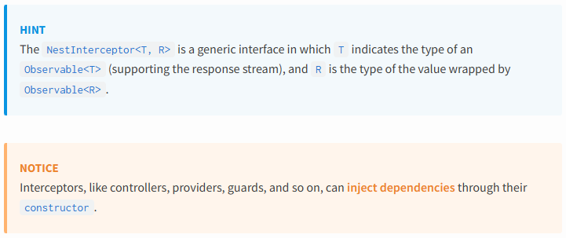
****************************************************
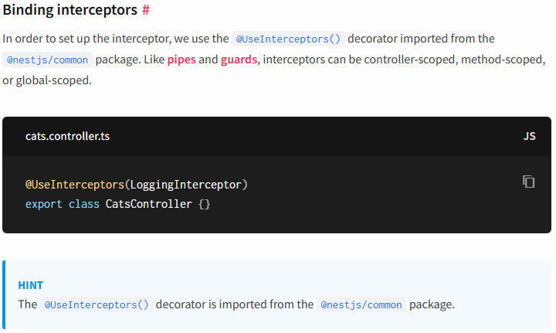
****************************************************
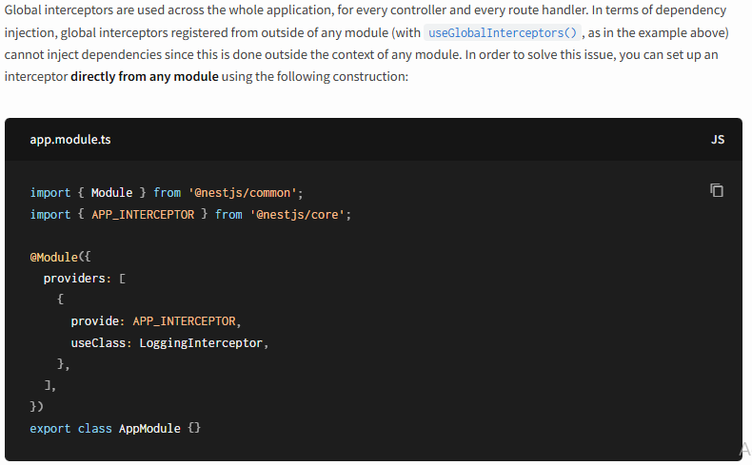
****************************************************
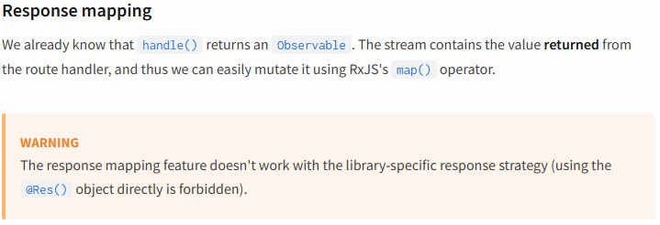
****************************************************
Here we can use constructor to inject the cache handler and check the values.
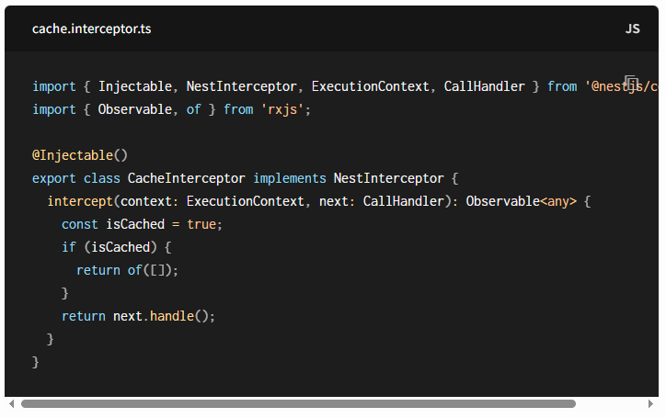
****************************************************
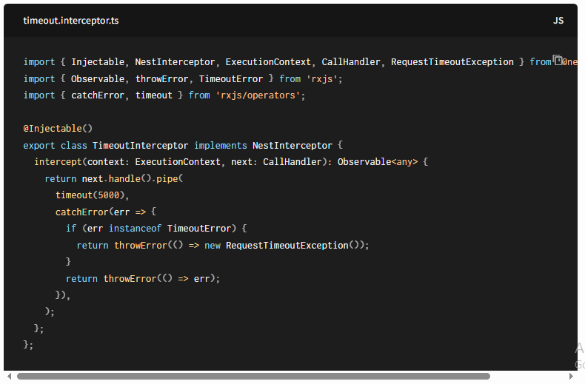
****************************************************
import { createParamDecorator, ExecutionContext } from '@nestjs/common';

export const User = createParamDecorator(
(data: unknown, ctx: ExecutionContext) => {
const request = ctx.switchToHttp().getRequest();
console.log(`The request is: ${request.path}`);
return { id: 1, username: 'JLoka-01' };
},
);
****************************************************
@Get('/user')
getLokaUser(@User() user) {
return user
}
****************************************************
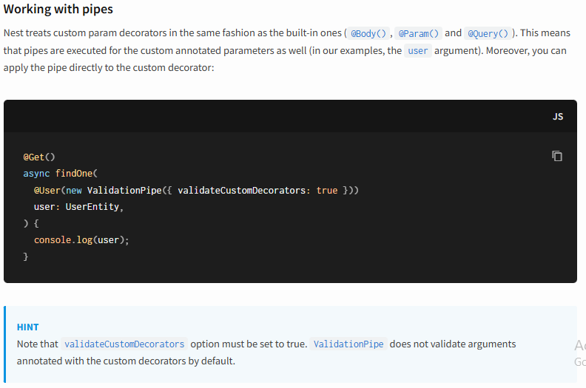
****************************************************
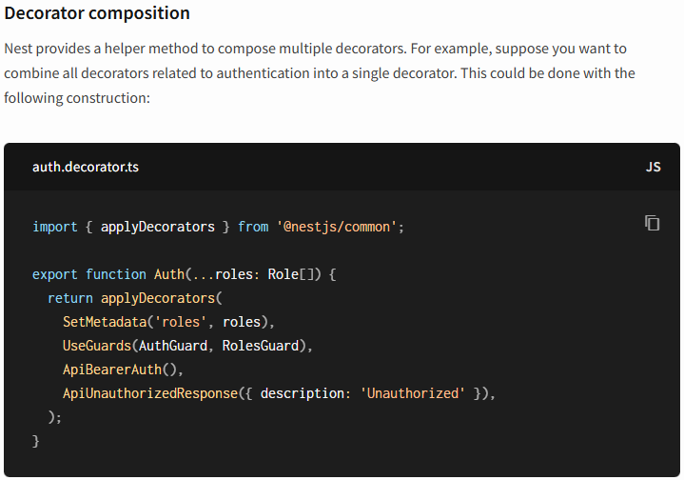
****************************************************
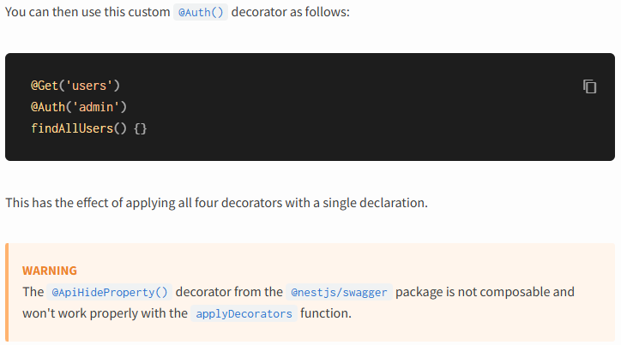
****************************************************
To add jwt auth for our apis; first we install jwt: npm i --save @nestjs/jwt
---------------------------------------------------------------------------------
import { Injectable } from '@nestjs/common';

// for real scenarios we must declare it using classes with class-validator
export type User = any;

@Injectable()
export class UsersService {

private readonly users = [
{
userId: 1,
username: 'Jafar',
password: 'Loka',
},
{
userId: 2,
username: 'Maria',
password: 'Loka',
},
];

async findOne(username: string): Promise<User | undefined> {
return this.users.find(user => user.username === username);
}
}
---------------------------------------------------------------------------------
For auth module:
import { Module } from '@nestjs/common';
import { AuthController } from './auth.controller';
import { AuthService } from './auth.service';
import { UsersModule } from 'src/users/users.module';
import { JwtModule } from '@nestjs/jwt';
import { jwtConstants } from './constants';

@Module({
controllers: [AuthController],
providers: [AuthService],
imports: [UsersModule, JwtModule.register({
global: true,
secret: jwtConstants.secret,
signOptions: { expiresIn: '3600s' }
})],
exports: [AuthService],
})
export class AuthModule {}
---------------------------------------------------------------------------------
For auth controller:
import { Body, Controller, Get, HttpCode, HttpStatus, Post, Request, UseGuards } from '@nestjs/common';
import { AuthService } from './auth.service';
import { SignInDto } from './dto/signin.dto';
import { AuthGuard } from './auth.guard';

@Controller('auth')
export class AuthController {
constructor(private readonly authService: AuthService) {}

@HttpCode(HttpStatus.OK)
@Post('login')
signIn(@Body() signInDto: SignInDto) {
return this.authService.signIn(signInDto.username, signInDto.password);
}

@UseGuards(AuthGuard)
@Get("profile")
async profile(@Request() req) {
return req.user
}
}
---------------------------------------------------------------------------------

For auth service:
import { Get, Injectable, Request, UnauthorizedException, UseGuards } from '@nestjs/common';
import { UsersService } from 'src/users/users.service';
import { JwtService } from '@nestjs/jwt'
import { AuthGuard } from './auth.guard';

@Injectable()
export class AuthService {
constructor(private readonly usersService: UsersService, private readonly jwtService: JwtService) {}

async signIn(username: string, pass: string): Promise<{ access_token: string }> {
const user = await this.usersService.findOne(username)
if(user.password !== pass) {
throw new UnauthorizedException();
}

const payload = { sub: user.userId, username: user.username }
return {
access_token: await this.jwtService.signAsync(payload),
}
}
}
---------------------------------------------------------------------------------
For constants:
export const jwtConstants = {
secret: 'JLoka@123'
}
---------------------------------------------------------------------------------
For auth guard:
import { CanActivate, ExecutionContext, Injectable, UnauthorizedException } from '@nestjs/common';
import { JwtService } from '@nestjs/jwt';
import { Request } from 'express';
import { jwtConstants } from './constants';
@Injectable()
export class AuthGuard implements CanActivate {

constructor(private readonly jwtService: JwtService){}

async canActivate(
context: ExecutionContext,
): Promise<boolean> {

const request = context.switchToHttp().getRequest()
const token = this.extractTokenFromHeaders(request);
if(!token) {
throw new UnauthorizedException()
}

try {
const payload = await this.jwtService.verifyAsync(token, {
secret: jwtConstants.secret,
})
request["user"] = payload
} catch {
throw new UnauthorizedException()
}

return true;
}

extractTokenFromHeaders(request: Request): string|undefined {
const [type, token] = request.headers["authorization"]?.split(' ') ?? []
return type == 'Bearer' ? token : undefined
}
}

