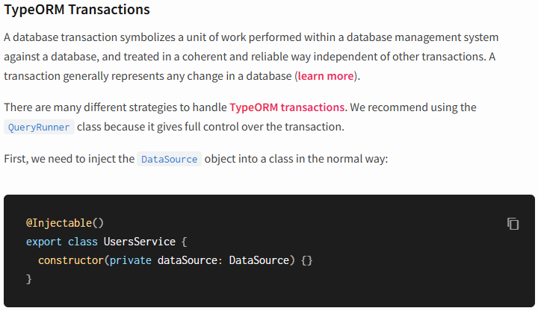
*******************************************************
import { Injectable } from '@nestjs/common';
import { InjectRepository } from '@nestjs/typeorm';
import { User } from './user.entity';
import { DataSource, DeleteResult, Repository } from 'typeorm';

@Injectable()
export class UsersService {

constructor(
@InjectRepository(User) private userRepository: Repository<User>,
private dataSource: DataSource
) {}

async findAll():Promise<User[]> {
return this.userRepository.find()
}

async findOne(id: number) :Promise<User | null> {
return this.userRepository.findOneBy({ id })
}

async remove(id: number): Promise<DeleteResult> {
return this.userRepository.delete(id)
}

async createMany(users: User[]) {
const queryRunner = this.dataSource.createQueryRunner()
await queryRunner.connect()
await queryRunner.startTransaction()
try {
await queryRunner.manager.save(users[0])
await queryRunner.manager.save(users[1])
await queryRunner.commitTransaction()
} catch (e) {
await queryRunner.rollbackTransaction()
} finally {
await queryRunner.release()
}
}
}
*******************************************************
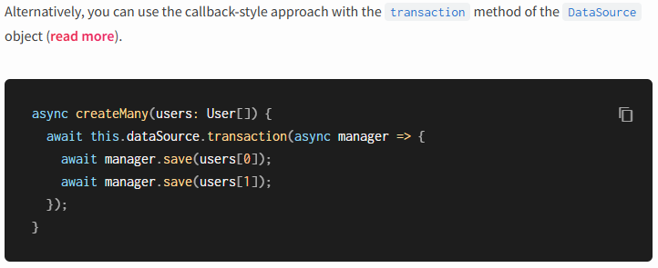
*******************************************************

To use all types of relation in nestjs we must consider the following:
- Avoid the cycle relations between entities when using @JoinColumn
- Avoid unsupported Queries (ex: ILike) when using MariaDB/MySQL
- Use the right configurations for typeorm with DataSource
- The problems when dealing with update one-to-one relationships
*******************************************************
The DataSource of project:
import { DataSource } from "typeorm";

export default new DataSource({
type: 'mariadb',
synchronize: false,
host: "localhost",
port: 3306,
username: "root",
password: "123",
database: "jloka_nestjs_01",
entities: [__dirname + '/**/*.entity{.ts,.js}'],
migrations: [__dirname + '/migrations/*{.ts,.js}'],
})
----------------------------------------------------------------------------------------
The required packages:
"@nestjs/typeorm": "^11.0.0",
"class-transformer": "^0.5.1",
"class-validator": "^0.14.3",
"mysql2": "^3.16.0",
"@nestjs/mapped-types": "^2.1.0",
"typeorm": "^0.3.28" // for cli operations
----------------------------------------------------------------------------------------

The app module is:
@Module({
imports: [
ConfigModule.forRoot(),
TypeOrmModule.forRootAsync({
imports: [ConfigModule],
useFactory: (configService: ConfigService) => ({
type: 'mariadb',
host: configService.get('DB_HOST'),
port: configService.get('DB_PORT'),
username: configService.get('DB_USERNAME'),
password: configService.get('DB_PASSWORD'),
database: configService.get('DB_DATABASE'),
entities: [__dirname + '/**/*.entity{.ts,.js}'],
migrations: [__dirname + '/migrations/**/*{.ts,.js}'],
cli: {
migrationsDir: 'src/migrations',
},
synchronize: false,
logging: true,
}),
inject: [ConfigService],
}),
UsersModule,
ProfileModule,
PostModule,
CategoryModule
],
controllers: [AppController],
providers: [AppService],
})
export class AppModule {}
----------------------------------------------------------------------------------------
The user entity is:
import {
Entity,
PrimaryGeneratedColumn,
Column,
OneToOne,
OneToMany,
CreateDateColumn,
UpdateDateColumn,
} from 'typeorm';
import { Profile } from '../profile/profile.entity';
import { Post } from '../post/post.entity';

@Entity('users')
export class User {
@PrimaryGeneratedColumn('uuid')
id: string;

@Column({ unique: true })
email: string;

@Column()
firstName: string;

@Column()
lastName: string;

@Column({ default: true })
isActive: boolean;

// One-to-One with Profile
@OneToOne(() => Profile, (profile) => profile.user, {
// cascade: true,
onDelete: 'CASCADE',
onUpdate: 'CASCADE'
})
// @JoinColumn()
profile: Profile;

// One-to-Many with Post
@OneToMany(() => Post, (post) => post.author)
posts: Post[];

@CreateDateColumn()
createdAt: Date;

@UpdateDateColumn()
updatedAt: Date;
}
----------------------------------------------------------------------------------------

The user service is:
import { ConflictException, Injectable, NotFoundException } from '@nestjs/common';
import { InjectRepository } from '@nestjs/typeorm';
import { User } from './user.entity';
import { DataSource, Repository } from 'typeorm';
import { Profile } from 'src/profile/profile.entity';
import { CreateUserDto } from './dto/create-user.dto';
import { UserResponseDto } from './dto/user-response.dto';
import { plainToInstance } from 'class-transformer';
import { UpdateUserDto } from './dto/update-user.dto';

@Injectable()
export class UsersService {

constructor(
@InjectRepository(User) private userRepository: Repository<User>,
@InjectRepository(Profile) private profileRepository: Repository<Profile>,
private dataSource: DataSource
) { }

async create(createUserDto: CreateUserDto): Promise<UserResponseDto> {
// Check if user with email already exists
const existingUser = await this.userRepository.findOne({
where: { email: createUserDto.email },
});

if (existingUser) {
throw new ConflictException('User with this email already exists');
}

return await this.dataSource.transaction(async (transactionalEntityManager) => {
const user = this.userRepository.create(createUserDto);

// Create profile if provided
if (createUserDto.profile) {
const profile = this.profileRepository.create(createUserDto.profile);
user.profile = profile;
}

const savedUser = await transactionalEntityManager.save(user);

// Load with relations
const userWithRelations = await transactionalEntityManager.findOne(User, {
where: { id: savedUser.id },
relations: ['profile', 'posts'],
});

return plainToInstance(UserResponseDto, userWithRelations, {
excludeExtraneousValues: true,
});
});
}

async findAll(): Promise<UserResponseDto[]> {
const users = await this.userRepository.find({
relations: ['profile'],
order: { createdAt: 'DESC' },
});

return plainToInstance(UserResponseDto, users, {
excludeExtraneousValues: true,
});
}

async findOne(id: string): Promise<UserResponseDto> {
const user = await this.userRepository.findOne({
where: { id },
relations: ['profile', 'posts'],
});

if (!user) {
throw new NotFoundException(`User with ID ${id} not found`);
}

return plainToInstance(UserResponseDto, user, {
excludeExtraneousValues: true,
});
}

async update(id: string, updateUserDto: UpdateUserDto): Promise<UserResponseDto> {
const user = await this.userRepository.findOne({
where: { id },
relations: ['profile'],
});

if (!user) {
throw new NotFoundException(`User with ID ${id} not found`);
}

if (updateUserDto.email && updateUserDto.email !== user.email) {
const existingUser = await this.userRepository.findOne({
where: { email: updateUserDto.email },
});

if (existingUser) {
throw new ConflictException('Email already in use');
}
}

// Update user fields
Object.assign(user, updateUserDto);

// Update profile if provided
if (updateUserDto.profile && user.profile) {
Object.assign(user.profile, updateUserDto.profile);
}
// here we must call the profile repository for updating
const updatedUser = await this.userRepository.save({...user, profile: user.profile});

// Reload with relations
const userWithRelations = await this.userRepository.findOne({
where: { id: updatedUser.id },
relations: ['profile', 'posts'],
});

return plainToInstance(UserResponseDto, userWithRelations, {
excludeExtraneousValues: true,
});
}

async remove(id: string): Promise<void> {
const user = await this.userRepository.findOne({ where: { id } });

if (!user) {
throw new NotFoundException(`User with ID ${id} not found`);
}

await this.userRepository.remove(user);
}

async searchUsers(searchTerm: string): Promise<UserResponseDto[]> {
const users = await this.userRepository
.createQueryBuilder('user')
.where('LOWER(user.email) LIKE :searchTerm', { searchTerm: `%${searchTerm.toLowerCase()}%` })
.orWhere('LOWER(user.firstName) LIKE :searchTerm', { searchTerm: `%${searchTerm.toLowerCase()}%` })
.orWhere('LOWER(user.lastName) LIKE :searchTerm', { searchTerm: `%${searchTerm.toLowerCase()}%` })
.orderBy('user.createdAt', 'DESC')
.getMany();

return plainToInstance(UserResponseDto, users, {
excludeExtraneousValues: true,
});
}

async createMany(users: User[]) {
const queryRunner = this.dataSource.createQueryRunner()
await queryRunner.connect()
await queryRunner.startTransaction()
try {
await queryRunner.manager.save(users[0])
await queryRunner.manager.save(users[1])
await queryRunner.commitTransaction()
} catch (e) {
await queryRunner.rollbackTransaction()
} finally {
await queryRunner.release()
}
}
}

