[HttpPost]
public async Task<ActionResult<Post>> CreatePost(Post post)
{
await _postsService.CreatePost(post);

return CreatedAtAction(nameof(GetPost), new { id = post.Id}, post);
}
When we call this endpoint, the post object will be serialized in the JSON format that is attached to the POST request body. In this method, we can get the post from the request and then call the CreatePost() method in the service to create a new post. Then, we will return the built-in CreatedAtAction, which returns a response message with the specified action name, route values, and post. For this case, it will call the GetPost() action to return the newly created post.
*******************************************************************
Note (To Remember for C#): If we don’t set the constructor as public then the error msg is:
System.InvalidOperationException: A suitable constructor for type 'MyFirstAPI.Controllers.PostsController' could not be located.
*******************************************************************
You may find the following terms being used interchangeably: Dependency Inversion Principle (DIP), Inversion of Control (IoC), and DI.
*******************************************************************
IoC is related to DIP, but it is not the same. DIP concerns decoupling dependencies between high-level modules and low-level modules through shared abstractions (interfaces). IoC is used to increase the modularity of the program and make it extensible. There are several technologies to implement IoC, such as Service Locator, DI, the template method design pattern, the strategy design pattern, and so on.
*******************************************************************

DI is a form of IoC. This term was coined by Martin Fowler in 2004. It separates the concerns of constructing objects and using them. When an object or a function (the client) needs a dependency, it does not know how to construct it. Instead, the client only needs to declare the interfaces of the dependency, and the dependency is injected into the client by external code (an injector). It makes it easier to change the implementation of the dependency. It is often similar to the strategy design pattern. The difference is that the strategy pattern can use different strategies to construct the dependency, while DI typically only uses a single instance of the dependency.
*******************************************************************
There are three main types of DI:
• Constructor injection: The dependencies are provided as parameters of the client’s constructor
• Setter injection: The client exposes a setter method to accept the dependency
• Interface injection: The dependency’s interface provides an injector method that will inject the dependency into any client passed to it
*******************************************************************
DI in ASP.NET Core
ASP.NET Core uses constructor injection to request dependencies. To use it, we need to do the following: 1. Define interfaces and their implementations.
2. Register the interfaces and the implementations to the service container.
3. Add services as the constructor parameters to inject the dependencies.
*******************************************************************
DI has four roles: services, clients, interfaces, and injectors. In this example, IPostService is the interface, PostService is the service, PostsController is the client, and builder. Services is the injector, which is a collection of services for the application to compose. It is sometimes referred to as a DI container.
*******************************************************************
This DI feature is provided in a NuGet package called Microsoft.Extensions.DependencyInjection. When an ASP.NET Core project is created, this package is added automatically. If you create a console project, you may need to install it manually by using the following command:
dotnet add package Microsoft.Extensions.DependencyInjection
*******************************************************************
In ASP.NET Core, there are three lifetimes when the service is registered:
• Transient: A transient service is created each time it is requested and disposed of at the end of the request.
• Scoped: In web applications, a scope means a request (connection). A scoped service is created once per client request and disposed of at the end of the request.
• Singleton: A singleton service is created the first time it is requested or when providing the implementation instance to the service container. All subsequent requests will use the same instance.
*******************************************************************
Action injection
Sometimes, one controller may need many services but may not need all of them for all actions. If we inject all the dependencies from the constructor, the constructor method will be large. For this case, we can use action injection to inject dependencies only when needed.
-------------------------------------------------------------------------------------------
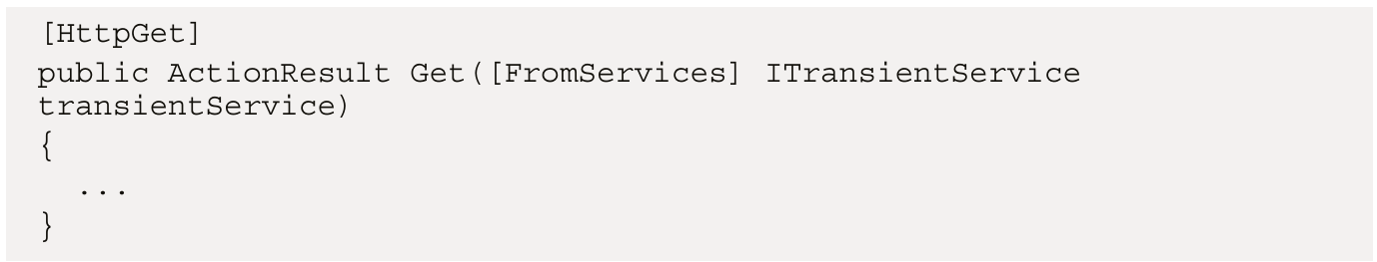
-------------------------------------------------------------------------------------------

The [FromServices] attribute enables the service container to inject dependencies when needed without using constructor injection. However, if you find that a service needs a lot of dependencies, it may indicate that the class has too many responsibilities. Based on the Single Responsibility Principle (SRP), consider refactoring the class to split the responsibilities into smaller classes.
-------------------------------------------------------------------------------------------
Keep in mind that this kind of action injection only works for actions in the controller. It does not support normal classes. Additionally, since ASP.NET Core 7.0, the [FromServices] attribute can be omitted as the framework will automatically attempt to resolve any complex type parameters registered in the DI container.
*******************************************************************

Keyed services
ASP.NET Core 8.0 introduces a new feature known as keyed services, or named services. This feature allows developers to register services with a key, allowing them to access the service with that key. This makes it easier to manage multiple services that implement the same interface within an application, as the key can be used to identify and access the service.
-------------------------------------------------------------------------------------------
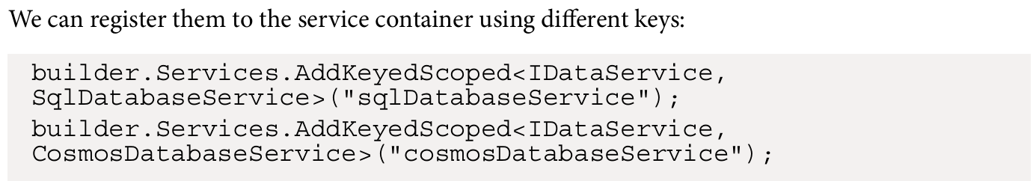
-------------------------------------------------------------------------------------------
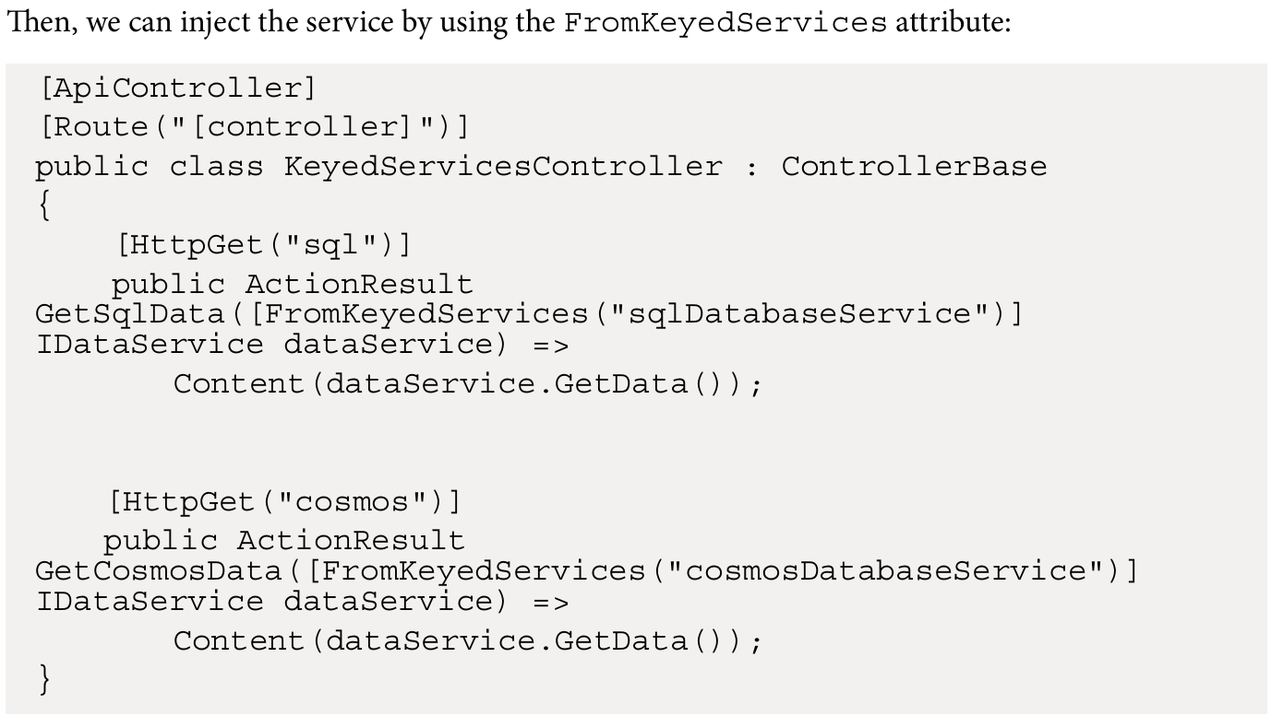
-------------------------------------------------------------------------------------------

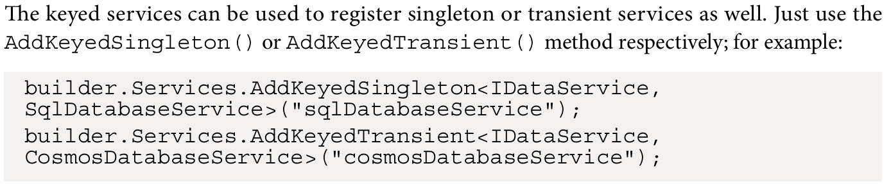
-------------------------------------------------------------------------------------------
It is important to note that if an empty string is passed as the key, a default implementation for the service must be registered with a key of an empty string, otherwise the service container will throw an exception.
*******************************************************************
Using primary constructors to inject dependencies
Beginning with .NET 8 and C# 12, we can use the primary constructor to inject dependencies. A primary constructor allows us to declare the constructor parameters directly in the class declaration, instead of using a separate constructor method.
-------------------------------------------------------------------------------------------
When using the primary constructor in a class, note that the parameters passed to the class declaration cannot be used as properties or members. For example, if a class declares a parameter named postService in the class declaration, it cannot be accessed as a class member using this.postService or from external code.
-------------------------------------------------------------------------------------------
Primary constructors can save us from writing fields and constructor methods.
*******************************************************************
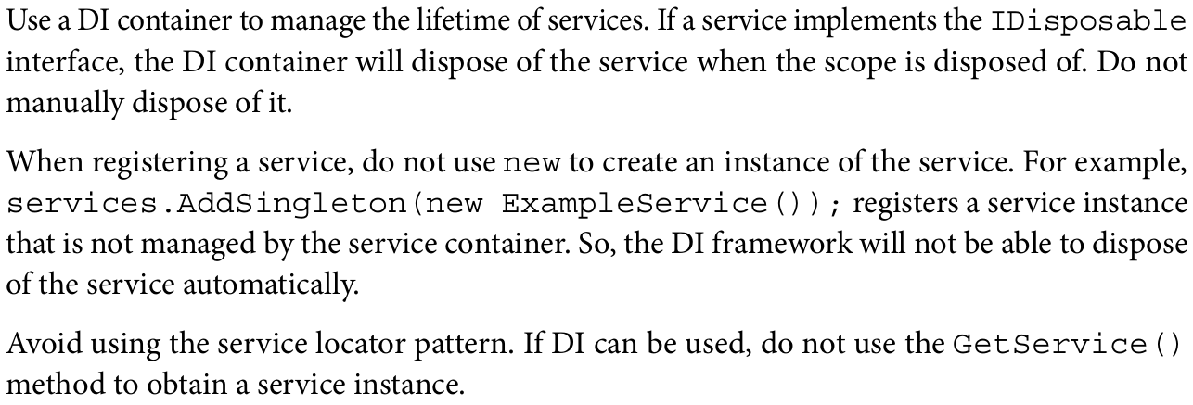
*******************************************************************
To use property injection, Fun<T> support for lazy initialization, and so on, you can use third-party DI containers, such as Autofac.
*******************************************************************
Minimal APIs is a new feature introduced in ASP.NET Core 6.0. It is a new way to create APIs without using controllers. Minimal APIs are designed to be simple and lightweight with minimal dependencies. They are a good choice for small projects or prototypes, and also for projects that do not need the full features of controllers.
*******************************************************************
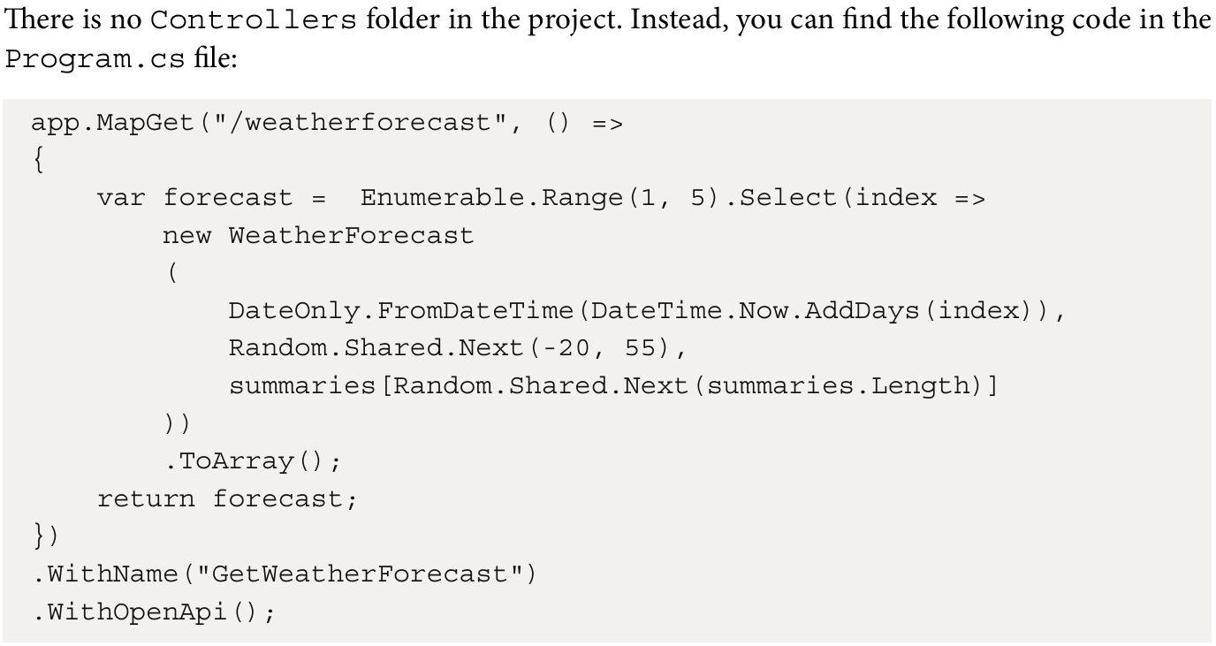
-------------------------------------------------------------------------------------------
The preceding code uses the MapGet() method to map the GET request to the /weatherforecast endpoint. The MapGet() method is an extension method of the IEndpointRouteBuilder interface. This interface is used to configure the endpoints in the application. Its extension method, MapGet(), returns an IEndpointConventionBuilder interface that allows us to use fluent APIs to configure the endpoint by using other extension methods, such as WithName() and WithOpenApi(). The WithName() method is used to set the name of the endpoint. The WithOpenApi() method is used to generate an OpenAPI document for the endpoint.
*******************************************************************

